Table of Contents
UNITED STATES
SECURITIES AND EXCHANGE COMMISSION
WASHINGTON, D.C. 20549
FORM 10-Q
x |  |  | QUARTERLY REPORT PURSUANT TO SECTION 13 OR 15(d) OF THE SECURITIES EXCHANGE ACT OF 1934
For the quarterly period ended June 30, 2026
OR
o |  |  | TRANSITION REPORT PURSUANT TO SECTION 13 OR 15(d) OF THE SECURITIES EXCHANGE ACT OF 1934
For the transition period from ______ to _______
Commission File Number: 001-41537
___________________________________
GRANITE RIDGE RESOURCES, INC.
( Exact Name of Registrant as Specified in Its Charter )
___________________________________
Texas |  |  |  |  |  | 88-2227812
(State or other jurisdiction of  incorporation or organization) |  |  |  |  |  | (I.R.S. Employer  Identification Number)
5217 McKinney Ave, Suite 400  Dallas, TX |  |  |  |  |  | 75205
(Address of principal executive offices) |  |  |  |  |  | (Zip Code)
(214) 396-2850
(Registrant’s telephone number, including area code)
(Former name, former address and former fiscal year, if changed since last report)
Securities registered pursuant to Section 12(b) of the Act:
Title of each class |  |  |  |  |  | Trading Symbol |  |  |  |  |  | Name of each exchange on which registered
Common Stock, par value $0.0001 per share |  |  |  |  |  | GRNT |  |  |  |  |  | New York Stock Exchange
Indicate by check mark whether the registrant (1) has filed all reports required to be filed by Section 13 or 15(d) of the Securities Exchange Act of 1934 during the preceding 12 months (or for such shorter period that the registrant was required to file such reports), and (2) has been subject to such filing requirements for the past 90 days. Yes x No o
Indicate by check mark whether the registrant has submitted electronically every Interactive Data File required to be submitted pursuant to Rule 405 of Regulation S-T (§232.405 of this chapter) during the preceding 12 months (or for such shorter period that the registrant was required to submit such files). Yes x No o
Indicate by check mark whether the registrant is a large accelerated filer, an accelerated filer, a non-accelerated filer, a smaller reporting company, or an emerging growth company. See the definitions of “large accelerated filer,” “accelerated filer,” “smaller reporting company” and “emerging growth company” in Rule 12b-2 of the Exchange Act.
 |  |  | Large accelerated filer |  |  | o |  |  | Accelerated filer |  |  | x |  |  | Non-accelerated filer |  |  | o |  |  | Smaller reporting company |  |  | o
 |  |  |  |  |  |  |  |  |  |  |  |  |  |  |  |  |  |  |  |  | Emerging growth company |  |  | o
If an emerging growth company, indicate by check mark if the registrant has elected not to use the extended transition period for complying with any new or revised financial accounting standards provided pursuant to Section 13(a) of the Exchange Act. o
Indicate by check mark whether the registrant is a shell company (as defined in Rule 12b-2 of the Exchange Act). Yes o No x
As of August 3, 2026, there were 131,900,242 shares of our common stock, par value $0.0001, outstanding.

Table of Contents
CAUTIONARY NOTE REGARDING FORWARD-LOOKING STATEMENTS
We are including the following discussion to inform our existing and potential security holders generally of some of the risks and uncertainties that can affect our company and to take advantage of the “safe harbor” protection for forward-looking statements that applicable federal securities law afford.
From time to time, our management or persons acting on our behalf may make "forward-looking statements," within the meaning of Section 27A of the Securities Act of 1933, as amended (the "Securities Act"), and Section 21E of the Securities Exchange Act of 1934, as amended (the "Exchange Act"), to inform existing and potential security holders about our company. All statements other than statements of historical facts included in this Quarterly Report on Form 10-Q (this "Report"), including, without limitation, statements regarding our financial position, operating and financial performance, business strategy, plans and objectives of management for future operations, industry conditions, indebtedness covenant compliance, capital expenditures, production, cash flow, borrowing base under our Credit Agreement (as defined below), our intention or ability to pay or increase dividends on our capital stock, and impairment are forward-looking statements. When used in this Report, forward-looking statements are generally accompanied by terms or phrases such as “estimate,” “project,” “predict,” “believe,” “expect,” “continue,” “anticipate,” “target,” “could,” “plan,” “intend,” “seek,” “goal,” “will,” “should,” “may” or other words and similar expressions that convey the uncertainty of future events or outcomes. Items contemplating or making assumptions about actual or potential future production, sales, market size, collaborations, cash flows, and trends or operating results also constitute such forward-looking statements.
Forward-looking statements involve inherent risks and uncertainties, and important factors (many of which are beyond our company’s control) could cause actual results to differ materially from those set forth in the forward-looking statements, including the following:
•changes in current or future commodity prices and interest rates;
•supply chain disruptions;
•infrastructure constraints and related factors affecting our properties;
•our ability to acquire additional development opportunities and potential or pending acquisition transactions, as well as the effects of such acquisitions on our company’s cash position and levels of indebtedness;
•changes in our reserves estimates or the value thereof;
•operational risks including, but not limited to, the pace of drilling and completions activity on our properties;
•changes in the markets in which Granite Ridge competes;
•geopolitical risk and changes in applicable laws, legislation, or regulations, including those relating to environmental matters;
•cyber-related risks;
•the fact that reserve estimates depend on many assumptions that may turn out to be inaccurate and that any material inaccuracies in reserve estimates or underlying assumptions will materially affect the quantities and present value of our reserves;
•the outcome of any known and unknown litigation and regulatory proceedings;
•limited liquidity and trading of Granite Ridge’s securities;
•acts of war, terrorism or uncertainty regarding the effects and duration of global hostilities, including the Israel-Hamas conflict, the Russia-Ukraine war, the conflict in Iran, continued instability in the Middle East, and any associated armed conflicts or related sanctions which may disrupt commodity prices and create instability in the financial markets;
2
Table of Contents
•market conditions and global, regulatory, technical, and economic factors beyond Granite Ridge’s control, including the potential adverse effects of world health events affecting capital markets, general economic conditions, global supply chains and Granite Ridge’s business and operations;
•increasing regulatory and investor emphasis on, and attention to, environmental, social, and governance matters;
•our ability to establish and maintain effective internal control over financial reporting; and
•other factors discussed in our Annual Report on Form 10-K for the year ended December 31, 2025 (the "2025 Form 10-K") under “Risk Factors,” as updated by any subsequent Quarterly Reports on Form 10-Q, including this Report, which we file with the United States Securities and Exchange Commission (“SEC”).
We have based any forward-looking statements on our current expectations and assumptions about future events. While our management considers these expectations and assumptions to be reasonable, they are inherently subject to significant business, economic, competitive, regulatory and other risks, contingencies and uncertainties, most of which are difficult to predict and many of which are beyond our control. If one or more of these risks or uncertainties materialize, or if the underlying assumptions prove incorrect, our actual results may vary materially from those expected or projected.
Reserve engineering is a process of estimating underground accumulations of natural gas and oil that cannot be measured in an exact manner. The accuracy of any reserve estimate depends on the quality of available data, the interpretation of such data, and the price and cost assumptions made by reservoir engineers. In addition, the results of drilling, testing and production activities, or changes in commodity prices, may justify revisions of estimates that were made previously. If significant, such revisions would change the schedule of any further production and development drilling. Accordingly, reserve estimates may differ significantly from the quantities of natural gas and oil that are ultimately recovered.
Readers are urged not to place undue reliance on these forward-looking statements, which speak only as of the date of this Report. We assume no obligation to update any forward-looking statements in order to reflect any event or circumstance that may arise after the date of this Report, other than as may be required by applicable law or regulation. Readers are urged to carefully review and consider the various disclosures made by us in our reports filed with the SEC which attempt to advise interested parties of the risks and factors that may affect our business, financial condition, results of operations and cash flows. If one or more of these risks or uncertainties materialize, or if the underlying assumptions prove incorrect, our actual results may vary materially from those expected or projected.

3
Table of Contents
TABLE OF CONTENTS
 |  |  |  |  |  | PAGE
CAUTIONARY NOTE REGARDING FORWARD-LOOKING STATEMENTS |  |  |  |  |  | 2
PART I – FINANCIAL INFORMATION |  |  |  |  |  | 5
Item 1. |  |  | Financial Statements |  |  | 5
 |  |  | Condensed Consolidated Balance Sheets |  |  | 5
 |  |  | Condensed Consolidated Statements of Operations |  |  | 6
 |  |  | Condensed Consolidated Statements of Changes in Stockholders’ Equity |  |  | 7
 |  |  | Condensed Consolidated Statements of Cash Flows |  |  | 8
 |  |  | Notes to Condensed Consolidated Financial Statements |  |  | 9
Item 2. |  |  | Management’s Discussion and Analysis of Financial Condition and Results of Operations |  |  | 27
Item 3. |  |  | Quantitative and Qualitative Disclosures about Market Risk |  |  | 38
Item 4. |  |  | Controls and Procedures |  |  | 39
PART II – OTHER INFORMATION |  |  |  |  |  | 39
Item 1. |  |  | Legal Proceedings |  |  | 39
Item 1A. |  |  | Risk Factors |  |  | 39
Item 2. |  |  | Unregistered Sales of Equity Securities and Use of Proceeds |  |  | 39
Item 3. |  |  | Defaults Upon Senior Securities |  |  | 39
Item 4. |  |  | Mine Safety Disclosures |  |  | 39
Item 5. |  |  | Other Information |  |  | 39
Item 6. |  |  | Exhibits |  |  | 40
Signatures |  |  |  |  |  | 41

4
Table of Contents
PART I – FINANCIAL INFORMATION

Item 1. Financial Statements

GRANITE RIDGE RESOURCES, INC.
CONDENSED CONSOLIDATED BALANCE SHEETS
Unaudited
(in thousands, except par value and share data) |  |  | June 30, 2026 |  |  |  |  |  | December 31, 2025
ASSETS
Current assets:
Cash |  |  | $ | 44,092 |  |  |  |  | $ | 14,846
Revenue receivable |  |  | 100,956 |  |  |  |  |  | 74,166
Advances to operators |  |  | 3,146 |  |  |  |  |  | 2,682
Prepaid and other current assets |  |  | 4,840 |  |  |  |  |  | 2,251
Derivative assets - commodity derivatives |  |  | 1,805 |  |  |  |  |  | 13,978
Equity investments |  |  | — |  |  |  |  |  | 10,960
Total current assets |  |  | 154,839 |  |  |  |  |  | 118,883
Property and equipment:
Oil and gas properties, successful efforts method |  |  | 2,039,497 |  |  |  |  |  | 1,897,388
Accumulated depletion |  |  | (964,968) |  |  |  |  |  | (857,832)
Total property and equipment, net |  |  | 1,074,529 |  |  |  |  |  | 1,039,556
Long-term assets:
Derivative assets - commodity derivatives |  |  | 3,088 |  |  |  |  |  | 3,743
Other long-term assets |  |  | 5,121 |  |  |  |  |  | 5,889
Total long-term assets |  |  | 8,209 |  |  |  |  |  | 9,632
Total assets |  |  | $ | 1,237,577 |  |  |  |  | $ | 1,168,071
LIABILITIES AND STOCKHOLDERS' EQUITY
Current liabilities:
Accounts payable and accrued liabilities |  |  | $ | 100,076 |  |  |  |  | $ | 76,847
Current portion of long-term debt |  |  | 35,000 |  |  |  |  |  | 17,500
Derivative liabilities - commodity derivatives |  |  | 10,635 |  |  |  |  |  | 24
Other liabilities |  |  | 5,536 |  |  |  |  |  | 810
Total current liabilities |  |  | 151,247 |  |  |  |  |  | 95,181
Long-term liabilities:
Long-term debt, net |  |  | 427,108 |  |  |  |  |  | 367,832
Derivative liabilities - commodity derivatives |  |  | 1,021 |  |  |  |  |  | —
Asset retirement obligations |  |  | 12,430 |  |  |  |  |  | 11,968
Deferred tax liability |  |  | 82,456 |  |  |  |  |  | 87,330
Other long-term payables |  |  | 942 |  |  |  |  |  | —
Total long-term liabilities |  |  | 523,957 |  |  |  |  |  | 467,130
Total liabilities |  |  | 675,204 |  |  |  |  |  | 562,311
Stockholders' equity:
Common stock, $0.0001 par value, 431,000,000 shares authorized, 137,592,654 and 136,941,978 issued at June 30, 2026 and December 31, 2025, respectively |  |  | 14 |  |  |  |  |  | 14
Additional paid-in capital |  |  | 661,876 |  |  |  |  |  | 659,228
Retained earnings (accumulated deficit) |  |  | (63,291) |  |  |  |  |  | (17,286)
Treasury stock, at cost, 5,692,412 and 5,686,711 shares at June 30, 2026 and December 31, 2025, respectively |  |  | (36,226) |  |  |  |  |  | (36,196)
Total stockholders' equity |  |  | 562,373 |  |  |  |  |  | 605,760
Total liabilities and stockholders' equity |  |  | $ | 1,237,577 |  |  |  |  | $ | 1,168,071
The accompanying notes are an integral part of these condensed consolidated financial statements.

5
Table of Contents
GRANITE RIDGE RESOURCES, INC.
CONDENSED CONSOLIDATED STATEMENTS OF OPERATIONS
Unaudited
 |  |  | Three Months Ended June 30, |  |  |  |  |  |  |  |  |  |  |  | Six Months Ended June 30,
(in thousands, except per share data) |  |  | 2026 |  |  |  |  |  | 2025 |  |  |  |  |  | 2026 |  |  |  |  |  | 2025
Revenues:
Oil and natural gas sales |  |  | $ | 149,273 |  |  |  |  | $ | 109,219 |  |  |  |  | $ | 277,537 |  |  |  |  | $ | 232,150
Operating costs and expenses:
Lease operating expenses |  |  | 29,961 |  |  |  |  |  | 20,118 |  |  |  |  |  | 59,640 |  |  |  |  |  | 36,358
Production and ad valorem taxes |  |  | 9,284 |  |  |  |  |  | 6,437 |  |  |  |  |  | 17,520 |  |  |  |  |  | 14,805
Depletion and accretion expense |  |  | 52,666 |  |  |  |  |  | 53,412 |  |  |  |  |  | 107,645 |  |  |  |  |  | 101,857
Impairments of long-lived assets |  |  | 9,149 |  |  |  |  |  | — |  |  |  |  |  | 20,323 |  |  |  |  |  | —
General and administrative |  |  | 9,151 |  |  |  |  |  | 8,517 |  |  |  |  |  | 18,231 |  |  |  |  |  | 15,980
Other, net |  |  | 45 |  |  |  |  |  | — |  |  |  |  |  | 312 |  |  |  |  |  | (120)
Total operating costs and expenses |  |  | 110,256 |  |  |  |  |  | 88,484 |  |  |  |  |  | 223,671 |  |  |  |  |  | 168,880
Net operating income |  |  | 39,017 |  |  |  |  |  | 20,735 |  |  |  |  |  | 53,866 |  |  |  |  |  | 63,270
Other income (expense):
Gain (loss) on derivatives - commodity derivatives |  |  | 12,992 |  |  |  |  |  | 23,925 |  |  |  |  |  | (59,035) |  |  |  |  |  | 9,068
Interest expense, net |  |  | (11,074) |  |  |  |  |  | (5,914) |  |  |  |  |  | (21,393) |  |  |  |  |  | (10,929)
Gain (loss) on equity investments |  |  | (2,223) |  |  |  |  |  | (5,795) |  |  |  |  |  | 4,452 |  |  |  |  |  | (15,766)
Other income (loss) |  |  | 157 |  |  |  |  |  | (93) |  |  |  |  |  | 315 |  |  |  |  |  | (93)
Total other income (expense) |  |  | (148) |  |  |  |  |  | 12,123 |  |  |  |  |  | (75,661) |  |  |  |  |  | (17,720)
Income (loss) before income taxes |  |  | 38,869 |  |  |  |  |  | 32,858 |  |  |  |  |  | (21,795) |  |  |  |  |  | 45,550
Income tax expense (benefit) |  |  | 8,873 |  |  |  |  |  | 7,777 |  |  |  |  |  | (4,760) |  |  |  |  |  | 10,657
Net income (loss) |  |  | $ | 29,996 |  |  |  |  | $ | 25,081 |  |  |  |  | $ | (17,035) |  |  |  |  | $ | 34,893
Net income (loss) per share:
Basic |  |  | $ | 0.23 |  |  |  |  | $ | 0.19 |  |  |  |  | $ | (0.13) |  |  |  |  | $ | 0.27
Diluted |  |  | $ | 0.23 |  |  |  |  | $ | 0.19 |  |  |  |  | $ | (0.13) |  |  |  |  | $ | 0.27
Weighted-average number of shares outstanding:
Basic |  |  | 130,805 |  |  |  |  |  | 130,469 |  |  |  |  |  | 130,713 |  |  |  |  |  | 130,403
Diluted |  |  | 130,824 |  |  |  |  |  | 130,588 |  |  |  |  |  | 130,713 |  |  |  |  |  | 130,496
The accompanying notes are an integral part of these condensed consolidated financial statements.

6
Table of Contents
GRANITE RIDGE RESOURCES, INC.
CONDENSED CONSOLIDATED STATEMENTS OF CHANGES IN STOCKHOLDERS’ EQUITY
Unaudited
Three and Six Months Ended June 30, 2026
 |  |  | Common Stock Issued |  |  |  |  |  |  |  |  |  |  |  | Additional  Paid-in  Capital |  |  |  |  |  | Retained  Earnings (Accumulated Deficit) |  |  |  |  |  | Treasury Stock |  |  |  |  |  |  |  |  |  |  |  | Total Stockholders'  Equity
(in thousands) |  |  | Shares |  |  |  |  |  | Amount |  |  |  |  |  |  |  |  |  |  |  |  |  |  |  |  |  | Shares |  |  |  |  |  | Amount
As of January 1, 2026 |  |  | 136,942 |  |  |  |  |  | $ | 14 |  |  |  |  | $ | 659,228 |  |  |  |  | $ | (17,286) |  |  |  |  | (5,687) |  |  |  |  |  | $ | (36,196) |  |  |  |  | $ | 605,760
Common stock issued related to stock-based compensation |  |  | 660 |  |  |  |  |  | — |  |  |  |  |  | — |  |  |  |  |  | — |  |  |  |  |  | — |  |  |  |  |  | — |  |  |  |  |  | —
Stock-based compensation expense |  |  | — |  |  |  |  |  | — |  |  |  |  |  | 1,398 |  |  |  |  |  | — |  |  |  |  |  | — |  |  |  |  |  | — |  |  |  |  |  | 1,398
Purchase of treasury stock |  |  | — |  |  |  |  |  | — |  |  |  |  |  | — |  |  |  |  |  | — |  |  |  |  |  | (5) |  |  |  |  |  | (30) |  |  |  |  |  | (30)
Common stock dividend declared ($0.11 per share) |  |  | — |  |  |  |  |  | — |  |  |  |  |  | — |  |  |  |  |  | (14,461) |  |  |  |  |  | — |  |  |  |  |  | — |  |  |  |  |  | (14,461)
Net loss |  |  | — |  |  |  |  |  | — |  |  |  |  |  | — |  |  |  |  |  | (47,031) |  |  |  |  |  | — |  |  |  |  |  | — |  |  |  |  |  | (47,031)
As of March 31, 2026 |  |  | 137,602 |  |  |  |  |  | $ | 14 |  |  |  |  | $ | 660,626 |  |  |  |  | $ | (78,778) |  |  |  |  | (5,692) |  |  |  |  |  | $ | (36,226) |  |  |  |  | $ | 545,636
Common stock issued related to stock-based compensation |  |  | 4 |  |  |  |  |  | — |  |  |  |  |  | — |  |  |  |  |  | — |  |  |  |  |  | — |  |  |  |  |  | — |  |  |  |  |  | —
Forfeitures of restricted stock |  |  | (13) |  |  |  |  |  | — |  |  |  |  |  | — |  |  |  |  |  | — |  |  |  |  |  | — |  |  |  |  |  | — |  |  |  |  |  | —
Stock-based compensation expense |  |  | — |  |  |  |  |  | — |  |  |  |  |  | 1,250 |  |  |  |  |  | — |  |  |  |  |  | — |  |  |  |  |  | — |  |  |  |  |  | 1,250
Common stock dividend declared ($0.11 per share) |  |  | — |  |  |  |  |  | — |  |  |  |  |  | — |  |  |  |  |  | (14,509) |  |  |  |  |  | — |  |  |  |  |  | — |  |  |  |  |  | (14,509)
Net income |  |  | — |  |  |  |  |  | — |  |  |  |  |  | — |  |  |  |  |  | 29,996 |  |  |  |  |  | — |  |  |  |  |  | — |  |  |  |  |  | 29,996
As of June 30, 2026 |  |  | 137,593 |  |  |  |  |  | $ | 14 |  |  |  |  | $ | 661,876 |  |  |  |  | $ | (63,291) |  |  |  |  | (5,692) |  |  |  |  |  | $ | (36,226) |  |  |  |  | $ | 562,373

Three and Six Months Ended June 30, 2025
 |  |  | Common Stock Issued |  |  |  |  |  |  |  |  |  |  |  | Additional  Paid-in  Capital |  |  |  |  |  | Retained  Earnings |  |  |  |  |  | Treasury Stock |  |  |  |  |  |  |  |  |  |  |  | Total Stockholders'  Equity
(in thousands) |  |  | Shares |  |  |  |  |  | Amount |  |  |  |  |  |  |  |  |  |  |  |  |  |  |  |  |  | Shares |  |  |  |  |  | Amount
As of January 1, 2025 |  |  | 136,418 |  |  |  |  |  | $ | 14 |  |  |  |  | $ | 655,472 |  |  |  |  | $ | 16,047 |  |  |  |  | (5,684) |  |  |  |  |  | $ | (36,180) |  |  |  |  | $ | 635,353
Common stock issued related to stock-based compensation |  |  | 413 |  |  |  |  |  | — |  |  |  |  |  | — |  |  |  |  |  | — |  |  |  |  |  | — |  |  |  |  |  | — |  |  |  |  |  | —
Forfeitures of restricted stock |  |  | (7) |  |  |  |  |  | — |  |  |  |  |  | — |  |  |  |  |  | — |  |  |  |  |  | — |  |  |  |  |  | — |  |  |  |  |  | —
Stock-based compensation expense |  |  | — |  |  |  |  |  | — |  |  |  |  |  | 653 |  |  |  |  |  | — |  |  |  |  |  | — |  |  |  |  |  | — |  |  |  |  |  | 653
Purchase of treasury stock |  |  | — |  |  |  |  |  | — |  |  |  |  |  | — |  |  |  |  |  | — |  |  |  |  |  | (3) |  |  |  |  |  | (16) |  |  |  |  |  | (16)
Common stock dividend declared ($0.11 per share) |  |  | — |  |  |  |  |  | — |  |  |  |  |  | — |  |  |  |  |  | (14,389) |  |  |  |  |  | — |  |  |  |  |  | — |  |  |  |  |  | (14,389)
Net income |  |  | — |  |  |  |  |  | — |  |  |  |  |  | — |  |  |  |  |  | 9,812 |  |  |  |  |  | — |  |  |  |  |  | — |  |  |  |  |  | 9,812
As of March 31, 2025 |  |  | 136,824 |  |  |  |  |  | $ | 14 |  |  |  |  | $ | 656,125 |  |  |  |  | $ | 11,470 |  |  |  |  | (5,687) |  |  |  |  |  | $ | (36,196) |  |  |  |  | $ | 631,413
Common stock issued related to stock-based compensation |  |  | 218 |  |  |  |  |  | — |  |  |  |  |  | — |  |  |  |  |  | — |  |  |  |  |  | — |  |  |  |  |  | — |  |  |  |  |  | —
Forfeitures of restricted stock |  |  | (90) |  |  |  |  |  | — |  |  |  |  |  | — |  |  |  |  |  | — |  |  |  |  |  | — |  |  |  |  |  | — |  |  |  |  |  | —
Stock-based compensation expense |  |  | — |  |  |  |  |  | — |  |  |  |  |  | 395 |  |  |  |  |  | — |  |  |  |  |  | — |  |  |  |  |  | — |  |  |  |  |  | 395
Common stock dividend declared ($0.11 per share) |  |  | — |  |  |  |  |  | — |  |  |  |  |  | — |  |  |  |  |  | (14,423) |  |  |  |  |  | — |  |  |  |  |  | — |  |  |  |  |  | (14,423)
Net income |  |  | — |  |  |  |  |  | — |  |  |  |  |  | — |  |  |  |  |  | 25,081 |  |  |  |  |  | — |  |  |  |  |  | — |  |  |  |  |  | 25,081
As of June 30, 2025 |  |  | 136,952 |  |  |  |  |  | $ | 14 |  |  |  |  | $ | 656,520 |  |  |  |  | $ | 22,128 |  |  |  |  | (5,687) |  |  |  |  |  | $ | (36,196) |  |  |  |  | $ | 642,466
The accompanying notes are an integral part of these condensed consolidated financial statements.

7
Table of Contents
GRANITE RIDGE RESOURCES, INC.
CONDENSED CONSOLIDATED STATEMENTS OF CASH FLOWS
Unaudited
 |  |  | Six Months Ended June 30,
(in thousands) |  |  | 2026 |  |  |  |  |  | 2025
Operating activities:
Net income (loss) |  |  | $ | (17,035) |  |  |  |  | $ | 34,893
Adjustments to reconcile net income (loss) to net cash provided by operating activities:
Depletion and accretion expense |  |  | 107,645 |  |  |  |  |  | 101,857
Impairments of long-lived assets |  |  | 20,323 |  |  |  |  |  | —
Unrealized (gain) loss on derivatives - commodity derivatives |  |  | 24,460 |  |  |  |  |  | (8,210)
Stock-based compensation expense |  |  | 2,648 |  |  |  |  |  | 1,048
Amortization of deferred financing costs and original issue discount |  |  | 2,658 |  |  |  |  |  | 800
(Gain) loss on equity investments |  |  | (4,452) |  |  |  |  |  | 15,766
Deferred income taxes |  |  | (4,874) |  |  |  |  |  | 10,275
Other |  |  | (135) |  |  |  |  |  | (258)
Increase (decrease) in cash attributable to changes in operating assets and liabilities:
Revenue receivable |  |  | (26,790) |  |  |  |  |  | (6,956)
Accounts payable and accrued liabilities |  |  | 6,581 |  |  |  |  |  | 3,202
Prepaid and other current assets |  |  | (2,589) |  |  |  |  |  | 1,615
Other liabilities and long-term payables |  |  | 5,488 |  |  |  |  |  | 102
Net cash provided by operating activities |  |  | 113,928 |  |  |  |  |  | 154,134
Investing activities:
Capital expenditures for oil and natural gas properties |  |  | (122,593) |  |  |  |  |  | (164,533)
Acquisition of oil and natural gas properties |  |  | (26,182) |  |  |  |  |  | (44,861)
Proceeds from sale of equity investments |  |  | 15,412 |  |  |  |  |  | 4,991
Proceeds from sale of oil and natural gas properties |  |  | 1,542 |  |  |  |  |  | 175
Refund of advances to operators |  |  | 1,139 |  |  |  |  |  | 3,695
Net cash used in investing activities |  |  | (130,682) |  |  |  |  |  | (200,533)
Financing activities:
Proceeds from borrowing on credit facilities |  |  | 105,000 |  |  |  |  |  | 95,000
Repayments of borrowing on credit facilities |  |  | (30,000) |  |  |  |  |  | (25,000)
Deferred financing costs |  |  | — |  |  |  |  |  | (449)
Purchase of treasury shares |  |  | (30) |  |  |  |  |  | (16)
Payment of dividends |  |  | (28,970) |  |  |  |  |  | (28,812)
Net cash provided by financing activities |  |  | 46,000 |  |  |  |  |  | 40,723
Net change in cash |  |  | 29,246 |  |  |  |  |  | (5,676)
Cash at beginning of period |  |  | 14,846 |  |  |  |  |  | 9,419
Cash at end of period |  |  | $ | 44,092 |  |  |  |  | $ | 3,743
Supplemental disclosure of non-cash investing activities:
Change in accrued capital expenditures included in accounts payable and accrued liabilities |  |  | $ | 7,396 |  |  |  |  | $ | (7,815)
Advances to operators applied to development of oil and natural gas properties |  |  | $ | 84,119 |  |  |  |  | $ | 72,541
The accompanying notes are an integral part of these condensed consolidated financial statements.

8
Table of Contents
GRANITE RIDGE RESOURCES, INC.
Notes to Condensed Consolidated Financial Statements

1. Nature of Operations
Granite Ridge Resources, Inc. (together with its consolidated subsidiaries, “Granite Ridge” or the “Company”), a Texas corporation, is a scaled energy company which aims to provide shareholders with exposure similar to energy private equity through operated partnerships and traditional non-operated assets in multiple basins throughout North America.
As discussed in Note 13 - Subsequent Events, on August 5, 2026, the Company completed its reincorporation from the State of Delaware to the State of Texas by means of a conversion.

2. Summary of Significant Accounting Policies
A complete discussion of the Company’s significant accounting policies is included in the 2025 Form 10-K.
Interim Financial Statements, Basis of Presentation, Consolidation, and Significant Estimates
The condensed consolidated financial statements have been prepared in conformity with accounting principles generally accepted in the United States of America (“U.S. GAAP”). The accompanying condensed consolidated financial statements include the accounts of the Company and all of its wholly owned subsidiaries. All intercompany balances and transactions have been eliminated in consolidation.
The accompanying condensed consolidated financial statements of the Company have not been audited by the Company’s independent registered public accounting firm, except that the condensed consolidated balance sheet at December 31, 2025 is derived from audited consolidated financial statements. In the opinion of management, the accompanying condensed consolidated financial statements reflect all adjustments necessary to present fairly the Company’s condensed consolidated financial statements. All such adjustments are of a normal, recurring nature.
The preparation of the condensed consolidated financial statements in conformity with U.S. GAAP requires management to make estimates and assumptions that affect the reported amounts of assets and liabilities at the date of the condensed consolidated financial statements and the reported amounts of revenues and expenses during the reporting period. Significant estimates of reserves are used to determine depletion and to conduct impairment analysis. Estimating reserves is inherently uncertain, including the projection of future rates of production and the timing of development expenditures. Additional significant estimates include, but are not limited to, fair value of derivative financial instruments, fair value of equity investments, fair value of business combinations, asset retirement obligations, revenue receivable and income taxes. Actual results could differ from those estimates. The results for interim periods are not necessarily indicative of annual results.
Certain disclosures have been condensed in, or omitted from, these condensed consolidated financial statements. Accordingly, these notes to the condensed consolidated financial statements should be read in conjunction with the audited consolidated financial statements and notes included in the Company’s 2025 Form 10-K.
Certain reclassifications have been made to prior period amounts to conform to the current period presentation.
Segment Reporting
The Company operates in one reporting segment, which is oil and natural gas development, exploration and production. All of the Company's operations are conducted in the geographic area of the United States. The reporting segment generates revenue through the sale of oil and natural gas. The Company’s chief operating decision maker (“CODM”), who is the Company’s Chief Executive Officer, manages operations on a consolidated basis for purposes of evaluating operational performance and allocating resources. Net income, as reported within the Company’s condensed consolidated statement of operations, is used by the CODM to assess performance for the oil and natural gas development, exploration and production segment. Significant segment expenses are the same as those reported in the condensed consolidated statements
9
Table of Contents
GRANITE RIDGE RESOURCES, INC.
Notes to Condensed Consolidated Financial Statements
of operations. Total assets, as reported within the Company’s condensed consolidated balance sheets, is the measure of segment assets.
Oil and Natural Gas Properties
The Company uses the successful efforts method of accounting for oil and natural gas producing activities, as further defined under Accounting Standards Codification ("ASC") 932, Extractive Activities - Oil and Gas (“ASC 932”). Costs to acquire mineral interests in oil and gas properties, to drill and equip exploratory leases that find proved reserves, and to drill and equip development leases and related asset retirement costs are capitalized. Costs to drill exploratory wells are capitalized pending determinations of whether the wells have proved reserves. If the Company determines that the wells do not have proved reserves, the costs are charged to expense.
Capitalized leasehold costs relating to proved properties are depleted using the unit-of-production method based on proved reserves. The depletion of capitalized drilling and development costs and integrated assets is based on the unit-of-production method using proved developed reserves. The Company recognized depletion expense of $52.4 million and $53.2 million for the three months ended June 30, 2026 and 2025, respectively, and $107.1 million and $101.4 million for the six months ended June 30, 2026 and 2025, respectively.
The Company reviews its long-lived assets to be held and used, including proved oil and natural gas properties, whenever events or circumstances indicate that the carrying value of those assets may not be recoverable; for instance, when there are declines in commodity prices or well performance. An impairment loss is indicated if the sum of the expected undiscounted future net cash flows is less than the carrying amount of the assets. For each property determined to be impaired, an impairment loss equal to the difference between the carrying value of the properties and the estimated fair market value is recognized at that time. The fair value of impaired assets is determined using the market or income valuation approach. The income approach is calculated using a discounted cash flow model. Discounted future cash flows use a discount rate similar to that used by market participants, or comparable market value if available. Estimating future cash flows involves the use of judgments, including estimation of the proved and risk-adjusted unproved oil and natural gas reserve quantities, timing of development and production, expected future commodity prices, capital expenditures and production costs. No proved property impairment was recorded for the three or six months ended June 30, 2026 or 2025.
Unproved oil and natural gas properties are periodically assessed for impairment by considering future drilling and exploration plans, results of exploration activities, commodity price outlooks, planned future sales and expiration of all or a portion of the projects. The Company recorded unproved oil and gas properties impairment of $9.1 million for the three months ended June 30, 2026 and $20.3 million for the six months ended June 30, 2026 as a result of changes in operator development plans and reassessment of the economic viability of certain acreage in the Permian Basin resulting from unfavorable drilling results and further geologic and reservoir analysis of the acreage. No unproved property impairment was recorded for the three and six months ended June 30, 2025.
Equity Investments
The Company follows the guidance in ASC 321, Investments - Equity Securities ("ASC 321") for its investment in common stock. ASC 321 requires equity investments with readily determinable fair values to be measured at fair value, with unrealized holding gains and losses recorded as a gain or loss in the condensed consolidated statements of operations. For the preferred stock that did not have a readily determinable fair value, the Company did not elect the measurement alternative in ASC 321 and instead accounted for the preferred stock at fair value with unrealized gains and losses recorded through net income for the period until the preferred stock was converted into common stock.
On December 15, 2025, Crescent Energy completed its previously announced merger with Vital Energy. Under the merger agreement, each issued and outstanding share of Vital Energy common stock was converted into 1.9062 shares of Crescent Energy Class A common stock. As a result of the transaction, the Company’s 685,271 outstanding shares at the time of the merger closing in Vital Energy common stock were converted into 1,306,263 shares of Crescent Energy Class A common stock.
During the second quarter of 2026, the Company disposed of its remaining 1,306,263 shares of Crescent Energy Company (“Crescent Energy”) common stock and realized a loss on sale of $2.2 million which is included in gain (loss) on equity investments within the Company’s condensed consolidated statements of operations for the three and six months ended
10
Table of Contents
GRANITE RIDGE RESOURCES, INC.
Notes to Condensed Consolidated Financial Statements
June 30, 2026. During the second quarter of 2025, the Company divested 342,636 shares of Vital Energy, Inc. ("Vital Energy") common stock and realized a loss on sale of $10.5 million, for the three and six months ended June 30, 2025. As of June 30, 2026, the Company holds no shares of Crescent Energy’s or Vital Energy’s common stock.
The following table summarizes the amounts reported as gain (loss) on equity investments in the condensed consolidated statements of operations for the three and six months ended June 30, 2026, and 2025:
 |  |  | Three Months Ended June 30, |  |  |  |  |  |  |  |  |  |  |  | Six Months Ended June 30,
(in thousands) |  |  | 2026 |  |  |  |  |  | 2025 |  |  |  |  |  | 2026 |  |  |  |  |  | 2025
Unrealized gain (loss) on equity investments |  |  | $ | — |  |  |  |  | $ | 4,723 |  |  |  |  | $ | 6,675 |  |  |  |  | $ | (5,248)
Realized loss on equity investment |  |  | (2,223) |  |  |  |  |  | (10,518) |  |  |  |  |  | (2,223) |  |  |  |  |  | (10,518)
Total gain (loss) on equity investments |  |  | $ | (2,223) |  |  |  |  | $ | (5,795) |  |  |  |  | $ | 4,452 |  |  |  |  | $ | (15,766)
Revenue Recognition
The Company’s revenues are primarily derived from its interests in the sale of oil and natural gas production. The Company recognizes revenue from its interests in the sales of oil and natural gas in the period that its performance obligations are satisfied.
Performance obligations are satisfied when the customer obtains control of the product, when the Company has no further obligations to perform related to the sale, when the transaction price has been determined, and when collectability is probable.
The Company receives payment from the sale of oil and natural gas production from one to three months after delivery. The transaction price is variable as it is based on market prices for oil and natural gas, less revenue deductions such as gathering, transportation, and compression costs. Management has determined that the variable revenue constraint is overcome at the date control passes to the customer since the variable consideration to be received can be reasonably estimated based on daily market prices and historical transportation charges. Revenue is presented net of these costs within the condensed consolidated statements of operations. At the end of each month when the performance obligations are satisfied, the variable consideration can be reasonably estimated and amounts due from customers are accrued in revenue receivable in the condensed consolidated balance sheets. Variances between the Company’s estimated revenue and actual payments are recorded in the month the payment is received; however, differences have been and are insignificant.
The Company does not disclose the value of unsatisfied performance obligations under its contracts with customers as it applies the practical expedient in accordance with ASC 606. The expedient, as described in ASC 606-10-50-14(a), applies to variable consideration that is recognized as control of the product is transferred to the customer. Since each unit of product represents a separate performance obligation, future volumes are wholly unsatisfied, and disclosure of the transaction price allocated to remaining performance obligations is not required.
Take in Kind Oil and Natural Gas Revenues
Under certain arrangements, the Company has the right to take a volume of unprocessed gas in kind at the operator's wellhead, representing its proportionate share of its natural gas production, in lieu of receiving a net payment from the operator. The Company currently takes certain natural gas volumes in kind in lieu of monetary settlement. When the Company elects to take volumes in kind, it pays third parties to transport the natural gas it took in kind to downstream delivery points, where it then sells to customers at prices applicable to those downstream markets. In such situations, revenues are recognized during the month in which control transfers to the customer at the delivery point and it is probable the Company will collect the consideration it is entitled to receive. Sales proceeds are generally received by the Company within one month after the month in which a sale has occurred. In these scenarios, gathering and processing costs and
11
Table of Contents
GRANITE RIDGE RESOURCES, INC.
Notes to Condensed Consolidated Financial Statements
transportation expenses the Company incurs to transport the volumes to downstream customers are recorded in lease operating expenses in the condensed consolidated statements of operations.
Disaggregated Oil and Natural Gas Revenues
The Company’s disaggregated revenue has two primary sources: oil sales and natural gas sales. Substantially all of the Company’s oil and natural gas sales come from six geographic areas in the United States: the Eagle Ford Basin (Texas), the Permian Basin (Texas/New Mexico), the Haynesville Basin (Texas/Louisiana), the Denver-Julesburg “DJ” Basin (Colorado), the Bakken Basin (Montana/North Dakota), and the Appalachian Basin (Ohio). The following tables present the disaggregation of the Company’s oil and natural gas revenues by basin for the three and six months ended June 30, 2026 and 2025.
 |  |  | Three Months Ended June 30, |  |  |  |  |  |  |  |  |  |  |  | Six Months Ended June 30,
(in thousands) |  |  | 2026 |  |  |  |  |  | 2025 |  |  |  |  |  | 2026 |  |  |  |  |  | 2025
Oil |  |  | $ | 139,674 |  |  |  |  | $ | 89,462 |  |  |  |  | $ | 243,120 |  |  |  |  | $ | 181,309
Natural gas |  |  | 9,599 |  |  |  |  |  | 19,757 |  |  |  |  |  | 34,417 |  |  |  |  |  | 50,841
Total |  |  | $ | 149,273 |  |  |  |  | $ | 109,219 |  |  |  |  | $ | 277,537 |  |  |  |  | $ | 232,150
Permian |  |  | $ | 108,939 |  |  |  |  | $ | 75,349 |  |  |  |  | $ | 195,988 |  |  |  |  | $ | 156,993
Eagle Ford |  |  | 8,576 |  |  |  |  |  | 7,898 |  |  |  |  |  | 15,145 |  |  |  |  |  | 18,882
Bakken |  |  | 9,774 |  |  |  |  |  | 7,142 |  |  |  |  |  | 16,186 |  |  |  |  |  | 16,999
Haynesville |  |  | 6,484 |  |  |  |  |  | 4,053 |  |  |  |  |  | 18,437 |  |  |  |  |  | 9,791
DJ |  |  | 6,617 |  |  |  |  |  | 7,493 |  |  |  |  |  | 14,106 |  |  |  |  |  | 17,893
Appalachian |  |  | 8,883 |  |  |  |  |  | 7,284 |  |  |  |  |  | 17,675 |  |  |  |  |  | 11,592
Total |  |  | $ | 149,273 |  |  |  |  | $ | 109,219 |  |  |  |  | $ | 277,537 |  |  |  |  | $ | 232,150
Recently Issued and Applicable Accounting Pronouncements (Issued and Not Yet Adopted)
In November 2024, the FASB issued ASU 2024-03, Disaggregation of Income Statement Expenses ("ASU 2024-03"), which requires enhanced disclosure about specific types of expenses included in the expense captions presented on the face of the consolidated statement of operations as well as disclosures about selling expenses. ASU 2024-03 is effective for annual periods beginning after December 15, 2026 and interim periods beginning after December 15, 2027. Early adoption is permitted. The Company has not early adopted the standard and is currently assessing the effect that ASU 2024-03 will have on its disclosures.

3. Derivative Financial Instruments
The Company uses derivative financial instruments in connection with its oil and natural gas operations to provide an economic hedge of the Company’s exposure to commodity price risk associated with anticipated future oil and natural gas production. The Company does not hold or issue derivative financial instruments for speculative trading purposes.
The Company does not designate its derivative instruments to qualify for hedge accounting. Accordingly, the Company reflects changes in the fair value of its derivative instruments in its condensed consolidated statements of operations as they occur.
Commodity Derivatives Collar Option Contracts and Swaps
The Company’s commodity derivative financial instruments consist of collar option contracts and swaps.
A collar option is established with the sale of a short call option (ceiling price) and the purchase of a long put option (floor price) set to expire at a predetermined date in the future. The options give the owner the right but not the obligation to exercise the option at the expiration date.
12
Table of Contents
GRANITE RIDGE RESOURCES, INC.
Notes to Condensed Consolidated Financial Statements
When the settlement price is below the established floor price, the Company receives an amount from its counterparty equal to the difference between the settlement price and the floor price multiplied by the hedged contract volume. When the settlement price is above the established ceiling price, the Company pays its counterparty an amount equal to the difference between the settlement price and the ceiling price multiplied by the hedged contract volume. When the settlement price is between the established floor and the ceiling, no amounts are due to or from the counterparty.
A swap contract allows the Company to receive a fixed price and pay a floating market price to the counterparty for the hedged commodity.
The Company has master netting agreements on individual derivative instruments with its counterparties and therefore certain amounts may be presented on a net basis in the condensed consolidated balance sheets.
Volume of Commodity Derivative Collar Option Contracts and Swap Activities
The following table sets forth the Company’s outstanding commodity derivative contracts as of June 30, 2026.
 |  |  | 2026 |  |  |  |  |  |  |  |  |  |  |  |  |  |  |  |  |  | 2027 |  |  |  |  |  | 2028
 |  |  | Third Quarter |  |  |  |  |  | Fourth Quarter |  |  |  |  |  | Total |  |  |  |  |  | Total |  |  |  |  |  | Total
Collars (oil)
Volume (Bbl) |  |  | 909,612 |  |  |  |  |  | 795,038 |  |  |  |  |  | 1,704,650 |  |  |  |  |  | 1,620,934 |  |  |  |  |  | —
Weighted-average floor price ($/Bbl) |  |  | $ | 60.53 |  |  |  |  | $ | 59.97 |  |  |  |  | $ | 60.27 |  |  |  |  | $ | 54.91 |  |  |  |  | $ | —
Weighted-average ceiling price ($/Bbl) |  |  | $ | 69.93 |  |  |  |  | $ | 68.53 |  |  |  |  | $ | 69.28 |  |  |  |  | $ | 76.63 |  |  |  |  | $ | —
Swaps (oil)
Volume (Bbl) |  |  | 73,484 |  |  |  |  |  | 53,974 |  |  |  |  |  | 127,458 |  |  |  |  |  | 452,936 |  |  |  |  |  | —
Weighted-average price ($/Bbl) |  |  | $ | 60.27 |  |  |  |  | $ | 60.24 |  |  |  |  | $ | 60.26 |  |  |  |  | $ | 60.21 |  |  |  |  | $ | —
Swaps (oil WTI / Brent CMA Diff)
Volume (Bbl) |  |  | 368,627 |  |  |  |  |  | 318,367 |  |  |  |  |  | 686,994 |  |  |  |  |  | — |  |  |  |  |  | —
Weighted-average price ($/Bbl) |  |  | $ | (5.51) |  |  |  |  | $ | (5.51) |  |  |  |  | $ | (5.51) |  |  |  |  | $ | — |  |  |  |  | $ | —
Collars (natural gas)
Volume (Mcf) |  |  | 1,727,756 |  |  |  |  |  | 3,868,320 |  |  |  |  |  | 5,596,076 |  |  |  |  |  | 6,427,940 |  |  |  |  |  | 2,211,640
Weighted-average floor price ($/Mcf) |  |  | $ | 3.25 |  |  |  |  | $ | 3.66 |  |  |  |  | $ | 3.53 |  |  |  |  | $ | 3.86 |  |  |  |  | $ | 3.60
Weighted-average ceiling price ($/Mcf) |  |  | $ | 4.00 |  |  |  |  | $ | 4.44 |  |  |  |  | $ | 4.30 |  |  |  |  | $ | 4.96 |  |  |  |  | $ | 4.73
Swaps (natural gas)
Volume (Mcf) |  |  | 3,961,363 |  |  |  |  |  | 1,222,218 |  |  |  |  |  | 5,183,581 |  |  |  |  |  | 9,323,814 |  |  |  |  |  | —
Weighted-average price ($/Mcf) |  |  | $ | 3.73 |  |  |  |  | $ | 3.73 |  |  |  |  | $ | 3.73 |  |  |  |  | $ | 3.60 |  |  |  |  | $ | —
Swaps (natural gas Waha Basis)
Volume (Mcf) |  |  | 2,712,563 |  |  |  |  |  | 2,300,200 |  |  |  |  |  | 5,012,763 |  |  |  |  |  | 5,677,944 |  |  |  |  |  | 111,100
Weighted-average price ($/Mcf) |  |  | $ | (4.74) |  |  |  |  | $ | (1.60) |  |  |  |  | $ | (3.30) |  |  |  |  | $ | (1.38) |  |  |  |  | $ | (1.60)
Power Capacity Contract

On December 12, 2025, the Company entered into a power capacity contract ("Power Capacity Contract") as part of its strategy to enhance the value of its natural gas production. The arrangement is intended to economically hedge exposure to weak regional gas pricing and negative basis differentials by providing participation in power market revenues derived from converting natural gas into electricity.

The counterparty is constructing a fleet of distributed power generation facilities with an aggregate capacity of 200 megawatts, which are expected to begin commercial operations in 2027. The Company’s agreement covers a portion of the total expected capacity and has a seven-year settlement term commencing upon the first facility achieving commercial operations.
13
Table of Contents
GRANITE RIDGE RESOURCES, INC.
Notes to Condensed Consolidated Financial Statements

Under the arrangement, the Company is obligated to make fixed monthly payments based on operating generation capacity multiplied by its participation interest. In return, the Company receives variable payments representing its share of the facilities’ operating profit. Operating profit is generally defined as revenue from the sale of power, less gas feedstock costs and a fixed operating and maintenance charge.

The structure allows the Company to benefit when power prices are favorable relative to gas prices, helping offset periods of depressed gas realizations. Conversely, when gas prices are strong and power generation is less economical, the Company may make net payments under the arrangement but benefits from improved cash flows on its physical gas sales. Overall, the arrangement is intended to stabilize and potentially enhance cash flows by diversifying the Company’s overall commodity price exposure.
The following table summarizes the amounts reported in the condensed consolidated statements of operations related to the commodity derivative instruments for the three and six months ended June 30, 2026 and 2025:
 |  |  | Three Months Ended June 30, |  |  |  |  |  |  |  |  |  |  |  | Six Months Ended June 30,
(in thousands) |  |  | 2026 |  |  |  |  |  | 2025 |  |  |  |  |  | 2026 |  |  |  |  |  | 2025
Net cash receipts from (payments on) commodity derivatives
Oil derivatives |  |  | $ | (27,189) |  |  |  |  | $ | 708 |  |  |  |  | $ | (33,505) |  |  |  |  | $ | 642
Natural gas derivatives |  |  | 4,456 |  |  |  |  |  | 263 |  |  |  |  |  | (1,070) |  |  |  |  |  | 216
Total net cash receipts from (payments on) commodity derivatives |  |  | $ | (22,733) |  |  |  |  | $ | 971 |  |  |  |  | $ | (34,575) |  |  |  |  | $ | 858
Unrealized gain (loss) on commodity derivatives
Oil derivatives |  |  | $ | 39,851 |  |  |  |  | $ | 9,519 |  |  |  |  | $ | (26,593) |  |  |  |  | $ | 10,873
Natural gas derivatives |  |  | (3,437) |  |  |  |  |  | 13,435 |  |  |  |  |  | 1,547 |  |  |  |  |  | (2,663)
Power capacity contract |  |  | (689) |  |  |  |  |  | — |  |  |  |  |  | 586 |  |  |  |  |  | —
Total unrealized gain (loss) on commodity derivatives |  |  | $ | 35,725 |  |  |  |  | $ | 22,954 |  |  |  |  | $ | (24,460) |  |  |  |  | $ | 8,210
Total gain (loss) on derivatives - commodity derivatives |  |  | $ | 12,992 |  |  |  |  | $ | 23,925 |  |  |  |  | $ | (59,035) |  |  |  |  | $ | 9,068

4. Fair Value Measurements
The Company has adopted and follows ASC 820, Fair Value Measurements and Disclosures, for measurement and disclosures about fair value of its financial instruments. ASC 820 establishes a framework for measuring fair value in U.S. GAAP, and expands disclosures about fair value measurements. To increase consistency and comparability in fair value measurements and related disclosures, ASC 820 establishes a fair value hierarchy which prioritizes the inputs to valuation techniques used to measure fair value into three (3) broad levels. The fair value hierarchy gives the highest priority to quoted prices (unadjusted) in active markets for identical assets or liabilities and the lowest priority to unobservable inputs. The three (3) levels of fair value hierarchy defined by ASC 820 are:
Level 1 — Inputs are unadjusted, quoted prices in active markets for identical assets or liabilities at the measurement date.
Level 2 — Inputs (other than quoted market prices included in Level 1) are either directly or indirectly observable for the asset or liability through correlation with market data at the measurement date and for the duration of the instrument’s anticipated life.
Level 3 — Inputs reflect management’s best estimate of what market participants would use in pricing the asset or liability at the measurement date. Consideration is given to the risk inherent in the valuation technique and the risk inherent in the inputs to the model. Valuation of instruments includes unobservable inputs to the valuation methodology that are significant to the measurement of fair value of assets or liabilities.
As defined by ASC 820, the fair value of a financial instrument is the amount at which the instrument could be exchanged in a current transaction between willing parties, other than in a forced or liquidation sale, which was further clarified as the
14
Table of Contents
GRANITE RIDGE RESOURCES, INC.
Notes to Condensed Consolidated Financial Statements
price that would be received to sell an asset or paid to transfer a liability (“an exit price”) in an orderly transaction between market participants at the measurement date.
As required, financial assets and liabilities are classified in their entirety based on the lowest level of input that is significant to the fair value measurement. The Company’s assessment of the significance of a particular input requires judgment and may affect the valuation of fair value assets and liabilities and their placement within the fair value hierarchy levels.
The following table presents the carrying amounts and fair values of the Company’s financial instruments as of June 30, 2026 and December 31, 2025:
 |  |  | June 30, 2026 |  |  |  |  |  |  |  |  |  |  |  | December 31, 2025
(in thousands) |  |  | Carrying Value |  |  |  |  |  | Fair Value |  |  |  |  |  | Carrying Value |  |  |  |  |  | Fair Value
Assets:
Derivative instruments - commodity derivatives |  |  | $ | 4,893 |  |  |  |  | $ | 4,893 |  |  |  |  | $ | 17,721 |  |  |  |  | $ | 17,721
Equity investments |  |  | $ | — |  |  |  |  | $ | — |  |  |  |  | $ | 10,960 |  |  |  |  | $ | 10,960
Liabilities:
Revolving credit facilities |  |  | $ | 125,000 |  |  |  |  | $ | 125,000 |  |  |  |  | $ | 50,000 |  |  |  |  | $ | 50,000
2029 Senior Notes |  |  | $ | 337,108 |  |  |  |  | $ | 345,915 |  |  |  |  | $ | 335,332 |  |  |  |  | $ | 348,373
Derivative instruments - commodity derivatives |  |  | $ | 11,656 |  |  |  |  | $ | 11,656 |  |  |  |  | $ | 24 |  |  |  |  | $ | 24
Revolving credit facilities — The carrying amounts of the revolving credit facilities approximate their fair values, as the applicable interest rates are variable and reflective of market rates and are classified as Level 2 in the fair value hierarchy.
2029 Senior Notes - The carrying value reported for the Senior Notes is shown net of unamortized discount and unamortized deferred financing costs. The fair value of the Senior Notes was determined utilizing a discounted cash flow approach, discounted using market rates, and is classified as Level 3 in the fair value hierarchy.
Other financial assets and liabilities — The carrying amounts of the Company’s other financial assets and liabilities, such as revenue receivable and accounts payable and accrued liabilities, approximate their fair values because of the short maturity of these instruments.
Derivative instruments - commodity derivatives - collar option contracts and swaps — The fair value of the Company’s collar option contracts and swap commodity derivative instruments are estimated by management considering various factors, including closing exchange and over-the-counter quotations and the time value of the underlying commitments. The fair value of the Company’s commodity derivative instruments is considered to be a Level 2 measurement. Substantially all of these inputs are observable in the marketplace throughout the full term of the derivative instrument, can be derived from observable data, or supported by observable levels at which transactions are executed in the marketplace. The Company’s valuation models are primarily industry-standard models that consider various inputs including: (i) quoted forward prices for commodities, (ii) current market and contractual prices for the underlying instruments, (iii) applicable credit-adjusted risk-free rate curves, as well as other relevant economic measures.
Derivative instruments - commodity derivatives - power capacity contract — The fair value of the Company’s power capacity contract is estimated by management using a valuation model that incorporates both observable and unobservable inputs, as well as the time value of the underlying contractual cash flows. The fair value measurement is classified within Level 3 of the fair value hierarchy because significant inputs, including hourly forward power prices over the term of the agreement, are not observable for the term of the arrangement.

The Company utilizes a Monte Carlo simulation model to estimate fair value. Key inputs include: (i) forecasted hourly forward power prices at the applicable delivery nodes of the generation facilities, (ii) forward natural gas prices, (iii) long-term power and natural gas price volatilities and correlations, (iv) expected commercial operation dates of the facilities, (v) assumed operating efficiencies of the facilities, (vi) credit-adjusted discount rates, (vii) risk-free interest rate curves, and (viii) other relevant economic assumptions.
15
Table of Contents
GRANITE RIDGE RESOURCES, INC.
Notes to Condensed Consolidated Financial Statements

Because the valuation incorporates significant unobservable inputs, changes in these assumptions could materially impact the estimated fair value of the arrangement.
Equity investments — The fair value of the Company’s equity investment in common stock was valued using the instrument's publicly listed trading price, which is considered to be a Level 1 measurement due to the use of an observable market quote in an active market.
On December 15, 2025, Crescent Energy completed its previously announced merger with Vital Energy. Under the merger agreement, each issued and outstanding share of Vital Energy common stock was converted into 1.9062 shares of Crescent Energy Class A common stock. As a result of the transaction, the Company’s 685,271 outstanding shares at the time of the merger closing in Vital Energy common stock were converted into 1,306,263 shares of Crescent Energy Class A common stock. As of June 30, 2026, the Company held no equity investments.
Financial assets and liabilities are classified based on the lowest level of input that is significant to the fair value measurement. The Company’s assessment of the significance of a particular input to the fair value measurement requires judgment and may affect the valuation of the fair value of assets and liabilities and their placement within the fair value hierarchy levels. The following tables summarize (i) the valuation of each of the Company’s financial instruments by required fair value hierarchy levels and (ii) the gross fair value by the appropriate balance sheet classification, even when the derivative instruments are subject to netting arrangements and qualify for net presentation in the Company’s condensed consolidated balance sheets as of June 30, 2026 and December 31, 2025. The Company nets the fair value of commodity derivative instruments by counterparty in the Company’s condensed consolidated balance sheets.
 |  |  | June 30, 2026
 |  |  | Fair Value Measurement Using
(in thousands) |  |  | Level 1 |  |  |  |  |  | Level 2 |  |  |  |  |  | Level 3 |  |  |  |  |  | Total Fair  Value |  |  |  |  |  | Gross Amounts  Offset in the Condensed  Consolidated  Balance Sheet |  |  |  |  |  | Net Fair Value  Presented in the Condensed  Consolidated  Balance Sheet
Assets (at fair value):
Commodity derivatives – current portion |  |  | $ | — |  |  |  |  | $ | 15,426 |  |  |  |  | $ | — |  |  |  |  | $ | 15,426 |  |  |  |  | $ | (13,621) |  |  |  |  | $ | 1,805
Commodity derivatives – noncurrent portion |  |  | — |  |  |  |  |  | 3,105 |  |  |  |  |  | 1,482 |  |  |  |  |  | 4,587 |  |  |  |  |  | (1,499) |  |  |  |  |  | 3,088
Liabilities (at fair value):
Commodity derivatives – current portion |  |  | — |  |  |  |  |  | (24,212) |  |  |  |  |  | (44) |  |  |  |  |  | (24,256) |  |  |  |  |  | 13,621 |  |  |  |  |  | (10,635)
Commodity derivatives – noncurrent portion |  |  | — |  |  |  |  |  | (2,520) |  |  |  |  |  | — |  |  |  |  |  | (2,520) |  |  |  |  |  | 1,499 |  |  |  |  |  | (1,021)
Net derivative instruments |  |  | $ | — |  |  |  |  | $ | (8,201) |  |  |  |  | $ | 1,438 |  |  |  |  | $ | (6,763) |  |  |  |  | $ | — |  |  |  |  | $ | (6,763)
16
Table of Contents
GRANITE RIDGE RESOURCES, INC.
Notes to Condensed Consolidated Financial Statements
 |  |  | December 31, 2025
 |  |  | Fair Value Measurement Using
(in thousands) |  |  | Level 1 |  |  |  |  |  | Level 2 |  |  |  |  |  | Level 3 |  |  |  |  |  | Total Fair  Value |  |  |  |  |  | Gross Amounts  Offset in the Condensed  Consolidated  Balance Sheet |  |  |  |  |  | Net Fair Value  Presented in the Condensed  Consolidated  Balance Sheet
Equity investments - common stock |  |  | $ | 10,960 |  |  |  |  | $ | — |  |  |  |  | $ | — |  |  |  |  | $ | 10,960 |  |  |  |  | $ | — |  |  |  |  | $ | 10,960
Assets (at fair value):
Commodity derivatives – current portion |  |  | $ | — |  |  |  |  | $ | 14,988 |  |  |  |  | $ | — |  |  |  |  | $ | 14,988 |  |  |  |  | $ | (1,010) |  |  |  |  | $ | 13,978
Commodity derivatives – noncurrent portion |  |  | — |  |  |  |  |  | 4,118 |  |  |  |  |  | 852 |  |  |  |  |  | 4,970 |  |  |  |  |  | (1,227) |  |  |  |  |  | 3,743
Liabilities (at fair value):
Commodity derivatives – current portion |  |  | — |  |  |  |  |  | (1,034) |  |  |  |  |  | — |  |  |  |  |  | (1,034) |  |  |  |  |  | 1,010 |  |  |  |  |  | (24)
Commodity derivatives – noncurrent portion |  |  | — |  |  |  |  |  | (1,227) |  |  |  |  |  | — |  |  |  |  |  | (1,227) |  |  |  |  |  | 1,227 |  |  |  |  |  | —
Net derivative instruments |  |  | — |  |  |  |  |  | 16,845 |  |  |  |  |  | 852 |  |  |  |  |  | 17,697 |  |  |  |  |  | — |  |  |  |  |  | 17,697
The following table presents the significant unobservable inputs used in the valuation of the Level 3 Power Capacity Contract as of June 30, 2026.
Significant Unobservable Inputs(1) |  |  | Range
 |  |  | Low |  |  |  |  |  | High |  |  |  |  |  | Average
Hourly forward power prices per MWh(2) |  |  | $ | (43.66) |  |  |  |  | $ | 530.52 |  |  |  |  | $ | 66.69
Forward gas prices per mmbtu(3) |  |  | $ | 0.64 |  |  |  |  | $ | 4.12 |  |  |  |  | $ | 2.41
Forward power volatility |  |  | 30 |  | % |  |  |  | 30 |  | % |  |  |  | 30 |  | %
Forward gas volatility |  |  | 40 |  | % |  |  |  | 40 |  | % |  |  |  | 40 |  | %
__________________________________________
(1)The range of the inputs may be influenced by factors such as time of day, delivery period, season and location. The average represents the arithmetic average of the underlying inputs and is not weighted by the related fair value or notional amount.
(2)Based on the Electric Reliability Council of Texas ("ERCOT") West Load Zone monthly forward around the clock swap prices shaped by historical hourly nodal prices in relation to ERCOT West Load Zone.
(3)Based on the Waha forward monthly gas prices.

The following table presents the changes in fair value of the Level 3 Power Capacity Contract:
(in thousands)
Balance as of December 31, 2025 |  |  | $ | 852
Gain (loss) on commodity derivatives |  |  | 1,275
Balance as of March 31, 2026 |  |  | $ | 2,127
Gain (loss) on commodity derivatives |  |  | (689)
Balance as of June 30, 2026 |  |  | $ | 1,438

Fair Values – Nonrecurring
Asset retirement obligations — The fair value measurements of asset retirement obligations are measured on a nonrecurring basis when a well is drilled or acquired or when production equipment and facilities are installed or acquired using a discounted cash flow model based on inputs that are not observable in the market and therefore represent Level 3
17
Table of Contents
GRANITE RIDGE RESOURCES, INC.
Notes to Condensed Consolidated Financial Statements
inputs. Significant inputs to the fair value measurement of asset retirement obligations include estimates of the costs of plugging and abandoning oil and natural gas wells, removing production equipment and facilities and restoring the surface of the land as well as estimates of the economic lives of the oil and natural gas wells and future inflation rates.
Impairments of long-lived assets — The Company periodically reviews its long-lived assets to be held and used whenever events or circumstances indicate that the carrying value of those assets may not be recoverable; for instance, when there are declines in commodity prices or well performance. An impairment loss is recognized for the amount by which the carrying amount of the asset exceeds the estimated fair value of the asset.
The Company calculates the estimated fair values of its long-lived assets using the market and income valuation approaches. The income approach is calculated using a discounted future cash flow model. Fair value assumptions associated with the calculation of discounted future net cash flows include (i) market estimates of commodity prices, which are based on the NYMEX strip, (ii) pricing adjustments for differentials, (iii) production costs, (iv) capital expenditures, (v) production volumes, (vi) estimated proved and unproved reserves, (vii) discount rate, and (viii) risk-adjustment factors. The expected future net cash flows are generally discounted using a market-based rate for proved developed producing reserves and an appropriate market discount rate based on risk for other reserve categories. The Company has historically also used the market approach by identifying market comparisons of recent transactions of oil and gas properties that share geographical and reserve characteristics to assess the fair value of the Company's assets. These are classified as Level 3 fair value assumptions.
During the three months ended June 30, 2026, the Company recognized an impairment of $9.1 million on certain unproved oil and natural gas properties as a result of unfavorable drilling results and a revised geologic interpretation of the related acreage. There were no recent comparable transactions of oil and gas properties sharing the geographical and reserve characteristics of the affected acreage. Therefore, the fair value was determined using the income approach. As of June 30, 2026, the Company's estimates of commodity prices for purposes of determining discounted future cash flows, which are based on the NYMEX strip, ranged from a 2026 price of $69.93 per barrel of oil decreasing to a 2030 price of $63.66 per barrel of oil, held flat thereafter. Natural gas prices ranged from a 2026 price of $3.35 per Mcf of natural gas increasing to a 2028 price of $3.68 per Mcf, then held flat beginning in 2030 at a price of $3.57 per Mcf. The resulting cash flows were discounted using a market-based discount rate of 10% then further risked based on reserve category.

5. Acquisitions and Divestitures
During the six months ended June 30, 2026 and 2025, the Company acquired various oil and natural gas properties. The following table presents the cumulative adjusted purchase price of transactions accounted for as asset acquisitions in accordance with ASC Topic 805, Business Combinations (“ASC 805”) by basin included in oil and gas properties on the Company’s condensed consolidated balance sheets:
 |  |  |  |  |  | Six Months Ended June 30,
(in thousands) |  |  |  |  |  | 2026 |  |  |  |  |  | 2025
Permian |  |  |  |  |  | $ | 14,985 |  |  |  |  | $ | 33,986
Bakken |  |  |  |  |  | 3,110 |  |  |  |  |  | —
Appalachian |  |  |  |  |  | 8,730 |  |  |  |  |  | 10,445
Total |  |  |  |  |  | $ | 26,825 |  |  |  |  | $ | 44,431
During the six months ended June 30, 2026, the Company disposed of proved properties for total net proceeds of $1.4 million, including estimated purchase price adjustments, which was accounted for as a normal retirement with no gain or loss recorded on the sale. During the six months ended June 30, 2025, the Company sold certain proved and unproved properties for total proceeds of $0.2 million. During the six months ended June 30, 2025, proceeds from the divested unproved properties of $0.1 million resulted in a gain on sale, which is included in other, net in the condensed consolidated statements of operations.

18
Table of Contents
GRANITE RIDGE RESOURCES, INC.
Notes to Condensed Consolidated Financial Statements
6. Stock Incentive Plan
The Granite Ridge Resources, Inc. 2022 Omnibus Incentive Plan (the “Plan”) provides the Company the ability to grant, among other award types, stock options, restricted stock awards, and performance stock units ("PSUs") to directors, officers, employees and consultants or advisors employed by or providing service to the Company.
During the six months ended June 30, 2026 and 2025, the Company granted restricted stock awards, stock options, and PSUs. Stock-based compensation expense during the three and six months ended June 30, 2026 was $1.3 million and $2.6 million, respectively. Stock-based compensation expense during the three and six months ended June 30, 2025 was $0.4 million and $1.0 million, respectively.
Restricted Stock Awards - The Company grants service-based restricted stock awards to certain of its employees and consultants, which generally vest ratably over a period of three years or cliff vest at the end of five years, and to non-employee directors, which vest in full after one year. Restricted stock awards are valued at the closing price of the Company's common stock on the date of grant. All restricted shares are legally issued and outstanding. If an employee terminates employment prior to the restriction lapse date, the awarded shares are forfeited and canceled and are no longer considered issued and outstanding. For restricted stock awards granted prior to March 2025, the holders of such unvested restricted stock awards have voting rights and the right to receive dividends. For restricted stock awards granted in March 2025 and thereafter, the holders of such unvested restricted stock awards do not have voting rights but do have the right to receive dividends. The Company recognizes compensation expense utilizing graded vesting whereby compensation expense is recognized over the service period for each separately vesting tranche.
PSUs - The Company grants PSUs to certain of its officers under the Plan. PSUs represent the contingent right to receive shares of the Company’s common stock once the PSU is vested and earned. Certain PSUs granted are based upon the achievement of "financial performance" and "market performance" criteria for the Company. Such PSUs cliff vest at the end of three years, generally subject to continued employment through the performance period. The total number of shares eligible to be earned may range from zero to 200% of the target number of PSUs granted, determined based upon achievement of the determined financial performance and market performance criteria. Financial performance is based on the Company's financial performance at the end of the applicable performance period, while market performance is based on the relative standing of total shareholder return ("TSR") achieved by the Company compared to the TSR achieved by a predetermined group of peer companies at the end of the applicable performance period. The Company utilizes the Monte Carlo simulation method to determine the fair value of the PSUs based on market performance, while PSUs based on financial performance are valued using the closing price of the Company's common stock on the date of grant. During the first quarter of 2026, the Company granted 86,504 PSUs with a performance period ending on December 31, 2028, half of which are related to financial performance criteria and half of which are related to market performance criteria. During the first quarter of 2025, the Company granted 76,650 PSUs with a performance period ending on December 31, 2027, half of which are related to financial performance criteria and half of which are related to market performance criteria. During the first quarter of 2026, the Company issued 21,515 shares of common stock as a result of the conversion of 13,287 PSUs that vested on December 31, 2025.
Certain PSUs granted are based on the Company's achievement of stock price thresholds. During the second quarter of 2025, the Company granted 644,330 of these PSUs to certain of its officers under the Plan. During the first quarter of 2026, the Company granted an additional 292,398 of these PSUs. Such PSUs are eligible to vest, generally subject to continued employment, upon the satisfaction of certain stock price thresholds during the performance period, which ends on December 31, 2032. Each such PSU is earned based on whether the Company's stock price achieves a target average stock price for any 20 consecutive trading days during the performance period. If the stock price thresholds are not met by the end of the performance period, the PSUs will be forfeited and no shares of common stock will be issued. Compensation expense for these awards is based on the grant date fair market value of the award, calculated using a Monte Carlo simulation, and such costs are recorded on a straight-line basis over the derived requisite service period for each separately vesting portion of the award, as if the award was, in substance, multiple awards, as applicable. During the three months ended June 30, 2026, the Company did not grant any additional PSUs under the Plan.
Stock Options - The Company grants stock options to certain of its officers under the Plan. The Company's outstanding stock options expire 10 years following the date of grant. Pursuant to the stock options granted under the Plan, 33% of the options vest immediately with an additional 33% vesting on each of the next two anniversaries of the date of the grant, generally subject to continued employment through each such vesting date. During the first quarter of 2026, the Company
19
Table of Contents
GRANITE RIDGE RESOURCES, INC.
Notes to Condensed Consolidated Financial Statements
granted 102,478 stock options with an exercise price of $5.26 per share. During the first quarter of 2025, the Company granted 110,257 stock options with an exercise price of $5.61 per share.
Other Awards - During the three and six months ended June 30, 2026, the Company issued 4,252 and 7,446 common shares, respectively, to a director in lieu of cash compensation. During the three and six months ended June 30, 2025, the Company issued 2,943 and 6,027 common shares, respectively, to a director in lieu of cash compensation.
Stock Awards - The Company may issue other awards to its employees and consultants under the Plan.
A summary of the Company’s activity under the Plan for the restricted stock awards, PSUs and stock options for the six months ended June 30, 2026 is presented below:
 |  |  | Restricted Stock Awards |  |  |  |  |  | Performance Stock Units |  |  |  |  |  | Stock Options
Outstanding at December 31, 2025 |  |  | 775,647 |  |  |  |  |  | 719,407 |  |  |  |  |  | 298,458
Awards granted(1) |  |  | 635,044 |  |  |  |  |  | 378,902 |  |  |  |  |  | 102,478
Awards canceled/forfeited |  |  | (13,329) |  |  |  |  |  | — |  |  |  |  |  | —
Awards vested(2) |  |  | (305,913) |  |  |  |  |  | (13,287) |  |  |  |  |  | —
Outstanding at June 30, 2026 |  |  | 1,091,449 |  |  |  |  |  | 1,085,022 |  |  |  |  |  | 400,936
(1) Weighted average grant date fair value per share / unit |  |  | $ | 5.14 |  |  |  |  | $ | 4.61 |  |  |  |  | $ | 1.08
(2) Represents restricted stock vested and PSUs converted to common stock during the period. During the six months ended June 30, 2026, 68,295 stock options vested. As of June 30, 2026, there were a total of 317,234 stock options exercisable.
A summary of the Company’s activity under the Plan for the restricted stock awards, PSUs and stock options for the six months ended June 30, 2025 is presented below:
 |  |  | Restricted Stock Awards |  |  |  |  |  | Performance Stock Units |  |  |  |  |  | Stock Options
Outstanding at December 31, 2024 |  |  | 518,048 |  |  |  |  |  | 97,532 |  |  |  |  |  | 526,483
Awards granted(1) |  |  | 625,527 |  |  |  |  |  | 720,980 |  |  |  |  |  | 110,257
Awards canceled/forfeited |  |  | (97,555) |  |  |  |  |  | (99,105) |  |  |  |  |  | (68,777)
Awards vested(2) |  |  | (253,220) |  |  |  |  |  | — |  |  |  |  |  | —
Outstanding at June 30, 2025 |  |  | 792,800 |  |  |  |  |  | 719,407 |  |  |  |  |  | 567,963
(1) Weighted average grant date fair value per share / unit |  |  | $ | 5.86 |  |  |  |  | $ | 5.38 |  |  |  |  | $ | 1.21
(2) Represents restricted stock and PSUs vested during the period. During the six months ended June 30, 2025, 212,249 stock options vested. As of June 30, 2025, there were a total of 518,444 stock options exercisable.

7. Income Taxes
The Company is a C corporation and subject to U.S. federal, state, and local income taxes. The Company records income taxes through the use of an estimated annual effective tax rate and specific events that are discretely recognized as they occur. For the three and six months ended June 30, 2026, the Company recorded income tax expense of $8.9 million and income tax benefit of $4.8 million, respectively. For the three and six months ended June 30, 2025, the Company recorded income tax expense of $7.8 million and $10.7 million, respectively.
At the end of each interim period, the Company applies an estimated annualized effective tax rate to the current period income or loss before income taxes, which can produce interim effective tax rate fluctuations. The Company’s effective income tax rate was 22.8% and 21.8% for the three and six months ended June 30, 2026, respectively. For the three and six months ended June 30, 2025, the Company’s effective income tax rate was 23.7% and 23.4%, respectively. The effective
20
Table of Contents
GRANITE RIDGE RESOURCES, INC.
Notes to Condensed Consolidated Financial Statements
tax rate differs from the enacted statutory rate of 21% primarily due to the impact of certain discrete items and state income taxes.
The Company has evaluated all tax positions for which the statute of limitations remains open and believes that the material positions taken would more likely than not be sustained upon examination. Therefore, as of June 30, 2026 and December 31, 2025, the Company had no unrecognized tax benefits and did not recognize any interest or penalties during those respective periods related to unrecognized tax benefits.

8. Debt
The Company’s long-term debt is comprised of the following:
(in thousands) |  |  |  |  |  | June 30, 2026 |  |  |  |  |  | December 31, 2025
Revolving credit facility |  |  |  |  |  | $ | 125,000 |  |  |  |  | $ | 50,000
Senior unsecured notes due 2029 |  |  |  |  |  | 350,000 |  |  |  |  |  | 350,000
Total debt |  |  |  |  |  | 475,000 |  |  |  |  |  | 400,000
Less: Unamortized debt issuance costs on senior notes |  |  |  |  |  | (1,171) |  |  |  |  |  | (1,214)
Less: Unamortized debt discount |  |  |  |  |  | (11,721) |  |  |  |  |  | (13,454)
Total debt, net |  |  |  |  |  | 462,108 |  |  |  |  |  | 385,332
Less: Current portion of outstanding long-term debt(1) |  |  |  |  |  | 35,000 |  |  |  |  |  | 17,500
Total long-term debt, net |  |  |  |  |  | $ | 427,108 |  |  |  |  | $ | 367,832
______________________________________
(1)As of June 30, 2026 and December 31, 2025, the current portion of long-term debt reflects $35.0 million and $17.5 million, respectively, due on the Senior Notes over the twelve months following the reported date.
Granite Ridge Credit Agreement
On October 24, 2022, Granite Ridge entered into a senior secured revolving credit agreement (as amended, the “Credit Agreement”) with a syndicate of banks, currently led by Bank of America, N.A., as administrative agent. The Credit Agreement has a maturity date of the earliest to occur of (A) November 5, 2029 or (B) the date that is ninety-one days prior to the stated maturity date of the unsecured senior notes issued in November 2025 if any such notes remain outstanding on such date.
The borrowing base is redetermined semiannually on or about April 1 and October 1 of each calendar year, and is subject to additional adjustments from time to time, including for asset sales, elimination or reduction of hedge positions and incurrence of other debt. As of June 30, 2026, the Company had a borrowing base of $375.0 million and elected commitments of $375.0 million.
The Company and the Required Lenders (as defined in the Credit Agreement) may request one unscheduled redetermination of the borrowing base between each scheduled redetermination. The amount of the borrowing base is determined by the lenders in their sole discretion and consistent with the oil and gas lending criteria of the lenders at the time of the relevant redetermination. The amount the Company is able to borrow under the Credit Agreement is subject to compliance with the financial covenants, satisfaction of various conditions precedent to borrowing and other provisions of the Credit Agreement.
At June 30, 2026, the Company had outstanding borrowings of $125.0 million and $0.3 million of letters of credit issued and outstanding under the Credit Agreement, resulting in availability of $249.7 million. The Credit Agreement is guaranteed by the restricted subsidiaries of Granite Ridge and is secured by a first priority mortgage and security interest in substantially all of the Company’s and its restricted subsidiaries’ assets.
Borrowings under the Credit Agreement may be base rate loans or secured overnight financing rate (“SOFR”) loans. Interest is payable quarterly for base rate loans and at the end of the applicable interest period for SOFR loans. SOFR loans bear interest at SOFR plus an applicable margin ranging from 275 to 375 basis points, depending on the percentage of the
21
Table of Contents
GRANITE RIDGE RESOURCES, INC.
Notes to Condensed Consolidated Financial Statements
borrowing base utilized. Base rate loans bear interest at a rate per annum equal to the greatest of: (i) the U.S. prime rate as publicly announced from time to time by Bank of America, N.A.; (ii) the federal funds effective rate plus 50 basis points; (iii) the adjusted SOFR rate for a one-month interest period plus 100 basis points; and (iv) 100 basis points plus, in the case of any base rate loan, an applicable margin ranging from 175 to 275 basis points, depending on the percentage of the borrowing base utilized.
The Company also pays a commitment fee on unused elected commitment amounts under its facility ranging from 37.5 to 50 basis points. The Company may repay any amounts borrowed under the Credit Agreement prior to the maturity date without any premium or penalty.
The Credit Agreement contains certain financial covenants, including the maintenance of the following financial ratios:
(i)a leverage ratio, which is the ratio of Consolidated Total Debt to EBITDAX (each as defined in the Credit Agreement), of not greater than 3.00 to 1.00 as of the last day of any fiscal quarter, and
(ii)a Current Ratio (as defined in the Credit Agreement), of not less than 1.00 to 1.00 as of the last day of each fiscal quarter, and
(iii)an Asset Coverage Ratio (as defined in the Credit Agreement), commencing with the fiscal quarter ended June 30, 2026, of not less than (a) for each such fiscal quarter ending prior to December 31, 2026, 1.25 to 1.00 and (b) for each such fiscal quarter ending on or after December 31, 2026, 1.50 to 1.00.
At June 30, 2026, the Company was in compliance with all covenants required by the Credit Agreement.
2029 Senior Notes
On November 5, 2025, the Company, as issuer, completed an issuance of $350.0 million aggregate principal amount of 8.875% senior unsecured notes at 96.0% of par with stated maturity on November 5, 2029 (the “2029 Senior Notes”) pursuant to the Note Purchase Agreement. The Company used the net proceeds from issuance of the 2029 Senior Notes to repay certain amounts under the Credit Agreement and to pay related fees and expenses. The Note Purchase Agreement allows the ability for the Company to incur up to $100.0 million of incremental notes for purposes of acquisition financing, subject to, among other things, the willingness of holders to provide such incremental notes and a pro forma net leverage ratio not greater than 2.00 to 1.00.
Interest is due at the end of each quarter. In addition, the Company will repay quarterly 2.5% of the original principal amount of the notes issued on the closing date beginning on September 30, 2026. If quarterly scheduled repayments are missed, the coupon increases to 11.875% and the Company is restricted from making any dividend payments until all delinquent scheduled repayments have been fulfilled. As of June 30, 2026, the Company had $35.0 million included in current liabilities in the condensed consolidated balance sheets related to quarterly principal repayments due within the next 12 months. On or after May 5, 2027 and on or prior to May 5, 2028, the Company may, at its option, redeem, at any time some or all of the 2029 Senior Notes at 103.0% of par, as set forth in the Note Purchase Agreement, plus accrued and unpaid interest, if any. Any redemption of the 2029 Senior Notes prior to May 5, 2027 is subject to payment of a make-whole amount. After May 5, 2028, the Company may redeem some or all of the Senior Notes at 100.0% of the principal amount thereof plus accrued and unpaid interest, if any. The principal remaining outstanding at the time of maturity is required to be paid in full by the Issuer.
The 2029 Senior Notes include certain covenants, which, among other things, requires the maintenance of (i) a net leverage ratio not greater than 3.25 to 1.00 and (ii) an asset coverage ratio greater than or equal to (A) for each Fiscal Quarter ending prior to December 31, 2026, 1.25 to 1.00 and (B) for each Fiscal Quarter ending on or after December 31, 2026, 1.50 to 1.00. The 2029 Senior Notes also contain a total leverage ratio and asset coverage ratio basket for Restricted Payments (as defined in the 2029 Senior Notes), which permits Restricted Payments in the form of cash distributions so long as, subject to certain other conditions, the leverage ratio, after giving pro forma effect to such Restricted Payments, cannot exceed 1.75 to 1.00, and the asset coverage ratio, after giving effect to such Restricted Payments, must be greater than or equal to 1.50 to 1.00. Under the 2029 Senior Notes, the Company must maintain a minimum hedging requirement included within the Senior Notes for oil and natural gas based on proved developed producing projected volumes for each commodity on a rolling 18-month basis.
22
Table of Contents
GRANITE RIDGE RESOURCES, INC.
Notes to Condensed Consolidated Financial Statements
The Senior Notes are general unsecured obligations ranking equally in right of payment with all other senior unsecured indebtedness of the Company and are senior in right of payment to all existing and future subordinated indebtedness of the Company. The Note Purchase Agreement contains customary terms and covenants and events of default, including limitations on the Company’s ability to incur additional secured and unsecured indebtedness.
At June 30, 2026, the Company was in compliance with all financial covenants required by the Note Purchase Agreement.

9. Equity
The Company paid dividends of $14.5 million, or $0.11 per share, and $29.0 million, or $0.22 per share during the three and six months ended June 30, 2026, respectively. For the three and six months ended June 30, 2025, the Company paid dividends of $14.4 million, or $0.11 per share, and $28.8 million, or $0.22 per share, respectively. Any payment of future dividends will be at the discretion of the Company’s Board of Directors.

10. Related Party Transactions
On October 24, 2022, Grey Rock Administration, LLC (the “Manager”) entered into a Management Services Agreement with Granite Ridge (the “MSA”). Under the MSA, the Manager provides general management, administrative, and operating services covering the oil and gas assets and other properties of the Company and other day-to-day business and affairs of the Company. In accordance with the MSA, the Company paid the Manager an annual services fee of $10.0 million and reimbursed the Manager for certain Granite Ridge group costs related to the operation of the Company's assets (including for third party costs allocated or attributable to the assets of the Company).
On December 10, 2025, the Company entered into Amendment No. 1 to the Management Services Agreement, which amended the Company's existing MSA with the Manager ("Amendment No. 1"). Amendment No. 1, among other things, (a) extended the initial term from April 30, 2028 to April 30, 2031 and (b) increased the Services Fee (as defined in the MSA) from $10.0 million to $11.75 million effective January 1, 2026, provided for annual CPI-based adjustments beginning January 1, 2027 and delegated to management the authority to increase the Services Fee up to a maximum total of $12.5 million. The MSA will automatically renew for additional consecutive one-year renewal terms until terminated in accordance with its terms. Upon any termination of the MSA, the Manager shall provide transition services for a period of up to 90 days.
For the three and six months ended June 30, 2026, service fees for the Company under the MSA were approximately $2.9 million and $5.9 million, respectively, and are included in general and administrative expenses within the accompanying condensed consolidated statements of operations. For the three and six months ended June 30, 2025, service fees for the Company under the MSA were approximately $2.5 million and $5.0 million, respectively.
On December 12, 2025, Granite Ridge Ventures, LLC, a Delaware limited liability company and wholly owned subsidiary of the Company, entered into a power capacity contract with a portfolio company of funds managed by affiliates of Grey Rock Investment Partners ("Conduit Bravo"). An unrelated third party entered into a transaction with Conduit Bravo on substantially similar terms and at a substantially similar time to this transaction.

11. Risk Concentrations
As a non-operator, 100% of the Company’s wells are operated by third-party operating partners. As a result, the Company is highly dependent on the success of these third-party operators. If they are not successful in the development, exploitation, production and exploration activities relating to the Company’s leasehold interests, or are unable or unwilling to perform, the Company’s financial condition and results of operations could be adversely affected. These risks are heightened in a low commodity price environment, which may present significant challenges to these third-party operators. The Company’s third-party operators will make decisions in connection with their operations that may not be in the Company’s best interests, and the Company may have little or no ability to exercise influence over the operational decisions of its third-party operators.
In the normal course of business, the Company maintains its cash balances in financial institutions, which at times may exceed federally insured limits. The Company is subject to credit risk to the extent any financial institution with which it
23
Table of Contents
GRANITE RIDGE RESOURCES, INC.
Notes to Condensed Consolidated Financial Statements
conducts business is unable to fulfill contractual obligations on its behalf. Management monitors the financial condition of such financial institutions and does not anticipate any losses from these counterparties.
Derivative Counterparties - The Company uses credit and other financial criteria to evaluate the creditworthiness of counterparties to its derivative instruments. The Company believes that all of its derivative counterparties are currently acceptable credit risks. All of the Company’s outstanding derivative instruments are covered by International Swap Dealers Association Master Agreements (“ISDAs”). All collar option contracts and swap derivatives entered into are with parties that are also lenders under the Company’s Credit Agreement. The Company’s obligations under the derivative instruments, with the exception of the Power Capacity Contract, are secured pursuant to the Credit Agreement, and no additional collateral has been posted by the Company.

12. Earnings (Loss) Per Share
The Company uses the two-class method of calculating earnings (loss) per share because certain of the Company’s unvested stock-based awards qualify as participating securities.
The Company’s basic earnings (loss) per share attributable to common stockholders is computed as (i) net income (loss) as reported, (ii) less participating basic earnings (iii) divided by weighted average basic common shares outstanding. The Company’s diluted earnings (loss) per share attributable to common stockholders is computed as (i) basic earnings (loss) attributable to common stockholders, (ii) plus reallocation of participating earnings, (iii) divided by weighted average diluted common shares outstanding.
The computation of diluted net income (loss) per share excludes contingently issuable shares related to certain market-based equity awards as the required market price conditions had not been satisfied as of the end of the reporting period. These awards represent 936,728 shares of common stock that may be issued if specified market price targets are achieved. Because the market conditions were not met as of June 30, 2026, the shares were not included in the diluted weighted average share count. If the market conditions are satisfied in future periods, these shares could have a dilutive effect on earnings per share.
24
Table of Contents
GRANITE RIDGE RESOURCES, INC.
Notes to Condensed Consolidated Financial Statements
The following table presents the basic and diluted earnings per share computations for the three and six months ended June 30, 2026 and 2025:
 |  |  | Three Months Ended June 30, |  |  |  |  |  |  |  |  |  |  |  | Six Months Ended June 30,
(in thousands) |  |  | 2026 |  |  |  |  |  | 2025 |  |  |  |  |  | 2026 |  |  |  |  |  | 2025
Net income (loss) |  |  | $ | 29,996 |  |  |  |  | $ | 25,081 |  |  |  |  | $ | (17,035) |  |  |  |  | $ | 34,893
Participating basic earnings (a) |  |  | (248) |  |  |  |  |  | (126) |  |  |  |  |  | (220) |  |  |  |  |  | (156)
Basic earnings attributable to common stockholders |  |  | 29,748 |  |  |  |  |  | 24,955 |  |  |  |  |  | (17,255) |  |  |  |  |  | 34,737
Reallocation of participating earnings |  |  | — |  |  |  |  |  | — |  |  |  |  |  | — |  |  |  |  |  | —
Diluted earnings attributable to common stockholders |  |  | $ | 29,748 |  |  |  |  | $ | 24,955 |  |  |  |  | $ | (17,255) |  |  |  |  | $ | 34,737
Weighted average common shares outstanding:
Weighted average common shares outstanding – basic |  |  | 130,805 |  |  |  |  |  | 130,469 |  |  |  |  |  | 130,713 |  |  |  |  |  | 130,403
Dilutive performance stock units |  |  | 17 |  |  |  |  |  | 119 |  |  |  |  |  | — |  |  |  |  |  | 90
Dilutive stock options |  |  | 2 |  |  |  |  |  | — |  |  |  |  |  | — |  |  |  |  |  | 3
Weighted average common shares outstanding – diluted |  |  | 130,824 |  |  |  |  |  | 130,588 |  |  |  |  |  | 130,713 |  |  |  |  |  | 130,496
Net income (loss) per common share:
Basic |  |  | $ | 0.23 |  |  |  |  | $ | 0.19 |  |  |  |  | $ | (0.13) |  |  |  |  | $ | 0.27
Diluted |  |  | $ | 0.23 |  |  |  |  | $ | 0.19 |  |  |  |  | $ | (0.13) |  |  |  |  | $ | 0.27
(a) Unvested restricted stock awards represent participating securities because they participate in nonforfeitable dividends or distributions with the common equity holders of the Company. Participating earnings represent the distributed and undistributed earnings of the Company attributable to the participating securities. Unvested restricted stock awards do not participate in undistributed net losses as they are not contractually obligated to do so.
The following table is a summary of the PSUs and stock options, which were not included in the computation of diluted earnings per share, as inclusion of these items would be antidilutive.
 |  |  | Three Months Ended June 30, |  |  |  |  |  |  |  |  |  |  |  | Six Months Ended June 30,
 |  |  | 2026 |  |  |  |  |  | 2025 |  |  |  |  |  | 2026 |  |  |  |  |  | 2025
Number of antidilutive common shares:
Antidilutive performance stock units |  |  | 112,104 |  |  |  |  |  | 250,566 |  |  |  |  |  | 107,107 |  |  |  |  |  | 134,411
Antidilutive stock options |  |  | 399,356 |  |  |  |  |  | 621,624 |  |  |  |  |  | 365,833 |  |  |  |  |  | 584,765
Total antidilutive common shares |  |  | 511,460 |  |  |  |  |  | 872,190 |  |  |  |  |  | 472,940 |  |  |  |  |  | 719,176

13. Subsequent Events
Dividend
The Company’s Board of Directors declared a regular quarterly cash dividend of $0.11 for the third quarter of 2026. The dividend will be paid on September 14, 2026 to stockholders of record as of August 28, 2026.
Seventh Amendment to the Credit Agreement
On August 3, 2026, the Company and its lenders entered into the Seventh Amendment to Credit Agreement, which amended the Credit Agreement to increase the pro forma net leverage ratio requirement for purposes of the restricted
25
Table of Contents
GRANITE RIDGE RESOURCES, INC.
Notes to Condensed Consolidated Financial Statements
payment and debt redemption covenants to 1.75 to 1.00 (from 1.50 to 1.00) for the period between August 3, 2026 and January 1, 2027.
Reincorporation into Texas
On August 5, 2026, the Company completed its reincorporation from the State of Delaware to the State of Texas by means of a conversion.

14. Supplementary Data
Capitalized Costs
(in thousands) |  |  | June 30, 2026 |  |  |  |  |  | December 31, 2025
Oil and natural gas properties:
Proved |  |  | $ | 1,927,192 |  |  |  |  | $ | 1,788,292
Unproved |  |  | 112,305 |  |  |  |  |  | 109,096
Less: accumulated depletion |  |  | (964,968) |  |  |  |  |  | (857,832)
Net capitalized costs for oil and natural gas properties |  |  | $ | 1,074,529 |  |  |  |  | $ | 1,039,556
Costs Incurred for Oil and Natural Gas Producing Activities
 |  |  | Three Months Ended June 30, |  |  |  |  |  |  |  |  |  |  |  | Six Months Ended June 30,
(in thousands) |  |  | 2026 |  |  |  |  |  | 2025 |  |  |  |  |  | 2026 |  |  |  |  |  | 2025
Property acquisition costs:
Proved |  |  | $ | 2 |  |  |  |  | $ | — |  |  |  |  | $ | 591 |  |  |  |  | $ | 13,341
Unproved |  |  | 16,682 |  |  |  |  |  | 10,069 |  |  |  |  |  | 26,234 |  |  |  |  |  | 31,090
Exploration costs |  |  | 5,339 |  |  |  |  |  | — |  |  |  |  |  | 5,339 |  |  |  |  |  | —
Development costs |  |  | 73,131 |  |  |  |  |  | 77,185 |  |  |  |  |  | 131,427 |  |  |  |  |  | 148,587
Total costs incurred for oil and natural gas properties |  |  | $ | 95,154 |  |  |  |  | $ | 87,254 |  |  |  |  | $ | 163,591 |  |  |  |  | $ | 193,018

26
Table of Contents
Item 2. Management’s Discussion and Analysis of Financial Condition and Results of Operations
The following discussion and analysis of our financial condition and results of operations should be read in conjunction with our unaudited condensed consolidated financial statements and related notes included elsewhere in this Quarterly Report on Form 10-Q.
The following discussion contains “forward-looking statements” reflecting our current expectations, estimates and assumptions concerning events and financial trends that may affect our future operating results or financial position. Actual results and the timing of events may differ materially from those contained in these forward-looking statements due to a number of factors. Factors that could cause or contribute to such differences include, but are not limited to, market prices for oil and natural gas, capital expenditures, economic and competitive conditions, regulatory changes and other uncertainties, as well as those factors discussed below and elsewhere in this Report. Please read “Cautionary Note Regarding Forward-Looking Statements.” Also, please read the risk factors and other cautionary statements described under “Part I, Item 1A. Risk Factors” in our Annual Report on Form 10-K for the year ended December 31, 2025 (the "2025 Form 10-K") and elsewhere in this Report. We assume no obligation to update any of these forward-looking statements, except as required by applicable law.

Overview
Granite Ridge is a scaled energy company which aims to provide shareholders with exposure similar to energy private equity through operated partnerships and traditional non-operated assets. We own assets in six prolific unconventional basins across the United States. We aim to deliver a diversified portfolio with best-in-class full cycle returns by investing in a large number of high-graded opportunities developed by proven public and private operators. We focus on success as measured by total shareholder returns, which we seek to balance with a low leverage profile.

Selected Factors That Affect Our Operating Results
Our revenues, cash flows from operations and future growth depend substantially upon:
•the timing and success of drilling and production activities by our operating partners;
•the prices and the supply and demand for oil and natural gas;
•the quantity of oil and natural gas production from the wells in which we participate;
•changes in the fair value of the derivative instruments we use to reduce our exposure to fluctuations in the price of oil and natural gas;
•our ability to continue to identify and acquire high-quality acreage and drilling opportunities; and
•the level of our operating expenses.
In addition to the factors that affect companies in our industry generally, the location of substantially all of our acreage in the Eagle Ford, Permian, Bakken, Haynesville, Denver-Julesburg, and Appalachian Basins subjects our operating results to factors specific to these regions. These factors include the potential adverse impact of weather on drilling, production and transportation activities, particularly during the winter and spring months, as well as infrastructure limitations, transportation capacity, regulatory matters, and other factors that may specifically affect one or more of these regions.
The price of oil and natural gas can vary depending on the market in which it is sold and the means of transportation used to transport the oil and natural gas to market.
The price at which our oil and natural gas production is sold typically reflects either a premium or discount to the NYMEX benchmark price. Thus, our operating results are also affected by changes in the oil and natural gas price differentials between the applicable benchmark and the sales prices we receive for our oil and natural gas production.
Our oil price differential to the NYMEX benchmark price during the three months ended June 30, 2026 and 2025 was a discount of $(1.72) per barrel and $(3.16) per barrel, respectively. For the six months ended June 30, 2026 and 2025, our
27
Table of Contents
oil price differential to the NYMEX benchmark price was a discount of $(2.32) per barrel and $(3.01) per barrel, respectively.
Our natural gas price differential to the average NYMEX price during the three months ended June 30, 2026 and 2025 was a discount of $(1.83) per Mcf and $(0.87) per Mcf, respectively. For the six months ended June 30, 2026 and 2025, our natural gas price differential to the average NYMEX price was a discount of $(1.93) per Mcf and $(0.55) per Mcf, respectively.

Market Conditions
The price that we receive for the oil and natural gas our operators produce is largely a function of market supply and demand. Because our oil and natural gas revenues are heavily weighted toward oil, we are more significantly impacted by changes in oil prices than by changes in the price of natural gas. Worldwide supply in terms of output, especially production from properties within the United States, the production quota set by OPEC, and the strength of the U.S. dollar can adversely impact oil prices.
Historically, commodity prices have been volatile, and we expect that volatility to continue in the future. Although we cannot predict the occurrence of events that may affect future commodity prices, or the degree to which these prices will be affected, the prices for any commodity that we produce will generally approximate current market prices in the geographic region of the production. From time to time, we expect that we may hedge a portion of our commodity price risk to mitigate the impact of price volatility on our business.
Prices for various quantities of oil and natural gas that we produce significantly impact our revenues and cash flows. The following table lists average NYMEX spot prices for oil and natural gas for the three and six months ended June 30, 2026 and 2025.
 |  |  | Three Months Ended June 30, |  |  |  |  |  |  |  |  |  |  |  | Six Months Ended June 30,
 |  |  | 2026 |  |  |  |  |  | 2025 |  |  |  |  |  | 2026 |  |  |  |  |  | 2025
Average NYMEX Prices(1)
Oil (per Bbl) |  |  | $ | 95.65 |  |  |  |  | $ | 64.57 |  |  |  |  | $ | 84.29 |  |  |  |  | $ | 68.12
Natural gas (per Mcf) |  |  | $ | 2.95 |  |  |  |  | $ | 3.19 |  |  |  |  | $ | 3.81 |  |  |  |  | $ | 3.66
(1)Based on average NYMEX spot prices.
For the three months ended June 30, 2026, the average NYMEX oil pricing was $95.65 per barrel of oil, or 48% higher than the average NYMEX price per barrel for the three months ended June 30, 2025. Our settled derivatives decreased our realized oil price per barrel by $18.28 for the three months ended June 30, 2026 and increased our realized oil price per barrel by $0.49 for the three months ended June 30, 2025. For the three months ended June 30, 2026, our average realized oil price per barrel after reflecting settled derivatives was $75.65 compared to $61.90 for the three months ended June 30, 2025. For the six months ended June 30, 2026, the average NYMEX oil pricing was $84.29 per barrel of oil, or 24% higher than the average NYMEX price per barrel for the six months ended June 30, 2025. Our settled derivatives decreased our realized oil price per barrel by $11.30 for the six months ended June 30, 2026 and increased our realized oil price per barrel by $0.23 for the six months ended June 30, 2025. For the six months ended June 30, 2026, our average realized oil price per barrel after reflecting settled derivatives was $70.67 compared to $65.34 for the six months ended June 30, 2025.
For the three months ended June 30, 2026, the average NYMEX natural gas pricing was $2.95 per Mcf, or 8% lower than the average NYMEX price per Mcf for the three months ended June 30, 2025. Our settled derivatives increased our realized natural gas price per Mcf by $0.52 and $0.03 for the three months ended June 30, 2026 and 2025, respectively. For the three months ended June 30, 2026, our average realized natural gas price per Mcf after reflecting settled derivatives was $1.64 compared to $2.35 for the three months ended June 30, 2025. For the six months ended June 30, 2026, the average NYMEX natural gas pricing was $3.81 per Mcf, or 4% higher than the average NYMEX price per Mcf for the six months ended June 30, 2025. Our settled derivatives decreased our realized natural gas price per Mcf by $0.06 for the six months ended June 30, 2026 and increased our realized natural gas price per Mcf by $0.01 for the six months ended June 30, 2025. For the six months ended June 30, 2026, our average realized natural gas price per Mcf after reflecting settled derivatives was $1.82 compared to $3.12 for the six months ended June 30, 2025.

28
Table of Contents
Results of Operations
The following table sets forth summary production and operating data for the periods indicated. Because of normal production declines, increased or decreased drilling activities, fluctuations in commodity prices and the effects of
29
Table of Contents
acquisitions and divestitures, the historical information presented below should not be interpreted as being indicative of future results.
 |  |  | Three Months Ended June 30, |  |  |  |  |  |  |  |  |  |  |  | Six Months Ended June 30,
 |  |  | 2026 |  |  |  |  |  | 2025 |  |  |  |  |  | 2026 |  |  |  |  |  | 2025
Net Sales (in thousands):
Oil sales |  |  | $ | 139,674 |  |  |  |  | $ | 89,462 |  |  |  |  | $ | 243,120 |  |  |  |  | $ | 181,309
Natural gas and related product sales |  |  | 9,599 |  |  |  |  |  | 19,757 |  |  |  |  |  | 34,417 |  |  |  |  |  | 50,841
Total revenues |  |  | $ | 149,273 |  |  |  |  | $ | 109,219 |  |  |  |  | $ | 277,537 |  |  |  |  | $ | 232,150
Net Production:
Oil (MBbl) |  |  | 1,487 |  |  |  |  |  | 1,457 |  |  |  |  |  | 2,966 |  |  |  |  |  | 2,784
Natural gas (MMcf) |  |  | 8,574 |  |  |  |  |  | 8,500 |  |  |  |  |  | 18,311 |  |  |  |  |  | 16,326
Total (MBoe)(1) |  |  | 2,916 |  |  |  |  |  | 2,874 |  |  |  |  |  | 6,018 |  |  |  |  |  | 5,505
Average Daily Production:
Oil (Bbl) |  |  | 16,341 |  |  |  |  |  | 16,009 |  |  |  |  |  | 16,387 |  |  |  |  |  | 15,384
Natural gas (Mcf) |  |  | 94,220 |  |  |  |  |  | 93,404 |  |  |  |  |  | 101,166 |  |  |  |  |  | 90,200
Total (Boe)(1) |  |  | 32,044 |  |  |  |  |  | 31,576 |  |  |  |  |  | 33,249 |  |  |  |  |  | 30,417
Average Sales Prices:
Oil (per Bbl) |  |  | $ | 93.93 |  |  |  |  | $ | 61.41 |  |  |  |  | $ | 81.97 |  |  |  |  | $ | 65.11
Effect of gain (loss) on settled oil derivatives on average price (per Bbl) |  |  | (18.28) |  |  |  |  |  | 0.49 |  |  |  |  |  | (11.30) |  |  |  |  |  | 0.23
Oil net of settled oil derivatives (per Bbl)(2) |  |  | $ | 75.65 |  |  |  |  | $ | 61.90 |  |  |  |  | $ | 70.67 |  |  |  |  | $ | 65.34
Natural gas sales (per Mcf) |  |  | $ | 1.12 |  |  |  |  | $ | 2.32 |  |  |  |  | $ | 1.88 |  |  |  |  | $ | 3.11
Effect of gain (loss) on settled natural gas derivatives on average price (per Mcf) |  |  | 0.52 |  |  |  |  |  | 0.03 |  |  |  |  |  | (0.06) |  |  |  |  |  | 0.01
Natural gas sales net of settled natural gas derivatives (per Mcf)(2) |  |  | $ | 1.64 |  |  |  |  | $ | 2.35 |  |  |  |  | $ | 1.82 |  |  |  |  | $ | 3.12
Realized price on a Boe basis excluding settled commodity derivatives |  |  | $ | 51.19 |  |  |  |  | $ | 38.01 |  |  |  |  | $ | 46.12 |  |  |  |  | $ | 42.17
Effect of gain (loss) on settled commodity derivatives on average price (per Boe) |  |  | (7.80) |  |  |  |  |  | 0.34 |  |  |  |  |  | (5.75) |  |  |  |  |  | 0.16
Realized price on a Boe basis including settled commodity derivatives(2) |  |  | $ | 43.39 |  |  |  |  | $ | 38.35 |  |  |  |  | $ | 40.37 |  |  |  |  | $ | 42.33
Operating Expenses (in thousands):
Lease operating expenses |  |  | $ | 29,961 |  |  |  |  | $ | 20,118 |  |  |  |  | $ | 59,640 |  |  |  |  | $ | 36,358
Production and ad valorem taxes |  |  | 9,284 |  |  |  |  |  | 6,437 |  |  |  |  |  | 17,520 |  |  |  |  |  | 14,805
Depletion and accretion expense |  |  | 52,666 |  |  |  |  |  | 53,412 |  |  |  |  |  | 107,645 |  |  |  |  |  | 101,857
General and administrative |  |  | 9,151 |  |  |  |  |  | 8,517 |  |  |  |  |  | 18,231 |  |  |  |  |  | 15,980
Costs and Expenses (per Boe):
Lease operating expenses |  |  | $ | 10.27 |  |  |  |  | $ | 7.00 |  |  |  |  | $ | 9.91 |  |  |  |  | $ | 6.60
Production and ad valorem taxes |  |  | 3.18 |  |  |  |  |  | 2.24 |  |  |  |  |  | 2.91 |  |  |  |  |  | 2.69
Depletion and accretion |  |  | 18.06 |  |  |  |  |  | 18.59 |  |  |  |  |  | 17.89 |  |  |  |  |  | 18.50
General and administrative |  |  | 3.14 |  |  |  |  |  | 2.96 |  |  |  |  |  | 3.03 |  |  |  |  |  | 2.90
Net Producing Wells at Period-End: |  |  | 249.92 |  |  |  |  |  | 227.42 |  |  |  |  |  | 249.92 |  |  |  |  |  | 227.42
(1)Natural gas is converted to Boe using the ratio of one barrel of oil to six Mcf of natural gas.
(2)The presentation of realized prices including settled commodity derivatives is a result of including the net cash receipts from (payments on) commodity derivatives that are presented in the footnotes to our condensed consolidated financial statements. This presentation of average prices with derivatives is a means by which to reflect the actual cash performance of our commodity derivatives for the respective periods and presents oil and natural gas prices with derivatives in a manner consistent with the presentation generally used by the investment community.
30
Table of Contents
Oil, Natural Gas and Related Product Sales
Our revenues vary from year to year primarily due to changes in realized commodity prices and production volumes. Our oil and natural gas sales for the three months ended June 30, 2026 increased 37% from the same period in 2025. Oil revenues for the three months ended June 30, 2026 increased by 56% compared to the same period in 2025, driven by a 2% increase in production and a 53% increase in realized prices, excluding the effect of settled commodity derivatives. Natural gas revenues decreased by 51% for the three months ended June 30, 2026 compared to 2025, driven by a 52% decrease in realized natural gas prices, excluding the effect of settled commodity derivatives, partially offset by a 1% increase in production.
Our oil and natural gas sales for the six months ended June 30, 2026 increased 20% from the same period in 2025. Oil revenues increased by 34% compared to the same period in 2025, driven by a 7% increase in production and a 26% increase in realized prices, excluding the effect of settled commodity derivatives. Natural gas revenues decreased by 32% compared to the same period in 2025 as a result of a 40% decrease in realized natural gas prices, excluding the effect of settled commodity derivatives, partially offset by a 12% increase in production.
Production from oil and gas properties increased as a result of drilling success and the acquisition of additional net revenue interests. The number of wells we participated in increased from 227.42 net wells on June 30, 2025 to 249.92 net wells on June 30, 2026.
Lease Operating Expenses
Lease operating expenses were $30.0 million ($10.27 per Boe) for the three months ended June 30, 2026, an increase of 49% from $20.1 million ($7.00 per Boe) during the same period in 2025. The increase was primarily due to an increase in well count due to acquisitions and additional wells successfully drilled and completed, increased saltwater disposal costs as a result of higher water cuts and flowback operations, surface equipment rentals, and contract labor.
Lease operating expenses were $59.6 million ($9.91 per Boe) for the six months ended June 30, 2026, an increase of 64% from $36.4 million ($6.60 per Boe) during the same period in 2025. The increase was primarily due to an increase in well count due to acquisitions and additional wells successfully drilled and completed, increased saltwater disposal costs as a result of higher water cuts and flowback operations, surface equipment rentals, contract labor, and recognition of minimum volume commitment delinquencies.
Production and Ad Valorem Taxes
We generally pay production taxes based on realized oil and natural gas sales. Production taxes were $6.6 million ($2.26 per Boe) for the three months ended June 30, 2026 compared to $5.3 million ($1.86 per Boe) during the same period in 2025. As a percentage of oil and natural gas sales, our production taxes were 4% and 5% during the three months ended June 30, 2026 and 2025, respectively.
Production taxes were $12.7 million ($2.11 per Boe) for the six months ended June 30, 2026 compared to $11.9 million ($2.16 per Boe) during the same period in 2025. As a percentage of oil and natural gas sales, our production taxes were 5% during both the six months ended June 30, 2026 and 2025.
Production taxes fluctuate with the market value of our production sold, while ad valorem taxes are generally based on the valuation of our oil and natural gas properties at the beginning of the year, which vary across the different areas in which we operate.
Ad valorem taxes were $2.7 million and $4.8 million for the three and six months ended June 30, 2026, respectively, compared to $1.1 million and $2.9 million during the same periods in 2025.
Depletion and Accretion
Depletion and accretion was $52.7 million ($18.06 per Boe) for the three months ended June 30, 2026, a decrease of 1% from $53.4 million ($18.59 per Boe) during the same period in 2025. Depletion and accretion expense was largely flat between periods, with a slight decrease driven by a shift in the relative cost basis weighting of the depletion pools.
31
Table of Contents
Depletion and accretion was $107.6 million ($17.89 per Boe) for the six months ended June 30, 2026, an increase of 6% from $101.9 million ($18.50 per Boe) during the same period in 2025. The increase in depletion and accretion expense was primarily due to the increase in production.
Impairment of Unproved Properties
For the three and six months ended June 30, 2026, the Company recognized impairment expense of $9.1 million and $20.3 million on unproved properties in the Permian Basin as a result of changes in operator development plans and reassessment of the economic viability of certain acreage in the Permian Basin resulting from unfavorable drilling results and further geologic and reservoir analysis of the acreage. No unproved property impairment was recorded for the three and six months ended June 30, 2025.
General and Administrative
The following table provides components of our general and administrative expenses for the three and six months ended June 30, 2026 and 2025:
 |  |  | Three Months Ended June 30, |  |  |  |  |  |  |  |  |  |  |  | Six Months Ended June 30,
(in thousands) |  |  | 2026 |  |  |  |  |  | 2025 |  |  |  |  |  | 2026 |  |  |  |  |  | 2025
General and administrative expenses |  |  | $ | 7,901 |  |  |  |  | $ | 8,122 |  |  |  |  | $ | 15,583 |  |  |  |  | $ | 14,932
Non-cash stock-based compensation |  |  | 1,250 |  |  |  |  |  | 395 |  |  |  |  |  | 2,648 |  |  |  |  |  | 1,048
Total general and administrative expenses |  |  | $ | 9,151 |  |  |  |  | $ | 8,517 |  |  |  |  | $ | 18,231 |  |  |  |  | $ | 15,980
Total general and administrative expenses were $9.2 million ($3.14 per Boe) for the three months ended June 30, 2026, an increase of 7% from $8.5 million ($2.96 per Boe) during the same period in 2025. The increase was primarily for expenses related to increased legal fees, stock-based compensation, and service fees under the Management Services Agreement with Grey Rock Administration, LLC.
Total general and administrative expenses were $18.2 million ($3.03 per Boe) for the six months ended June 30, 2026, an increase of 14% from $16.0 million ($2.90 per Boe) during the same period in 2025. The increase was primarily for expenses related to increased legal fees, stock-based compensation, and service fees under the Management Services Agreement with Grey Rock Administration, LLC.
Gain/(Loss) on Derivatives – Commodity Derivatives
The following table sets forth the gain (loss) on derivatives for the three and six months ended June 30, 2026 and 2025:
 |  |  | Three Months Ended June 30, |  |  |  |  |  |  |  |  |  |  |  | Six Months Ended June 30,
(in thousands) |  |  | 2026 |  |  |  |  |  | 2025 |  |  |  |  |  | 2026 |  |  |  |  |  | 2025
Net cash receipts from (payments on) commodity derivatives
Oil derivatives |  |  | $ | (27,189) |  |  |  |  | $ | 708 |  |  |  |  | $ | (33,505) |  |  |  |  | $ | 642
Natural gas derivatives |  |  | 4,456 |  |  |  |  |  | 263 |  |  |  |  |  | (1,070) |  |  |  |  |  | 216
Total net cash receipts from (payments on) commodity derivatives |  |  | $ | (22,733) |  |  |  |  | $ | 971 |  |  |  |  | $ | (34,575) |  |  |  |  | $ | 858
Unrealized gain (loss) on commodity derivatives
Oil derivatives |  |  | $ | 39,851 |  |  |  |  | $ | 9,519 |  |  |  |  | $ | (26,593) |  |  |  |  | $ | 10,873
Natural gas derivatives |  |  | (3,437) |  |  |  |  |  | 13,435 |  |  |  |  |  | 1,547 |  |  |  |  |  | (2,663)
Power capacity contract |  |  | (689) |  |  |  |  |  | — |  |  |  |  |  | 586 |  |  |  |  |  | —
Total unrealized gain (loss) on commodity derivatives |  |  | $ | 35,725 |  |  |  |  | $ | 22,954 |  |  |  |  | $ | (24,460) |  |  |  |  | $ | 8,210
Total gain (loss) on derivatives - commodity derivatives |  |  | $ | 12,992 |  |  |  |  | $ | 23,925 |  |  |  |  | $ | (59,035) |  |  |  |  | $ | 9,068
Our earnings are affected by the changes in the value of our derivatives portfolio between periods and the related cash settlements of those derivatives, which could be significant. To the extent the future commodity price outlook declines
32
Table of Contents
between measurement periods, we will have mark-to-market gains; while to the extent future commodity price outlook increases between measurement periods, we will have mark-to-market losses.
Interest Expense
Interest expense was $11.1 million for the three months ended June 30, 2026 compared to $5.9 million for the three months ended June 30, 2025. The increase in interest expense during the three months ended June 30, 2026 as compared to 2025 was primarily due to the issuance of $350.0 million aggregate principal amount of 8.875% senior unsecured notes in November 2025 that was outstanding during the entirety of the three months ended June 30, 2026.
Interest expense was $21.4 million for the six months ended June 30, 2026 compared to $10.9 million for the six months ended June 30, 2025. The increase in interest expense during the six months ended June 30, 2026 as compared to 2025 was primarily due to the issuance of $350.0 million aggregate principal amount of 8.875% senior unsecured notes in November 2025 that was outstanding during the entirety of the six months ended June 30, 2026.
Gain/(Loss) on Equity Investments
We recorded a loss on equity investments of $2.2 million for the three months ended June 30, 2026 as a result of a $2.2 million realized loss on sale of common stock. We recorded a loss of $5.8 million for the three months ended June 30, 2025 as a result of a $10.5 million realized loss on sale of common stock and an unrealized gain of $4.7 million from the change in fair value of the common stock held.
We recorded a gain on equity investments of $4.5 million for the six months ended June 30, 2026. The gain is a result of an unrealized gain of $6.7 million from the change in fair value of the common stock held during the first quarter of 2026 offset by a $2.2 million realized loss on sale of common stock during the second quarter of 2026. We recorded a loss of $15.8 million for the six months ended June 30, 2025. The loss is a result of a $10.5 million realized loss on sale of common stock and an unrealized loss of $5.2 million from the change in fair value of common stock held.
Income Tax Expense
We recorded income tax expense of $8.9 million and income tax benefit of $4.8 million for the three and six months ended June 30, 2026 compared to $7.8 million and $10.7 million for the three and six months ended June 30, 2025. The effective income tax rate differs from the statutory rate primarily due to the impact of certain discrete items and state income taxes.

Liquidity and Capital Resources
Our main sources of liquidity and capital resources as of the periods covered by this Report have been internally generated cash flow from operations, credit facility borrowings, and the issuance of senior notes. Our primary use of capital has been for the development and acquisition of oil and natural gas properties. We continually monitor potential capital sources for opportunities to enhance liquidity or otherwise improve our financial position.
As of June 30, 2026, we had $350.0 million of principal debt outstanding on 8.875% senior unsecured notes and $125.0 million of debt outstanding under our senior secured revolving credit agreement. We had $293.8 million of liquidity as of June 30, 2026, consisting of $249.7 million of committed borrowing availability under the Credit Agreement and $44.1 million of cash on hand.
With our cash on hand, cash flow from operations, senior unsecured notes and borrowing capacity under the Credit Agreement, we believe that we will have sufficient cash flow and liquidity to fund our budgeted capital expenditures and operating expenses for at least the next twelve months. However, we may seek additional access to capital and liquidity. We cannot assure you that any additional capital will be available to us on favorable terms or at all.
Capital Commitments
Our recent capital commitments have been to fund the development and acquisition of oil and natural gas properties. We expect to fund our near-term capital requirements and working capital needs with cash on hand, cash flows from operations and available borrowing capacity under our Credit Agreement. Our capital expenditures could be curtailed if our cash flows decline from expected levels.
33
Table of Contents
Common Stock Dividends
We paid dividends of $14.5 million, or $0.11 per share, and $29.0 million, or $0.22 per share during the three and six months ended June 30, 2026, respectively. For the three and six months ended June 30, 2025, the Company paid dividends of $14.4 million, or $0.11 per share, and $28.8 million, or $0.22 per share, respectively.
Any payment of future dividends will be at the discretion of the Company’s Board of Directors.
Cash Flows
The following table summarizes our changes in cash for the six months ended June 30, 2026 and 2025:
 |  |  | Six Months Ended June 30,
(in thousands) |  |  | 2026 |  |  |  |  |  | 2025
Net cash provided by operating activities |  |  | $ | 113,928 |  |  |  |  | $ | 154,134
Net cash used in investing activities |  |  | (130,682) |  |  |  |  |  | (200,533)
Net cash provided by financing activities |  |  | 46,000 |  |  |  |  |  | 40,723
Net change in cash |  |  | $ | 29,246 |  |  |  |  | $ | (5,676)
Cash Flows from Operating Activities
The primary factors impacting our cash flows from operating activities generally include: (i) levels of production from our oil and natural gas properties, (ii) prices we receive from sales of oil and natural gas production, including settlement proceeds or payments related to our commodity derivatives, (iii) operating costs of our oil and natural gas properties, (iv) costs of our general and administrative activities and (v) interest expense. Our cash flows from operating activities have historically been impacted by fluctuations in oil and natural gas prices and our production volumes.
The $40.2 million decrease in operating cash flows during the six months ended June 30, 2026 as compared to the same period in 2025 was primarily due to realized loss on derivatives of $34.6 million and increase in lease operating expenses of $23.3 million, partially offset by an increase in oil and natural gas sales of $45.4 million during the six months ended June 30, 2026 as compared to the same period in 2025.
Our net cash provided by operating activities included a reduction of $17.3 million and a reduction of $2.0 million for the six months ended June 30, 2026 and 2025, respectively, associated with changes in working capital items. Changes in working capital items adjust for the timing of receipts and payments of actual cash.
Cash Flows from Investing Activities
For the six months ended June 30, 2026, our net cash used in investing activities was $130.7 million, which consisted primarily of $122.6 million of capital expenditures for development of oil and natural gas properties and $26.2 million of acquisitions of oil and natural gas properties, partially offset by $15.4 million of proceeds from sale of equity investments.
For the six months ended June 30, 2025, our net cash used in investing activities was $200.5 million, which consisted primarily of $164.5 million of capital expenditures for development of oil and natural gas properties and $44.9 million of acquisitions of oil and natural gas properties, partially offset by $5.0 million of proceeds from sale of equity investments.
Cash Flows from Financing Activities
For the six months ended June 30, 2026, our net cash provided by financing activities was $46.0 million, primarily due to $75.0 million of net borrowings under our Credit Agreement, partially offset by $29.0 million of dividends paid on our common stock.
For the six months ended June 30, 2025, our net cash provided by financing activities was $40.7 million, primarily due to $70.0 million of net borrowings under our Credit Agreement, partially offset by $28.8 million of dividends paid on our common stock.
34
Table of Contents
Granite Ridge Credit Agreement
At June 30, 2026, the Company had outstanding borrowings of $125.0 million and $0.3 million of letters of credit issued and outstanding under the Credit Agreement, resulting in availability of $249.7 million. The Credit Agreement is guaranteed by the restricted subsidiaries of Granite Ridge and is secured by a first priority mortgage and security interest in substantially all of the Company’s and its restricted subsidiaries’ assets.
On October 24, 2022, Granite Ridge entered into a senior secured revolving credit agreement (as amended, the “Credit Agreement”) with a syndicate of banks, currently led by Bank of America, N.A., as administrative agent. The Credit Agreement has a maturity date of the earliest to occur of (A) November 5, 2029 or (B) the date that is ninety-one days prior to the stated maturity date of the unsecured senior notes issued in November 2025 if any such notes remain outstanding on such date.
The Company and the Required Lenders (as defined in the Credit Agreement) may request one unscheduled redetermination of the borrowing base between each scheduled redetermination. The amount of the borrowing base is determined by the lenders in their sole discretion and consistent with the oil and gas lending criteria of the lenders at the time of the relevant redetermination. The amount the Company is able to borrow under the Credit Agreement is subject to compliance with the financial covenants, satisfaction of various conditions precedent to borrowing and other provisions of the Credit Agreement.
Borrowings under the Credit Agreement may be base rate loans or secured overnight financing rate (“SOFR”) loans. Interest is payable quarterly for base rate loans and at the end of the applicable interest period for SOFR loans. SOFR loans bear interest at SOFR plus an applicable margin ranging from 275 to 375 basis points, depending on the percentage of the borrowing base utilized. Base rate loans bear interest at a rate per annum equal to the greatest of: (i) the U.S. prime rate as publicly announced from time to time by Bank of America, N.A.; (ii) the federal funds effective rate plus 50 basis points; (iii) the adjusted SOFR rate for a one-month interest period plus 100 basis points; and (iv) 100 basis points plus, in the case of any base rate loan, an applicable margin ranging from 175 to 275 basis points, depending on the percentage of the borrowing base utilized.
The Company also pays a commitment fee on unused elected commitment amounts under its facility ranging from 37.5 to 50 basis points. The Company may repay any amounts borrowed under the Credit Agreement prior to the maturity date without any premium or penalty.
The Credit Agreement contains certain financial covenants, including the maintenance of the following financial ratios:
(i)a leverage ratio, which is the ratio of Consolidated Total Debt to EBITDAX (each as defined in the Credit Agreement), of not greater than 3.00 to 1.00 as of the last day of any fiscal quarter, and
(ii)a Current Ratio (as defined in the Credit Agreement), of not less than 1.00 to 1.00 as of the last day of each fiscal quarter, and
(iii)an Asset Coverage Ratio (as defined in the Credit Agreement), commencing with the fiscal quarter ended June 30, 2026, of not less than (a) for each such fiscal quarter ending prior to December 31, 2026, 1.25 to 1.00 and (b) for each such fiscal quarter ending on or after December 31, 2026, 1.50 to 1.00.
On August 3, 2026, the Company and its lenders entered into the Seventh Amendment to Credit Agreement, which amended the Credit Agreement to increase the pro forma net leverage ratio requirement for purposes of the restricted payment and debt redemption covenants to 1.75 to 1.00 (from 1.50 to 1.00) for the period between August 3, 2026 and January 1, 2027.
As of June 30, 2026, we were in compliance with all covenants required by the Credit Agreement.
2029 Senior Notes
On November 5, 2025, the Company, as issuer, completed an issuance of $350.0 million aggregate principal amount of 8.875% senior unsecured notes at 96.0% of par with stated maturity on November 5, 2029 pursuant to the Note Purchase Agreement. The Company used the net proceeds from issuance of the 2029 Senior Notes to repay certain amounts under
35
Table of Contents
the Credit Agreement and to pay related fees and expenses. The Note Purchase Agreement allows the ability for the Company to incur up to $100.0 million of incremental notes for purposes of acquisition financing, subject to, among other things, the willingness of holders to provide such incremental notes and a pro forma net leverage ratio not greater than 2.00 to 1.00.
Interest is due at the end of each quarter. In addition, the Company will repay quarterly 2.5% of the original principal amount of the notes issued on the closing date beginning on September 30, 2026. If quarterly scheduled repayments are missed, the coupon increases to 11.875% and the Company is restricted from making any dividend payments until all delinquent scheduled repayments have been fulfilled. As of June 30, 2026, the Company had $35.0 million included in current liabilities in the condensed consolidated balance sheets related to quarterly principal repayments due within the next 12 months. On or after May 5, 2027 and on or prior to May 5, 2028, the Company may, at its option, redeem, at any time some or all of the 2029 Senior Notes at 103.0% of par, as set forth in the Note Purchase Agreement, plus accrued and unpaid interest, if any. Any redemption of the 2029 Senior Notes prior to May 5, 2027 is subject to payment of a make-whole amount. After May 5, 2028, the Company may redeem some or all of the Senior Notes at 100.0% of the principal amount thereof plus accrued and unpaid interest, if any. The principal remaining outstanding at the time of maturity is required to be paid in full by the Issuer.
The 2029 Senior Notes include certain covenants, which, among other things, requires the maintenance of (i) a net leverage ratio not greater than 3.25 to 1.00 and (ii) an asset coverage ratio greater than or equal to (A) for each Fiscal Quarter ending prior to December 31, 2026, 1.25 to 1.00 and (B) for each Fiscal Quarter ending on or after December 31, 2026, 1.50 to 1.00. The 2029 Senior Notes also contain a total leverage ratio and asset coverage ratio basket for Restricted Payments (as defined in the 2029 Senior Notes), which permits Restricted Payments in the form of cash distributions so long as, subject to certain other conditions, the leverage ratio, after giving pro forma effect to such Restricted Payments, cannot exceed 1.75 to 1.00, and the asset coverage ratio, after giving effect to such Restricted Payments, must be greater than or equal to 1.50 to 1.00. Under the 2029 Senior Notes, the Company must maintain a minimum hedging requirement included within the Senior Notes for oil and natural gas based on our proved developed producing projected volumes for each commodity on a rolling 18-month basis.
The Senior Notes are general unsecured obligations ranking equally in right of payment with all other senior unsecured indebtedness of the Company and are senior in right of payment to all existing and future subordinated indebtedness of the Company. The Note Purchase Agreement contains customary terms and covenants and events of default, including limitations on the Company’s ability to incur additional secured and unsecured indebtedness.
At June 30, 2026, the Company was in compliance with all financial covenants required by the Note Purchase Agreement.
Known Contractual and Other Obligations; Planned Capital Expenditures
Contractual and Other Obligations
Our contractual obligations include long-term debt, cash interest expense on debt, derivative liabilities, asset retirement obligations, joint development agreements, and an annual service fee to the Manager. Since December 31, 2025, there have been no material changes in our contractual obligations, other than (i) the $75.0 million increase in long-term debt due to borrowings under the Credit Agreement and (ii) increase in contractually obligated fees under our joint development agreements.
The Company enters into joint development agreements that outline the terms for the joint evaluation, acquisition, exploration, development, and production of hydrocarbons from jointly owned interests subject to such agreements. These agreements designate a third party as the operator of all jointly owned interests in the applicable development area, while Granite Ridge retains the right to manage and control acquisition costs and strategy, development costs, timing and rig schedules, well design and other development operations in exchange for a fee. The aggregate minimum financial commitment amount over the noncancellable term of these joint development agreements is $12.4 million, which is due over the next two years.
Planned Capital Expenditures
For 2026, we are budgeting approximately $345 million to $385 million in total planned capital expenditures, including approximately $45 million to $55 million of acquisitions of oil and natural gas properties. Our costs incurred on
36
Table of Contents
oil and natural gas properties, excluding acquisitions, during the three months ended June 30, 2026 and 2025 totaled $78.5 million and $77.2 million, respectively, and $136.8 million and $148.6 million during the six months ended June 30, 2026 and 2025, respectively. Our capital expenditures for the six months ended June 30, 2026 were primarily funded with cash flows from operations and borrowings under the Credit Agreement. We expect to fund planned capital expenditures with cash generated from operations and, if required, borrowings under our Credit Agreement.
The amount, timing and allocation of capital expenditures are largely discretionary and subject to change based on a variety of factors. If oil and natural gas prices decline below our acceptable levels, or costs increase above our acceptable levels, we may choose to defer a portion of our budgeted capital expenditures until later periods to achieve the desired balance between sources and uses of liquidity and prioritize capital projects that we believe have the highest expected returns and potential to generate near-term cash flow. We may also increase our capital expenditures significantly to take advantage of opportunities we consider to be attractive. We will carefully monitor and may adjust our projected capital expenditures in response to changes in prices, availability of financing, drilling and acquisition costs, industry conditions, the timing of regulatory approvals, contractual obligations, internally generated cash flow, and other factors both within and outside our control.
Acquisitions
The following table reflects our expenditures for acquisitions of proved and unproved properties for the three and six months ended June 30, 2026 and 2025:
 |  |  | Three Months Ended June 30, |  |  |  |  |  |  |  |  |  |  |  | Six Months Ended June 30,
(in thousands) |  |  | 2026 |  |  |  |  |  | 2025 |  |  |  |  |  | 2026 |  |  |  |  |  | 2025
Property acquisition costs:
Proved |  |  | $ | 2 |  |  |  |  | $ | — |  |  |  |  | $ | 591 |  |  |  |  | $ | 13,341
Unproved |  |  | 16,682 |  |  |  |  |  | 10,069 |  |  |  |  |  | 26,234 |  |  |  |  |  | 31,090
Total property acquisition costs |  |  | $ | 16,684 |  |  |  |  | $ | 10,069 |  |  |  |  | $ | 26,825 |  |  |  |  | $ | 44,431
Satisfaction of Our Cash Obligations for the Next Twelve Months
With our Credit Agreement and our positive cash flows from operations, we believe we will have sufficient capital to meet our drilling commitments, expected general and administrative expenses, and other cash needs for the next twelve months. Nonetheless, any strategic acquisition of assets or increase in drilling activity may lead us to seek additional capital. We may also choose to seek additional capital rather than utilize our credit to fund accelerated or continued drilling at the discretion of management and depending on prevailing market conditions. We will evaluate any potential opportunities for acquisitions as they arise. However, there can be no assurance that any additional capital will be available to us on favorable terms or at all.
Effects of Inflation and Pricing
The oil and natural gas industry is typically very cyclical and the demand for goods and services of oilfield companies, suppliers and others associated with the industry put extreme pressure on the economic stability and pricing structure within the industry. Typically, as prices for oil and natural gas increase, so do all associated costs. Conversely, in a period of declining prices, associated cost declines are likely to lag and may not adjust downward in proportion.
Material changes in prices also impact our current revenue stream, estimates of future reserves, borrowing base calculations of bank loans, impairment assessments of oil and natural gas properties, and values of properties in purchase and sale transactions. Material changes in prices can impact the value of oil and natural gas companies and their ability to raise capital, borrow money and retain personnel. Higher prices for oil and natural gas could result in increases in the costs of materials, services and personnel.

Critical Accounting Estimates
The establishment and consistent application of accounting policies is a vital component of accurately and fairly presenting our financial statements in accordance with generally accepted accounting principles in the United States (“U.S. GAAP”), as well as ensuring compliance with applicable laws and regulations governing financial reporting. While there are rarely alternative methods or rules from which to select in establishing accounting and financial reporting policies,
37
Table of Contents
proper application often involves significant judgment regarding a given set of facts and circumstances and a complex series of decisions. Further, these estimates and other factors, including those outside of management’s control, could have a significant adverse impact to the financial condition, results of operations and cash flows of the Company.
In management’s opinion, the more significant reporting areas impacted by management’s judgments and estimates are the choice of accounting method for oil and natural gas activities, oil and natural gas reserve estimation, revenue recognition, impairment of long-lived assets and valuation of financial derivatives.
There have been no material changes in our critical accounting policies and procedures during the six months ended June 30, 2026. See our disclosure of critical accounting policies in “Item 7. Management’s Discussion and Analysis of Financial Condition and Results of Operations” and “Item 8. Financial Statements and Supplementary Data” of our 2025 Form 10-K.

Recently Issued or Adopted Accounting Pronouncements
For discussion of recent accounting pronouncements, see Note 2 of the Notes to Condensed Consolidated Financial Statements.

Off-Balance Sheet Arrangements
We do not have any off-balance sheet arrangements that have or are reasonably likely to have a current or future effect on our financial condition, changes in financial condition, revenues or expenses, results of operations, liquidity, capital expenditures or capital resources that is material to investors.

Item 3. Quantitative and Qualitative Disclosures about Market Risk
Commodity Price Risk
We are exposed to market risk as the prices of our commodities are subject to fluctuations resulting from changes in supply and demand. To reduce our exposure to changes in the prices of our commodities, we have entered into, and may in the future enter into, additional commodity price risk management arrangements for a portion of our oil and natural gas production. The agreements that we have entered into generally have the effect of providing us with a fixed price for a portion of our expected future oil and natural gas production over a fixed period of time. Our commodity price risk management arrangements are recorded at fair value and thus changes to the future commodity prices will have an impact on our earnings. For the six months ended June 30, 2026, a 10% increase in average commodity prices would have decreased the fair value of our collar option and swap commodity derivatives by $22.8 million. We may incur significant unrealized losses in the future from our use of derivative financial instruments to the extent market prices increase and our derivatives contracts remain in place.
We generally use derivatives to economically hedge a portion of our anticipated future production. Any payments due to counterparties under our derivative contracts are funded by proceeds received from the sale of our production. Production receipts, however, lag payments to the counterparties. Any interim cash needs are funded by cash from operations or borrowings under our Credit Agreement.
Interest Rate Risk
At June 30, 2026, our exposure to interest rate changes related primarily to the borrowings under the Credit Agreement as the 2029 Senior Notes bear a fixed interest rate. The interest we pay on these borrowings is set periodically based upon market rates. We had total indebtedness of $125.0 million outstanding under our Credit Agreement at June 30, 2026. The impact of a 100 basis point increase in interest rates on this amount of debt would result in increased annual interest expense of approximately $1.3 million.
We may utilize interest rate derivatives to alter interest rate exposure in an attempt to reduce interest rate expense related to existing debt issues. Interest rate derivatives are used solely to modify interest rate exposure and not to modify the overall leverage of the debt portfolio. We had no outstanding interest rate derivative contracts at June 30, 2026.

38
Table of Contents
Item 4. Controls and Procedures
Disclosure Controls and Procedures
Disclosure controls and procedures are controls and other procedures that are designed to ensure that information required to be disclosed in our reports filed or submitted under the Exchange Act is recorded, processed, summarized and reported within the time periods specified in the SEC’s rules and forms. Disclosure controls and procedures include, without limitation, controls and procedures designed to ensure that information required to be disclosed in company reports filed or submitted under the Exchange Act is accumulated and communicated to management, including our Chief Executive Officer and Chief Financial Officer, to allow timely decisions regarding required disclosure.
In designing and evaluating the disclosure controls and procedures, management recognizes that any controls and procedures, no matter how well designed and operated, can provide only reasonable assurance of achieving the desired control objectives. In addition, the design of disclosure controls and procedures must reflect the fact that there are resource constraints and that management is required to apply judgment in evaluating the benefits of possible controls and procedures relative to their costs.
As of June 30, 2026, an evaluation was performed under the supervision and with the participation of management, including our Chief Executive Officer and Chief Financial Officer, of the effectiveness of the design and operation of our disclosure controls and procedures pursuant to Rule 13a-15(b) under the Exchange Act. Based upon our evaluation, our Chief Executive Officer and Chief Financial Officer have concluded that as of June 30, 2026, our disclosure controls and procedures were effective at a level of reasonable assurance.
Changes in Internal Control over Financial Reporting
There were no changes in our internal control over financial reporting (as such term is defined in Rules 13a-15(f) and 15d-15(f) of the Exchange Act) during the second quarter of 2026 that have materially affected, or are reasonably likely to materially affect, our internal control over financial reporting.

PART II – OTHER INFORMATION

Item 1. Legal Proceedings
The Company was not a party to any material legal proceedings during the three months ended June 30, 2026. In the future, the Company may be subject from time to time to litigation claims and governmental and regulatory proceedings arising in the ordinary course of business.

Item 1A. Risk Factors
There have been no material changes in our risk factors from those described in our 2025 Form 10-K.

Item 2. Unregistered Sales of Equity Securities and Use of Proceeds
None.

Item 3. Defaults Upon Senior Securities
None.

Item 4. Mine Safety Disclosures
Not applicable.

Item 5. Other Information
On August 3, 2026, the Company and its lenders entered into the Seventh Amendment to Credit Agreement, which amended the Credit Agreement to increase the pro forma net leverage ratio requirement for purposes of the restricted
39
Table of Contents
payment and debt redemption covenants to 1.75 to 1.00 (from 1.50 to 1.00) for the period between August 3, 2026 and January 1, 2027.

Item 6. Exhibits
Exhibit No. |  |  |  |  |  | Description
2.1 |  |  |  |  |  | Plan of Conversion (incorporated by reference to Exhibit 2.1 to the Company’s Current Report on Form 8-K12B filed with the SEC on August 6, 2026).
3.1 |  |  |  |  |  | Certificate of Formation of Granite Ridge Resources, Inc. (incorporated by reference to Exhibit 3.1 to the Company’s Current Report on Form 8-K12B filed with the SEC on August 6, 2026).
3.2 |  |  |  |  |  | Amended and Restated By Laws of Granite Ridge Resources, Inc. (incorporated by reference to Exhibit 3.2 to the Company’s Current Report on Form 8-K12B filed with the SEC on August 6, 2026).
10.1* |  |  |  |  |  | Seventh Amendment to Credit Agreement, dated as of August 3, 2026, by and among Granite Ridge Resources, Inc., as borrower, the guarantors party thereto, Bank of America, N.A., as administrative agent, and the lenders party thereto.
10.2# |  |  |  |  |  | Amended and Restated Granite Ridge Resources, Inc. 2022 Omnibus Incentive Plan (incorporated by reference to Exhibit 10.1 to the Company’s Current Report on Form 8-K filed with the SEC on May 22, 2026).
10.3 |  |  |  |  |  | Form of Indemnification Agreement for directors affiliated with the Grey Rock funds (incorporated by reference to Exhibit 10.1 to the Company’s Current Report on Form 8-K12B filed with the SEC on August 6, 2026).
10.4 |  |  |  |  |  | Form of Indemnification Agreement for officers and outside directors (incorporated by reference to Exhibit 10.2 to the Company’s Current Report on Form 8-K12B filed with the SEC on August 6, 2026.
31.1* |  |  |  |  |  | Certification of the Company’s Chief Executive Officer Pursuant to Section 302 of the Sarbanes Oxley Act of 2002.
31.2* |  |  |  |  |  | Certification of the Company’s Chief Financial Officer Pursuant to Section 302 of the Sarbanes Oxley Act of 2002.
32.1** |  |  |  |  |  | Certification of the Company’s Chief Executive Officer and Chief Financial Officer Pursuant to Section 906 of the Sarbanes Oxley Act of 2002.
101.INS* |  |  |  |  |  | Inline XBRL Instance Document
101.SCH* |  |  |  |  |  | Inline XBRL Taxonomy Extension Schema Document
101.CAL* |  |  |  |  |  | Inline XBRL Taxonomy Extension Calculation Linkbase Document
101.DEF* |  |  |  |  |  | Inline XBRL Taxonomy Extension Definition Document
101.LAB* |  |  |  |  |  | Inline XBRL Taxonomy Extension Label Linkbase Document
101.PRE* |  |  |  |  |  | Inline XBRL Taxonomy Extension Presentation Linkbase Document
104 |  |  |  |  |  | Cover Page Interactive Data File (embedded within the Inline XBRL document)
__________________________________________
* Filed herewith
** Furnished herewith
# Indicates management plan or compensatory arrangement

40
Table of Contents
SIGNATURES
Pursuant to the requirements of the Securities Exchange Act of 1934, the registrant has duly caused this report to be signed on its behalf by the undersigned thereunto duly authorized.
 |  |  | GRANITE RIDGE RESOURCES, INC.
August 6, 2026 |  |  | By: |  |  | /s/ TYLER S. FARQUHARSON
 |  |  |  |  |  | Name: |  |  | Tyler S. Farquharson
 |  |  |  |  |  | Title: |  |  | President and Chief Executive Officer
August 6, 2026 |  |  | By: |  |  | /s/ R. KYLE KETTLER
 |  |  |  |  |  | Name: |  |  | R. Kyle Kettler
 |  |  |  |  |  | Title: |  |  | Chief Financial Officer
August 6, 2026 |  |  | By: |  |  | /s/ KIMBERLY A. WEIMER
 |  |  |  |  |  | Name: |  |  | Kimberly A. Weimer
 |  |  |  |  |  | Title: |  |  | Chief Accounting Officer

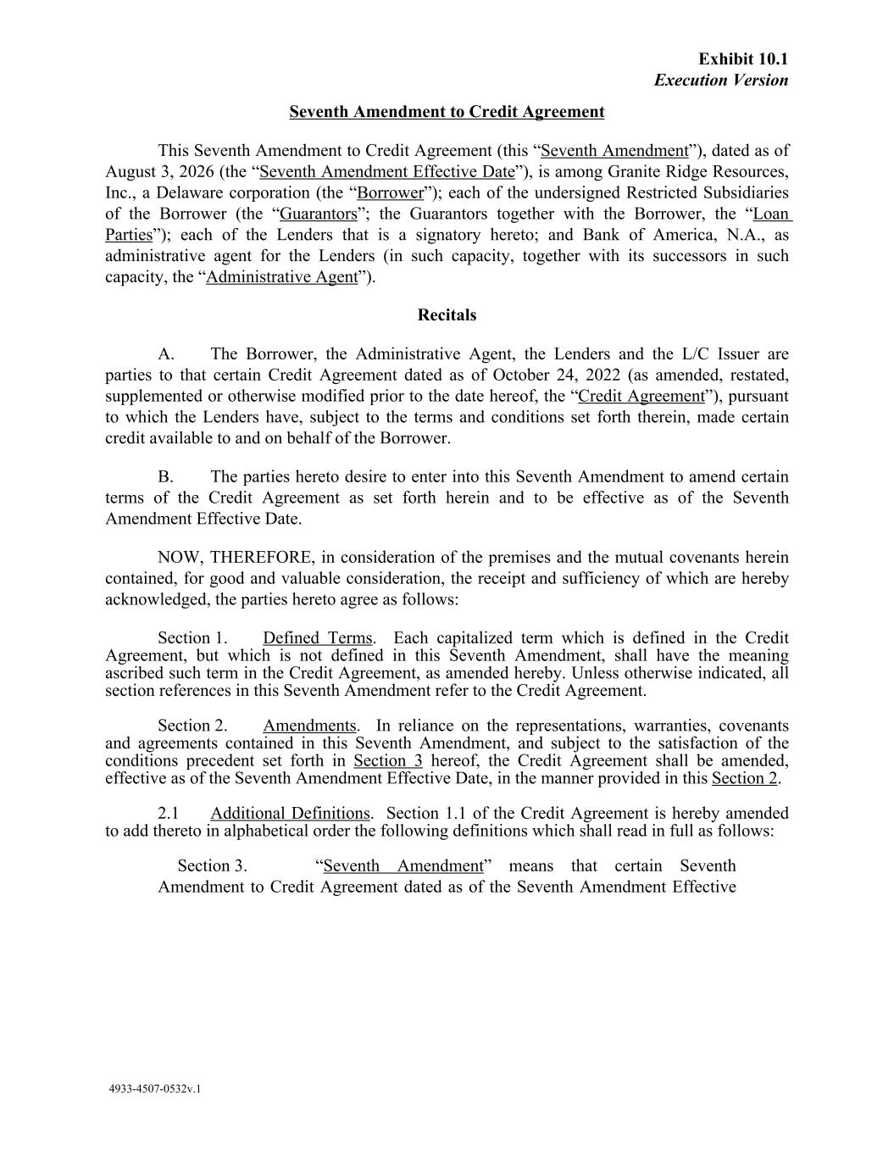
41
Seventh Amendment to Credit Agreement This Seventh Amendment to Credit Agreement (this “Seventh Amendment”), dated as of August 3, 2026 (the “Seventh Amendment Effective Date”), is among Granite Ridge Resources, Inc., a Delaware corporation (the “Borrower”); each of the undersigned Restricted Subsidiaries of the Borrower (the “Guarantors”; the Guarantors together with the Borrower, the “Loan Parties”); each of the Lenders that is a signatory hereto; and Bank of America, N.A., as administrative agent for the Lenders (in such capacity, together with its successors in such capacity, the “Administrative Agent”). Recitals A. The Borrower, the Administrative Agent, the Lenders and the L/C Issuer are parties to that certain Credit Agreement dated as of October 24, 2022 (as amended, restated, supplemented or otherwise modified prior to the date hereof, the “Credit Agreement”), pursuant to which the Lenders have, subject to the terms and conditions set forth therein, made certain credit available to and on behalf of the Borrower. B. The parties hereto desire to enter into this Seventh Amendment to amend certain terms of the Credit Agreement as set forth herein and to be effective as of the Seventh Amendment Effective Date. NOW, THEREFORE, in consideration of the premises and the mutual covenants herein contained, for good and valuable consideration, the receipt and sufficiency of which are hereby acknowledged, the parties hereto agree as follows: Section 1. Defined Terms. Each capitalized term which is defined in the Credit Agreement, but which is not defined in this Seventh Amendment, shall have the meaning ascribed such term in the Credit Agreement, as amended hereby. Unless otherwise indicated, all section references in this Seventh Amendment refer to the Credit Agreement. Section 2. Amendments. In reliance on the representations, warranties, covenants and agreements contained in this Seventh Amendment, and subject to the satisfaction of the conditions precedent set forth in Section 3 hereof, the Credit Agreement shall be amended, effective as of the Seventh Amendment Effective Date, in the manner provided in this Section 2. 2.1 Additional Definitions. Section 1.1 of the Credit Agreement is hereby amended to add thereto in alphabetical order the following definitions which shall read in full as follows: Section 3. “Seventh Amendment” means that certain Seventh Amendment to Credit Agreement dated as of the Seventh Amendment Effective Exhibit 10.1 Execution Version 4933-4507-0532v.1

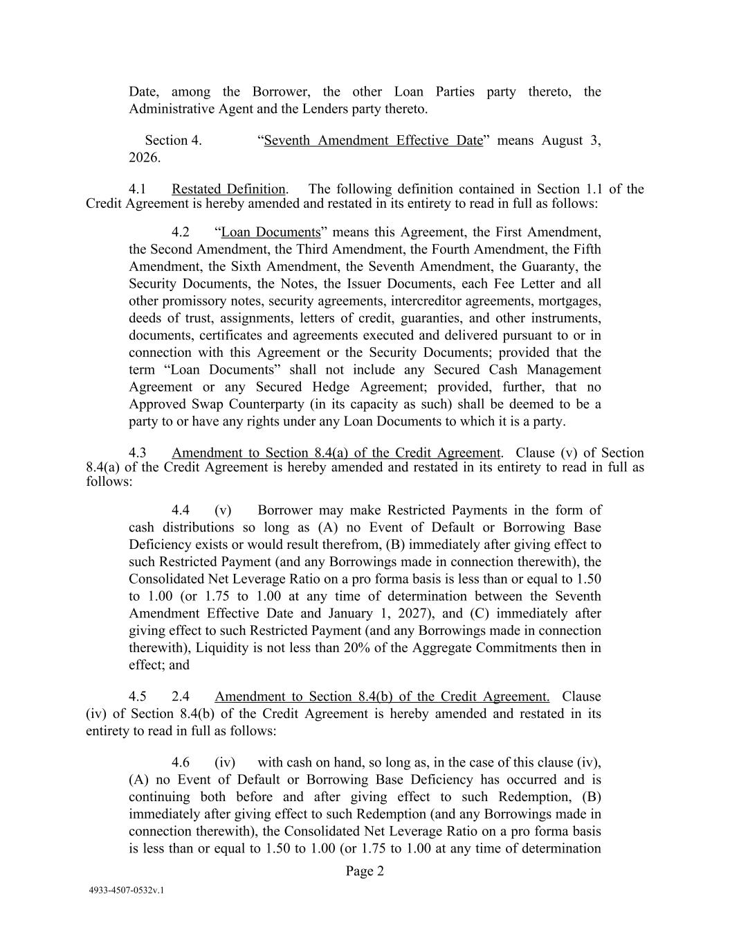
Date, among the Borrower, the other Loan Parties party thereto, the Administrative Agent and the Lenders party thereto. Section 4. “Seventh Amendment Effective Date” means August 3, 2026. 4.1 Restated Definition. The following definition contained in Section 1.1 of the Credit Agreement is hereby amended and restated in its entirety to read in full as follows: 4.2 “Loan Documents” means this Agreement, the First Amendment, the Second Amendment, the Third Amendment, the Fourth Amendment, the Fifth Amendment, the Sixth Amendment, the Seventh Amendment, the Guaranty, the Security Documents, the Notes, the Issuer Documents, each Fee Letter and all other promissory notes, security agreements, intercreditor agreements, mortgages, deeds of trust, assignments, letters of credit, guaranties, and other instruments, documents, certificates and agreements executed and delivered pursuant to or in connection with this Agreement or the Security Documents; provided that the term “Loan Documents” shall not include any Secured Cash Management Agreement or any Secured Hedge Agreement; provided, further, that no Approved Swap Counterparty (in its capacity as such) shall be deemed to be a party to or have any rights under any Loan Documents to which it is a party. 4.3 Amendment to Section 8.4(a) of the Credit Agreement. Clause (v) of Section 8.4(a) of the Credit Agreement is hereby amended and restated in its entirety to read in full as follows: 4.4 (v) Borrower may make Restricted Payments in the form of cash distributions so long as (A) no Event of Default or Borrowing Base Deficiency exists or would result therefrom, (B) immediately after giving effect to such Restricted Payment (and any Borrowings made in connection therewith), the Consolidated Net Leverage Ratio on a pro forma basis is less than or equal to 1.50 to 1.00 (or 1.75 to 1.00 at any time of determination between the Seventh Amendment Effective Date and January 1, 2027), and (C) immediately after giving effect to such Restricted Payment (and any Borrowings made in connection therewith), Liquidity is not less than 20% of the Aggregate Commitments then in effect; and 4.5 2.4 Amendment to Section 8.4(b) of the Credit Agreement. Clause (iv) of Section 8.4(b) of the Credit Agreement is hereby amended and restated in its entirety to read in full as follows: 4.6 (iv) with cash on hand, so long as, in the case of this clause (iv), (A) no Event of Default or Borrowing Base Deficiency has occurred and is continuing both before and after giving effect to such Redemption, (B) immediately after giving effect to such Redemption (and any Borrowings made in connection therewith), the Consolidated Net Leverage Ratio on a pro forma basis is less than or equal to 1.50 to 1.00 (or 1.75 to 1.00 at any time of determination Page 2 4933-4507-0532v.1

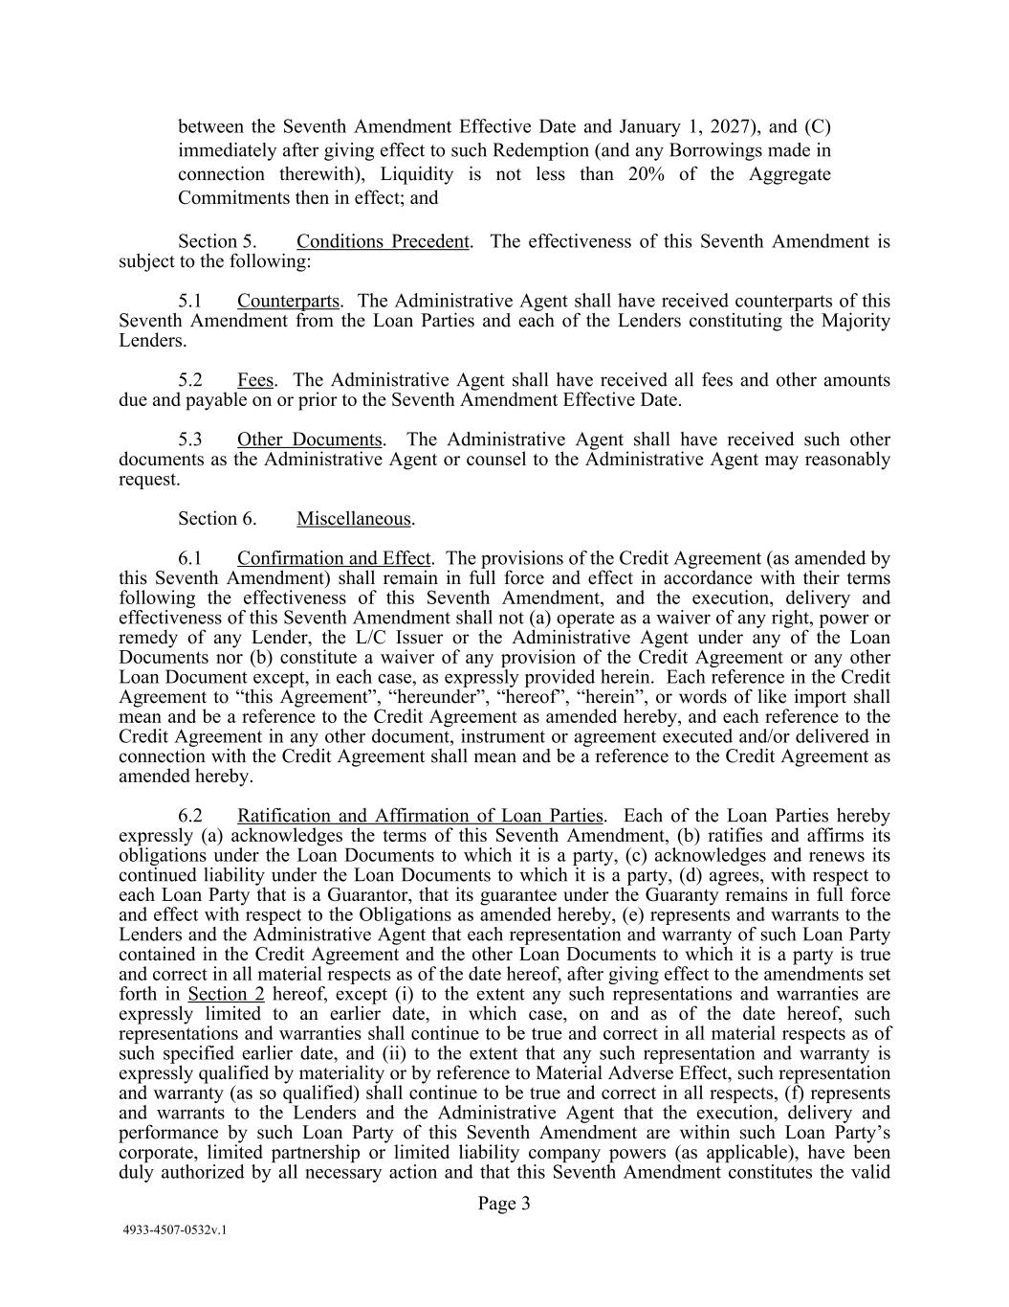
between the Seventh Amendment Effective Date and January 1, 2027), and (C) immediately after giving effect to such Redemption (and any Borrowings made in connection therewith), Liquidity is not less than 20% of the Aggregate Commitments then in effect; and Section 5. Conditions Precedent. The effectiveness of this Seventh Amendment is subject to the following: 5.1 Counterparts. The Administrative Agent shall have received counterparts of this Seventh Amendment from the Loan Parties and each of the Lenders constituting the Majority Lenders. 5.2 Fees. The Administrative Agent shall have received all fees and other amounts due and payable on or prior to the Seventh Amendment Effective Date. 5.3 Other Documents. The Administrative Agent shall have received such other documents as the Administrative Agent or counsel to the Administrative Agent may reasonably request. Section 6. Miscellaneous. 6.1 Confirmation and Effect. The provisions of the Credit Agreement (as amended by this Seventh Amendment) shall remain in full force and effect in accordance with their terms following the effectiveness of this Seventh Amendment, and the execution, delivery and effectiveness of this Seventh Amendment shall not (a) operate as a waiver of any right, power or remedy of any Lender, the L/C Issuer or the Administrative Agent under any of the Loan Documents nor (b) constitute a waiver of any provision of the Credit Agreement or any other Loan Document except, in each case, as expressly provided herein. Each reference in the Credit Agreement to “this Agreement”, “hereunder”, “hereof”, “herein”, or words of like import shall mean and be a reference to the Credit Agreement as amended hereby, and each reference to the Credit Agreement in any other document, instrument or agreement executed and/or delivered in connection with the Credit Agreement shall mean and be a reference to the Credit Agreement as amended hereby. 6.2 Ratification and Affirmation of Loan Parties. Each of the Loan Parties hereby expressly (a) acknowledges the terms of this Seventh Amendment, (b) ratifies and affirms its obligations under the Loan Documents to which it is a party, (c) acknowledges and renews its continued liability under the Loan Documents to which it is a party, (d) agrees, with respect to each Loan Party that is a Guarantor, that its guarantee under the Guaranty remains in full force and effect with respect to the Obligations as amended hereby, (e) represents and warrants to the Lenders and the Administrative Agent that each representation and warranty of such Loan Party contained in the Credit Agreement and the other Loan Documents to which it is a party is true and correct in all material respects as of the date hereof, after giving effect to the amendments set forth in Section 2 hereof, except (i) to the extent any such representations and warranties are expressly limited to an earlier date, in which case, on and as of the date hereof, such representations and warranties shall continue to be true and correct in all material respects as of such specified earlier date, and (ii) to the extent that any such representation and warranty is expressly qualified by materiality or by reference to Material Adverse Effect, such representation and warranty (as so qualified) shall continue to be true and correct in all respects, (f) represents and warrants to the Lenders and the Administrative Agent that the execution, delivery and performance by such Loan Party of this Seventh Amendment are within such Loan Party’s corporate, limited partnership or limited liability company powers (as applicable), have been duly authorized by all necessary action and that this Seventh Amendment constitutes the valid Page 3 4933-4507-0532v.1

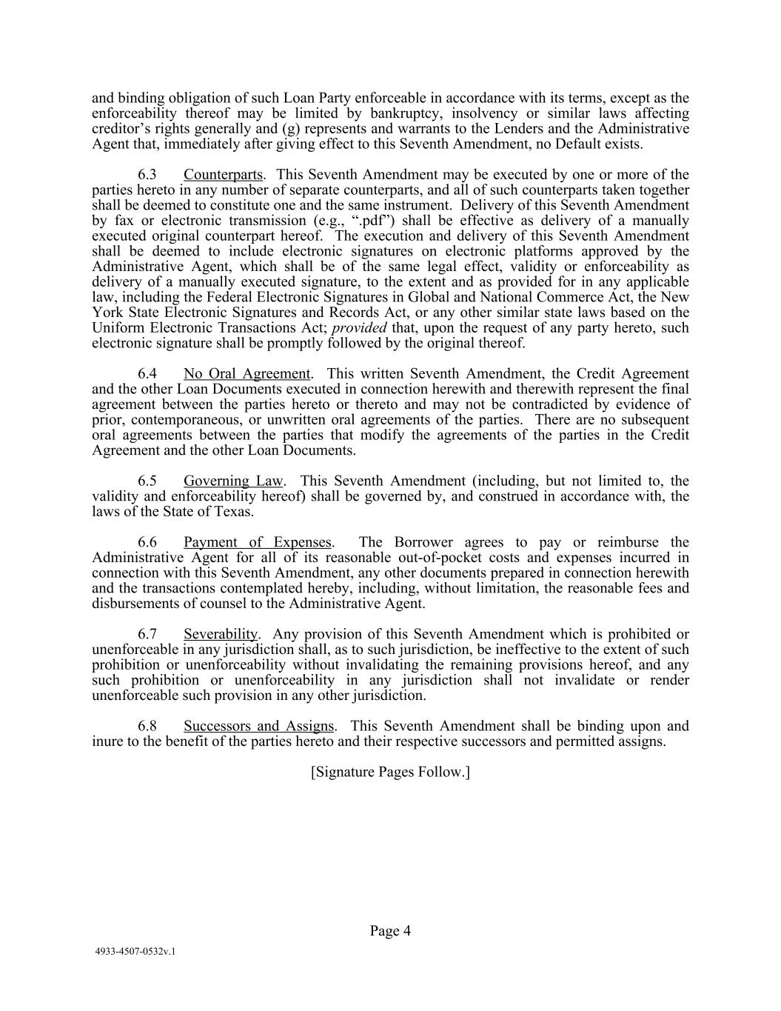
and binding obligation of such Loan Party enforceable in accordance with its terms, except as the enforceability thereof may be limited by bankruptcy, insolvency or similar laws affecting creditor’s rights generally and (g) represents and warrants to the Lenders and the Administrative Agent that, immediately after giving effect to this Seventh Amendment, no Default exists. 6.3 Counterparts. This Seventh Amendment may be executed by one or more of the parties hereto in any number of separate counterparts, and all of such counterparts taken together shall be deemed to constitute one and the same instrument. Delivery of this Seventh Amendment by fax or electronic transmission (e.g., “.pdf”) shall be effective as delivery of a manually executed original counterpart hereof. The execution and delivery of this Seventh Amendment shall be deemed to include electronic signatures on electronic platforms approved by the Administrative Agent, which shall be of the same legal effect, validity or enforceability as delivery of a manually executed signature, to the extent and as provided for in any applicable law, including the Federal Electronic Signatures in Global and National Commerce Act, the New York State Electronic Signatures and Records Act, or any other similar state laws based on the Uniform Electronic Transactions Act; provided that, upon the request of any party hereto, such electronic signature shall be promptly followed by the original thereof. 6.4 No Oral Agreement. This written Seventh Amendment, the Credit Agreement and the other Loan Documents executed in connection herewith and therewith represent the final agreement between the parties hereto or thereto and may not be contradicted by evidence of prior, contemporaneous, or unwritten oral agreements of the parties. There are no subsequent oral agreements between the parties that modify the agreements of the parties in the Credit Agreement and the other Loan Documents. 6.5 Governing Law. This Seventh Amendment (including, but not limited to, the validity and enforceability hereof) shall be governed by, and construed in accordance with, the laws of the State of Texas. 6.6 Payment of Expenses. The Borrower agrees to pay or reimburse the Administrative Agent for all of its reasonable out-of-pocket costs and expenses incurred in connection with this Seventh Amendment, any other documents prepared in connection herewith and the transactions contemplated hereby, including, without limitation, the reasonable fees and disbursements of counsel to the Administrative Agent. 6.7 Severability. Any provision of this Seventh Amendment which is prohibited or unenforceable in any jurisdiction shall, as to such jurisdiction, be ineffective to the extent of such prohibition or unenforceability without invalidating the remaining provisions hereof, and any such prohibition or unenforceability in any jurisdiction shall not invalidate or render unenforceable such provision in any other jurisdiction. 6.8 Successors and Assigns. This Seventh Amendment shall be binding upon and inure to the benefit of the parties hereto and their respective successors and permitted assigns. [Signature Pages Follow.] Page 4 4933-4507-0532v.1

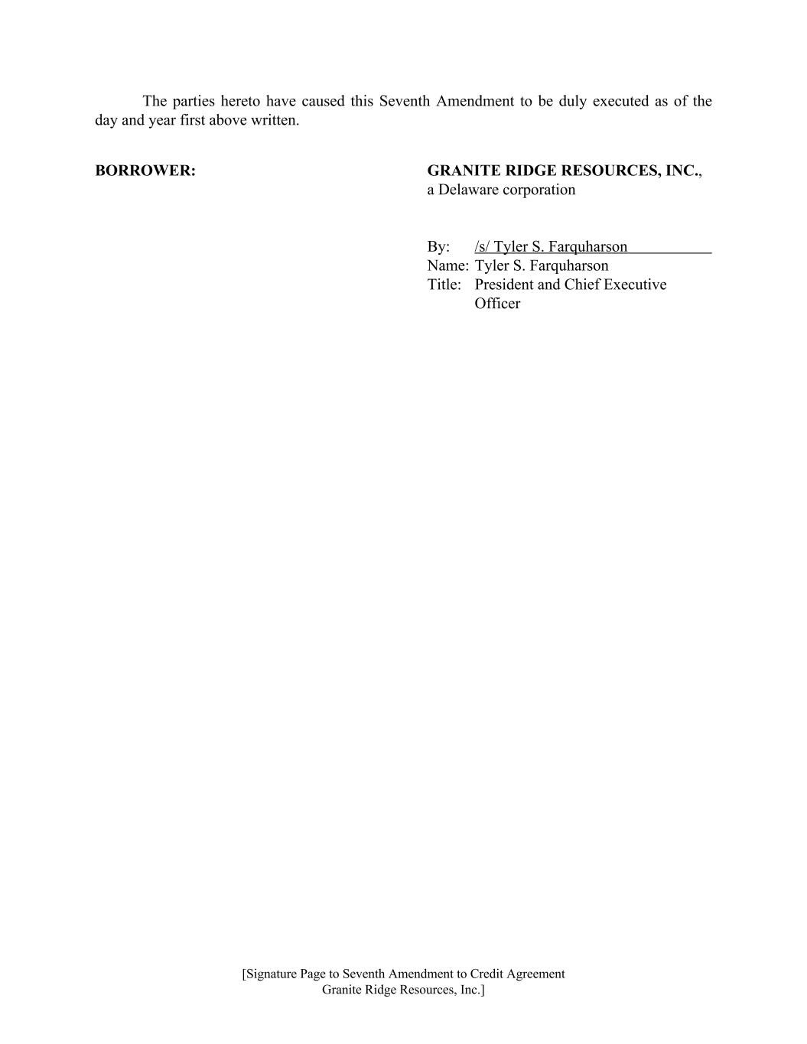
The parties hereto have caused this Seventh Amendment to be duly executed as of the day and year first above written. BORROWER: GRANITE RIDGE RESOURCES, INC., a Delaware corporation By: /s/ Tyler S. Farquharson Name: Tyler S. Farquharson Title: President and Chief Executive Officer [Signature Page to Seventh Amendment to Credit Agreement Granite Ridge Resources, Inc.]

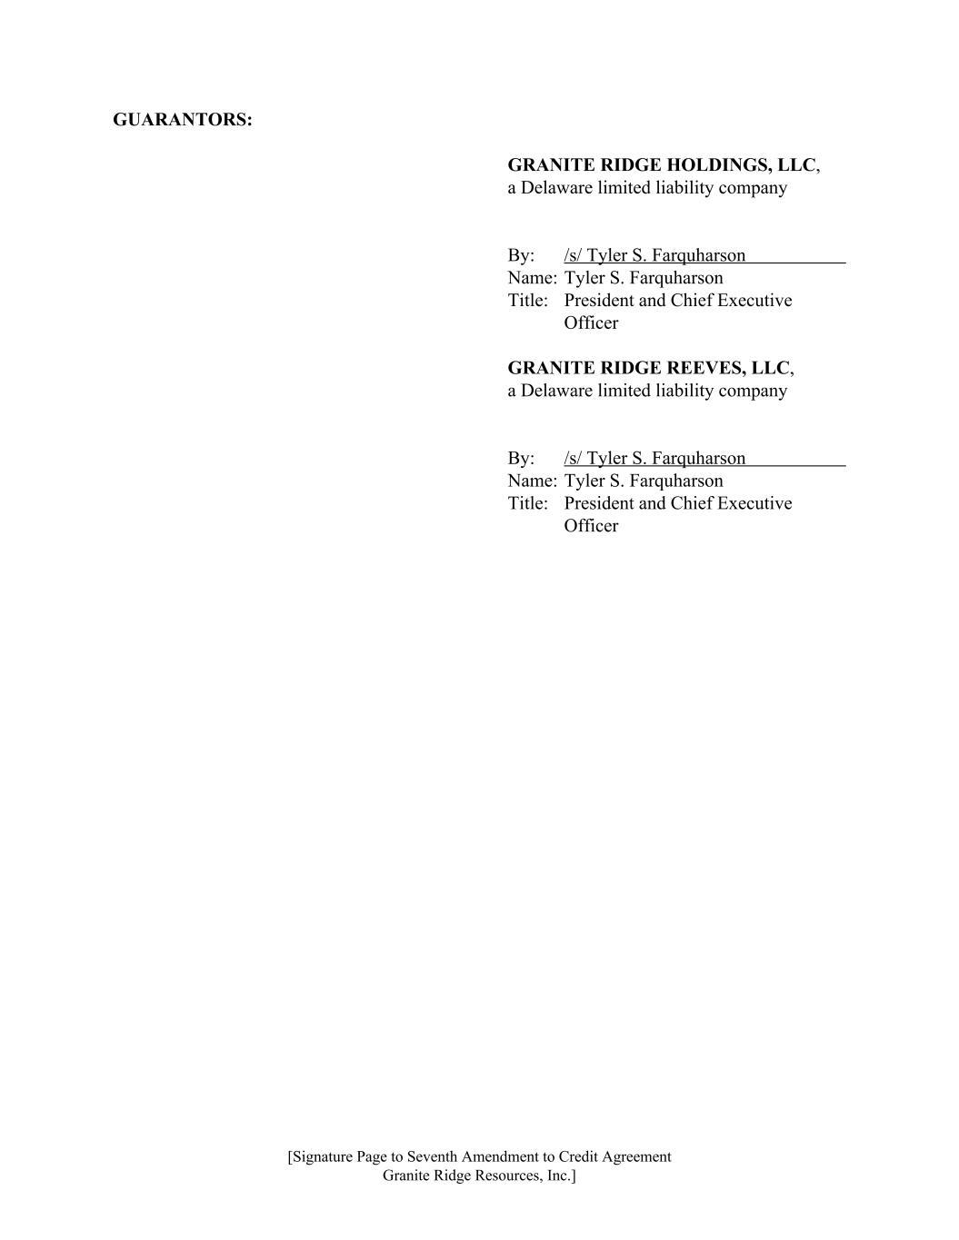
GUARANTORS: GRANITE RIDGE HOLDINGS, LLC, a Delaware limited liability company By: /s/ Tyler S. Farquharson Name: Tyler S. Farquharson Title: President and Chief Executive Officer GRANITE RIDGE REEVES, LLC, a Delaware limited liability company By: /s/ Tyler S. Farquharson Name: Tyler S. Farquharson Title: President and Chief Executive Officer [Signature Page to Seventh Amendment to Credit Agreement Granite Ridge Resources, Inc.]

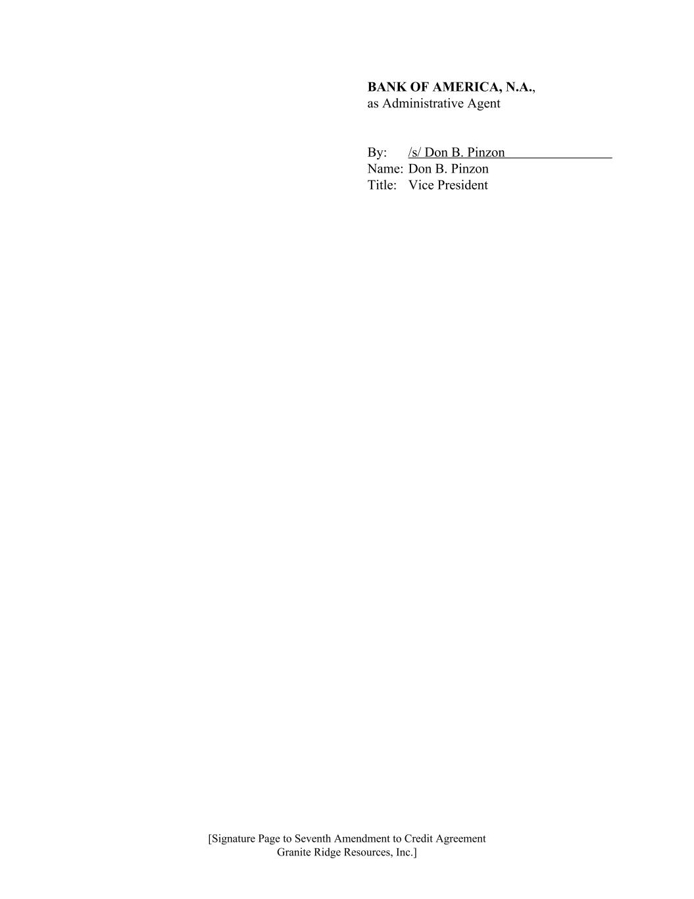
BANK OF AMERICA, N.A., as Administrative Agent By: /s/ Don B. Pinzon Name: Don B. Pinzon Title: Vice President [Signature Page to Seventh Amendment to Credit Agreement Granite Ridge Resources, Inc.]

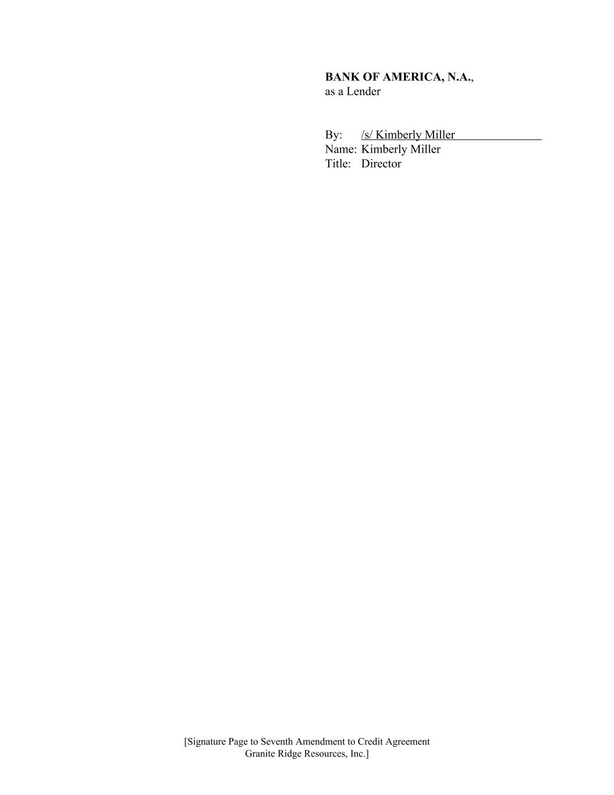
BANK OF AMERICA, N.A., as a Lender By: /s/ Kimberly Miller Name: Kimberly Miller Title: Director [Signature Page to Seventh Amendment to Credit Agreement Granite Ridge Resources, Inc.]

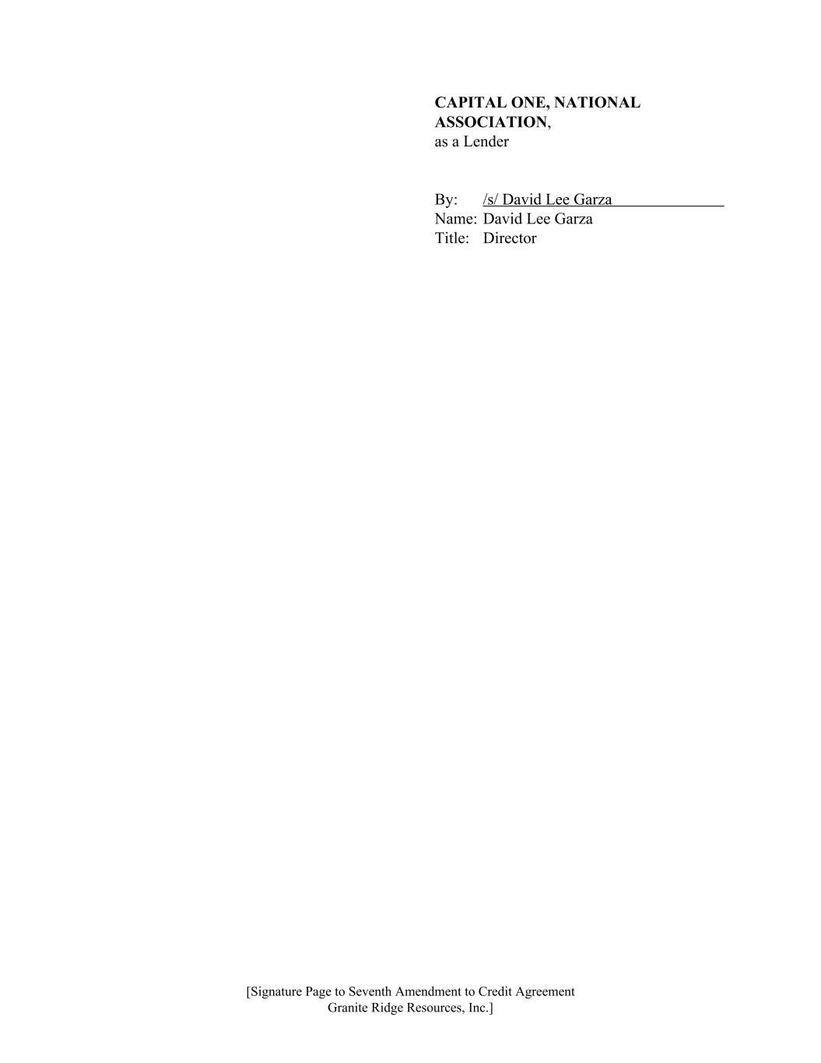
CAPITAL ONE, NATIONAL ASSOCIATION, as a Lender By: /s/ David Lee Garza Name: David Lee Garza Title: Director [Signature Page to Seventh Amendment to Credit Agreement Granite Ridge Resources, Inc.]

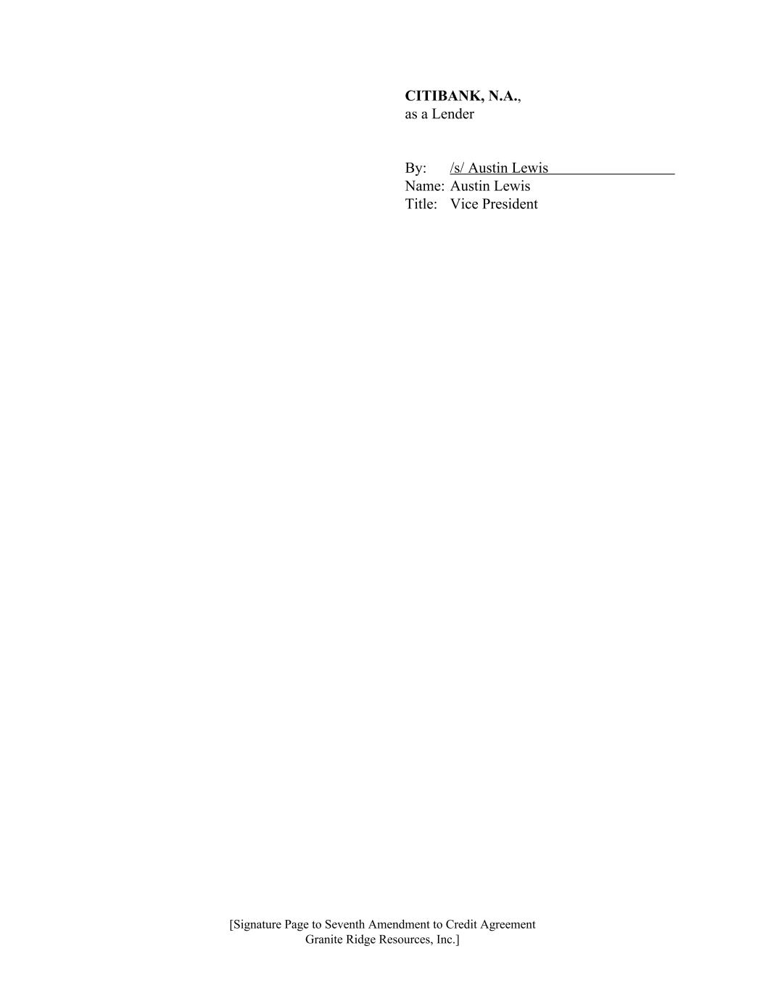
CITIBANK, N.A., as a Lender By: /s/ Austin Lewis Name: Austin Lewis Title: Vice President [Signature Page to Seventh Amendment to Credit Agreement Granite Ridge Resources, Inc.]

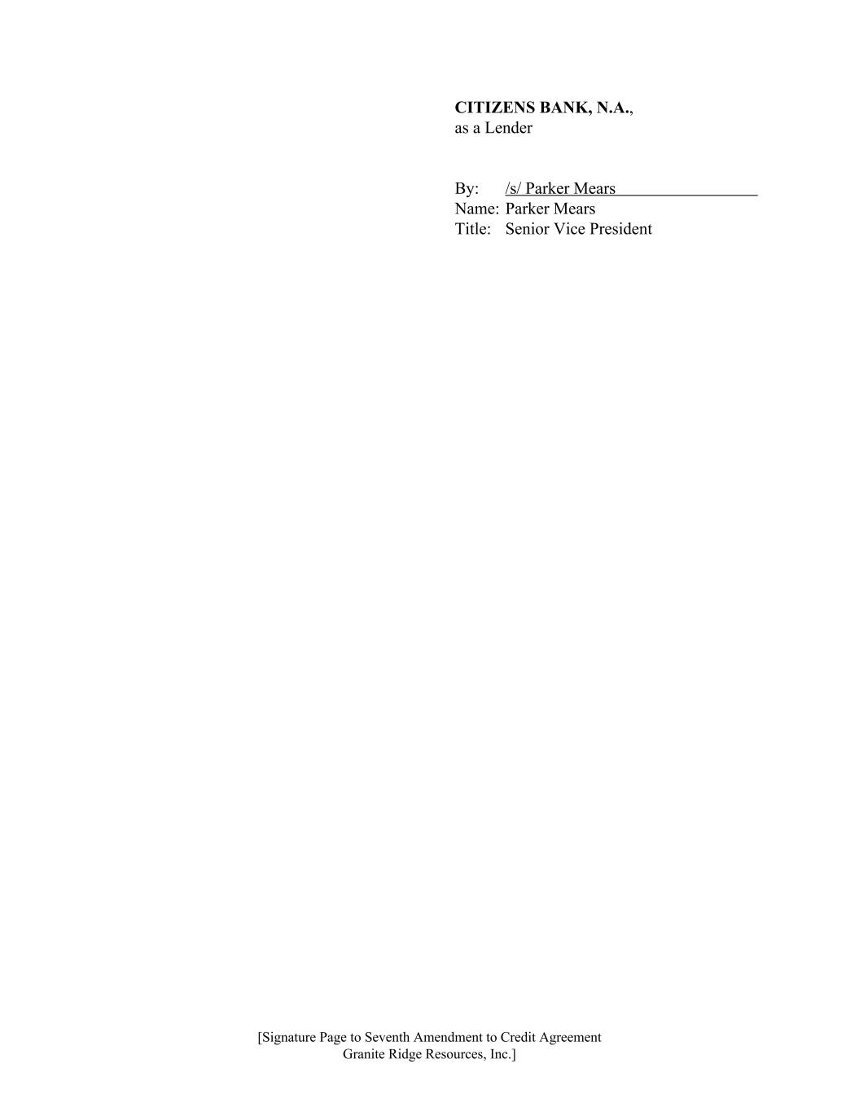
CITIZENS BANK, N.A., as a Lender By: /s/ Parker Mears Name: Parker Mears Title: Senior Vice President [Signature Page to Seventh Amendment to Credit Agreement Granite Ridge Resources, Inc.]

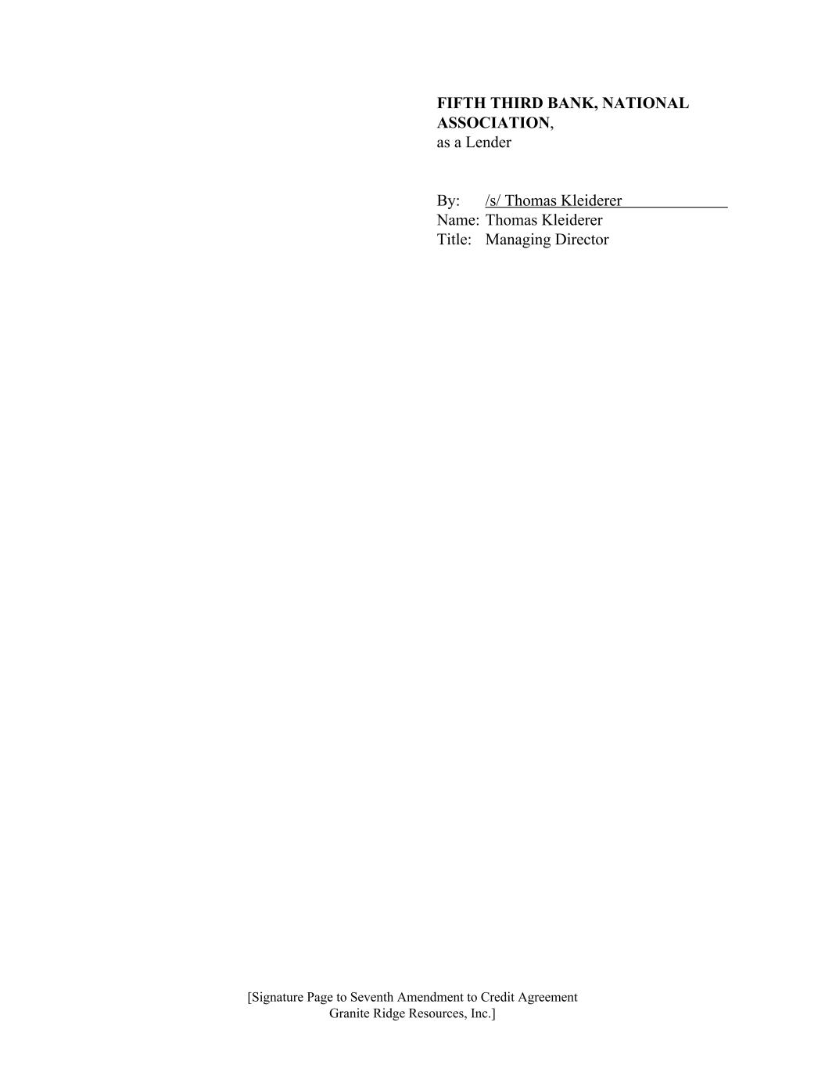
FIFTH THIRD BANK, NATIONAL ASSOCIATION, as a Lender By: /s/ Thomas Kleiderer Name: Thomas Kleiderer Title: Managing Director [Signature Page to Seventh Amendment to Credit Agreement Granite Ridge Resources, Inc.]

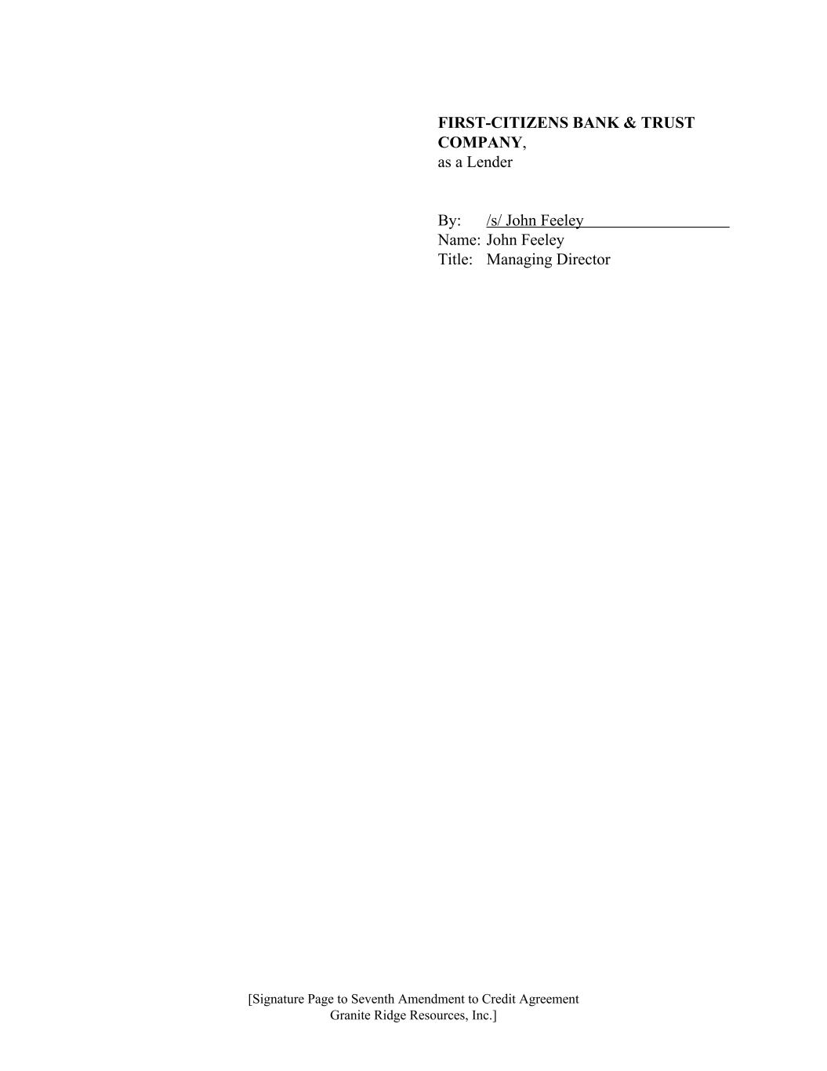
FIRST-CITIZENS BANK & TRUST COMPANY, as a Lender By: /s/ John Feeley Name: John Feeley Title: Managing Director [Signature Page to Seventh Amendment to Credit Agreement Granite Ridge Resources, Inc.]

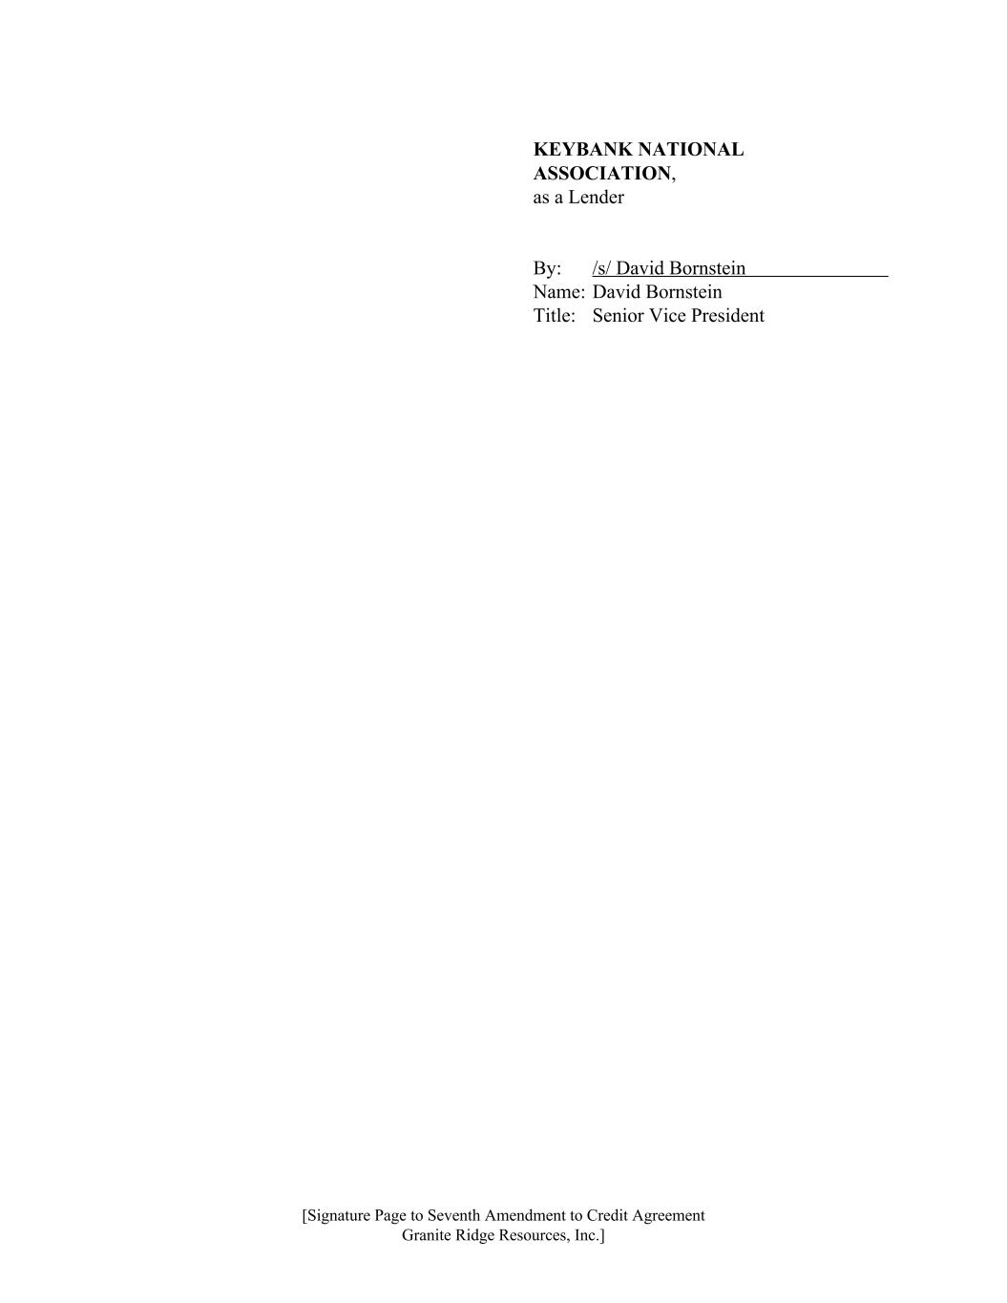
KEYBANK NATIONAL ASSOCIATION, as a Lender By: /s/ David Bornstein Name: David Bornstein Title: Senior Vice President [Signature Page to Seventh Amendment to Credit Agreement Granite Ridge Resources, Inc.]

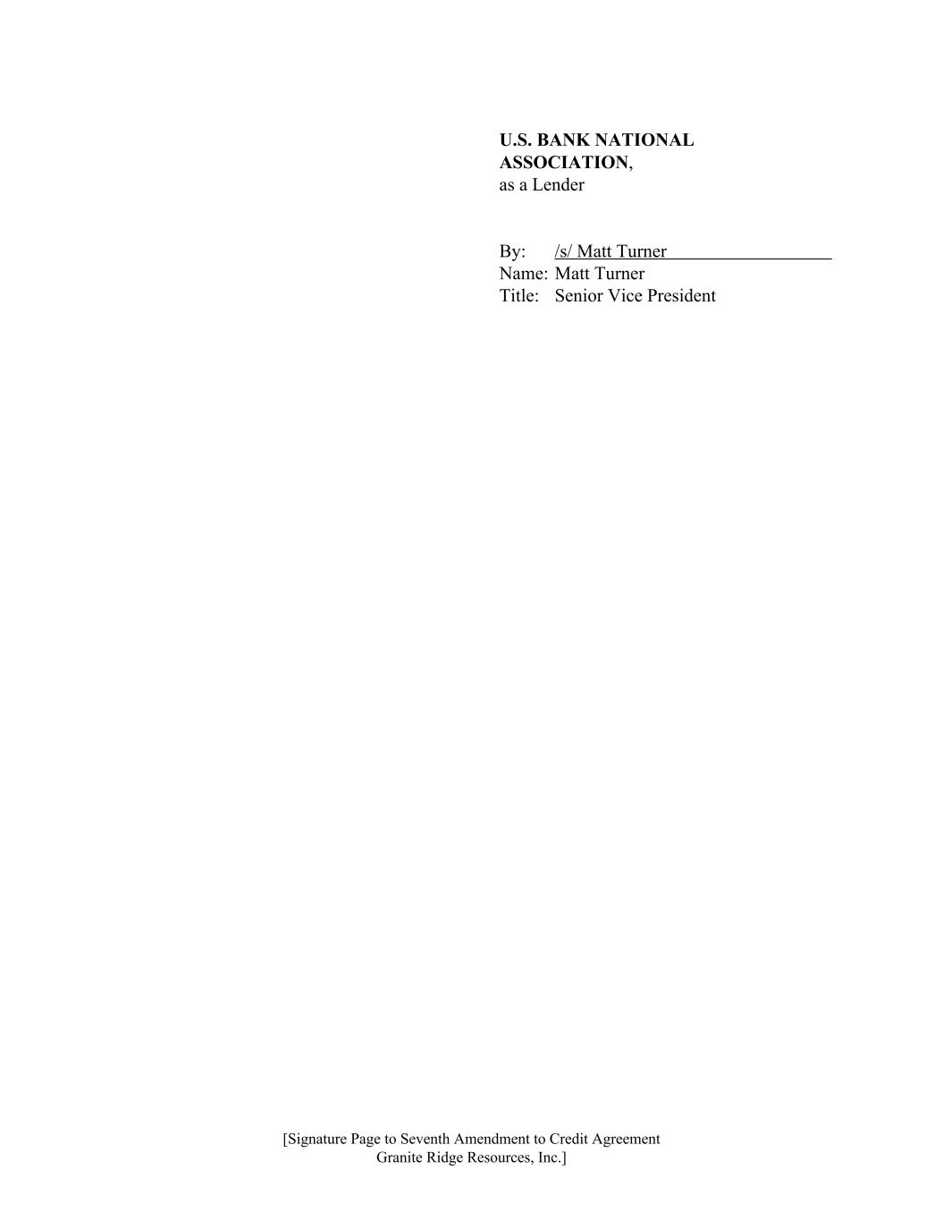
U.S. BANK NATIONAL ASSOCIATION, as a Lender By: /s/ Matt Turner Name: Matt Turner Title: Senior Vice President [Signature Page to Seventh Amendment to Credit Agreement Granite Ridge Resources, Inc.]

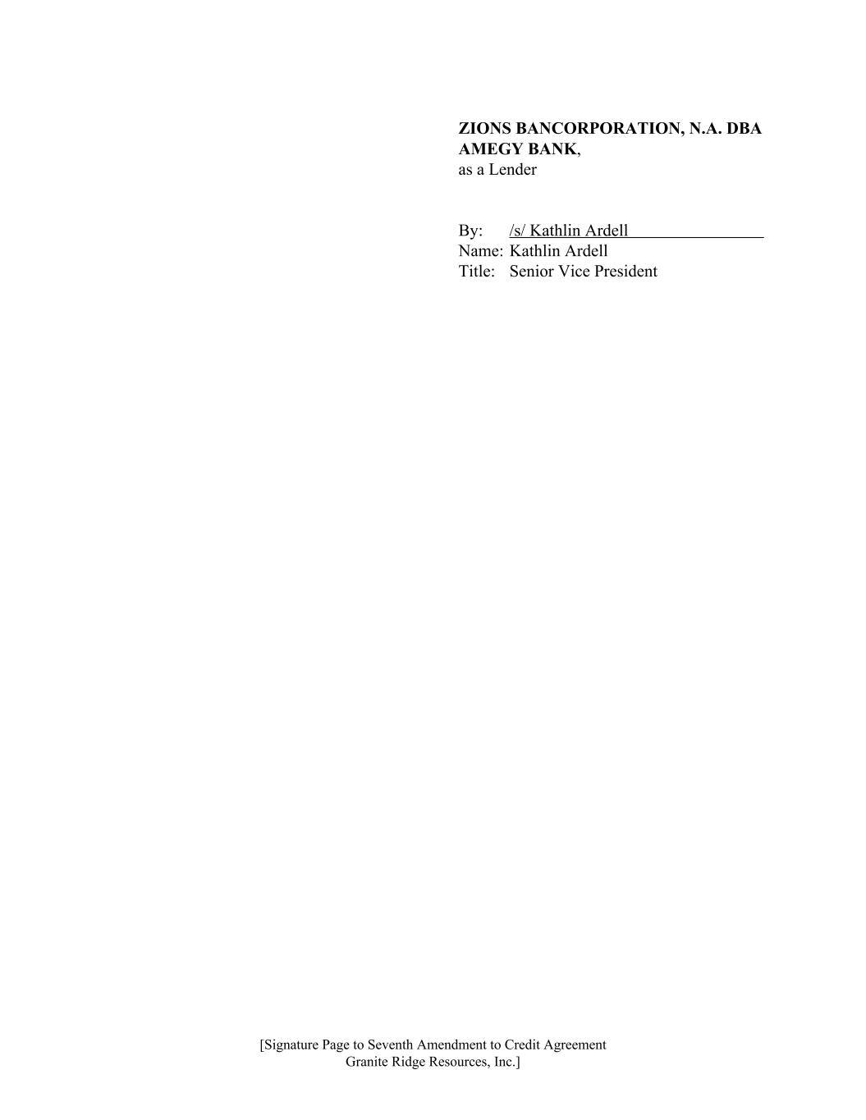
ZIONS BANCORPORATION, N.A. DBA AMEGY BANK, as a Lender By: /s/ Kathlin Ardell Name: Kathlin Ardell Title: Senior Vice President [Signature Page to Seventh Amendment to Credit Agreement Granite Ridge Resources, Inc.]

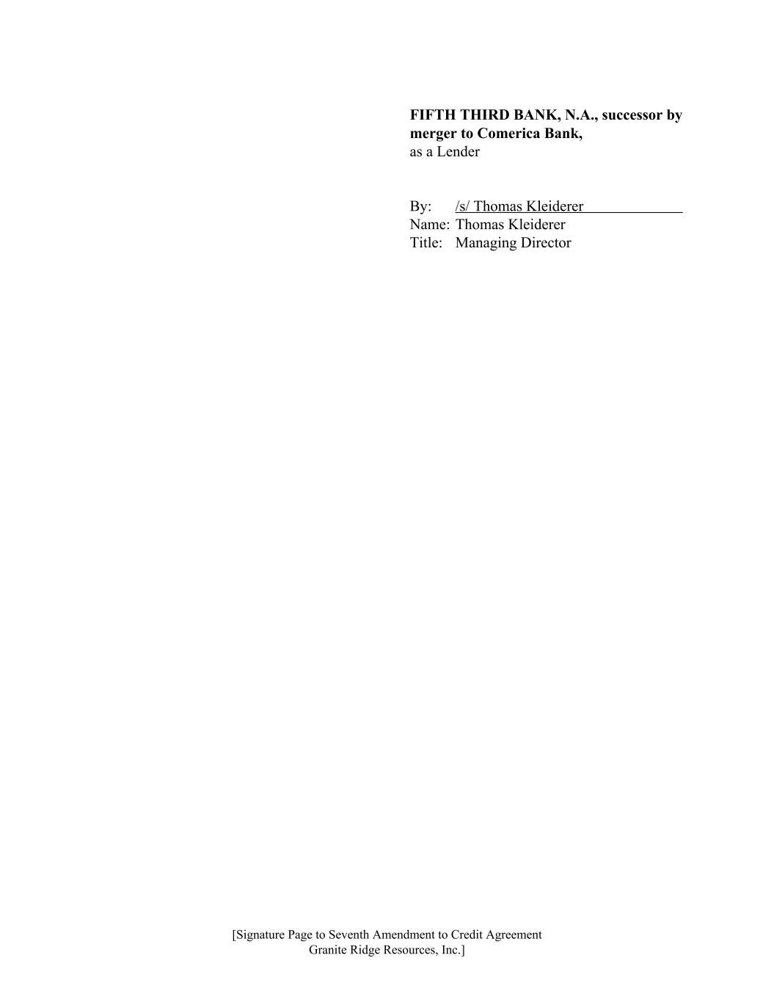
FIFTH THIRD BANK, N.A., successor by merger to Comerica Bank, as a Lender By: /s/ Thomas Kleiderer Name: Thomas Kleiderer Title: Managing Director [Signature Page to Seventh Amendment to Credit Agreement Granite Ridge Resources, Inc.]

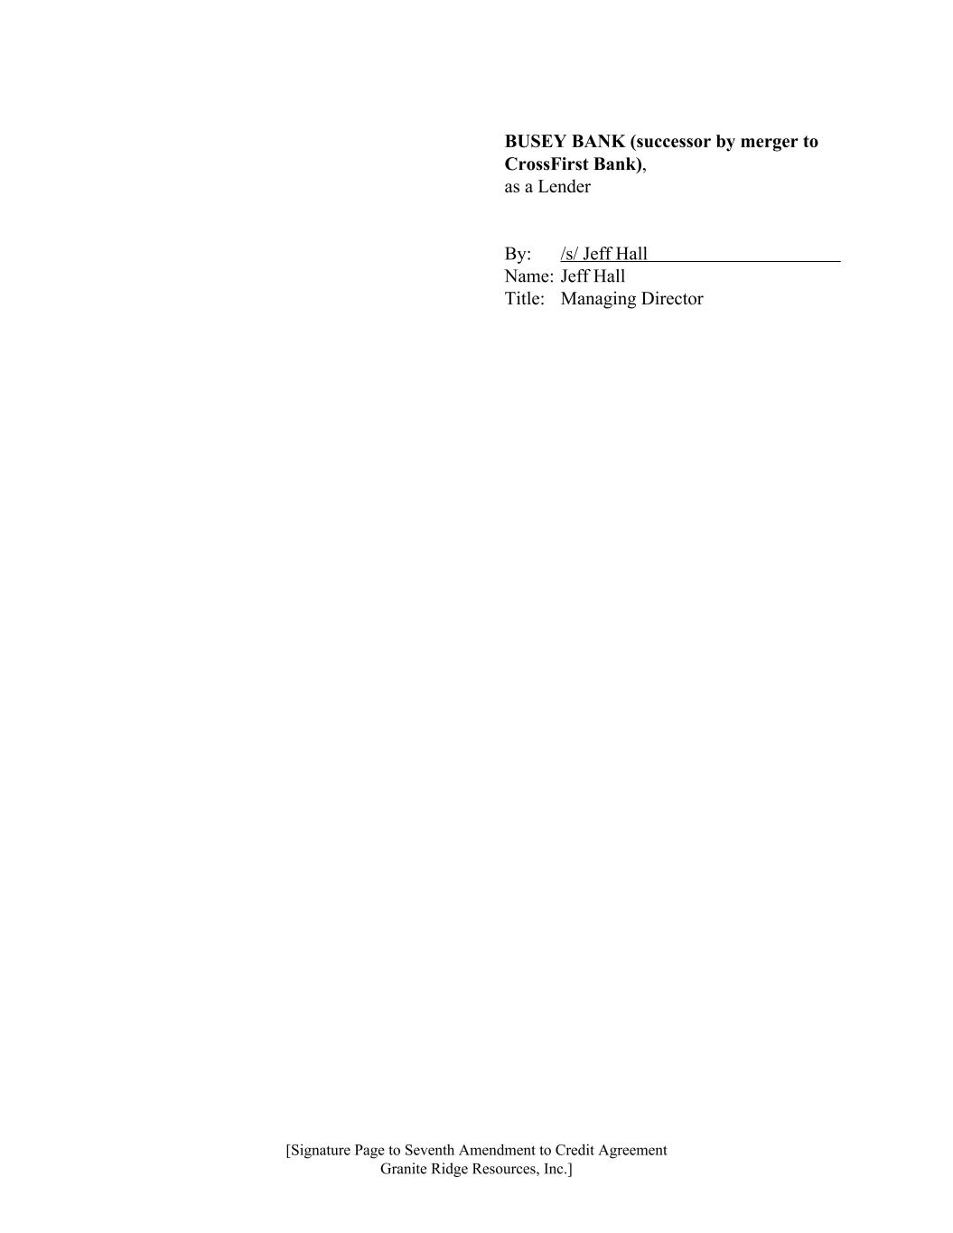
BUSEY BANK (successor by merger to CrossFirst Bank), as a Lender By: /s/ Jeff Hall Name: Jeff Hall Title: Managing Director [Signature Page to Seventh Amendment to Credit Agreement Granite Ridge Resources, Inc.]

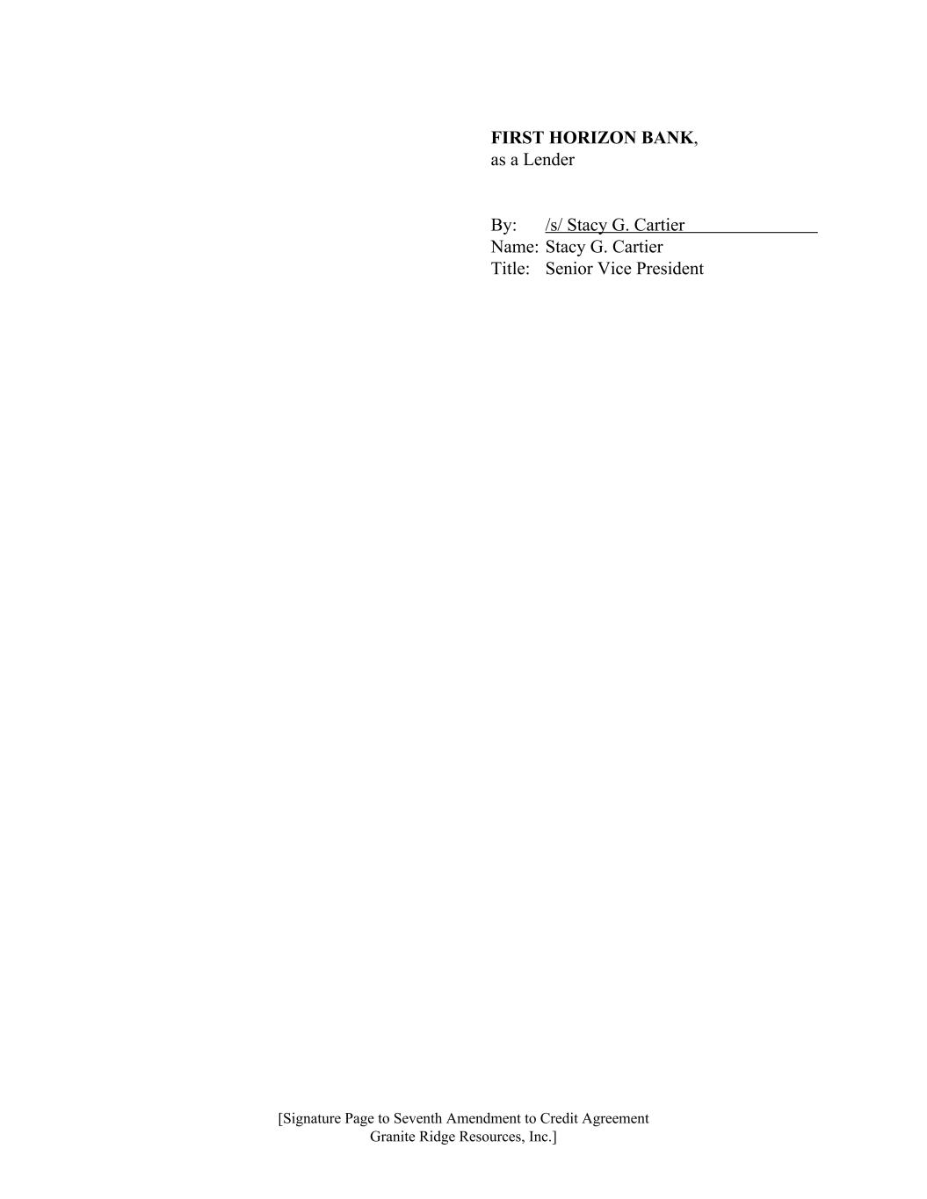
FIRST HORIZON BANK, as a Lender By: /s/ Stacy G. Cartier Name: Stacy G. Cartier Title: Senior Vice President [Signature Page to Seventh Amendment to Credit Agreement Granite Ridge Resources, Inc.]

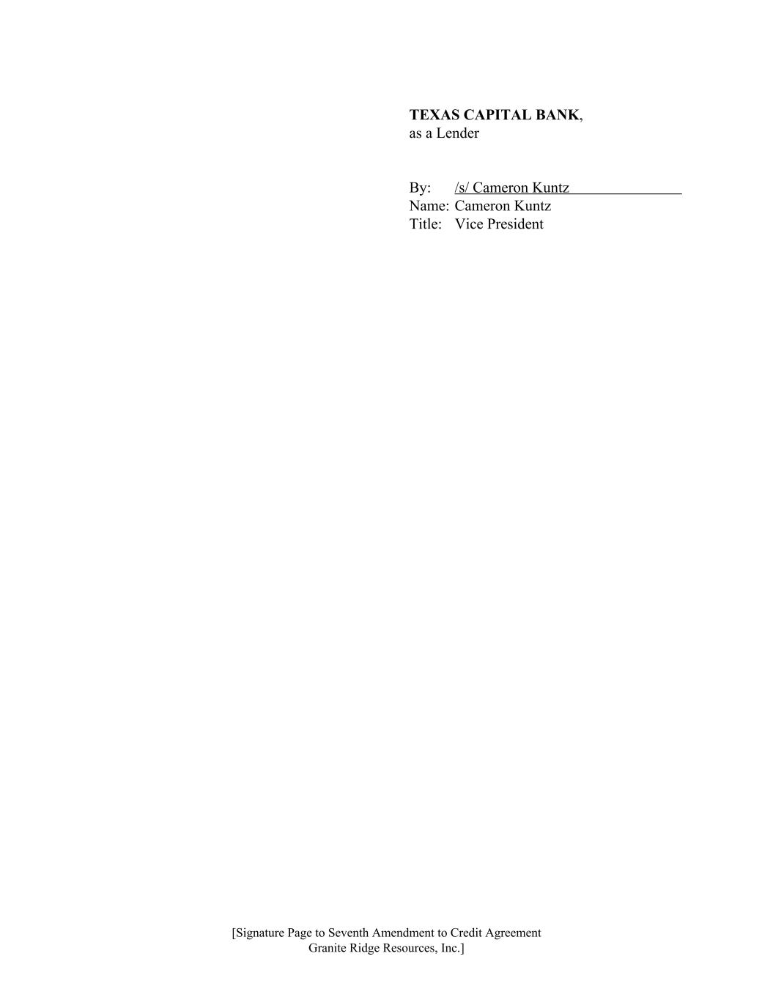
TEXAS CAPITAL BANK, as a Lender By: /s/ Cameron Kuntz Name: Cameron Kuntz Title: Vice President [Signature Page to Seventh Amendment to Credit Agreement Granite Ridge Resources, Inc.]

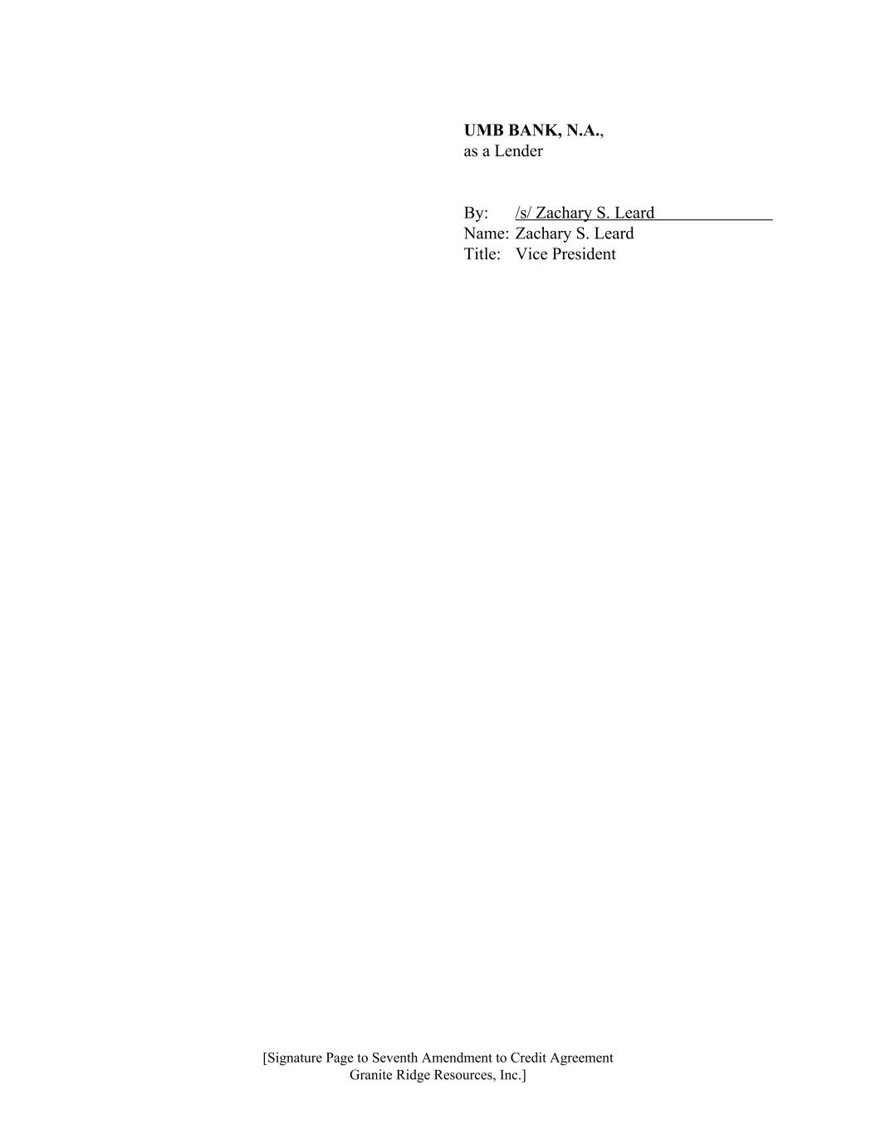
UMB BANK, N.A., as a Lender By: /s/ Zachary S. Leard Name: Zachary S. Leard Title: Vice President [Signature Page to Seventh Amendment to Credit Agreement Granite Ridge Resources, Inc.]

Exhibit 31.1
CERTIFICATION
I, Tyler S. Farquharson, certify that:
1.I have reviewed this quarterly report on Form 10-Q of Granite Ridge Resources, Inc.;
2.Based on my knowledge, this report does not contain any untrue statement of a material fact or omit to state a material fact necessary to make the statements made, in light of the circumstances under which such statements were made, not misleading with respect to the period covered by this report;
3.Based on my knowledge, the financial statements, and other financial information included in this report, fairly present in all material respects the financial condition, results of operations and cash flows of the registrant as of, and for, the periods presented in this report;
4.The registrant’s other certifying officer(s) and I are responsible for establishing and maintaining disclosure controls and procedures (as defined in Exchange Act Rules 13a-15(e) and 15d-15(e)) and internal control over financial reporting (as defined in Exchange Act Rules 13a-15(f) and 15d-15(f)) for the registrant and have:
a)Designed such disclosure controls and procedures, or caused such disclosure controls and procedures to be designed under our supervision, to ensure that material information relating to the registrant, including its consolidated subsidiaries, is made known to us by others within those entities, particularly during the period in which this report is being prepared;
b)Designed such internal control over financial reporting, or caused such internal control over financial reporting to be designed under our supervision, to provide reasonable assurance regarding the reliability of financial reporting and the preparation of financial statements for external purposes in accordance with generally accepted accounting principles;
c)Evaluated the effectiveness of the registrant’s disclosure controls and procedures and presented in this report our conclusions about the effectiveness of the disclosure controls and procedures, as of the end of the period covered by this report based on such evaluation; and
d)Disclosed in this report any change in the registrant’s internal control over financial reporting that occurred during the registrant’s most recent fiscal quarter (the registrant's fourth fiscal quarter in the case of an annual report) that has materially affected, or is reasonably likely to materially affect, the registrant’s internal control over financial reporting; and
5.The registrant’s other certifying officer(s) and I have disclosed, based on our most recent evaluation of internal control over financial reporting, to the registrant's auditors and the audit committee of registrant’s board of directors (or persons performing the equivalent functions):
a)All significant deficiencies and material weaknesses in the design or operation of internal control over financial reporting which are reasonably likely to adversely affect the registrant’s ability to record, process, summarize and report financial information; and
b)Any fraud, whether or not material, that involves management or other employees who have a significant role in the registrant’s internal control over financial reporting.
Dated: August 6, 2026 |  |  | By: /s/ |  |  | TYLER S. FARQUHARSON
 |  |  |  |  |  | Tyler S. Farquharson
 |  |  |  |  |  | President and Chief Executive Officer

Exhibit 31.2
CERTIFICATION
I, R. Kyle Kettler, certify that:
1.I have reviewed this quarterly report on Form 10-Q of Granite Ridge Resources, Inc.;
2.Based on my knowledge, this report does not contain any untrue statement of a material fact or omit to state a material fact necessary to make the statements made, in light of the circumstances under which such statements were made, not misleading with respect to the period covered by this report;
3.Based on my knowledge, the financial statements, and other financial information included in this report, fairly present in all material respects the financial condition, results of operations and cash flows of the registrant as of, and for, the periods presented in this report;
4.The registrant’s other certifying officer(s) and I are responsible for establishing and maintaining disclosure controls and procedures (as defined in Exchange Act Rules 13a-15(e) and 15d-15(e)) and internal control over financial reporting (as defined in Exchange Act Rules 13a-15(f) and 15d-15(f)) for the registrant and have:
a)Designed such disclosure controls and procedures, or caused such disclosure controls and procedures to be designed under our supervision, to ensure that material information relating to the registrant, including its consolidated subsidiaries, is made known to us by others within those entities, particularly during the period in which this report is being prepared;
b)Designed such internal control over financial reporting, or caused such internal control over financial reporting to be designed under our supervision, to provide reasonable assurance regarding the reliability of financial reporting and the preparation of financial statements for external purposes in accordance with generally accepted accounting principles;
c)Evaluated the effectiveness of the registrant’s disclosure controls and procedures and presented in this report our conclusions about the effectiveness of the disclosure controls and procedures, as of the end of the period covered by this report based on such evaluation; and
d)Disclosed in this report any change in the registrant’s internal control over financial reporting that occurred during the registrant’s most recent fiscal quarter (the registrant's fourth fiscal quarter in the case of an annual report) that has materially affected, or is reasonably likely to materially affect, the registrant’s internal control over financial reporting; and
5.The registrant’s other certifying officer(s) and I have disclosed, based on our most recent evaluation of internal control over financial reporting, to the registrant’s auditors and the audit committee of registrant's board of directors (or persons performing the equivalent functions):
a)All significant deficiencies and material weaknesses in the design or operation of internal control over financial reporting which are reasonably likely to adversely affect the registrant’s ability to record, process, summarize and report financial information; and
b)Any fraud, whether or not material, that involves management or other employees who have a significant role in the registrant’s internal control over financial reporting.
Dated: August 6, 2026 |  |  | By: /s/ |  |  | R. KYLE KETTLER
 |  |  |  |  |  | R. Kyle Kettler
 |  |  |  |  |  | Chief Financial Officer

Exhibit 32.1
CERTIFICATION PURSUANT TO
18 U.S.C. SECTION 1350
AS ADOPTED PURSUANT TO
SECTION 906 OF THE SARBANES-OXLEY ACT OF 2002
In connection with the quarterly report on Form 10-Q of Granite Ridge Resources, Inc. (the “Company”) for the period ended June 30, 2026, as filed with the United States Securities and Exchange Commission on the date hereof (the “Report”), the undersigned officers of the Company hereby certify, pursuant to 18 U.S.C. Section 1350, as adopted pursuant to Section 906 of the Sarbanes-Oxley Act of 2002, that, to their knowledge:
1.The Report fully complies with the requirements of Section 13(a) or 15(d) of the Securities Exchange Act of 1934; and
2.The information contained in the Report fairly presents, in all material respects, the financial condition and results of operations of the Company.
Dated: August 6, 2026 |  |  | By: |  |  | /s/ TYLER S. FARQUHARSON
 |  |  |  |  |  | Name: |  |  | Tyler S. Farquharson
 |  |  |  |  |  | Title: |  |  | President and Chief Executive Officer
Dated: August 6, 2026 |  |  | By: |  |  | /s/ R. KYLE KETTLER
 |  |  |  |  |  | Name: |  |  | R. Kyle Kettler
 |  |  |  |  |  | Title: |  |  | Chief Financial Officer

