Table of Contents
UNITED STATES
SECURITIES AND EXCHANGE COMMISSION
WASHINGTON, D.C. 20549
FORM 10-K
x |  |  | ANNUAL REPORT PURSUANT TO SECTION 13 OR 15(d) OF THE SECURITIES EXCHANGE ACT OF 1934
For the fiscal year ended December 31, 2025
OR
o |  |  | TRANSITION REPORT PURSUANT TO SECTION 13 OR 15(d) OF THE SECURITIES EXCHANGE ACT OF 1934
For the transition period from ______ to _______
Commission File Number: 001-41537
___________________________________
GRANITE RIDGE RESOURCES, INC.
(Exact name of registrant as specified in its charter)
___________________________________
Delaware |  |  |  |  |  | 88-2227812
(State or other jurisdiction of  incorporation or organization) |  |  |  |  |  | (I.R.S. Employer  Identification Number)
5217 McKinney Ave, Suite 400  Dallas, Texas |  |  |  |  |  | 75205
(Address of principal executive offices) |  |  |  |  |  | (Zip Code)
Registrant's telephone number, including area code: (214) 396-2850
Securities registered pursuant to Section 12(b) of the Act:
Title of each class |  |  |  |  |  | Trading Symbol(s) |  |  |  |  |  | Name of each exchange on which registered
Common Stock, par value $0.0001 per share |  |  |  |  |  | GRNT |  |  |  |  |  | New York Stock Exchange
Securities registered pursuant to Section 12(g) of the Act: None
Indicate by check mark if the registrant is a well-known seasoned issuer, as defined in Rule 405 of the Securities Act. Yes o No x
Indicate by check mark if the registrant is not required to file reports pursuant to Section 13 or 15(d) of the Act. Yes o No x
Indicate by check mark whether the registrant (1) has filed all reports required to be filed by Section 13 or 15(d) of the Securities Exchange Act of 1934 during the preceding 12 months (or for such shorter period that the registrant was required to file such reports), and (2) has been subject to such filing requirements for the past 90 days. Yes x No o
Indicate by check mark whether the registrant has submitted electronically every Interactive Data File required to be submitted pursuant to Rule 405 of Regulation S-T (§232.405 of this chapter) during the preceding 12 months (or for such shorter period that the registrant was required to submit such files). Yes x No o
Indicate by check mark whether the registrant is a large accelerated filer, an accelerated filer, a non-accelerated filer, a smaller reporting company, or an emerging growth company. See the definitions of “large accelerated filer,” “accelerated filer,” “smaller reporting company” and “emerging growth company” in Rule 12b-2 of the Exchange Act.
 |  |  | Large accelerated filer |  |  | o |  |  |  |  |  |  |  |  | Accelerated filer |  |  | x
 |  |  | Non-accelerated filer |  |  | o |  |  |  |  |  |  |  |  | Smaller reporting company |  |  | o
 |  |  |  |  |  |  |  |  |  |  |  |  |  |  | Emerging growth company |  |  | o
If an emerging growth company, indicate by check mark if the registrant has elected not to use the extended transition period for complying with any new or revised financial accounting standards provided pursuant to Section 13(a) of the Exchange Act. o
Indicate by check mark whether the registrant has filed a report on and attestation to its management’s assessment of the effectiveness of its internal control over financial reporting under Section 404(b) of the Sarbanes-Oxley Act (15 U.S.C. 7262(b)) by the registered public accounting firm that prepared or issued its audit report.x
If securities are registered pursuant to Section 12(b) of the Act, indicate by check mark whether the financial statements of the registrant included in the filing reflect the correction of an error to previously issued financial statements. o
Indicate by check mark whether any of those error corrections are restatements that required a recovery analysis of incentive-based compensation received by any of the registrant’s executive officers during the relevant recovery period pursuant to § 240.10D-1(b). o
Indicate by check mark whether the registrant is a shell company (as defined in Rule 12b-2 of the Act). Yes o No x
The aggregate market value of the voting common stock held by non-affiliates of the registrant as of June 30, 2025, the last business day of the registrant’s most recently completed second fiscal quarter, was approximately $411,021,199 based on the $6.37 per share closing price of the registrant's common stock as reported on that day on the New York Stock Exchange.
As of March 2, 2026, there were 131,464,915 shares of the registrant's common stock outstanding.
DOCUMENTS INCORPORATED BY REFERENCE
Portions of the definitive proxy statement related to the registrant's 2026 Annual Meeting of Stockholders to be filed pursuant to Regulation 14A are incorporated by reference into Part III of this Annual Report on Form 10-K.

Table of Contents
CAUTIONARY NOTE REGARDING FORWARD-LOOKING STATEMENTS
We are including the following discussion to inform our existing and potential security holders generally of some of the risks and uncertainties that can affect our company and to take advantage of the “safe harbor” protection for forward-looking statements that applicable federal securities law afford.
From time to time, our management or persons acting on our behalf may make "forward-looking statements," within the meaning of Section 27A of the Securities Act of 1933, as amended (the "Securities Act"), and Section 21E of the Securities Exchange Act of 1934, as amended (the "Exchange Act"), to inform existing and potential security holders about our company. All statements other than statements of historical facts included in this Annual Report on Form 10-K (this "Annual Report"), including, without limitation, statements regarding our financial position, operating and financial performance, business strategy, plans and objectives of management for future operations, industry conditions, indebtedness covenant compliance, capital expenditures, production, cash flow, borrowing base under our Credit Agreement (as defined below), our intention or ability to pay or increase dividends on our capital stock, and impairment are forward-looking statements. When used in this Annual Report, forward-looking statements are generally accompanied by terms or phrases such as “estimate,” “project,” “predict,” “believe,” “expect,” “continue,” “anticipate,” “target,” “could,” “plan,” “intend,” “seek,” “goal,” “will,” “should,” “may” or other words and similar expressions that convey the uncertainty of future events or outcomes. Items contemplating or making assumptions about actual or potential future production, sales, market size, collaborations, cash flows, and trends or operating results also constitute such forward-looking statements.
Forward-looking statements involve inherent risks and uncertainties, and important factors (many of which are beyond our company’s control) that could cause actual results to differ materially from those set forth in the forward-looking statements, including the following:
•changes in current or future commodity prices and interest rates;
•supply chain disruptions;
•infrastructure constraints and related factors affecting our properties;
•our ability to acquire additional development opportunities and potential or pending acquisition transactions, as well as the effects of such acquisitions on our company’s cash position and levels of indebtedness;
•changes in our reserves estimates or the value thereof;
•operational risks including, but not limited to, the pace of drilling and completions activity on our properties;
•changes in the markets in which Granite Ridge competes;
•geopolitical risk and changes in applicable laws, legislation, or regulations, including those relating to environmental matters;
•cyber-related risks;
•the fact that reserve estimates depend on many assumptions that may turn out to be inaccurate and that any material inaccuracies in reserve estimates or underlying assumptions will materially affect the quantities and present value of our reserves;
•the outcome of any known and unknown litigation and regulatory proceedings;
•limited liquidity and trading of Granite Ridge’s securities;
•acts of war, terrorism or uncertainty regarding the effects and duration of global hostilities, including the Israel-Hamas conflict, the Russia-Ukraine war, the joint U.S.-Israel strikes on Iran, continued instability in the Middle East, and any associated armed conflicts or related sanctions which may disrupt commodity prices and create instability in the financial markets;
2
Table of Contents
•market conditions and global, regulatory, technical, and economic factors beyond Granite Ridge’s control, including the potential adverse effects of world health events affecting capital markets, general economic conditions, global supply chains and Granite Ridge’s business and operations;
•increasing regulatory and investor emphasis on, and attention to, environmental, social, and governance matters;
•our ability to establish and maintain effective internal control over financial reporting; and
•other factors discussed in this Annual Report under the section titled Item 1A. “Risk Factors,” as updated by any subsequent Quarterly Reports on Form 10-Q, which we file with the United States Securities and Exchange Commission (“SEC”).

We have based any forward-looking statements on our current expectations and assumptions about future events. While our management considers these expectations and assumptions to be reasonable, they are inherently subject to significant business, economic, competitive, regulatory and other risks, contingencies and uncertainties, most of which are difficult to predict and many of which are beyond our control. If one or more of these risks or uncertainties materialize, or if the underlying assumptions prove incorrect, our actual results may vary materially from those expected or projected.
Reserve engineering is a process of estimating underground accumulations of natural gas and oil that cannot be measured in an exact manner. The accuracy of any reserve estimate depends on the quality of available data, the interpretation of such data, and the price and cost assumptions made by reservoir engineers. In addition, the results of drilling, testing and production activities, or changes in commodity prices, may justify revisions of estimates that were made previously. If significant, such revisions would change the schedule of any further production and development drilling. Accordingly, reserve estimates may differ significantly from the quantities of natural gas and oil that are ultimately recovered.
Readers are urged not to place undue reliance on these forward-looking statements, which speak only as of the date of this Annual Report. We assume no obligation to update any forward-looking statements in order to reflect any event or circumstance that may arise after the date of this report, other than as may be required by applicable law or regulation. Readers are urged to carefully review and consider the various disclosures made by us in our reports filed with the SEC which attempt to advise interested parties of the risks and factors that may affect our business, financial condition, results of operation and cash flows. If one or more of these risks or uncertainties materialize, or if the underlying assumptions prove incorrect, our actual results may vary materially from those expected or projected.

3
Table of Contents
GLOSSARY OF TERMS
The following definitions shall apply to the technical terms used in this report.
Terms used to describe quantities of crude oil and natural gas:
“Bbl.” One stock tank barrel, of 42 U.S. gallons liquid volume, used herein in reference to crude oil, condensate or NGLs.
“Boe.” A barrel of oil equivalent and is a standard convention used to express crude oil, NGL and natural gas volumes on a comparable crude oil equivalent basis. Gas equivalents are determined under the relative energy content method by using the ratio of 6.0 Mcf of natural gas to 1.0 Bbl of crude oil or NGL.
“Btu or British Thermal Unit.” The quantity of heat required to raise the temperature of one pound of water by one degree Fahrenheit.
“MBbl.” One thousand barrels of crude oil, condensate or NGLs.
“MBoe.” One thousand Boe.
“Mcf.” One thousand cubic feet of natural gas.
“MMBtu.” One million British Thermal Units.
“MMcf.” One million cubic feet of natural gas.
“NGLs.” Natural gas liquids. Hydrocarbons found in natural gas that may be extracted as liquefied petroleum gas and natural gasoline.
Terms used to describe our interests in wells and acreage:
“Basin” A large natural depression on the earth’s surface in which sediments generally brought by water accumulate.
“Completion” The process of treating a drilled well followed by the installation of permanent equipment for the production of crude oil, NGLs, and/or natural gas.
“Developed acreage” Acreage consisting of leased acres spaced or assignable to productive wells. Acreage included in spacing units of infill wells is classified as developed acreage at the time production commences from the initial well in the spacing unit. As such, the addition of an infill well does not have any impact on a company’s amount of developed acreage.
“Development costs” Costs incurred to obtain access to proved reserves and to provide facilities for extracting, treating, gathering and storing the oil and natural gas. For a complete definition of development costs, refer to the SEC’s Regulation S-X, Rule 4-10(a)(7).
“Development well” A well drilled within the proved area of a crude oil, NGL, or natural gas reservoir to the depth of a stratigraphic horizon (rock layer or formation) known to be productive for the purpose of extracting proved crude oil, NGL, or natural gas reserves.
“Differential” The difference between a benchmark price of crude oil and natural gas, such as the NYMEX crude oil spot market price, and the wellhead price received.
“Dry hole” A well found to be incapable of producing hydrocarbons in sufficient quantities such that proceeds from the sale of such production exceed production expenses and taxes.
“Exploratory well” A well drilled to find and produce crude oil, NGLs, or natural gas in an unproved area, to find a new reservoir in a field previously found to be producing crude oil, NGLs, or natural gas in another reservoir, or to extend a known reservoir.
4
Table of Contents
“Field” An area consisting of a single reservoir or multiple reservoirs all grouped on, or related to, the same individual geological structural feature or stratigraphic condition. The field name refers to the surface area, although it may refer to both the surface and the underground productive formations.
“Formation” A layer of rock which has distinct characteristics that differs from nearby rock.
“Gross acres or Gross wells” The total acres or wells, as the case may be, in which a working interest is owned.
“Held by operations” A provision in an oil and gas lease that extends the stated term of the lease as long as drilling operations are ongoing on the property.
“Held by production” A provision in an oil and gas lease that extends the stated term of the lease as long as the property produces a minimum quantity of crude oil, NGLs, and natural gas.
“Hydraulic fracturing” The technique of improving a well’s production by pumping a mixture of fluids into the formation and rupturing the rock, creating an artificial channel. As part of this technique, sand or other material may also be injected into the formation to keep the channel open, so that fluids or natural gases may more easily flow through the formation.
“Horizontal drilling” A drilling technique used in certain formations where a well is drilled vertically to a certain depth and then drilled at a right angle within a specified interval.
“Infill well” A subsequent well drilled in an established spacing unit of an already established productive well in the spacing unit. Acreage on which infill wells are drilled is considered developed commencing with the initial productive well established in the spacing unit. As such, the addition of an infill well does not have any impact on a company’s amount of developed acreage.
“Lease operating expenses” The expenses of lifting oil or natural gas from a producing formation to the surface, constituting part of the current operating expenses of a working interest, and also including labor, superintendence, supplies, repairs, short-lived assets, maintenance, allocated overhead costs, workovers, marketing and transportation costs, insurance and other expenses incidental to production, but excluding lease acquisition or drilling or completion expenses.
“Net acres” The percentage ownership of gross acres. Net acres are deemed to exist when the sum of fractional ownership working interests in gross acres equals one (e.g., a 10% working interest in a lease covering 640 gross acres is equivalent to 64 net acres).
“Net well” The total of fractional working interests owned in gross wells.
“NYMEX” The New York Mercantile Exchange.
“OPEC” The Organization of Petroleum Exporting Countries.
“Operator” The individual or company responsible for the exploration and/or production of an oil or natural gas well or lease.
“Production costs” Costs incurred to operate and maintain wells and related equipment and facilities, including depreciation and applicable operating costs of support equipment and facilities and other costs of operating and maintaining those wells and related equipment and facilities. For a complete definition of production costs, refer to the SEC’s Regulation S-X, Rule 4-10(a)(20).
“Productive well” A well that is found to be capable of producing hydrocarbons in sufficient quantities such that proceeds from the sale of the production exceed production expenses and taxes.
“Recompletion” The process of treating a drilled well followed by the installation of permanent equipment for the production of crude oil, NGLs or natural gas or, in the case of a dry hole, the reporting of abandonment to the appropriate agency.
5
Table of Contents
“Reservoir” A porous and permeable underground formation containing a natural accumulation of producible crude oil, NGLs and/or natural gas that is confined by impermeable rock or water barriers and is separate from other reservoirs.
“Royalty” An interest in an oil and natural gas lease that gives the owner the right to receive a portion of the production from the leased acreage (or of the proceeds from the sale thereof) but does not require the owner to pay any portion of the production or development costs on the leased acreage. Royalties may be either landowner’s royalties, which are reserved by the owner of the leased acreage at the time the lease is granted, or overriding royalties, which are usually reserved by an owner of the leasehold in connection with a transfer to a subsequent owner.
“Spacing” The distance between wells producing from the same reservoir. Spacing is often expressed in terms of acres, e.g., 40-acre spacing, and is often established by regulatory agencies.
“Spot market price” The cash market price without reduction for expected quality, transportation and demand adjustments.
“Undeveloped acreage” Leased acreage on which wells have not been drilled or completed to a point that would permit the production of economic quantities of crude oil, NGLs, and natural gas, regardless of whether such acreage contains proved reserves. Undeveloped acreage includes net acres held by operations until a productive well is established in the spacing unit.
“Unit” The joining of all or substantially all interests in a reservoir or field, rather than a single tract, to provide for development and operation without regard to separate property interests. Also, the area covered by a unitization agreement.
“Wellbore” The hole drilled by the bit that is equipped for hydrocarbon production on a completed well. Also called well or borehole.
“West Texas Intermediate or WTI” A light, sweet blend of oil produced from the fields in West Texas.
“Working interest” The right granted to the lessee of a property to explore for and to produce and own crude oil, NGLs, natural gas or other minerals. The working interest owners bear the exploration, development, and operating costs on either a cash, penalty, or carried basis.
“Workover” Operations on a producing well to restore or increase production.
Terms used to assign a present value to or to classify our reserves:
“Possible reserves” The additional reserves which analysis of geoscience and engineering data suggest are less likely to be recoverable than probable reserves.
“Pre-tax PV-10% or PV-10” The estimated future net revenue, discounted at a rate of 10% per annum, before income taxes and with no price or cost escalation or de-escalation in accordance with guidelines promulgated by the SEC.
“Probable reserves” The additional reserves which analysis of geoscience and engineering data indicate are less likely to be recovered than proved reserves but which together with proved reserves, are as likely as not to be recovered.
“Proved developed producing reserves (PDPs)” Reserves that can be expected to be recovered through existing wells with existing equipment and operating methods. Additional crude oil, NGLs, and natural gas expected to be obtained through the application of fluid injection or other improved recovery techniques for supplementing the natural forces and mechanisms of primary recovery are included in “proved developed reserves” only after testing by a pilot project or after the operation of an installed program has confirmed through production response that increased recovery will be achieved.
“Proved developed non-producing reserves (PDNPs)” Proved crude oil, NGLs, and natural gas reserves that are developed behind pipe, shut-in or that can be recovered through improved recovery only after the necessary equipment has been installed, or when the costs to do so are relatively minor. Shut-in reserves are expected to be recovered from (1) completion intervals which are open at the time of the estimate but which have not started producing, (2) wells that were shut-in for market conditions or pipeline connections, or (3) wells not capable of production for mechanical reasons. Behind-pipe reserves are expected to be recovered from zones in existing wells that will require additional completion work or future recompletion prior to the start of production.
6
Table of Contents
“Proved reserves” The quantities of crude oil, NGLs and natural gas, which, by analysis of geosciences and engineering data, can be estimated with reasonable certainty to be economically producible, from a given date forward, from known reservoirs, and under existing economic conditions, operating methods, and government regulations, prior to the time at which contracts providing the right to operate expire, unless evidence indicates that renewal is reasonably certain, regardless of whether deterministic or probabilistic methods are used for the estimation. The project to extract the hydrocarbons must have commenced or the operator must be reasonably certain that it will commence the project within a reasonable time.
“Proved undeveloped reserves” or “PUDs” Reserves that are expected to be recovered from new wells on undrilled acreage, or from existing wells where a relatively major expenditure is required for development. Reserves on undrilled acreage are limited to those drilling units offsetting productive units that are reasonably certain of production when drilled. Proved reserves for other undrilled units are claimed only where it can be demonstrated with reasonable certainty that there is continuity of production from the existing productive formation. Estimates for proved undeveloped reserves will not be attributable to any acreage for which an application of fluid injection or other improved recovery technique is contemplated, unless such techniques have been proved effective by actual tests in the area and in the same reservoir or an analogous reservoir.
(i)The area of the reservoir considered as proved includes: (A) the area identified by drilling and limited by fluid contacts, if any, and (B) adjacent undrilled portions of the reservoir that can, with reasonable certainty, be judged to be continuous with it and to contain economically producible crude oil, NGLs or natural gas on the basis of available geoscience and engineering data.
(ii)In the absence of data on fluid contacts, proved quantities in a reservoir are limited by the lowest known hydrocarbons (“LKH”) as seen in a well penetration unless geoscience, engineering, or performance data and reliable technology establishes a lower contact with reasonable certainty.
(iii)Where direct observation from well penetrations has defined a highest known oil (“HKO”) elevation and the potential exists for an associated gas cap, proved oil reserves may be assigned in the structurally higher portions of the reservoir only if geoscience, engineering or performance data and reliable technology establish the higher contact with reasonable certainty.
(iv)Reserves which can be produced economically through application of improved recovery techniques (including, but not limited to, fluid injection) are included in the proved classification when: (A) successful testing by a pilot project in an area of the reservoir with properties no more favorable than in the reservoir as a whole, the operation of an installed program in the reservoir or an analogous reservoir, or other evidence using reliable technology establishes the reasonable certainty of the engineering analysis on which the project or program was based; and (B) the project has been approved for development by all necessary parties and entities, including governmental entities.
(v)Existing economic conditions include prices and costs at which economic producibility from a reservoir is to be determined. The price shall be the average during the twelve-month period prior to the ending date of the period covered by the report, determined as an unweighted arithmetic average of the first-day-of-the-month price for each month within such period, unless prices are defined by contractual arrangements, excluding escalations based on future conditions.
“Reserves” Reserves are estimated remaining quantities of oil and gas and related substances anticipated to be economically producible, as of a given date, by application of development projects to known accumulations. In addition, there must exist, or there must be a reasonable expectation that there will exist, the legal right to produce or a revenue interest in the production, installed means of delivering oil and gas or related substances to market, and all permits and financing required to implement the project.
“Standardized measure” Discounted future net cash flows estimated by applying year-end prices to the estimated future production of year-end proved reserves. Future cash inflows are reduced by estimated future production and development costs based on period end costs to determine pre-tax cash inflows. Future income taxes, if applicable, are computed by applying the statutory tax rate to the excess of pre-tax cash inflows over our tax basis in the oil and natural gas properties. Future net cash inflows after income taxes are discounted using a 10% annual discount rate.

7
Table of Contents
TABLE OF CONTENTS
 |  |  |  |  |  | PAGE
PART I |  |  |  |  |  | 10
Item 1. |  |  | Business |  |  | 10
Item 1A. |  |  | Risk Factors |  |  | 23
Item 1B. |  |  | Unresolved Staff Comments |  |  | 43
Item 1C. |  |  | Cybersecurity |  |  | 44
Item 2. |  |  | Properties |  |  | 44
Item 3. |  |  | Legal Proceedings |  |  | 52
Item 4. |  |  | Mine Safety Disclosures |  |  | 52
PART II. |  |  |  |  |  | 52
Item 5. |  |  | Market for Registrant’s Common Equity, Related Stockholder Matters and Issuer Purchases of Equity Securities |  |  | 52
Item 6. |  |  | [RESERVED] |  |  | 53
Item 7. |  |  | Management’s Discussion and Analysis of Financial Condition and Results of Operations |  |  | 53
Item 7A. |  |  | Quantitative and Qualitative Disclosures About Market Risk |  |  | 66
Item 8. |  |  | Financial Statements and Supplementary Data |  |  | 67
Item 9. |  |  | Changes in and Disagreements With Accountants on Accounting and Financial Disclosure |  |  | 67
Item 9A. |  |  | Controls and Procedures |  |  | 67
Item 9B. |  |  | Other Information |  |  | 69
Item 9C. |  |  | Disclosure Regarding Foreign Jurisdictions that Prevent Inspections |  |  | 70
PART III. |  |  |  |  |  | 70
Item 10. |  |  | Directors, Executive Officers and Corporate Governance |  |  | 70
Item 11. |  |  | Executive Compensation |  |  | 70
Item 12. |  |  | Security Ownership of Certain Beneficial Owners and Management and Related Stockholder Matters |  |  | 71
Item 13. |  |  | Certain Relationships and Related Transactions, and Director Independence |  |  | 71
Item 14. |  |  | Principal Accountant Fees and Services |  |  | 71
PART IV. |  |  |  |  |  | 71
Item 15. |  |  | Exhibits and Financial Statement Schedules |  |  | 71
Item 16. |  |  | Form 10-K Summary |  |  | 74
Signatures |  |  |  |  |  | 75
Index to Financial Statements |  |  |  |  |  | F-1

8
Table of Contents
Summary of Risk Factors
We believe that the risks associated with our business, and consequently the risks associated with an investment in our securities, fall within the following categories:
Risks Related to Granite Ridge’s Business and Operations
•As a non-operator, Granite Ridge’s development of successful operations relies extensively on third parties.
•The loss of a key member of the Manager’s management team could diminish our ability to conduct our operations and harm our ability to execute our business plan.
•Oil and natural gas prices are volatile. Extended declines in such prices have adversely affected, and could in the future adversely affect, Granite Ridge’s business and results of operations.
•Certain of Granite Ridge’s undeveloped leasehold acreage is subject to leases that will expire over the next several years unless production is established, operations are commenced or the leases are extended.
•Granite Ridge’s estimated reserves are based on many assumptions that may prove to be inaccurate.
•Granite Ridge’s future success depends on its ability to replace reserves that its operators produce.
•Deficiencies of title to Granite Ridge’s leased interests could significantly affect its financial condition.
•Various laws and regulations govern aspects of the oil and gas business including natural resource conservation and environmental, health, and safety matters, and these laws and regulations could change and become stricter over time.
•Fuel and energy conservation measures, technological advances and negative shift in market perception towards the oil and natural gas industry could reduce demand for oil and natural gas.
•Increased attention to environmental, social and governance matters may impact Granite Ridge’s business.
•Granite Ridge relies on the Manager for various certain key services under the MSA, which could result in conflicts of interest and other unforeseen risks.
•We may fail to maintain an effective system of internal control over financial reporting and we may not be able to accurately report our financial results or prevent fraud.
•The borrowing base under our Credit Agreement may be reduced in light of commodity price declines, which could limit us in the future.
Risks Related to Ownership of Granite Ridge Common Stock
•Sales by our securityholders or issuances by the Company, or the perception that such sales or issuances may occur may cause the market price of Granite Ridge common stock to drop.
•Anti-takeover provisions in the Granite Ridge organizational documents could delay or prevent a change of control.
•Granite Ridge is a “controlled company” under the corporate governance rules of the NYSE, which means that our stockholders are not afforded the same protections as stockholders of companies that are not “controlled companies.”
•Changes in applicable tax laws or interpretations thereof or the imposition of new or increased taxes or fees may increase our future tax liabilities and adversely affect our operating results and cash flows.
•The payment of dividends is at the discretion of our Board of Directors, and we cannot assure you that we will continue making dividend payments in the future.
We describe these and other risks in much greater detail below in the section titled Item 1A. "Risk Factors."

9
Table of Contents
GRANITE RIDGE RESOURCES, INC.
ANNUAL REPORT ON FORM 10-K
FOR FISCAL YEAR ENDED DECEMBER 31, 2025
PART I

Item 1. Business
In this “Business” section, unless otherwise specified or the context otherwise requires, “Granite Ridge,” the “Company,” “we,” “us,” and “our” refer to Granite Ridge Resources, Inc. and its consolidated subsidiaries. The following discussion of our business should be read in conjunction with the accompanying audited consolidated financial statements and related notes included elsewhere in this Annual Report.
Overview
Granite Ridge is a scaled energy company which aims to provide shareholders with exposure similar to energy private equity through operated partnerships and traditional non-operated assets. We own assets in six prolific unconventional basins across the United States. We aim to deliver a diversified portfolio with best-in-class full cycle returns by investing in a large number of high-graded opportunities developed by proven public and private operators. We focus on success as measured by total shareholder returns, which we seek to balance with a low leverage profile.
To this end, we aim to:
•manage our current portfolio of assets to generate cash flow;
•participate in the development of new wells alongside operators with significant expertise in our core asset areas;
•source and evaluate new opportunities which provide healthy risk-adjusted returns; and
•return cash to shareholders as appropriate while maintaining a low leverage profile.
Business Combination
Granite Ridge is a Delaware corporation, formed on May 9, 2022 to consummate the Business Combination (as defined below). On October 24, 2022 (the “Closing Date”), Granite Ridge and Executive Network Partnering Corporation, a Delaware corporation (“ENPC”) consummated a business combination pursuant to the terms of the Business Combination Agreement, dated as of May 16, 2022 (the “Business Combination Agreement”), by and among ENPC, Granite Ridge, ENPC Merger Sub, Inc., a Delaware corporation and a wholly-owned subsidiary of Granite Ridge (“ENPC Merger Sub”), GREP Merger Sub, LLC, a Delaware limited liability company and a wholly-owned subsidiary of Granite Ridge (“GREP Merger Sub”), and GREP Holdings, LLC, a Delaware limited liability company (“GREP”).
Pursuant to the Business Combination Agreement, on the Closing Date, (i) ENPC Merger Sub merged with and into ENPC (the “ENPC Merger”), with ENPC surviving the ENPC Merger as a wholly-owned subsidiary of Granite Ridge and (ii) GREP Merger Sub merged with and into GREP (the “GREP Merger,” and together with the ENPC Merger, the “Mergers”), with GREP surviving the GREP Merger as a wholly-owned subsidiary of Granite Ridge (the transactions contemplated by the foregoing clauses (i) and (ii) the “Business Combination,” and together with the other transactions contemplated by the Business Combination Agreement, the “Transactions”). Immediately prior to the Transactions, the net assets of certain funds managed by Grey Rock Energy Management, LLC (“Grey Rock”) were contributed to GREP and are now held by the Company.
Assets of Granite Ridge
We hold assets in the Permian (Delaware and Midland basins), Eagle Ford, Bakken, Haynesville, Denver-Julesburg (“DJ”) and Appalachian basins (collectively, our “Properties”). The operators of our Properties include other public companies and experienced private companies. Operated partnerships are comprised of transactions where Granite Ridge makes controlled investments with proven teams in their area of expertise. Traditional non-operated assets are comprised of minority interests in core areas managed by experienced operators.
10
Table of Contents
Operated Partnerships
We create operated partnerships by investing in assets which are drilled, developed and operated by private operators. We aim to partner with energy entrepreneurs who are experts within concentrated areas and back them with sufficient capital to develop a defined project. In these partnerships, we account for a significant majority of the capital at risk, so we have significant control over acquisition costs and strategy, development costs, timing and rig schedules, and well design. While it's unlikely that we would choose to do so, we also have a right to remove the operator of the position if need be and bring in a substitute operator for the asset. These partnerships resemble traditional energy private equity structures for the private operators as well as for Granite Ridge's investors. Typically, we structure these transactions to have an economic interest in the wells that benefits the operator after certain return hurdles are met to incentivize and align the operator with our interest.
Traditional Non-Operated Assets
Our non-operated asset base is built by investing in minority interests which give us a right to participate on a proportionate basis alongside third-party operators who propose, drill, and operate the assets. Once we own an asset in our portfolio, we assess each well proposal on a case-by-case basis to see if the well meets our return thresholds based upon our estimates of production from such well, capital expenditures, operating costs, expected oil and gas prices, operator expertise, as well as other factors. Our team uses an extensive proprietary data set to make these investment decisions. Given our acreage footprint and substantial number of well participations, we believe we can make reliably accurate decisions regarding the economics of participating in any proposed development project.
The following is a summary of information regarding our assets as of December 31, 2025, including reserves information as estimated by our third-party independent reserve engineers, Netherland, Sewell & Associates, Inc.
 |  |  | As of December 31, 2025
 |  |  |  |  |  |  |  |  | Productive Oil Wells |  |  |  |  |  |  |  |  |  |  |  | Productive Gas Wells
 |  |  | Net Acres |  |  |  |  |  | Gross |  |  |  |  |  | Net |  |  |  |  |  | Gross |  |  |  |  |  | Net |  |  |  |  |  | Average Daily  Production  (Boe per day) |  |  |  |  |  | Proved Reserves  (MBoe) |  |  |  |  |  | % Oil |  |  |  |  |  | % Proved  Developed
Permian |  |  | 30,190 |  |  |  |  |  | 962 |  |  |  |  |  | 100.73 |  |  |  |  |  | — |  |  |  |  |  | — |  |  |  |  |  | 20,307 |  |  |  |  |  | 41,805 |  |  |  |  |  | 58% |  |  |  |  |  | 69%
Eagle Ford |  |  | 4,366 |  |  |  |  |  | 138 |  |  |  |  |  | 28.31 |  |  |  |  |  | 106 |  |  |  |  |  | 7.86 |  |  |  |  |  | 2,532 |  |  |  |  |  | 4,659 |  |  |  |  |  | 43% |  |  |  |  |  | 96%
Bakken |  |  | 13,167 |  |  |  |  |  | 998 |  |  |  |  |  | 39.81 |  |  |  |  |  | — |  |  |  |  |  | — |  |  |  |  |  | 1,800 |  |  |  |  |  | 3,023 |  |  |  |  |  | 68% |  |  |  |  |  | 100%
Haynesville |  |  | 5,495 |  |  |  |  |  | — |  |  |  |  |  | — |  |  |  |  |  | 187 |  |  |  |  |  | 19.21 |  |  |  |  |  | 3,751 |  |  |  |  |  | 6,691 |  |  |  |  |  | 0% |  |  |  |  |  | 86%
DJ |  |  | 2,502 |  |  |  |  |  | 1,127 |  |  |  |  |  | 44.94 |  |  |  |  |  | 18 |  |  |  |  |  | 1.28 |  |  |  |  |  | 2,044 |  |  |  |  |  | 3,767 |  |  |  |  |  | 35% |  |  |  |  |  | 97%
Appalachian |  |  | 4,318 |  |  |  |  |  | 63 |  |  |  |  |  | 2.59 |  |  |  |  |  | 3 |  |  |  |  |  | 0.01 |  |  |  |  |  | 1,550 |  |  |  |  |  | 2,402 |  |  |  |  |  | 44% |  |  |  |  |  | 82%
Total |  |  | 60,038 |  |  |  |  |  | 3,288 |  |  |  |  |  | 216.38 |  |  |  |  |  | 314 |  |  |  |  |  | 28.36 |  |  |  |  |  | 31,984 |  |  |  |  |  | 62,347 |  |  |  |  |  | 49% |  |  |  |  |  | 76%
Business Strategy
Key elements of our business strategy include:
Build a Diversified Portfolio: We invest in a large number of high-graded (typically directly sourced) opportunities which allow us to build a portfolio of oil and gas assets across the United States that is highly diversified in terms of geography, geology, hydrocarbon mix, and operator (both public and private) as well as operatorship. This diversification reduces the risk of our portfolio across commodity price cycles and idiosyncratic project-level risks.
Directly Source Accretive Opportunities: We are highly selective and focused only on investments that offer the best full cycle returns. We typically find higher risk-adjusted returns from aggregating multiple smaller transactions rather than larger marketed packages. As such, we seek to capture opportunities at an attractive entry cost by targeting non-marketed packages and developing creative partnerships.
Capture Accretive Opportunities with Upside: We focus on investments with high-graded drilling inventory. Historically, we have achieved higher returns by focusing on projects with near-term development rather than buying assets with a higher proportion of flowing production. We have a diverse range of opportunities, significantly reducing the risk associated with any single capital allocation decision. We allocate capital towards investments with compelling risk-reward balances and best-in-class full cycle returns.
11
Table of Contents
Leverage Proprietary Data: As an owner in thousands of wells with dozens of operators across almost every core basin, we collect and analyze an immense amount of data. We invest in technology to drive accuracy and efficiency when evaluating opportunities, using our significant data set to gain unique insights for each transaction. Our robust technology capabilities allow for streamlined engineering processes, enabling our team to focus on value drivers to help us make effective and efficient investment decisions.
Maintain a Healthy Balance Sheet: Prudent balance sheet management is a core tenet of both our risk management and value-creation strategies. In a challenging commodity price environment, our goal is to maintain liquidity to capitalize on accretive opportunities and to stay comfortably within credit covenants across commodity price cycles.
Pay a Quarterly Dividend: We believe that a quarterly cash dividend is the cornerstone of a sustainable and resilient business model. Subject to compliance with applicable law, and depending on, among other things, economic conditions, financial condition, results of operations, projections, liquidity, earnings, legal requirements, and restrictions in the Credit Agreement and Note Purchase Agreement, we expect that Granite Ridge will pay quarterly cash dividends.
Mitigate Price Risk: We take a programmatic approach to commodity price risk management by hedging new drilling and acquisitions to protect near-term cash flow and provide through-cycle financial stability. While we cannot remove commodity price risk, we use a significant amount of hedging to help reduce that risk within a rolling 18 to 24-month period. In addition to entering into hedging derivative instruments tied to the price of oil or natural gas, we actively pursue diversification across hydrocarbon, basin, and operator to mitigate price swings specific to any particular area, company or contract.
Be a Good Partner: We lean heavily on our operating partners. By building relationships across multiple disciplines and actively seeking creative opportunities to be a value-added partner, we can often access off-market opportunities and mitigate risks inherent in the energy business.
Empower People: Our people are the lifeblood of our organization. We aim to encourage, support, and incentivize our team to develop and implement ideas that make us better.
Operating Areas
Permian
The Permian Basin extends from southeastern New Mexico into west Texas and is currently one of the most active drilling regions in the United States. The Permian Basin consists of mature legacy onshore oil and liquids-rich natural gas reservoirs. The extensive operating history, favorable operating environment, mature infrastructure, long reserve life, multiple producing horizons, horizontal development potential and liquids-rich reserves make the Permian Basin one of the most prolific oil-producing regions in the United States. At December 31, 2025, 67% of our total proved reserves were located in the Permian Basin. During the year ended December 31, 2025, operators completed 148 gross (31.77 net) wells in the Permian Basin.
Eagle Ford
The Eagle Ford shale formation stretches across south Texas and includes Austin Chalk and Buda formations. At December 31, 2025, 7% of our total proved reserves were located in the Eagle Ford Basin. During the year ended December 31, 2025, operators completed 7 gross (0.50 net) wells in the Eagle Ford Basin.
Bakken
The Williston Basin stretches through North Dakota, the northwest part of South Dakota, and eastern Montana and is best known for the Bakken/Three Forks shale formations. The Bakken ranks as one of the largest oil developments in the United States. At December 31, 2025, 5% of our total proved reserves were located in the Bakken Basin. During the year ended December 31, 2025, operators completed 14 gross (0.26 net) wells in the Bakken Basin.
12
Table of Contents
Haynesville
The Haynesville Basin is a premier natural gas basin located in northwestern Louisiana and east Texas. At December 31, 2025, 11% of our total proved reserves were located in the Haynesville Basin. During the year ended December 31, 2025, operators completed 14 gross (1.90 net) wells in the Haynesville Basin.
DJ
The Denver-Julesburg Basin, also known as the DJ Basin, is a geologic basin centered in eastern Colorado stretching into southeast Wyoming, western Nebraska and western Kansas. Development in this area is currently focused on horizontal drilling in the Niobrara and Codell formations. At December 31, 2025, 6% of our total proved reserves were located in the DJ Basin. During the year ended December 31, 2025, operators completed 79 gross (1.37 net) wells in the DJ Basin.
Appalachian
The Appalachian Basin is a geologic basin in the eastern United States. Our acquisition and development efforts in this area are currently focused in the northern Utica Shale play within Ohio. At December 31, 2025, 4% of our total proved reserves were located in the Appalachian Basin. During the year ended December 31, 2025, operators completed 60 gross (2.47 net) wells in the Appalachian Basin.
Industry Operating Environment
The oil and natural gas industry is a global market impacted by many factors, including government regulations, particularly in the areas of taxation, energy, climate change and the environment, political and social developments in the Middle East and Russia, demand in Asian and European markets, and the extent to which members of OPEC and other oil exporting nations manage oil supply through export quotas. Natural gas prices are generally determined by North American supply and demand and are also affected by imports and exports of liquefied natural gas. Weather also has a significant impact on demand for natural gas as it is a primary heating source.
Oil and natural gas prices have been volatile and may continue to be volatile in the future. Lower oil and gas prices not only decrease our revenues, but an extended decline in oil or natural gas prices may affect planned capital expenditures and the oil and natural gas reserves that the Properties can economically produce. If commodity prices decline, the cost of developing, completing, and operating a well may not decline in proportion to prices received for the production, resulting in higher operating and capital costs as a percentage of revenues.
Development
We primarily engage in oil and natural gas development and production by participating on a proportionate basis alongside third-party interests in wells drilled and completed in spacing units that include our acreage. In addition, we acquire wellbore-only working interests in wells separate from the underlying leasehold interests from third parties unable or unwilling to participate in particular well proposals. We typically depend on drilling partners to propose, permit, and initiate the drilling of wells. Prior to commencing drilling, our operating partners are required to provide all owners of oil, natural gas, and mineral interests within the designated spacing unit the opportunity to participate in the drilling costs and revenues of the well proportionate to their pro-rata share of such interest within the spacing unit. We assess each participation opportunity in any given well on a case-by-case basis and expect to meet our return thresholds based upon our estimates of ultimate recoverable oil and natural gas from such well, forward curve pricing, expected oil and gas prices, expertise of the operator in such well, and completed well costs from each project, as well as other factors.
Historically, we have participated, pursuant to our working interests, in a vast majority of the wells proposed to us. However, declines in oil and natural gas prices typically reduce both the number of well proposals we receive and the proportion of well proposals in which we elect to participate. Our land and engineering team uses an extensive proprietary data set to assist us in making these investment decisions. Given our acreage footprint and substantial number of well participations, we believe we can make relatively accurate decisions regarding the economics of well participation.
While we regularly have the right to take a portion of our production in kind, we typically elect to have our operating partners market and sell oil and natural gas produced from wells in which we have an interest. Our operating partners coordinate the transportation of our oil and natural gas production from their wells to appropriate pipelines or rail transport
13
Table of Contents
facilities pursuant to arrangements that they negotiate and maintain with various parties purchasing the production. We may, from time to time, enter into financial hedging contracts to help mitigate pricing risk and volatility with respect to differentials.
Competition
Although we focus on a target asset class and transaction size where we believe competition and costs are reduced as compared to the broader oil and natural gas industry, the overall industry remains intensely competitive. We compete with other oil and natural gas exploration and production companies, some of which have substantially greater resources and may be able to pay more for exploratory prospects and productive oil and natural gas properties, and competition for our target asset classes is subject to increase in the future. Our larger or integrated competitors may be better able to absorb the burden of existing, as well as any changes to, federal, state, and local laws and regulations, which would adversely affect our competitive position. Our ability to acquire additional properties in the future is dependent upon our ability and resources to evaluate and select suitable properties and to consummate transactions in this highly competitive environment.
Marketing and Customers
The market for oil and natural gas produced from our Properties depends on many factors, including the extent of domestic production and imports of oil and natural gas, the proximity and capacity of pipelines and other transportation and storage facilities, demand for oil and natural gas, the marketing of competitive fuels and the effects of state and federal regulation. The oil and natural gas industry also competes with other industries in supplying the energy and fuel requirements of industrial, commercial, and individual consumers.
Our oil production is expected to be sold at prices tied to the spot oil markets. Our natural gas production is expected to be sold under short-term contracts and priced based on first of the month index prices or on daily spot market prices. We generally rely on our operating partners to market and sell our production. Our operating partners include a variety of exploration and production companies, from large publicly traded companies to privately-owned companies.
The following table sets forth the percentage of revenues attributable to third-party operating partners who have accounted for 10% or more of revenues attributable to our assets during the years ended December 31, 2025, 2024 and 2023.
Major Operators |  |  | 2025 |  |  |  |  |  | 2024 |  |  |  |  |  | 2023
Operator A |  |  | * |  |  |  |  |  | * |  |  |  |  |  | 11 |  | %
Operator B |  |  | * |  |  |  |  |  | * |  |  |  |  |  | 12 |  | %
Operator C |  |  | 11 |  | % |  |  |  | * |  |  |  |  |  | *
Operator D |  |  | 26 |  | % |  |  |  | 14 |  | % |  |  |  | *
__________________________________________
*Less than 10%
No other operator accounted for 10% or more of revenue attributable to our assets on a combined basis in the years ended December 31, 2025, 2024, or 2023. The loss of any such operator could adversely affect revenues attributable to the Company’s assets in the short term.
Title to Properties
Our oil and natural gas properties are subject to customary royalty and other interests, liens under indebtedness, liens incident to operating agreements, liens for current taxes, and other burdens, including other mineral encumbrances and restrictions. At the closing of the Business Combination, we entered into a credit agreement with a syndicate of lenders, currently led by Bank of America, N.A, as administrative agent (as amended, the “Credit Agreement”), secured by a first priority mortgage and security interest in substantially all of our and our restricted subsidiaries' assets.
We believe that we have satisfactory title to, or rights in, the Properties. As is customary in the oil and natural gas industry, due diligence investigation of title is made at the time of acquisition of any properties.
14
Table of Contents
Seasonality
Weather events and conditions, such as ice storms, freezing conditions, droughts, floods, and tornados can limit or temporarily halt the drilling and producing activities of our operating partners and other oil and natural gas operations. These constraints and the resulting shortages or high costs could delay or temporarily halt the operations of our operating partners and materially increase our operating and capital costs. Such seasonal anomalies can also pose challenges for meeting well drilling objectives and may increase competition for equipment, supplies, and personnel during the spring and summer months, which could lead to shortages and increase costs or delay or temporarily halt our operating partners’ operations.
Principal Agreements Affecting Our Business
We generally do not own physical real estate but, instead, our assets are primarily comprised of leasehold interests subject to the terms and provisions of lease agreements that provide us with the right to participate in drilling and maintenance of wells in specific geographic areas. Lease arrangements that comprise our acreage positions are generally established using industry-standard terms that have been established and used in the oil and natural gas industry for many years. Many of our leases are or were acquired from other parties that obtained the original leasehold interest prior to our acquisition of the leasehold interest.
In general, our lease agreements stipulate three-year primary terms. Bonuses and royalty rates are negotiated on a case-by-case basis consistent with industry standard pricing. Once a well is drilled and production is established, the leased acreage in the applicable spacing unit is considered developed acreage and is held by production or continuous drilling obligations. Other locations within the drilling unit created for a well may also be drilled at any time with no time limit as long as the lease is held by production and continuous drilling obligations are satisfied. Given the current pace of drilling in the areas of our operations, we do not believe lease expiration issues will materially affect our acreage position.

Our operated partnerships are governed by joint development agreements that outline the terms for the joint evaluation, acquisition, exploration, development, and production of hydrocarbons from jointly owned interests subject to such agreements. These agreements designate a third party as the operator of all jointly owned interests in the applicable development area, while Granite Ridge retains the right to manage and control acquisition costs and strategy, development costs, timing and rig schedules, well design and other development operations in exchange for a fee.
At the closing of the Business Combination, we entered into a Management Services Agreement (“MSA”) with Grey Rock Administration, LLC (the "Manager"), pursuant to which the Manager supplies land, accounting, engineering, finance, and other back-office services to us in connection with continued management of the Properties contributed to us as part of the Business Combination.
Governmental Regulation and Environmental Matters
Our operations are subject to various rules, regulations, and limitations impacting the oil and natural gas exploration and production industry as a whole.
Regulation of Oil and Natural Gas Production
Our oil and natural gas exploration and production business and development and operation of the Properties are subject to extensive rules and regulations promulgated by federal, state, tribal and local authorities and agencies. For example, North Dakota, Montana, Louisiana, Colorado, Oklahoma, New Mexico, Ohio, and Texas require permits for drilling operations, drilling bonds or other forms of financial security, and reports concerning operations, and impose other requirements relating to the exploration and production of oil and natural gas. Such states may also have statutes or regulations addressing conservation matters, including provisions for the unitization or pooling of oil and natural gas properties, the location of wells, the method of drilling and casing wells, the surface use and restoration of properties upon which wells are drilled, the sourcing and disposal of water used in the process of drilling, completion, and production, the establishment of maximum rates of production from wells, and the regulation of spacing, plugging and abandonment of such wells. The effect of these regulations is to limit the amount of oil and natural gas that can be produced from the wells in which we participate and to limit the number of wells or the locations at which our operating partners can drill. Moreover, many states impose a production or severance tax with respect to the production and sale of oil, natural gas, and natural gas liquids within their jurisdictions. Failure to comply with any such rules and regulations can result in substantial penalties or other liabilities. The regulatory burden on the oil and natural gas industry will most likely increase our cost of
15
Table of Contents
doing business and may affect our profitability. Because such rules and regulations are frequently amended or reinterpreted, and typically become more stringent over time, we are unable to predict the future cost or impact of our and our operating partners’ compliance with such laws. Significant expenditures may be required to comply with governmental laws and regulations and may have a material adverse effect on our financial condition and profitability. Additionally, unforeseen environmental incidents may occur on the Properties or past non-compliance with environmental laws or regulations may be discovered, resulting in unforeseen liabilities. Additional proposals, proceedings, and regulations that affect the oil and natural gas industry are regularly considered by Congress; the courts; federal regulatory agencies such as the Federal Energy Regulatory Commission (“FERC”), the U.S. Environmental Protection Agency, and the Bureau of Land Management; and state legislatures and regulatory authorities. We cannot predict when or whether any such proposals may become effective, the substance of those regulations, or the outcome of such proceedings. Therefore, we are unable to predict with certainty the future compliance costs or implications of compliance on profitability.
Regulation of Transportation and Sales of Oil
Sales of crude oil, condensate, and natural gas liquids are not currently regulated and are made at negotiated prices. Nevertheless, Congress could reenact price controls in the future. Sales of crude oil are affected by the availability, terms, and cost of transportation. The transportation of oil by common carrier pipelines is also subject to rate and access regulation. The FERC regulates interstate oil pipeline transportation rates under the Interstate Commerce Act. In general, interstate oil pipeline rates must be cost-based, although settlement rates agreed to by all shippers are permitted, and market-based rates may be permitted in certain circumstances.
Effective January 1, 1995, the FERC implemented regulations establishing an indexing system (based on inflation) for transportation rates for oil pipelines that allows a pipeline to increase its rates annually up to a prescribed ceiling, without making a cost of service filing. Every five years, the FERC reviews the appropriateness of the index level in relation to changes in industry costs. On December 17, 2020, the FERC established a new price index for the five-year period which commenced on July 1, 2021. Following an appeal to and remand from the D.C. Circuit, the FERC confirmed on November 20, 2025 that the index established in December 2020 will remain in place through June 30, 2026.
Intrastate oil pipeline transportation rates are subject to regulation by state regulatory commissions. The basis for intrastate oil pipeline regulation, and the degree of regulatory oversight and scrutiny given to intrastate oil pipeline rates varies from state to state. Insofar as effective interstate and intrastate rates are equally applicable to all comparable shippers, we believe that the regulation of oil transportation rates will not affect operations on the Properties in any way that is of material difference from those of our competitors who are similarly situated.
Further, interstate and intrastate common carrier oil pipelines must provide service on a non-discriminatory basis. Under this open access standard, common carriers must offer service to all similarly situated shippers requesting service on the same terms and under the same rates. In Texas, when oil or natural gas pipelines operate at full capacity, access is generally governed by pro-rationing rules established by the Railroad Commission of Texas (“RRC”), in addition to certain pro-rationing provisions that may be set forth in the pipelines’ published tariffs. Accordingly, we believe that access to oil pipeline transportation services generally will be available to our operating partners to the same extent as to our similarly situated competitors.
Regulation of Transportation and Sales of Natural Gas
Historically, the transportation and sale for resale of natural gas in interstate commerce has been regulated by the FERC under the Natural Gas Act of 1938 (“NGA”), the Natural Gas Policy Act of 1978 and regulations issued under those statutes. In the past, the federal government has regulated the prices at which natural gas could be sold. While sales by producers of natural gas can currently be made at market prices, Congress could reenact price controls in the future.
Onshore gathering services, which occur upstream of FERC jurisdictional transmission services, are regulated by the states. Section 1(b) of the NGA exempts natural gas gathering facilities from regulation by FERC as a natural gas company under the NGA. Although the FERC has set forth a general test for determining whether facilities perform a non-jurisdictional gathering function or a jurisdictional transmission function, the FERC’s determinations as to the classification of facilities is done on a case-by-case basis. State regulation of natural gas gathering facilities generally includes various safety, environmental and, in some circumstances, nondiscriminatory take requirements. Although such regulation has not generally been affirmatively applied by state agencies, natural gas gathering may receive greater regulatory scrutiny in the future.
16
Table of Contents
Intrastate natural gas transportation and facilities are also subject to regulation by state regulatory agencies, and certain transportation services provided by intrastate pipelines are also regulated by FERC. The basis for intrastate regulation of natural gas transportation and the degree of regulatory oversight and scrutiny given to intrastate natural gas pipeline rates and services varies from state to state. Insofar as such regulation within a particular state will generally affect all intrastate natural gas shippers within the state on a comparable basis, we believe that the regulation of similarly situated intrastate natural gas transportation in any states in which our operating partners operate and ship natural gas on an intrastate basis will not affect our operations in any way that is of material difference from those of our competitors. Like the regulation of interstate transportation rates, the regulation of intrastate transportation rates affects the marketing of natural gas that is produced from wells in which we hold an interest, as well as the revenues we receive from sales of natural gas.
Environmental Matters
A variety of stringent federal, tribal, state, and local laws and regulations govern the environmental aspects of the oil and gas business. The recent trend in environmental legislation and regulation generally is toward stricter standards, and this trend will likely continue. These laws and regulations may: (i) require the acquisition of a permit or other authorization and procurement of financial assurance before construction or drilling commences and for certain other activities; (ii) limit or prohibit construction, drilling or other activities on certain lands lying within wilderness and other protected areas; and (iii) impose substantial liabilities for pollution resulting from our operations. Any noncompliance with these laws and regulations could subject us or any of our properties to material administrative, civil, or criminal penalties; investigatory or remedial obligations; injunctive relief; or other liabilities. Additionally, compliance with these laws and regulations may, from time to time, result in increased costs of operations, delay in operations, or decreased production, and may affect acquisition costs.
The permits required for development and construction of and operations on the Properties may be subject to revocation, modification, and renewal by issuing authorities, and such permitting could cause delays in development, construction, or operation of the Properties, thus increasing costs and potentially affecting our profitability. Governmental authorities have the power to enforce their regulations, and violations are subject to fines or injunctions, or both. In the opinion of our management, the operators of the Properties are in substantial compliance with current applicable environmental laws and regulations, and we have no material commitments for capital expenditures to comply with existing environmental requirements. Nevertheless, changes in existing environmental laws and regulations or in interpretations thereof could have a significant impact on us or any of our properties or operating partners, as well as the oil and natural gas industry in general.
The federal Clean Air Act (“CAA”) and comparable state laws and regulations impose obligations related to the emission of air pollutants, including emissions from oil and gas sources. Under the CAA and comparable state laws, the Environmental Protection Agency (“EPA”) and state environmental regulatory agencies have developed stringent regulations governing both permitting of emissions and emissions of certain air pollutants at specified sources, including certain oil and gas sources. Both existing CAA and state regulations, and any future regulations, may require pre-approval for the construction, expansion, or modification of certain facilities that produce, or which are expected to produce, air emissions. Such regulations may also impose stringent air permit requirements, limit natural gas venting and flaring activity, and require the use of specific equipment or technologies to control emissions. Notwithstanding the EPA’s final rule in February 2026 revoking the greenhouse gas (“GHG”) “Endangerment Finding” that provides the basis for its authority to regulate GHG emissions, the EPA in previous administrations had enacted final regulations under the CAA requiring owners and operators of certain facilities that emit GHGs above certain thresholds to report those emissions. The EPA had also promulgated regulations establishing construction and operating permit requirements for GHG emissions from stationary sources that already emit conventional pollutants (i.e., sulfur dioxide, particulate matter, nitrogen dioxide, carbon monoxide, ozone, and lead) above certain thresholds. Litigation has already been filed challenging the February 2026 rule, and while we cannot predict the final outcome, as a result, there is significant uncertainty with respect to regulation of GHG emissions. Further, the CAA requires that owners and operators of stationary sources producing, processing, and storing extremely hazardous substances have a general duty to identify hazards associated with an accidental release, design and maintain a safe facility, and minimize the consequences of any releases that occur. The CAA further requires such facilities that handle more than threshold amounts of extremely hazardous substances to develop risk management plans intended to prevent and minimize impacts if releases do occur.
CAA regulations also include New Source Performance Standards (“NSPS”) for the oil and natural gas source category to address emissions of sulfur dioxide and volatile organic compounds (“VOCs”) and a separate set of emission standards to address hazardous air pollutants frequently associated with oil and natural gas production, storage, transportation, and processing activities. Additionally, the CAA regulates the emission of methane from oil and gas
17
Table of Contents
facilities, which has been subject to uncertainty in recent years. In December 2023, the EPA finalized more stringent methane rules for new, modified, and reconstructed facilities, known as OOOOb, as well as standards for existing sources for the first time ever, known as OOOOc that set standards for emission capture and control systems and equipment, leak detection equipment and monitoring, and so-called “green well” completion requirements. Fines and penalties for violations of these rules can be substantial. The rules have been subject to legal challenge, and in February 2025, the D.C. Circuit Court granted the EPA’s motion to hold the cases in abeyance while the agency reviews the final rules. In March 2025, the EPA announced plans to reconsider Subparts OOOOb and OOOOc, and in November 2025, the EPA issued an interim final rule extending several compliance for certain provisions in the December 2023 rule. Litigation challenging the interim final rule remains pending. We cannot predict when or whether the EPA may take further action to repeal or modify the final rules. The requirements of the EPA's final methane rules have the potential to increase the operating costs of our operators and thus may adversely affect our financial results and cash flows. Moreover, failure to comply with these CAA requirements can result in the imposition of substantial fines and penalties as well as costly injunctive relief.
The federal Clean Water Act (“CWA”) and comparable state laws and regulations impose strict obligations related to discharges of pollutants and dredge and fill material into regulated bodies of water, including wetlands. The discharge of pollutants into regulated waters is prohibited except in accordance with a permit issued by the EPA, the United States Army Corps of Engineers (“USACE”), or state agency or tribe with a delegated CWA permit program. Permitting of discharges of stormwater associated with oil and gas facility construction or operation activities may also be required. Compliance with permitting requirements could increase the length of time it takes to construct an oil and gas facility, and impose heightened operating standards, which in turn could increase our operators' cost of construction and operation. In addition, compliance with CWA requirements could limit the locations where wells, other oil and natural gas facilities, and associated access resources can be constructed.
The scope of regulated waters, or waters of the United States (“WOTUS”) has been subject to substantial controversy. In September 2023, the EPA and USACE issued a final rule conforming the regulatory definition of WOTUS to the U.S. Supreme Court’s decision in Sackett v. EPA, which narrowed the scope of WOTUS. However, the rule is currently subject to litigation, and as a result, the September 2023 rule is only in effect in 24 states. Thus, the operative definition of WOTUS currently varies by state. In November 2025, the EPA and USACE issued a proposed rule to further update and narrow the definition of WOTUS. To the extent the implementation of the September 2023 rule, challenges to the November 2025 proposed rule, results of the litigation, or any action further expands the scope of the CWA’s jurisdiction, operators could face increased costs and delays with respect to obtaining permits for dredge and fill activities in wetland areas.
The Oil Pollution Act of 1990 (“OPA”), which amends and augments the oil spill provisions of the federal CWA, imposes duties and liabilities on certain “responsible parties” related to the prevention of oil spills and damages resulting from such spills into or threatening waters of the United States or adjoining shorelines. For example, operators of certain oil and natural gas facilities that store oil in more than threshold quantities, the release of which could reasonably be expected to reach jurisdictional waters, must develop, implement, and maintain Spill Prevention, Control, and Countermeasure (“SPCC”) Plans.
The federal Safe Drinking Water Act (“SDWA”), its implementing regulations, and delegated regulatory programs (e.g., state programs) impose requirements on drilling and operation of underground injection wells, including injection wells used for the injection disposal of oil and gas wastes, such as produced water. In addition, the EPA has asserted authority under the SDWA to regulate hydraulic fracturing that uses diesel fuel. The EPA directly administers the Underground Injection Control (“UIC”) program in some states, and in others, administration of all or portions of the program is delegated to the state. Permits must be obtained before drilling salt water disposal wells, and casing integrity monitoring must be conducted periodically to ensure that the disposed waters are not leaking into groundwater. In addition, because some states, including Oklahoma and Texas, have become concerned that the injection or disposal of produced water could, under certain circumstances, trigger or contribute to earthquakes, they have issued directives to operators and/or have adopted or are considering additional regulations regarding such disposal methods. Changes in regulations or the inability to obtain permits for new disposal wells in the future may affect the ability of the operators of the Properties to dispose of produced water and ultimately increase the cost of operation of the Properties or delay production schedules. For example, in recent years, the RRC has imposed prohibitions and restrictions on SWD wells in response to a number of earthquakes in recent years in the Midland Basin. Most recently, in May 2025, the RRC released updated guidance for disposal well permits in the Permian Basin that placed new limits on maximum injection pressure and volumes to ensure safety.
18
Table of Contents
In addition, several cases have in recent years put a spotlight on the issue of whether injection wells may be regulated under the CWA if a direct hydrological connection to a jurisdictional surface water can be established. In April 2020, the Supreme Court issued a ruling in County of Maui, Hawaii v. Hawaii Wildlife Fund, holding that discharges into groundwater may be regulated under the CWA if the discharge is the “functional equivalent” of a direct discharge into navigable waters. On January 14, 2021, the EPA issued a guidance on the ruling, which emphasized that discharges to groundwater are not necessarily the “functional equivalent” of a direct discharge based solely on proximity to jurisdictional waters. However, on September 16, 2021, the EPA rescinded its January 14, 2021 guidance, and the EPA’s rule updating the definition of WOTUS proposed in November 2025 would exclude groundwater. If in the future CWA permitting is required for saltwater injection wells as a result of the Supreme Court’s ruling in County of Maui, Hawaii v. Hawaii Wildlife Fund, the costs of permitting and compliance for injection well operations by the companies that operate the Properties could increase.
The federal Comprehensive Environmental Response, Compensation, and Liability Act (“CERCLA”), also known as the “Superfund” law, and comparable state statutes impose strict liability, and in some cases joint and several liability, on classes of persons who are considered to be responsible for the release of a hazardous substance into the environment. These persons include the current or previous owner and operator of a site where a hazardous substance has been disposed and persons who generated, transported, disposed or arranged for the transport or disposal of a hazardous substance. Such persons may be responsible for the costs of investigating releases of hazardous substances, remediating releases of hazardous substances, and compensating for damages to natural resources. CERCLA also authorizes the EPA and, in some cases, private parties to take actions in response to threats to public health or the environment and to seek recovery from such responsible classes of persons of the costs of such an action, including the costs of certain health studies. From time to time, the EPA may designate additional materials as hazardous substances under CERCLA, which could result in additional investigation and remediation at current Superfund sites, or the reopening of Superfund sites that previously received regulatory closure. For example, in May 2024, the EPA designated perfluorooctanoic acid (“PFOA”) and perfluorooctanesulfonic acid (“PFOS”), which have been commonly used in a variety of industrial and consumer products, as hazardous substances. While CERCLA does contain an exclusion for petroleum, the exclusion is limited and could ultimately be repealed, and oil and gas facilities often contain hazardous substances subject to regulation under CERCLA. Although the non-operating status of our interests in the Properties likely presents a lower risk that we would be held subject to CERCLA liability, should we or any of our operating partners become subject to strict liability under federal or state laws for environmental damages caused by previous owners or operators of properties we purchase, without regard to fault, our profitability could be negatively affected.
The federal Resource Conservation and Recovery Act (“RCRA”) and comparable state laws regulate the generation, transportation, treatment, storage, disposal, and cleanup of hazardous and non-hazardous wastes. Most wastes associated with the exploration, development, and production of oil or gas, including drilling fluids and produced water, are currently regulated as non-hazardous wastes pursuant to an exemption from regulation as a hazardous waste under RCRA. However, certain wastes generated at oil and gas exploration, development, production, and transmission sites are regulated as hazardous under RCRA. It is also possible that “RCRA-exempt” exploration and production wastes currently regulated as non- hazardous could be regulated as hazardous wastes in the future.
Various state and federal statutes prohibit certain actions that adversely affect endangered or threatened species and their habitat, migratory birds and their habitat, and natural resources. These statutes include the federal Endangered Species Act, the Migratory Bird Treaty Act (“MTBA”), the Bald and Golden Eagle Protection Act, the Clean Water Act, CERCLA, analogous state laws, and each of their implementing regulations. The United States Fish and Wildlife Service (“USFWS”) may designate critical habitat and suitable habitat areas that it believes are necessary for the survival of threatened or endangered species. A critical habitat or suitable habitat designation could result in further material restrictions to federal land use and private land use and could delay or prohibit land access or development. Where takings of, or harm to, species or damages to habitat or natural resources occur or may occur, government entities or at times private parties may act to restrict or prevent oil and gas exploration or production activities or seek damages for harm to species, habitat or natural resources resulting from drilling or construction or production activities, including, for example, for releases of oil, wastes, hazardous substances, sediments, or other regulated materials, and may seek natural resources damages and, in some cases, criminal penalties. For example, the Dunes Sagebrush Lizard (“DSL”) was listed as endangered by the USFWS in May 2024; however, in August 2025, the U.S. District Court for the Western District of Texas vacated and remanded the final rule listing the DSL. An appeal challenging this order is pending. The DSL is found in southeastern New Mexico and adjacent portions of Texas. To the extent the DSL is re-listed, operations in any area that is designated as the DSL’s habitat may be limited, delayed or, in some circumstances, prohibited, and our operators could be required to comply with expensive mitigation measures intended to protect the dunes sagebrush lizard and its habitat, thereby impacting our profitability.
19
Table of Contents
The purpose of the Occupational Safety and Health Act (“OSHA”), comparable state statutes, and each of their implementing regulations is to protect the health and safety of workers. In addition, the OSHA hazard communication standard, the Emergency Planning and Community Right-to-Know Act (“EPCRA”), and comparable state statutes and any implementing regulations thereof may require disclosure of information about hazardous materials stored, used, or produced in operations on the Properties and that such information be provided to employees, state and local governmental authorities, and/or citizens, as applicable.
These regulations and proposals and any other new regulations requiring the installation of more sophisticated pollution control equipment, additional evaluation or assessment, or more stringent permitting or environmental protection measures could have a material adverse impact on our business, results of operations, and financial condition.
Several states, including states where the Properties are located, have also proposed or adopted legislative or regulatory restrictions on hydraulic fracturing. A number of municipalities in other states, including Colorado and Texas, have enacted bans on hydraulic fracturing. However, in May 2015, the Texas legislature enacted a bill preempting local bans on hydraulic fracturing. Colorado has also begun to increasingly regulate oil and gas operations with consideration towards GHG emissions and cumulative impacts. In October 2024, the Colorado Energy and Carbon Management Commission (formerly the Colorado Oil and Gas Conversation Commission) finalized rules that require regulators to consider cumulative impacts of oil and gas operations in permitting decisions and increase scrutiny on the project’s proximity to other industrial sites, residential and school areas, “disproportionately impacted communities,” and “cumulatively impacted communities.” The rules also set GHG emissions intensity targets for oil and gas operators and require regulators to consider such targets in their cumulative impacts analysis, as well as the potential to restrict operations during the summer in Ozone Nonattainment Areas. Further, the February 2026, the Colorado Department of Public Health and Environment finalized regulations for methane emissions from oil and gas operations to align with the federal subparts OOOOb and OOOOc. We cannot predict whether other similar legislation in other states will ever be enacted and if so, what the provisions of such legislation would be. If additional levels of regulation and permits were required through the adoption of new laws and regulations at the federal or state level, it could lead to delays, increased operating costs and process prohibitions that would materially adversely affect our operating partners and our revenues and results of operations.
The National Environmental Policy Act (“NEPA”) establishes a national environmental policy and goals for the protection, maintenance and enhancement of the environment and provides a process for implementing these goals within federal agencies. A major federal agency action having the potential to significantly impact the environment requires review under NEPA. If, for example, our third-party operating partners conduct activities on federal land, receive federal funding, or require federal permits, such activities may be covered under NEPA. Certain activities are subject to robust NEPA review which could lead to delays and increased costs that could materially adversely affect our revenues and results of operations. Other activities are covered under categorical exclusions which results in a shorter NEPA review process. In November 2024, the U.S. Court of Appeals for the D.C. Circuit held that the Council on Environmental Quality (“CEQ”) lacks authority to issue NEPA regulations, and a federal district court in North Dakota reached the same conclusion in February 2025. On February 25, 2025, the CEQ published an Interim Final Rule rescinding its regulations implementing NEPA and adopted this rule as final in January 2026. In June 2025, several federal agencies issued their own regulations or procedures for implementing NEPA. Further, in May 2025, the U.S. Supreme Court held in Seven County Infrastructure Coalition v. Eagle County, Colorado that agency determinations under NEPA are owed substantial judicial deference and that agencies are not required to consider environmental effects associated with separate projects. As a result, there is significant uncertainty with respect to the scope of environmental reviews under NEPA, and NEPA procedures currently vary by agency. Any further changes to the NEPA review process would affect the assessment of projects ranging from oil and natural gas leasing to development on public and Indian lands.
Climate Change
The energy industry is affected from time to time in varying degrees by political developments and a wide range of federal, tribal, state and local statutes, rules, orders and regulations that may, in turn, affect the operations and costs of the companies engaged in the energy industry. Notwithstanding the EPA’s final rule in February 2026 rescinding the GHG “Endangerment Finding” that provides the basis for its authority to regulate GHG emissions, the EPA under previous administrations has adopted regulations under existing provisions of the CAA that, among other things, require preconstruction and operating permits for GHG emissions from certain large stationary sources that already emit conventional pollutants above a certain threshold. Litigation has already been filed challenging the February 2026 rule, and while we cannot predict the final outcome, as a result, there is significant uncertainty with respect to regulation of GHG emissions. In addition, the EPA has adopted rules requiring the monitoring and reporting of GHG emissions from specified
20
Table of Contents
onshore and offshore oil and gas production sources in the United States on an annual basis, which may include operations on the Properties. Further, the Inflation Reduction Act (“IRA”), which passed in August 2022, includes a charge for excess methane emissions from certain facilities, though the EPA’s rule implementing the charge was revoked in March 2025 following a Joint Resolution of Disapproval under the Congressional Review Act, and the One Big Beautiful Bill Act, passed in July 2025, delayed implementation of the charge until 2034. While Congress has from time to time considered legislation to reduce emissions of GHGs, in recent years there has not been significant activity at the federal level in the form of adopted legislation aimed at reducing GHG emissions.
In the absence of comprehensive federal climate legislation, a number of state and regional efforts have emerged that are aimed at tracking or reducing GHG emissions by means of cap and trade programs. These programs typically require major sources of GHG emissions to acquire and surrender emission allowances in return for emitting those GHGs. Although it is not possible at this time to predict how legislation or new regulations that may be adopted to address GHG emissions would impact us, any future laws and regulations imposing reporting obligations on, or limiting emissions of GHGs from, operators’ equipment and operations could require it to incur costs to reduce emissions of GHGs associated with its operations. In addition, substantial limitations on GHG emissions could adversely affect demand for the oil and gas produced from the Properties. Restrictions on emissions of methane or carbon dioxide, such as restrictions on venting and flaring of natural gas or increased fuel or energy efficiency requirements, that may be imposed in various states, as well as state and local climate change initiatives, could adversely affect the oil and natural gas industry, and, at this time, it is not possible to accurately estimate how potential future laws or regulations addressing GHG emissions would impact oil and natural gas assets.
Additionally, various states and groups of states have adopted or are considering adopting legislation, regulations or other regulatory initiatives that are focused on such areas as greenhouse gas cap and trade programs, carbon taxes, reporting and tracking programs, and restriction of emissions. At the international level, there exists the United Nations-sponsored Paris Agreement, which is a non-binding agreement for nations to limit their greenhouse gas emissions through individually determined reduction goals every five years after 2020. However, on January 20, 2025, President Trump signed an Executive Order once again withdrawing the U.S. from the Paris Agreement and from any commitments made under the United Nations Framework Convention on Climate Change. Additionally, President Trump revoked any purported financial commitment made by the U.S. pursuant to the same. The full impact of these actions is uncertain at this time. Finally, it should be noted that climate changes may have significant physical effects, such as increased frequency and severity of storms, freezes, floods, drought, hurricanes and other climatic events; if any of these effects were to occur, they could have an adverse effect on the operations of our operating partners, and ultimately, our business. In addition, spurred by increasing concerns regarding climate change, the oil and gas industry faces growing demand for corporate transparency and a demonstrated commitment to sustainability goals.
There have also recently been increasing financial risks for fossil fuel producers as certain shareholders currently invested in fossil-fuel energy companies may elect in the future to shift some or all of their investments into non-fossil fuel related sectors. Institutional lenders who provide financing to fossil-fuel energy companies also have become more attentive to sustainable lending practices and some of them may elect not to provide funding for fossil fuel energy companies, although this trend has waned recently, with several high-profile banks and institutional investors withdrawing from various associations that aim to limit the financing of such industries. Limitation of investments in and financings for fossil fuel energy companies could result in the restriction, delay or cancellation of drilling programs or development or production activities.
Environmental, social, and governance (“ESG”) programs and goals, which are often aspirational, typically include voluntary targets related to environmental stewardship, social responsibility, and corporate governance matters, have become an increasing focus of certain investors and stockholders across the industry that often have conflicting priorities and perspectives. While reporting on ESG metrics, generally speaking, is currently voluntary, access to capital and investors has frequently favored companies with robust perceived strength in ESG topics or ESG programs in place. In March 2024, the SEC finalized rules establishing a framework for the reporting of climate risks, targets, and metrics. However, the future of the rule is uncertain at this time given that its implementation has been stayed pending the outcome of legal challenges, with such litigation held in abeyance until the SEC repeals, reconsiders, or otherwise modifies the rule. In March 2025, the SEC voted to end its defense of the rule, though to date no further action has been taken to repeal the rule. Similarly, certain states have enacted or are otherwise considering disclosure requirements for certain climate-related risks. Enhanced climate-related disclosure requirements could increase our operators’ operating costs and lead to reputational or other harm with customers, regulators, or other stakeholders to the extent our, disclosures do not meet their own standards or expectations. These rules, if adopted, along with increasing pressure related to ESG from the investor
21
Table of Contents
community could lead to increased operating costs that would materially adversely affect our operating partners and our revenues and results of operations.
Certain public statements with respect to ESG matters, such as emissions reduction goals, other environmental targets, or other commitments addressing certain social issues, are becoming increasingly subject to heightened scrutiny from public and governmental authorities related to the risk of potential “greenwashing,” i.e., misleading information or false claims overstating potential ESG benefits. Consequently, we may also be exposed to increased litigation risks relating to alleged climate-related damages resulting from our operators’ operations, statements alleged to have been made by us or others in our industry regarding climate change risks, or in connection with any future disclosures we may make regarding reported emissions, particularly given the inherent uncertainties, estimation and evolving methodologies required with respect to collecting, calculating and reporting GHG emissions. Additionally, certain institutional lenders may, of their own accord, decide not to provide funding for fossil fuel energy companies or related infrastructure projects based on climate or other ESG-related concerns, which could affect our access to capital.
In addition, scientific studies on climate change suggest that extreme weather conditions and other risks may occur in the future in the areas where we operate, although the scientific studies are not unanimous. Although operators may take steps to mitigate any such risks, no assurance can be given that they will not have material adverse effect on our business.
Human Capital Resources
As of December 31, 2025, we had six full time employees. We have an MSA with the Manager, pursuant to which the Manager provides general and administrative, engineering, land, contract administration, tax, accounting, legal and compliance services to us.
We believe, and the Manager believes, that our future success depends partially on our ability to attract, retain, and motivate qualified personnel. We and the Manager strive to provide employees with a rewarding work environment, including the opportunity for success and a platform for personal and professional development. Together with our Manager, we seek to provide a working environment that empowers employees, allows them to execute at their highest potential, keeps them safe, and promotes their professional growth. We and our Manager offer a competitive total rewards program to employees, comprised of base salary, short-term incentives tied to our performance, comprehensive employee benefits that include medical and dental coverage, and paid parental leave for both birth and non-birth parents. Our Manager also offers a 401(k) program, which includes fully-vested employer matched contributions. We believe that our values, rewarding work environment, and competitive pay help us retain our employees and those of our Manager and minimize employee turnover in a very challenging personnel market.
Office Locations, Internet Website and Availability of Public Filings
Our principal office is located at 5217 McKinney Avenue, Suite 400, Dallas, TX 75205. Our website address is www.graniteridge.com.
We share a portion of the Manager’s office space (which consists of approximately 18,400 square feet), pursuant to the MSA. We believe our office space is sufficient to meet our needs and that additional office space can be obtained if necessary.
We furnish or file our Annual Reports on Form 10-K, our Quarterly Reports on Form 10-Q, our Current Reports on Form 8-K and amendments and exhibits to such reports or other documents with the SEC under the Securities Exchange Act of 1934, as amended (the "Exchange Act"). The SEC also maintains an internet website at www.sec.gov that contains reports, proxy and information statements and other information regarding issuers, including us, that file electronically with the SEC.
We also make these documents available free of charge at www.graniteridge.com under the "Investors" link as soon as reasonably practicable after they are filed or furnished with the SEC.
Information on our website is not incorporated into this Annual Report or our other filings with the SEC and is not a part of them.

22
Table of Contents
Item 1A. Risk Factors
The following risk factors apply to our business and operations. These risk factors are not exhaustive, and investors are encouraged to perform their own investigation with respect to our business, financial condition and prospects. You should carefully consider the following risk factors in addition to the other information included in this Annual Report, including matters addressed in the section entitled “Cautionary Note Regarding Forward-Looking Statements” and the financial statements and notes to the financial statements included herein. We may face additional risks and uncertainties that are not presently known to us, or that we currently deem immaterial, which may also impair our business or financial condition. The following discussion should be read in conjunction with the financial statements and notes to the financial statements included herein. As used in the risks described in this subsection, references to “we,” “us,” “our” and the “Company” are intended to refer to Granite Ridge and its consolidated subsidiaries, unless the context clearly indicates otherwise.
Risks Related to Our Business and Operations
As a non-operator, our development of successful operations relies extensively on third parties, which could have a material adverse effect on our results of operation.
We have only participated in wells operated by third parties. The success of our business operations depends on the timing of drilling activities and success of our third-party operators. If our operators are not successful in the development, exploitation, production, and exploration activities relating to our leasehold interests, or are unable or unwilling to perform, our financial condition and results of operation would be materially adversely affected.
Our operators will make decisions in connection with their operations (subject to their contractual and legal obligations to other owners of working interests), which may not be in our best interests. We may have no ability to exercise influence over the operational decisions of our operators, including the setting of capital expenditure budgets and drilling locations and schedules. Dependence on third-party operators could prevent us from realizing target returns for those locations. The success and timing of development activities by our operators will depend on a number of factors that will largely be outside of our control, including oil and natural gas prices and other factors generally affecting the industry operating environment; the timing and amount of capital expenditures; their expertise and financial resources; approval of other participants in drilling wells; selection of technology; and the rate of production of reserves, if any.

In recent years, we have also made investments in operated partnerships, which comprise of investments in assets that are drilled, developed and operated by private operators. Our operated partnerships are structured such that we retain significant control over acquisition costs and strategy, development costs, timing and rig schedules, and well design. In these partnerships, while we have more influence over development decisions, we still rely on third-party operators for the execution of these decisions. The success of these partnerships is contingent upon the third-party operators’ ability to effectively implement our development plans. Any failure or delay by these operators in executing our development strategies could materially and adversely affect our financial condition and results of operations.
These risks are heightened in a low commodity price environment, which may present significant challenges to our operators. The challenges and risks faced by our operators may be similar to or greater than our own, including with respect to their ability to service their debt, remain in compliance with their debt instruments and, if necessary, access additional capital. Commodity prices and/or other conditions have in the past and may in the future cause oil and gas operators to file for bankruptcy. The insolvency of an operator of any of the Properties, the failure of an operator of any of the Properties to adequately perform operations or an operator’s breach of applicable agreements (including failure to spud or place wells into production) could result in penalties, reduce our production and revenue and result in our liability to governmental authorities for compliance with environmental, safety, and other regulatory requirements, to the operator’s suppliers and vendors and to royalty owners under oil and gas leases jointly owned with the operator or another insolvent owner. Finally, an operator of the Properties may have the right, if another non-operator fails to pay its share of costs because of its insolvency or otherwise, to require us to pay its proportionate share of the defaulting party’s share of costs.
The inability of one or more of our operating partners to meet their obligations to us may adversely affect our financial results.
Our exposures to credit risk, in part, are through receivables resulting from the sale of our oil and natural gas production, which operating partners market on our behalf to energy marketing companies, refineries, and their affiliates. We are subject to credit risk due to the relative concentration of our oil and natural gas receivables with a limited number
23
Table of Contents
of operating partners. This may impact our overall credit risk since these entities may be similarly affected by changes in economic and other conditions. A low commodity price environment may strain our operating partners, which could heighten this risk. The inability or failure of our operating partners to meet their obligations to us or their insolvency or liquidation may adversely affect our financial results.
Our business depends on transportation and processing facilities and other assets that are owned by third parties.
The marketability of our oil and natural gas depends in part on the availability, proximity and capacity of pipeline systems, processing facilities, oil trucking fleets and rail transportation assets owned by third parties. The lack of available capacity on these systems and facilities, whether as a result of proration, growth in demand outpacing growth in capacity, physical damage, adverse weather events or natural disasters, equipment malfunctions or failures, scheduled or unscheduled maintenance, legal or other reasons, could result in a substantial increase in costs, declines in realized commodity prices, the shut-in of producing wells, or the delay or discontinuance of development plans for the Properties. In many cases, operators are provided only with limited, if any, notice as to when these circumstances will arise and their duration. In addition, our wells may be drilled in locations that are serviced to a limited extent, if at all, by gathering and transportation pipelines, which may or may not have sufficient capacity to transport production from all of the wells in the area. As a result, we may rely on third-party oil trucking to transport a significant portion of our production to third-party transportation pipelines, rail loading facilities, and other market access points.
In addition, the third parties on whom operators rely for transportation services are subject to complex federal, state, tribal, and local laws that could adversely affect the cost, manner, or feasibility of conducting business on the Properties. Further, concerns about the safety and security of oil and gas transportation by pipeline may result in public opposition to pipeline development and increased regulation of pipelines by the Pipeline and Hazardous Materials Safety Administration, and therefore less capacity to transport our products by pipeline. Any significant curtailment in gathering system or transportation, processing, or refining-facility capacity could reduce our operating partners’ ability to market oil production and have an adverse effect on us. Operators’ access to transportation options and the prices they receive can also be affected by federal and state regulation — including regulation of oil production, transportation, and pipeline safety — as well as by general economic conditions and changes in supply and demand.
The loss of a key member of the Manager’s management team, upon whose knowledge, relationships with industry participants, leadership and technical expertise we rely, could diminish our ability to conduct our operations and harm our ability to execute our business plan.
We rely on continued contributions of the members of the Manager’s management team by virtue of the MSA. Our success depends heavily upon the continued contributions of those members of the Manager’s management team whose knowledge, relationships with industry participants, leadership, and technical expertise would be difficult to replace. In particular, our ability to successfully acquire additional properties, to increase our reserves, to participate in drilling opportunities, and to identify and enter into commercial arrangements depends on developing and maintaining close working relationships with industry participants. In addition, our ability to select and evaluate suitable properties and to consummate transactions in a highly competitive environment is dependent on the Manager’s management team’s knowledge and expertise in the industry. To continue to develop our business, we rely on the Manager’s management team’s knowledge and expertise in the industry and will use the Manager’s management team’s relationships with industry participants to enter into strategic relationships. The members of the Manager’s management team may terminate their employment with the Manager at any time. If the Manager were to lose key members of its management team, neither the Manager nor we may be able to replace the knowledge or relationships that they possess, and our ability to execute our business plan could be materially harmed. As a result, our operations and financial condition could suffer.
Oil and natural gas prices are volatile. Extended declines in such prices have adversely affected, and could in the future adversely affect, our business, financial position, results of operations and cash flow.
The oil and natural gas markets are very volatile, and we cannot predict future oil and natural gas prices. Oil and natural gas prices have fluctuated significantly, including periods of rapid and material decline, in recent years. The prices we receive for the oil and natural gas production associated with our working interests heavily influence our production, revenue, cash flows, profitability, reserve bookings and access to capital. Although we seek to mitigate volatility and potential declines in commodity prices through derivative arrangements that hedge a portion of the expected production associated with our working interests, this merely seeks to mitigate (not eliminate) these risks, and such activities come with their own risks.
24
Table of Contents
The prices we receive for the production and the levels of the production associated with our working interests depend on numerous factors beyond our control. These factors include, but are not limited to, the following:
•changes in global supply and demand for oil and natural gas;
•the actions of OPEC and other major oil producing countries;
•worldwide and regional economic, political and social conditions impacting the global supply and demand for oil and natural gas, which may be driven by various risks including war, terrorism, political unrest, or health epidemics;
•the price and quantity of imports of foreign oil and natural gas;
•political and economic conditions, including embargoes, in oil-producing countries or affecting other oil-producing activity, particularly those in the Middle East, Russia, South America and Africa;
•the outbreak or escalation of military hostilities, including between Russia and Ukraine, Israel and Hamas, the U.S., Israel and Iran, continued instability in the Middle East, and the potential destabilizing effect such conflicts may pose for the European continent or the global oil and natural gas markets;
•the level of global oil and natural gas exploration, production activity and inventories;
•changes in U.S. energy policy;
•weather conditions and world health events;
•technological advances affecting energy consumption;
•domestic, local and foreign governmental taxes, tariffs and/or regulations;
•proximity and capacity of processing, gathering, storage, oil and natural gas pipelines and other transportation facilities;
•the price and availability of competitors’ supplies of oil and natural gas in captive market areas; and
•the price and availability of alternative fuels.
These factors and the volatility of the energy markets make it extremely difficult to predict oil and natural gas prices. A substantial or extended decline in oil or natural gas prices, such as the significant and rapid decline that occurred in 2020, has resulted in and could result in future impairments of our proved oil and natural gas properties and may materially and adversely affect our future business, financial condition, results of operations, liquidity or ability to finance planned capital expenditures. To the extent commodity prices received from production are insufficient to fund planned capital expenditures, we may be required to reduce spending or borrow or issue additional equity to cover any such shortfall. Lower oil and natural gas prices may limit our ability to comply with the covenants under any credit facilities (or other debt instruments) and/or limit our ability to access borrowing availability thereunder, which is dependent on many factors including the value of our proved reserves.
Drilling for and producing oil and natural gas are high risk activities with many uncertainties that could adversely affect our financial condition or results of operations.
Our operating partners’ drilling activities are subject to many risks, including the risk that they will not discover commercially productive reservoirs. Drilling for oil or natural gas can be uneconomical, not only from dry holes, but also from productive wells that do not produce sufficient revenues to be commercially viable. In addition, drilling and producing operations on our acreage may be curtailed, delayed, or canceled by the operators of the Properties as a result of other factors, including:
•declines in oil or natural gas prices;
25
Table of Contents
•infrastructure limitations, such as gas gathering and processing constraints;
•the high cost, shortages or delays of equipment, materials and services;
•unexpected operational events, adverse weather conditions and natural disasters, facility or equipment malfunctions, and equipment failures or accidents;
•title problems;
•pipe or cement failures and casing collapses;
•lost or damaged oilfield development and service tools;
•compliance with environmental, health, safety and other governmental requirements;
•increases in severance taxes;
•regulations, restrictions, moratoria and bans on hydraulic fracturing;
•unusual or unexpected geological formations, and pressure or irregularities in formations;
•loss of drilling fluid circulation;
•environmental hazards, such as oil, natural gas or well fluids spills or releases, pipeline or tank ruptures and discharges of toxic gas;
•fires, blowouts, craterings and explosions;
•uncontrollable flows of oil, natural gas or well fluids; and
•pipeline capacity curtailments.
In addition to causing curtailments, delays and cancellations of drilling and producing operations, many of these events can cause substantial losses, including personal injury or loss of life, damage to or destruction of property, natural resources and equipment, pollution, environmental contamination, loss of wells, regulatory penalties and third party claims. We ordinarily maintain insurance against various losses and liabilities arising from our operations; however, insurance against all operational risks is not available to us. Additionally, we may elect not to obtain insurance if we believe that the cost of available insurance is excessive relative to the perceived risks presented. Losses could therefore occur for uninsurable or uninsured risks or in amounts in excess of existing insurance coverage. The occurrence of an event that is not fully covered by insurance could have a material adverse impact on our business activities, financial condition and results of operations.
Certain of our undeveloped leasehold acreage is subject to leases that will expire over the next several years unless production is established or operations are commenced on units containing the acreage or the leases are extended.
A portion of our acreage is not currently held by production or held by operations. Unless production in paying quantities is established or operations are commenced on units containing these leases during their terms, the leases will expire. If our leases expire and we are unable to renew the leases, we will lose our right to participate in the development of the related Properties. Drilling plans for these areas are generally in the discretion of third-party operators and are subject to change based on various factors that are beyond our control, such as: the availability and cost of capital, equipment, services and personnel; seasonal conditions; regulatory and third-party approvals; oil and natural gas prices; results of title work; gathering system and other transportation constraints; drilling costs and results; and production costs. As of December 31, 2025, we had leases that were not developed that represented 3,922 net acres potentially expiring in 2026, 1,065 net acres potentially expiring in 2027 and 5,524 net acres potentially expiring in 2028 and beyond.
26
Table of Contents
We could experience periods of higher costs as activity levels fluctuate or if commodity prices rise. These increases could reduce our profitability, cash flow, and ability to complete development activities as planned.
An increase in commodity prices or other factors could result in increased development activity and investment in our areas of operations, which may increase competition for and cost of equipment, labor and supplies. Shortages of, or increasing costs for, experienced drilling crews and equipment, labor or supplies could restrict our operating partners’ ability to conduct desired or expected operations. In addition, capital and operating costs in the oil and natural gas industry have generally risen during periods of increasing commodity prices as producers seek to increase production in order to capitalize on higher commodity prices. In situations where cost inflation exceeds commodity price inflation, our profitability and cash flow, and our operators’ ability to complete development activities as scheduled and on budget, may be negatively impacted. Any delay in the drilling of new wells or significant increase in drilling costs could reduce our revenues and cash flows.
New technologies may cause the current exploration and drilling methods of our operating partners to become obsolete, and such operators may not be able to keep pace with technological developments in the oil and gas industry.
The oil and natural gas industry is subject to rapid and significant advancements in technology, including the introduction of new products and services using new technologies. As competitors use or develop new technologies, we may be placed at a competitive disadvantage, and competitive pressures may force our operating partners to implement new technologies at a substantial cost. In addition, competitors may have greater financial, technical and personnel resources that allow them to enjoy technological advantages, and that may in the future, allow them to implement new technologies before we or our operating partners can. We cannot be certain that we or our operators will be able to implement technologies on a timely basis or at a cost that is acceptable to us. If our operators are unable to maintain technological advancements consistent with industry standards, our business, results of operations and financial condition may be materially adversely affected.
Due to previous declines in oil and natural gas prices, we have in the past taken writedowns of the properties that constitute our oil and natural gas properties. We may be required to record further writedowns of our oil and natural gas properties in the future.
In 2025, 2024, and 2023, we were required to write down the carrying value of certain properties that constitute our oil and natural gas properties, and further writedowns could be required by us in the future. Under the successful efforts method of accounting, capitalized costs related to proved oil and natural gas properties, including wells and related support equipment and facilities, are evaluated for impairment on an annual basis, or more frequently if indicators of impairment exist. If undiscounted cash flows are insufficient to recover the net capitalized costs, an impairment charge for the difference between the net capitalized cost of proved properties and their estimated fair values is recognized. A substantial or extended decline in oil or natural gas prices, could result in future impairments of our proved oil and natural gas properties.
Our estimated reserves are based on many assumptions that may prove to be inaccurate. Any material inaccuracies in these reserve estimates or underlying assumptions will materially affect the quantities and present value of our reserves.
Determining the amount of oil and natural gas recoverable from various formations involves significant complexity and uncertainty. No one can measure underground accumulations of oil or natural gas in an exact way. Oil and natural gas reserve engineering requires subjective estimates of underground accumulations of oil and/or natural gas and assumptions concerning future oil and natural gas prices, production levels, and operating, exploration and development costs. Some of our reserve estimates are made without the benefit of a lengthy production history and are less reliable than estimates based on a lengthy production history. As a result, estimated quantities of proved reserves and projections of future production rates and the timing of development expenditures may prove to be inaccurate.
We routinely make estimates of oil and natural gas reserves in connection with managing our business and preparing reports to our lenders and investors, including estimates prepared by our independent reserve engineering firm. Although the reserve information contained herein is reviewed by our independent reserve engineers, estimates of crude oil and natural gas reserves are inherently imprecise. The process also requires economic assumptions about matters such as oil and natural gas prices, development schedules, drilling and operating expenses, capital expenditures, taxes and availability of funds. Some of these assumptions are inherently subjective, and the accuracy of our estimated reserves relies in part on the ability of the Manager’s reserve engineers to make accurate assumptions. Any significant variance from these assumptions by actual figures could greatly affect our estimated reserves, the economically recoverable quantities of oil
27
Table of Contents
and natural gas attributable to any particular group of properties, the classifications of reserves based on risk of recovery, and estimates of the future net cash flows. Numerous changes over time to the assumptions on which our estimated reserves are based result in the actual quantities of oil and natural gas our operating partners ultimately recover being different from our estimated reserves. Any significant variance could materially affect the estimated quantities and present value of reserves shown in this Annual Report, subsequent reports we file with the SEC or other Company materials.
The present value of future net cash flows from our proved reserves is not necessarily the same as the current market value of our estimated proved reserves.
We base the estimated discounted future net cash flows from our proved reserves using specified pricing and cost assumptions. However, actual future net cash flows from our oil and natural gas properties will be affected by factors such as the volume, pricing and duration of our oil and natural gas hedging contracts; actual prices we receive for oil and natural gas; our actual operating costs in producing oil and natural gas; the amount and timing of our capital expenditures; the amount and timing of actual production; and changes in governmental regulations or taxation. In addition, the 10% discount factor we use when calculating discounted future net cash flows may not be the most appropriate discount factor based on interest rates in effect from time to time and risks associated with our or the oil and natural gas industry in general. Any material inaccuracies in these reserve estimates or underlying assumptions will materially affect the quantities and present value of our reserves, which could adversely affect our business, results of operations and financial condition.
Our future success depends on our ability to replace reserves that our operators produce.
Because the rate of production from oil and natural gas properties generally declines as reserves are depleted, our future success depends upon our ability to economically find or acquire and produce additional oil and natural gas reserves. Except to the extent that we acquire additional properties containing proved reserves, conduct successful exploration and development activities or, through engineering studies, identify additional behind-pipe zones or secondary recovery reserves, our proved reserves will decline as our reserves are produced. Future oil and natural gas production, therefore, is highly dependent upon our level of success in acquiring or finding additional reserves that are economically recoverable. We cannot assure you that we will be able to find or acquire and develop additional reserves at an acceptable cost.
We may acquire significant amounts of unproved property to further our development efforts. Development and exploratory drilling and production activities are subject to many risks, including the risk that no commercially productive reservoirs will be discovered. We seek to acquire both proved and producing properties as well as undeveloped acreage that we believe will enhance growth potential and increase our earnings over time. However, we cannot assure you that all of these properties will contain economically viable reserves or that we will not abandon our initial investments. Additionally, we cannot assure you that unproved reserves or undeveloped acreage that we acquire will be profitably developed, that new wells drilled on the Properties will be productive or that we will recover all or any portion of our investments in the Properties and our reserves.
Extreme weather conditions could adversely affect operators’ ability to conduct drilling activities in some of the areas where the Properties are located.
Drilling and producing activities and other operations in some of our operating areas could be adversely affected by extreme weather conditions, such as floods, lightning, drought, ice and other storms, prolonged freeze events, and tornadoes, which may cause a loss of production from temporary cessation of activity, or lost or damaged facilities and equipment on the part of our operating partners. Such extreme weather conditions could also impact other areas of operations for our operating partners, including access to drilling and production facilities for routine operations, maintenance and repairs and the availability of, and access to, necessary third-party services, such as electrical power, water, gathering, processing, compression and transportation services. These constraints and the resulting shortages or high costs could delay or temporarily halt operations on the affected Properties and materially increase operation and capital costs, which could have a material adverse effect on our business, financial condition and results of operations.
The development of our proved undeveloped reserves may take longer and may require higher levels of capital expenditures than we currently anticipate. Therefore, our undeveloped reserves may not be ultimately developed or produced.
Approximately 24% of our estimated net proved reserves volumes were classified as proved undeveloped as of December 31, 2025. Development of these reserves may take longer and require higher levels of capital expenditures than we currently anticipate. Delays in the development of our reserves or increases in costs to drill and develop such reserves
28
Table of Contents
will reduce the PV-10 value of our estimated proved undeveloped reserves and future net revenues estimated for such reserves and may result in some projects becoming uneconomic. In addition, delays in the development of reserves could cause us to have to reclassify our proved reserves as unproved reserves.
Our acquisition strategy will subject us to certain risks associated with the inherent uncertainty in evaluating properties for which we have limited information.
We intend to continue to expand our operations in part through acquisitions. Our decision to acquire a property will depend in part on the evaluation of data obtained from production reports and engineering studies, geophysical and geological analyses and seismic and other information, the results of which are often inconclusive and subject to various interpretations. Also, our reviews of acquired properties are inherently incomplete because it generally is not economically feasible to perform an in-depth review of the individual properties involved in each acquisition. Even a detailed review of records and properties may not necessarily reveal existing or potential problems, nor will it permit us to become sufficiently familiar with the properties to fully assess their deficiencies and potential. Inspections are often not performed on properties being acquired, and environmental matters, such as subsurface contamination, are not necessarily observable even when an inspection is undertaken. Any acquisition involves other potential risks, including, among other things:
•the validity of our assumptions about reserves, future production, revenues and costs;
•a decrease in our liquidity by using a significant portion of our cash from operations or borrowing capacity to finance acquisitions;
•a significant increase in our interest expense or financial leverage if we incur additional debt to finance acquisitions;
•the ultimate value of any contingent consideration agreed to be paid in an acquisition;
•the assumption of unknown liabilities, losses or costs for which we are not indemnified or for which our indemnity is inadequate;
•“geological risk,” which refers to the risk that hydrocarbons may not be present or, if present, may not be recoverable economically;
•an inability to hire, train or retain qualified personnel to manage and operate our growing business and assets; and
•an increase in our costs or a decrease in our revenues associated with any potential royalty owner or landowner claims or disputes, or other litigation encountered in connection with an acquisition.
We may also acquire multiple assets in a single transaction. Portfolio acquisitions via joint-venture or other structures are more complex and expensive than single project acquisitions, and the risk that a multiple-project acquisition will not close may be greater than in a single-project acquisition. An acquisition of a portfolio of projects may result in our ownership of projects in geographically dispersed markets which place additional demands on our ability to manage such operations. A seller may require that a group of projects be purchased as a package, even though one or more of the projects in the portfolio does not meet our investment criteria. In such cases, we may attempt to make a joint bid with another buyer, and such other buyer may default on its obligations.
Further, we may acquire properties subject to known or unknown liabilities and with limited or no recourse to the former owners or operators. As a result, if liability were asserted against us based upon such properties, we may have to pay substantial sums to dispute or remedy the matter, which could adversely affect our cash flow. Unknown liabilities with respect to assets acquired could include, for example: liabilities for clean-up of undiscovered or undisclosed environmental contamination; claims by developers, site owners, vendors or other persons relating to the asset or project site; liabilities incurred in the ordinary course of business; and claims for indemnification by general partners, directors, officers and others indemnified by the former owners of the asset or project sites.
29
Table of Contents
We may not be able to successfully integrate future acquisitions or realize all of the anticipated benefits from our future acquisitions, and our future results will suffer if we do not effectively manage our expanded operations.
Our growth strategy will, in part, rely on acquisitions. We have to plan and manage acquisitions effectively to achieve revenue growth and maintain profitability in our evolving market. Our future success will depend, in part, upon our ability to manage our expanded business, which may pose substantial challenges for management, including challenges related to the management and monitoring of new operations and basins and associated increased costs and complexity. We may also face increased scrutiny from governmental authorities as a result of increases in the size of our business. There can be no assurances that we will be successful or that we will realize the expected benefits currently anticipated from our acquisitions. In addition, the process of integrating our operations could cause an interruption of, or loss of momentum in, the activities of our business. Members of our and the Manager’s management may be required to devote considerable amounts of time to this integration process, which decreases the time they have to manage our business. If management is not able to effectively manage the integration process, or if any business activities are interrupted as a result of the integration process, our business could suffer.
Deficiencies of title to our leased interests could significantly affect our financial condition.
Prior to drilling an oil or natural gas well, it is the normal practice in the oil and natural gas industry for the person or company acting as the operator of the well to obtain a preliminary title review of the spacing unit within which the proposed oil or natural gas well is to be drilled to ensure there are no obvious deficiencies in title to the well. Frequently, as a result of such examinations, certain curative work must be done to correct deficiencies in the marketability of the title, such as obtaining affidavits of heirship or causing an estate to be administered. Such curative work entails expense, and the operator may elect to proceed with a well despite defects to the title identified in the preliminary title opinion. Furthermore, title issues may arise at a later date that were not initially detected in any title review or examination. Any one or more of the foregoing could require us to reverse revenues previously recognized and potentially negatively affect our cash flows and results of operations. While we typically conduct title examination prior to our acquisition of oil and natural gas leases or undivided interests in oil and natural gas leases or other developed rights, any failure to obtain perfect title to our leaseholds may adversely affect our current production and reserves and our ability in the future to increase production and reserves.
Our derivatives activities could adversely affect our cash flow, results of operations and financial condition.
To achieve more predictable cash flows and reduce our exposure to adverse fluctuations in the price of oil and natural gas, we enter into derivative instrument contracts for a portion of our expected production, which may include swaps, collars, puts and other structures. In accordance with applicable accounting principles, we are required to record our derivatives at fair market value, and recognize all gains and losses on such instruments in earnings in the period in which they occur. Accordingly, our earnings may fluctuate significantly as a result of changes in the fair market value of our derivative instruments. In addition, while intended to mitigate the effects of volatile oil and natural gas prices, our derivatives transactions may limit our potential gains and increase our potential losses if oil and natural gas prices were to rise substantially over the price established by the hedge.
Our actual future production may be significantly higher or lower than our estimates at the time we enter into derivative contracts for such period. If the actual amount of production is higher than we estimate, we will have greater commodity price exposure than we intended. If the actual amount of production is lower than the notional amount that is subject to our derivative financial instruments, we may be forced to satisfy all or a portion of our derivative transactions without the benefit of the cash flow from our sale of the underlying physical commodity, resulting in a substantial diminution of our liquidity. As a result of these factors, our hedging activities may not be as effective as we intend in reducing the volatility of our cash flows, and in certain circumstances may actually increase the volatility of our cash flows. In addition, such transactions may expose us to the risk of loss in certain circumstances, including instances in which a counterparty to our derivative contracts is unable to satisfy our obligations under the contracts; our production is less than expected; or there is a widening of price differentials between delivery points for our production and the delivery point assumed in the derivative arrangement.
Decommissioning costs are unknown and may be substantial. Unplanned costs could divert resources from other projects.
We may become responsible for costs associated with plugging, abandoning and reclaiming wells, pipelines and other facilities that our operators use for production of oil and natural gas reserves. Abandonment and reclamation of these
30
Table of Contents
facilities and the costs associated therewith is often referred to as “decommissioning.” We accrue a liability for decommissioning costs associated with our operators' wells but have not established any cash reserve account for these potential costs in respect of any of the Properties. If decommissioning is required before economic depletion of the Properties or if our estimates of the costs of decommissioning exceed the value of the reserves remaining at any particular time to cover such decommissioning costs, we may have to draw on funds from other sources to satisfy such costs. The use of other funds to satisfy such decommissioning costs could impair our ability to focus capital investment in other areas of our business.
We are not insured against all of the operating risks to which our business is exposed.
In accordance with industry practice, we maintain insurance against some, but not all, of the operating risks to which our business is exposed. We insure some, but not all, of the Properties from operational loss-related events. We have insurance policies that include coverage for general liability, operational control of well, oil pollution, workers’ compensation and employers’ liability and other coverage. Our insurance coverage includes deductibles that have to be met prior to recovery, as well as sub-limits or self-insurance. Additionally, our insurance is subject to exclusions and limitations, and there is no assurance that such coverage will adequately protect us against liability from all potential consequences, damages or losses.
We may be liable for damages from an event relating to a project in which we own a non-operating working interest. Such events may also cause a significant interruption to our business, which might also severely impact our financial position. We may experience production interruptions for which we do not have production interruption insurance.
We intend to reevaluate the purchase of insurance, policy limits and terms annually. Future insurance coverage for our industry could increase in cost and may include higher deductibles or retentions. In addition, some forms of insurance may become unavailable in the future or unavailable on terms that we believe are economically acceptable. No assurance can be given that we will be able to maintain insurance in the future at rates that we consider reasonable, and we may elect to maintain minimal or no insurance coverage. We may not be able to secure additional insurance or bonding that might be required by new governmental regulations. This may cause us to restrict our operations, which might severely impact our financial position. The occurrence of a significant event, not fully insured against, could have a material adverse effect on our financial condition and results of operations.
We conduct business in a highly competitive industry.
The oil and natural gas industry is highly competitive. The key areas in respect of which we face competition include: acquisition of assets offered for sale by other companies; access to capital (debt and equity) for financing and operational purposes; purchasing, leasing, hiring, chartering or other procuring of equipment by our operators that may be scarce; and employment of qualified and experienced skilled management and oil and natural gas professionals.
Competition in our markets is intense and depends, among other things, on the number of competitors in the market, their financial resources, their degree of geological, geophysical, engineering and management expertise and capabilities, their pricing policies, their ability to develop properties on time and on budget, their ability to select, acquire and develop reserves and their ability to foster and maintain relationships with the relevant authorities.
Our competitors also include entities with greater technical, physical and financial resources. Finally, companies and certain private equity firms not previously investing in oil and natural gas may choose to acquire reserves to establish a firm supply or simply as an investment. Any such companies will also increase market competition which may directly affect our business. If we are unsuccessful in competing against other companies, our business, results of operations, financial condition or prospects could be materially adversely affected.
We and our operating partners depend on computer and telecommunications systems and other information and operational technology systems, and failures in those systems or cybersecurity threats, attacks and other disruptions could significantly disrupt our business operations.
We and the Manager have entered into agreements with third parties for hardware, software, telecommunications and other information technology services in connection with our business. In addition, we and the Manager have developed or may develop proprietary software systems, management techniques and other information and operational technologies incorporating software licensed from third parties. It is possible that we, the Manager, or these third parties, could incur interruptions from cybersecurity attacks, computer viruses or malware, user error, or that third-party service providers
31
Table of Contents
could cause a breach of our systems or our data. We believe that we and the Manager have positive relations with their information and operational technology vendors; however, any interruptions to our or the Manager’s arrangements with third parties for their computing, communications, or operational infrastructure or any other interruptions to, or breaches of, their information or operational systems could lead to data corruption, communication interruption, corruption or loss of sensitive or confidential information, misdirected wire transfers, and an inability to perform services for our customers; complete or settle transactions; maintain our books and records; prevent environmental damage; and maintain communications or operations; or otherwise significantly disrupt our business operations. Although we and the Manager utilize various procedures and controls designed to monitor these threats and mitigate exposure to such threats, there can be no assurance that these procedures and controls will be sufficient in preventing security threats from materializing. Furthermore, various third-party resources that we or the Manager rely on, directly or indirectly, in the operation of our business (such as pipelines and other infrastructure) could suffer interruptions or breaches from cyberattacks or similar events that are entirely outside the control of us or the Manager, and any such events could significantly disrupt our business operations and/or have a material adverse effect on our results of operations and financial condition. As of the date of this Annual Report, we have not, to our knowledge, experienced any material losses relating to cyberattacks; however, there can be no assurance that we will not suffer material losses in the future.
We are not able to anticipate, detect or prevent all cyberattacks, particularly because the methodologies used by attackers change frequently or may not be recognized until an attack is already underway or significantly thereafter, and because attackers are increasingly using technologies designed to circumvent cybersecurity measures and avoid detection. Cybersecurity attacks are also becoming more sophisticated and include, but are not limited to, ransomware, credential stuffing, spear phishing, social engineering, use of deepfakes (i.e., highly realistic synthetic media generated by artificial intelligence) and other attempts to gain unauthorized access to data for purposes of extortion or other malfeasance. Additionally, as cyberattacks become more sophisticated, we may incur significant cost to upgrade or enhance our security measures and procedures to protect against such cyberattacks.
In addition, our operating partners face various security threats, including cybersecurity threats to gain unauthorized access to sensitive information or to render data or systems unusable, threats to the security of their facilities and infrastructure or third-party facilities and infrastructure, such as processing plants and pipelines, and threats from terrorist acts. If any of these security breaches were to occur, they could lead to losses of sensitive information, critical infrastructure or capabilities essential to our operations and could have a material adverse effect on our financial position, results of operations or cash flows. The U.S. government has issued warnings that U.S. energy assets may be the future targets of terrorist organizations. These developments subject our operations to increased risks. Any future terrorist attack at our operating partners’ facilities, or those of their purchasers or vendors, could have a material adverse effect on our financial condition and operations.
We are subject to various laws related to data privacy and cybersecurity. These data laws are not uniform and as the privacy legal landscape develops, we may need to incur additional costs to upgrade or enhance our compliance measures. Any failure or perceived failure by us, the Manager, or our third-party service providers to comply with such data privacy and cybersecurity laws or any unauthorized access or improper disclosure of our data could have a material adverse effect on our financial condition and operations.
A variety of stringent federal, tribal, state, and local laws and regulations govern the environmental aspects of the oil and gas business, and noncompliance with these laws and regulations could subject us to material administrative, civil or criminal penalties, injunctive relief, or other liabilities.
A variety of stringent federal, tribal, state, and local laws and regulations govern the environmental aspects of the oil and gas business. Any noncompliance with these laws and regulations could subject us to material administrative, civil or criminal penalties, injunctive relief, or other liabilities.
Additionally, compliance with these laws and regulations may, from time to time, result in increased costs of operations, delay in operations, or decreased production, and may affect acquisition costs. Examples of laws and regulations that govern the environmental aspects of the oil and gas business include the following:
•the CAA, which restricts the emission of air pollutants from many sources, imposes various pre-construction, operating, permitting monitoring, control, recordkeeping, and reporting requirements and is relied upon by the EPA as an authority for adopting climate change regulatory initiatives, including relating to GHG emissions;
32
Table of Contents
•the CWA, which regulates discharges of pollutants and dredge and fill material to state and federal waters and establishes the extent to which waterways are subject to federal jurisdiction as protected waters of the United States;
•the OPA, which requires oil spill prevention, control, and countermeasure planning and imposes liabilities for removal costs and damages arising from an oil spill into waters of the United States;
•the SDWA, which protects the quality of the nation’s public drinking water sources through adoption of drinking water standards and control over the subsurface injection of fluids into belowground formations;
•the CERCLA, which imposes liability without regard to fault on certain categories of potentially responsible parties including generators, transporters and arrangers of hazardous substances at sites where hazardous substance releases have occurred or are threatening to occur, as well as on present and certain past owners and operators of sites were hazardous substance releases have occurred or are threatening to occur;
•the RCRA, which imposes requirements for the generation, treatment, storage, transport, disposal and cleanup of non-hazardous and hazardous wastes;
•the Endangered Species Act (“ESA”), which restricts activities that may affect federally identified endangered and threatened species or their habitats through the implementation of operating limitations or restrictions or a temporary, seasonal or permanent ban on operations in affected areas. Similar protections are afforded to migratory birds under the Migratory Bird Treaty Act (“MBTA”) and bald and golden eagles under the Bald and Golden Eagle Protection Act (“BGEPA”);
•the EPCRA, which requires certain facilities to report toxic chemical uses, inventories, and releases and to disseminate such information to local emergency planning committees and response departments; and
•the OSHA and comparable state statutes, which impose regulations related to the protection of worker health and safety, including requiring employers to implement a hazard communication program and disseminate hazard information to employees.
These U.S. laws and their implementing regulations, as well as state counterparts, generally restrict or otherwise regulate the management of hazardous substances and wastes, the level of pollutants emitted to ambient air, discharges to surface water, and disposals or other releases to surface and below-ground soils and groundwater, including through permitting requirements, monitoring and reporting requirements, limitations or prohibitions of operations on certain protected areas, requirements to install certain emissions monitoring or control equipment, spill planning and preparedness requirements, and the application of specific worker health and safety criteria (see Item 1. "Business - Governmental Regulation and Environmental Matters" and Item 1. "Business - Climate Change" for further discussion). Failure to comply with applicable environmental laws and regulations by us or third-party operators or contractors could trigger a variety of administrative, civil and criminal enforcement measures, including the assessment of monetary penalties, the imposition of remedial requirements or other corrective measures, and the issuance of orders enjoining existing or future operations. In addition, we or our operating partners may be strictly liable under state or federal laws for environmental damages caused by the previous owners or operators of properties they purchase, without regard to fault.
Environmental laws and regulations change frequently and tend to become more stringent over time, and the implementation of new, or the modification of existing, laws or regulations could adversely affect our business. For example, the regulation of methane from oil and gas facilities has been subject to uncertainty in recent years. In December 2023, the EPA finalized more stringent methane rules for new, modified, and reconstructed facilities, known as OOOOb, as well as standards for existing sources for the first time ever, known as OOOOc that set standards for emission capture and control systems and equipment, leak detection equipment and monitoring, and so-called “green well” completion requirements. Fines and penalties for violations of these rules can be substantial. The rules have been subject to legal challenge, and in February 2025, the D.C. Circuit granted the EPA’s motion to hold the cases in abeyance while the agency reviews the final rules. In March 2025, the EPA announced plans to reconsider Subparts OOOOb and OOOOc, and in November 2025, the EPA issued an interim final rule extending several compliance for certain provisions in the December 2023 rule. Litigation challenging the interim final rule remains pending. We cannot predict when or whether the EPA or the Trump administration may take further action to repeal or modify the final rules, we cannot predict the substance or timing of such changes, if any. However, the requirements of the EPA’s final methane rules have the potential to increase the operating costs of our operators and thus may adversely affect our financial results and cash flows. Moreover, failure to
33
Table of Contents
comply with these CAA requirements can result in the imposition of substantial fines and penalties as well as costly injunctive relief. These rules could further increase the cost of development and operation of the Properties.
Additionally, some states in which the Properties are located, such as Colorado and New Mexico, have adopted stringent rules and regulations to reduce methane emissions and emissions of other hydrocarbons, VOCs, and nitrogen oxides associated with oil and gas facilities. For example, the Colorado Department of Public Health and Environment’s Air Quality Control Commission (“AQCC”) have adopted more stringent standards for leak detection and repair inspection frequency, pipeline and compressor station inspection and maintenance frequencies, the development of pre-production air monitoring plans at certain oil and gas facilities, enclosed combustion device testing, a methane intensity reduction requirement based on statewide volume of production and additional measures for reducing and eliminating emissions from pneumatic devices. AQCC is expected to undertake several additional rulemaking efforts to further reduce emissions over the next several years, and in February 2026, adopted regulations to reduce methane emissions from oil and gas operations in line with the federal Subparts OOOOb and OOOOc. Additionally, the Colorado Energy and Carbon Management Commission in October 2024 finalized rules that consider the cumulative impacts of air emissions from oil and gas projects in permitting decisions. State rules and regulations such as these could significantly increase the costs to develop and operate the Properties, result in a delay in operations or decreased production, and may affect acquisition costs.
We anticipate that hydraulic fracturing will be engaged in by some or all opportunities in which we invest, which could be adversely affected by regulatory initiatives related to hydraulic fracturing.
Hydraulic fracturing is an important and commonly used process that we anticipate will be engaged in by some or all opportunities in which it invests. Hydraulic fracturing is used to stimulate production of natural gas and/or oil from dense subsurface rock formations.
The EPA has asserted authority over certain hydraulic-fracturing activities that use diesel fuel under the SDWA. In addition, legislation such as the Fracturing Responsibility and Awareness of Chemicals Act and similar proposals have been repeatedly introduced before Congress to provide for federal regulation of hydraulic fracturing, such as through disclosure requirements for chemical additives used in hydraulic fracturing fluids. Certain states (including states in which the Properties are located) have adopted, and other states are considering adopting, regulations that could impose more stringent permitting and well construction requirements on hydraulic-fracturing operations or seek to ban fracturing activities altogether. For example, Colorado Senate Bill 19-181 amended state law to give municipalities and counties greater local control over siting and permitting of oil and gas facilities, and some municipalities within the state have implemented regulations within their jurisdictions. In the event federal, tribal, state, local, or municipal legal restrictions are adopted in our target areas, the investments may incur significant additional compliance costs, experience delays in exploration, development, or production activities, and perhaps even be precluded from the drilling of wells. A number of governmental bodies, including the EPA, a committee of the U.S. House of Representatives, the U.S. Department of Energy, and a number of other federal agencies have from time to time analyzed, or have been requested to review, a variety of environmental issues associated with hydraulic fracturing. As these studies proceed, and depending on their scope and results, they could spur initiatives to further regulate hydraulic fracturing under the SDWA or other regulatory programs. This, in turn, could lead to operational delays or increased operating costs in the production of oil and natural gas, including from the developing shale plays, or could make it more difficult to perform hydraulic fracturing, which could adversely affect the investments.
Seismicity concerns associated with injection of produced water and certain other field fluids into disposal wells has led to increased regulation of saltwater injection and disposal wells in certain areas of states in which the Properties are located, which could increase the cost of, or limit the number of facilities available for, disposal of produced water from oil and gas exploration and production operations at the Properties.
Flowback and produced water or certain other field fluids gathered from oil and natural gas exploration and production operations are often injected or disposed of in underground disposal wells. This disposal process has been linked to increased induced seismicity events in certain areas of the country. Certain states (including states in which the Properties are located) have begun to consider or adopt laws and regulations that may restrict or otherwise prohibit oilfield fluid disposal in certain areas or in underground disposal wells, and state agencies implementing these requirements may issue orders directing certain wells where seismic incidents have occurred to restrict or suspend disposal well operations or impose standards related to disposal well construction and monitoring. For example, the Colorado Oil and Gas Conservation Commission adopted regulations in November 2020 that impose various new requirements on the underground injection of fluid wastes to further seismic safety and protection of the environment. In recent years, the RRC has also imposed prohibitions and restrictions on SWD wells in response to a number of earthquakes in the Midland Basin.
34
Table of Contents
Most recently, in May 2025, the RRC released updated guidance for disposal well permits in the Permian Basin that placed new limits on maximum injection pressure and volumes to ensure safety. Such restrictions and requirements could limit oil and gas well exploration and production activities underlying the investments or increase the cost of those activities if wastewater disposal options become limited (see Item 1. "Business - Governmental Regulation and Environmental Matters - Environmental Matters" for further discussion).
Specific climate legislation and regulation regarding emissions of carbon dioxide, methane, and other greenhouse gases may develop or be enacted, which could adversely affect the oil and gas industry and demand for the oil and gas produced from the Properties.
The energy industry is affected from time to time in varying degrees by political developments and a wide range of federal, tribal, state and local statutes, rules, orders and regulations that may, in turn, affect the operations and costs of the companies engaged in the energy industry. Notwithstanding the EPA’s final rule in February 2026 revoking the GHG “Endangerment Finding” that provides the basis for its authority to regulate GHG emissions, the EPA under previous administrations has adopted regulations under existing provisions of the CAA that, among other things, require preconstruction and operating permits for GHG emissions from certain large stationary sources that already emit conventional pollutants above a certain threshold. Litigation has already been filed challenging the February 2026 rule, and while we cannot predict the final outcome, as a result, there is significant uncertainty with respect to regulation of GHG emissions. In addition, the EPA has adopted rules requiring the monitoring and reporting of GHG emissions from specified onshore and offshore oil and gas production sources in the United States on an annual basis, which may include operations on the Properties. Further, the IRA, which the U.S. Congress passed in August 2022, includes a charge for excess methane emissions from certain oil and gas facilities, though the EPA’s rule implementing the charge was revoked in March 2025 following a Joint Resolution of Disapproval under the Congressional Review Act, and the One Big Beautiful Bill Act, passed in July 2025, delayed implementation of the charge until 2034.
In the absence of comprehensive federal climate legislation, a number of state and regional efforts have emerged that are aimed at tracking or reducing GHG emissions by means of cap and trade programs. These programs typically require major sources of GHG emissions to acquire and surrender emission allowances in return for emitting those GHGs.
Although it is not possible at this time to predict how legislation or new regulations that may be adopted to address GHG emissions would impact us, any future laws and regulations imposing reporting obligations on, or limiting emissions of GHGs from, operators’ equipment and operations could require them to incur costs to reduce emissions of GHGs associated with their operations. In addition, substantial limitations on GHG emissions could adversely affect demand for the oil and gas produced from the Properties. Restrictions on emissions of methane or carbon dioxide, such as restrictions on venting and flaring of natural gas, that may be imposed in various states, as well as state and local climate change initiatives, such as increased energy efficiency standards or mandates for renewable energy sources, could adversely affect the oil and gas industry, and, at this time, it is not possible to accurately estimate how potential future laws or regulations addressing GHG emissions would impact oil and gas assets. Finally, it should be noted that climate changes may have significant physical effects, such as increased frequency and severity of storms, freezes, floods, drought, hurricanes and other climatic events; if any of these effects were to occur, they could have an adverse effect on us.
In addition, spurred by increasing concerns regarding climate change, the oil and natural gas industry faces demand for corporate transparency and a demonstrated commitment to sustainability goals. ESG programs and goals, which are often aspirational, and which may include voluntary targets related to environmental stewardship, social responsibility, and corporate governance, have become an increasing, and sometimes conflicting, focus of certain investors and stakeholders, and companies that are perceived to be ESG laggards or are without robust ESG programs may find access to capital and investors more challenging in the future. Further, while reporting on most ESG information is, generally, currently voluntary, in March 2024, the SEC finalized rules establishing a framework for the reporting of climate risks, targets, and metrics. However, the future of the rule is uncertain at this time given that its implementation has been stayed pending the outcome of legal challenges, with such litigation held in abeyance until the SEC repeals, reconsiders, or otherwise modifies the rule. In March 2025, the SEC voted to end its defense of the rule, though to date no further action has been taken to repeal the rule.
Fuel and energy conservation measures, technological advances and negative shift in market perception towards the oil and natural gas industry could reduce demand for oil and natural gas.
Fuel and energy conservation measures, alternative fuel requirements, increasing consumer demand for alternatives to oil and natural gas, technological advances in fuel economy and energy generation devices, and the increased
35
Table of Contents
competitiveness of alternative energy sources could reduce demand for oil and natural gas. Additionally, the increased competitiveness of alternative energy sources (such as electric vehicles, wind, solar, geothermal, tidal, fuel cells and biofuels) could reduce demand for oil and natural gas and, therefore, our revenues.
Additionally, certain segments of the investor community have recently expressed negative sentiment towards investing in the oil and natural gas industry. Recent equity returns in the sector versus other industry sectors have led to lower oil and natural gas representation in certain key equity market indices. Some investors, including certain pension funds, university endowments and family foundations, have stated policies to reduce or eliminate their investments in the oil and natural gas sector based on social and environmental considerations. Furthermore, certain other stakeholders have pressured commercial and investment banks to stop funding oil and gas exploration and production and related infrastructure projects. With the continued volatility in oil and natural gas prices, and the possibility that interest rates will continue to rise in the future, increasing the cost of borrowing, certain investors have emphasized capital efficiency and free cash flow from earnings as key drivers for energy companies, especially shale producers. This may also result in a reduction of available capital funding for potential development projects, further impacting our future financial results.
The impact of the changing demand for oil and natural gas services and products, together with a change in investor sentiment, may have a material adverse effect on our business, financial condition, results of operations and cash flows.
Increased attention to ESG matters may impact our business.
Increased attention to climate change, fuel conservation measures, alternative fuel requirements, incentives to conserve energy or use alternative energy sources, increasing consumer demand for alternatives to oil and natural gas, and technological advances in fuel economy and energy generation devices may result in increased costs, reduced demand for our products, reduced profits, increased investigations and litigation, and negative impacts on our access to capital markets. Increased attention to climate change and any related negative public perception regarding us and/or our industry, for example, may result in demand shifts for our products, increased litigation risk for us, and increased, and sometimes conflicting, regulatory, legislative and judicial scrutiny, which may, in turn, lead to new state, local, tribal and federal safety and environmental laws, regulations, guidelines and enforcement interpretations.

In addition, certain organizations that provide information, ratings or proxy advisory services to investors on corporate governance and related matters have developed processes for evaluating companies on their approach to ESG matters. Such ratings or recommendations are used by some investors to inform their investment and voting decisions. Although this trend has waned recently, to the extent unfavorable ESG ratings and recent activism directed at shifting funding away from companies with energy-related assets leads to increased negative investor sentiment toward us and our industry and to the diversion of investment to other industries, such ratings could have a negative impact on our access to and costs of capital or the ability to complete projects. Certain financial institutions may also, of their own accord, elect not to provide or place additional restrictions on funding or insurance for fossil fuel energy companies based on climate change related concerns, which could affect our access to capital for potential growth projects.
We rely on the Manager for various certain key services under the MSA, which could result in conflicts of interest and other unforeseen risks.
Under the MSA with the Manager, our success depends upon the Manager who will have overall supervision and control certain business affairs of us and our investment activities. Further, the employees of the Manager and its respective principals and managers (as applicable) will devote a portion of their time to the affairs of our business for the proper performance of their duties. However, other investment activities of the Manager are likely to require those individuals to devote substantial amounts of their time to matters unrelated to our business. Pursuant to the MSA, we will be offered the opportunity to participate in certain of these activities.
The MSA provides for the Manager to offer us the opportunity to participate in certain investments made by funds affiliated with the Manager and for us to offer such funds the opportunity to participate in certain investments made by us. The Manager may make investments on behalf of its funds that are not a part of our Company or in which such funds may co-invest with us, any such transactions may involve conflicts of interest among us, the Manager, and their affiliates, some or all of which may not be thought of or taken into account in reviewing and approving such transactions. In certain events, the Manager may not be in a position unilaterally to control such investments or exercise certain rights associated with such investments. We may be subject to conflicts of interest involving the Manager and its affiliates, and the Manager may enter into relationships with developers, co-owners or other affiliates, some of which may give rise to conflicts of interest. To the
36
Table of Contents
extent not addressed by the MSA, we and the Manager have implemented policies as necessary or appropriate to deal with such potential conflicts.
Investment analyses and decisions by the Manager may frequently be required to be undertaken on an expedited basis to take advantage of investment opportunities. In such cases, the information available at the time of making an investment decision may be limited, and the Manager may not have access to complete information regarding the investment. Therefore, no assurance can be given that the Manager will have knowledge of all circumstances that may adversely affect an investment. In addition, the Manager expects to rely upon specialized expert input by various third-party consultants and service providers in connection with its evaluation of proposed investments.
Additionally, if the MSA is terminated or not renewed upon the end of its term, it may be difficult for us to hire the necessary personnel in a timely manner to handle the matters and services being provided by the Manager, which could have a material adverse effect on our business and results of operations.
We rely to a large degree on the Manager to maintain an effective system of internal control over financial reporting and we may not be able to accurately report our financial results or prevent fraud.
Under the terms of the MSA, we must rely to a large extent on the internal controls and financial reporting controls of the Manager, and the Manager’s failure to maintain effective controls or comply with applicable standards may adversely affect us. On March 3, 2023, the Audit Committee of our Board of Directors concluded that our previously issued unaudited condensed combined financial statements as of and for the three and nine month periods ended September 30, 2022, included in the Company’s Quarterly Report on Form 10-Q filed on November 14, 2022 were materially misstated. In addition, the Company did not have effective controls over Information Technology General Controls pertaining to user access management. In connection with the material misstatement and lack of effective user access controls, our Company’s management identified material weaknesses in our disclosure controls and internal control over financial reporting.
In addition, any failure of the Manager to remediate any identified material weakness, or any future failure of the Manager to maintain adequate internal controls over financial reporting or to implement required, new or improved controls, or difficulties encountered in their implementation, could cause additional material weaknesses or significant deficiencies in our financial reporting and could result in errors or misstatements in our consolidated financial statements that could be material. Any third-party failure to achieve and maintain effective internal controls could have a material adverse effect on our business, our ability to access capital markets and investors’ perception of us. Additionally, if we or our independent registered public accounting firm were to conclude that third-party internal controls over financial reporting were not effective, any material weaknesses in such internal controls could require significant expense and management time to remediate.
The borrowing base under our Credit Agreement may be reduced in light of commodity price declines, which could limit us in the future.
At the closing of the Business Combination, we entered into a Credit Agreement, secured by a first priority mortgage and security interest in substantially all of our assets and our restricted subsidiaries. Availability under the Credit Agreement is limited to the aggregate commitments of the lenders, which is the least of the aggregate maximum credit amounts of the lenders, the borrowing base and the elected commitment amount chosen by us and, in the case of an elected commitment increase, consented to by the increasing lender(s). Our borrowing base under the Credit Agreement will depend on, among other things, the value of the proved reserves attributed to, and projected revenues from, the oil and natural gas properties securing our Credit Agreement, many of which factors are beyond our control. Accordingly, lower commodity volumes and prices may reduce the available amount of our borrowing base under the Credit Agreement. Our borrowing base is determined at the discretion of the lenders party to the Credit Agreement and is subject to semi-annual redeterminations, as well as any special redeterminations described in the Credit Agreement. We may reset the elected commitment amount under the Credit Agreement in conjunction with each borrowing base redetermination. Upon a redetermination of the borrowing base, if borrowings in excess of the revised borrowing capacity are outstanding, we would be required to repay the excess or otherwise remedy the deficiency in accordance with the terms of the Credit Agreement. We may not have sufficient funds to make such repayments, and may not have access to the equity or debt capital markets, at the time such repayment obligations are due. If we do not have sufficient funds and are otherwise unable to raise sufficient funds, negotiate renewals of our borrowings or arrange new financing, we may have to sell significant assets. Any such sale could have a material adverse effect on our business and financial results. Please see the section
37
Table of Contents
entitled “Management’s Discussion and Analysis of Results of Operations and Financial Condition — Liquidity and Capital Resources — Granite Ridge Credit Agreement” for more information.
Risks Relating to Ownership of Our Common Stock
Sales of our common stock by our securityholders (or the perception that such shares may be sold) or issuances by us may cause the market price of our securities to drop significantly, even if our business is doing well.
The sale of shares of our common stock in the public market, or the perception that such sales could occur, could harm the prevailing market price of shares of our common stock. These sales, or the possibility that these sales may occur, also might make it more difficult for us to sell equity securities in the future at a time and at a price that it deems appropriate.
In addition, the shares of our common stock reserved for future issuance under the Granite Ridge 2022 Omnibus Incentive Plan (the “Incentive Plan”) will become eligible for sale in the public market once those shares are issued, subject to provisions relating to various vesting requirements and, in some cases, limitations on volume and manner of sale applicable to affiliates under Rule 144. The maximum number of shares of our common stock reserved for issuance to directors, officers, employees and consultants or advisors employed by or providing service to the Company under our equity incentive plans is 6.5 million, which represented approximately 4.9% of the shares of our common stock outstanding following the consummation of the Business Combination. As of December 31, 2025, the Company had 3.8 million shares of common stock remaining available for future awards under the Incentive Plan. We have filed a registration statement on Form S-8 under the Securities Act of 1933, as amended (the "Securities Act") to register shares of our common stock or securities convertible into or exchangeable for shares of our common stock issued pursuant to the Incentive Plan. Accordingly, shares registered under such registration statements are available for sale in the open market.
In the future, we may also issue securities in connection with investments or acquisitions. The amount of shares of our common stock issued in connection with an investment or acquisition could constitute a material portion of our then-outstanding shares of common stock. Any issuance of additional securities in connection with investments or acquisitions may result in additional dilution to our stockholders and may have an adverse effect on the price of shares of our common stock.
Future issuances of debt securities and/or equity securities may adversely affect us, including the market price of our common stock, and may be dilutive to our existing stockholders.
In the future, we may incur debt and/or issue equity ranking senior to our common stock. Those securities will generally have priority upon liquidation. Such securities also may be governed by an indenture or other instrument containing covenants restricting our operating flexibility. Additionally, any convertible or exchangeable securities that we issue in the future may have rights, preferences and privileges more favorable than those of our common stock. Because our decision to issue debt and/or equity in the future will depend, in part, on market conditions and other factors beyond our control, we cannot predict or estimate the amount, timing, nature or success of our future capital raising efforts. As a result, future capital raising efforts may reduce the market price of our common stock and be dilutive to our existing stockholders.
Anti-takeover provisions in our organizational documents could delay or prevent a change of control.
Certain provisions of our amended and restated certificate of incorporation and our amended and restated bylaws may have an anti- takeover effect and may delay, defer or prevent a merger, acquisition, tender offer, takeover attempt or other change of control transaction that a stockholder might consider in their best interest, including those attempts that might result in a premium over the market price for the shares held by our stockholders. These provisions, among other things:
•establish a staggered board of directors divided into three classes serving staggered three-year terms, such that not all members of our Board will be elected at one time;
•authorize our Board to issue new series of preferred stock without stockholder approval and create, subject to applicable law, a series of preferred stock with preferential rights to dividends or our assets upon liquidation, or with superior voting rights to existing common stock;
•eliminate the ability of stockholders to call special meetings of stockholders;
38
Table of Contents
•eliminate the ability of stockholders to fill vacancies on our Board;
•establish advance notice requirements for nominations for election to our Board or for proposing matters that can be acted upon by stockholders at annual stockholder meetings;
•permit our Board to establish the number of directors;
•provide that our Board is expressly authorized to make, alter or repeal our amended and restated bylaws;
•provide that stockholders can remove directors only for cause; and
•limit the jurisdictions in which certain stockholder litigation may be brought.
These anti-takeover provisions could make it more difficult for a third-party to acquire us, even if the third party’s offer may be considered beneficial by many of our stockholders. As a result, our stockholders may be limited in their ability to obtain a premium for their shares. These provisions could also discourage proxy contests and make it more difficult for you and other stockholders to elect directors of your choosing and to cause us to take other corporate actions you desire.
Our amended and restated certificate of incorporation contains a provision renouncing our interest and expectancy in certain corporate opportunities.
Our amended and restated certificate of incorporation provides that we, to the fullest extent provided by law, renounce any expectancy that our directors or officers will offer to us any corporate opportunity to which it becomes aware, except to the extent such corporate opportunity was offered to such person solely in his or her capacity as a director or officer of ours. Officers and directors, including those nominated by the funds managed by Grey Rock or its affiliates, may become aware, from time to time, of certain business opportunities (such as acquisition opportunities) and may direct such opportunities to affiliates (subject to the MSA that sets forth an allocation of certain acquisition opportunities between us and funds associated with the Manager) or other businesses in which they have invested or are otherwise associated, in which case we may not become aware of or otherwise have the ability to pursue such opportunity. Further, such businesses may choose to compete with us for these opportunities, possibly causing these opportunities to not be available to us or causing them to be more expensive for us to pursue. In addition, Grey Rock and its affiliates, may dispose of properties or other assets in the future, without any obligation to offer us the opportunity to purchase any of those assets. As a result, our renouncing of our interest and expectancy in any business opportunity that may be from time to time presented our officers and directors, could adversely impact our business or prospects if attractive business opportunities are procured by such parties for their own benefit rather than for us. We cannot assure you that any conflicts that may arise between us and any of such parties, on the other hand, will be resolved in our favor. As a result, competition from Grey Rock and its affiliates or businesses associated with our other officers and directors could adversely impact our results of operations.
Our amended and restated certificate of incorporation designates the Court of Chancery of the State of Delaware as the sole and exclusive forum for certain types of actions and proceedings that may be initiated by our stockholders, which could limit our stockholders’ ability to obtain a favorable judicial forum for disputes with us or our directors, officers, employees or stockholders.
Our amended and restated certificate of incorporation provides that, unless we consent in writing to the selection of an alternative forum, that the Court of Chancery shall, to the fullest extent permitted by law, be the sole and exclusive forum for any stockholder (including a beneficial owner) to bring any derivative action on our behalf, any action asserting a claim of breach of a fiduciary duty owed by any director, officer or other employee of ours, any action asserting a claim against us, our directors, officers or employees arising pursuant to any provision of the DGCL or our amended and restated certificate of incorporation or our amended and restated bylaws, or any action asserting a claim against us, our directors, officers or employees governed by the internal affairs doctrine, in each case subject to the Court of Chancery having personal jurisdiction over any indispensable parties (or such parties consent to the personal jurisdiction of the Court of Chancery within ten days following the Court of Chancery’s determination as to such personal jurisdiction) and subject matter jurisdiction over the claim. The foregoing forum selection provision shall not apply to claims arising under the Exchange Act, the Securities Act, or any other claim for which the federal courts have exclusive jurisdiction.
In addition, our amended and restated certificate of incorporation provides that the federal district courts of the United States will be the exclusive forum for resolving any complaint asserting a cause of action arising under the Securities Act;
39
Table of Contents
however, there is uncertainty as to whether a court would enforce such provision. Although we believe these provisions benefit us by providing increased consistency in the application of Delaware law for the specified types of actions and proceedings, the provisions may have the effect of discouraging lawsuits against us or our directors and officers.
Alternatively, if a court were to find the choice of forum provision contained in our amended and restated certificate of incorporation to be inapplicable or unenforceable in an action, we may incur additional costs associated with resolving such action in other jurisdictions, which could harm our business, financial condition, and operating results. For example, under the Securities Act, state and federal courts have concurrent jurisdiction over all suits brought to enforce any duty or liability created by the Securities Act, and investors cannot waive compliance with the federal securities laws and the rules and regulations thereunder. Any person or entity purchasing or otherwise acquiring any interest in our common stock shall be deemed to have notice of and consented to this exclusive forum provision, but will not be deemed to have waived our compliance with the federal securities laws and the rules and regulations thereunder.
We are a “controlled company” under the corporate governance rules of the NYSE and, as a result, qualify for exemptions from certain corporate governance requirements. We rely on certain of these exemptions, which means you will not have the same protections afforded to stockholders of companies that are subject to such requirements.
Grey Rock Energy Partners GP III, L.P. ("Grey Rock Fund III"), pursuant to a Voting Agreement, dated as of August 25, 2023, by and among Grey Rock Fund III, Grey Rock Energy Partners GP II, L.P., and the other stockholders party thereto, controls a majority of our voting common stock. As a result, we are a “controlled company” within the meaning of the corporate governance standards of the rules of the NYSE. Under these rules, a listed company of which more than 50% of the voting power is held by an individual, group or another company is a “controlled company” and may elect not to comply with certain corporate governance requirements, including:
•the requirement that a majority of our Board of Directors consist of independent directors;
•the requirement that our director nominations be made, or recommended to the full Board of Directors, by our independent directors or by a nominations committee that is comprised entirely of independent directors and that we adopt a written charter or board resolution addressing the nominations process; and
•the requirement that we have a compensation committee that is composed entirely of independent directors with a written charter addressing the committee’s purpose and responsibilities.
As long as we remain a “controlled company,” we may elect to take advantage of any of these exemptions. Our Board of Directors does not have a majority of independent directors, our compensation committee does not consist entirely of independent directors and does not have a nominating committee. Accordingly, you will not have the same protections afforded to stockholders of companies that are subject to all of the corporate governance requirements of the rules of the NYSE.
Changes in applicable tax laws or interpretations thereof or the imposition of new or increased taxes or fees may increase our future tax liabilities and adversely affect our operating results and cash flows.
We are subject to various complex and evolving U.S. federal, state and local tax laws. U.S. federal, state and local tax laws, policies, statutes, rules, regulations or ordinances could be interpreted, changed, modified or applied adversely to us (in each case, possibly with retroactive effect). For example, the IRA resulted in fundamental changes to the U.S. Internal Revenue Code, as amended, including, among many other things, a 15% corporate alternative minimum tax on certain large corporations, a nondeductible 1% excise tax on the value of certain stock that a company repurchases, and various tax incentives for energy and climate initiatives. In addition, from time to time, U.S. federal and state level legislation has been proposed that that would, if enacted into law, make significant changes to tax laws, including to certain key U.S. federal and state income tax provisions currently applicable to natural gas and oil exploration and development companies. Such proposed legislative changes include, but are not limited to, (i) the elimination of the percentage depletion allowance for oil and natural gas properties, (ii) the elimination of current deductions for intangible drilling and development costs, (iii) an extension of the amortization period for certain geological and geophysical expenditures, (iv) the elimination of certain other tax deductions and relief previously available to oil and natural gas companies and (v) an increase in the U.S. federal income tax rate applicable to corporations. It is unclear whether these or similar changes will be enacted and, if enacted, how soon any such changes could take effect. Further, states in which we operate or own assets may impose new or increased taxes or fees on natural gas and oil extraction. The passage of any legislation as a result of these proposals and
40
Table of Contents
other changes in tax laws or the imposition of new or increased taxes or fees could increase our future tax liabilities and adversely affect our operating results and cash flows.
In addition, our effective tax rate and tax liability are based on the application of current income tax laws, regulations and treaties. These laws, regulations and treaties are complex and often open to interpretation. In the future, the tax authorities could challenge our interpretation of laws, regulations and treaties, resulting in additional tax liability or adjustment to our income tax provision that could increase our effective tax rate which could adversely affect our operating results and cash flows. Changes to tax laws may also adversely affect our ability to attract and retain key personnel.
The payment of dividends is at the discretion of our Board of Directors, and we cannot assure you that we will continue making dividend payments in the future.
We paid dividends of $57.7 million, or $0.44 per share, and $57.5 million, or $0.44 per share during the years ended December 31, 2025 and 2024, respectively. However, our Board of Directors is not obligated to make any future dividend payments. Instead, the declaration and payment of dividends are at the discretion of our Board of Directors and depend on a number of factors, including applicable law, economic conditions, financial condition, results of operations, projections, liquidity, earnings, legal requirements, restrictions in the Credit Agreement, and other factors our Board of Directors deems relevant. There can be no assurance that dividends will be declared in the future, or if declared, that the amount will be consistent with historical levels.
General Risks
The market price of shares of our common stock may be volatile.
Fluctuations in the price of our securities could contribute to the loss of all or part of your investment. The trading price of our securities could be volatile and subject to wide fluctuations in response to various factors, some of which are beyond our control. Price volatility may be greater if the public float and trading volume of our common stock is low.
Any of the factors listed below could have a material adverse effect on your investment. Our securities may trade at prices significantly below the price you paid for them. In such circumstances, the trading price of our securities may not recover and may experience a further decline. Factors affecting the trading price of our securities may include:
•actual or anticipated fluctuations in our quarterly financial results or the quarterly financial results of companies perceived to be similar to us;
•changes in the market’s expectations about our operating results;
•lack of adjacent competitors;
•our operating results failing to meet the expectation of securities analysts or investors in a particular period;
•changes in financial estimates and recommendations by securities analysts concerning us or the industries in which we operate in general;
•operating and stock price performance of other companies that investors deem comparable to us;
•announcements by us or our competitors of significant contracts, acquisitions, joint ventures, other strategic relationships or capital commitments;
•changes in laws and regulations affecting our business;
•commencement of, or involvement in, litigation involving us;
•changes in our capital structure, such as future issuances of securities or the incurrence of additional debt;
•the volume of shares of our common stock available for public sale;
•any significant change in our Board of Directors or management;
41
Table of Contents
•speculation by the press or investment community;
•sales of substantial amounts of our common stock by our directors, executive officers or significant stockholders or the perception that such sales could occur;
•general economic and political conditions such as recessions, interest rates, fuel prices, international currency fluctuations and acts of war or terrorism; and
•changes in accounting standards, policies, guidelines, interpretations or principles.
Broad market and industry factors may materially harm the market price of our securities irrespective of our operating performance. The stock market in general and the NYSE have experienced price and volume fluctuations that have often been unrelated or disproportionate to the operating performance of the particular companies affected.
The ongoing military conflicts between Ukraine and Russia, Israel and Hamas, the joint U.S.-Israel strikes on Iran, and continued instability in the Middle East has caused unstable market and economic conditions and is expected to have additional global consequences, such as heightened risks of cyberattacks. Our business, financial condition, and results of operations may be materially adversely affected by the negative global and economic impact resulting from these conflicts or any other geopolitical tensions.

Worldwide economic, political and military events, including war, terrorist activity, and events in the Middle East, have contributed, and are likely to continue to contribute, to oil and natural gas price volatility. For example, the ongoing armed conflicts between Russia and Ukraine, Israel and Hamas, the U.S., Israel and Iran and the continuation of, and the escalation in the severity of, these conflicts has led to extreme regional instability, caused dramatic fluctuations in global financial markets and has increased the level of global economic uncertainty, including uncertainty about world-wide oil supply and demand, which in turn has caused increased volatility in commodity prices. Further, the Houthi movement, which controls parts of Yemen, has targeted and launched numerous attacks on Israeli, American and international commercial marine vessels in the Red Sea as the ships approach the Suez Canal, resulting in many shipping companies re-routing to avoid the region altogether and worsening existing supply chain issues, including delays in supplier deliveries, extended lead times and increased cost of freight, impacts to the shipping of oil and gas, insurance and materials. The joint U.S.-Israel military strikes on Iran have heightened the potential for further conflict with Iran, a major oil producer. Continued hostilities involving the Houthi movement in Yemen and the Hezbollah movement in Lebanon have further contributed to instability in the region.
In addition, the United States and other countries have imposed sanctions on Russia which increases the risk that Russia, as a retaliatory action, may launch cyberattacks against the United States, its government, infrastructure and businesses.
The extent and duration of the military action, sanctions and resulting market disruptions are impossible to predict, but could be substantial. Prolonged unfavorable economic conditions or uncertainty as a result of the military conflict in the Middle East may adversely affect our business, financial condition, and results of operations. Any of the foregoing may also magnify the impact of other risks described in this Annual Report.
World health events may materially adversely affect our business.
World health events may cause disruptions to our business and operational plans, which may include (i) shortages of employees or partners, (ii) unavailability of contractors and subcontractors, (iii) interruption of supplies from third parties upon which we rely, (iv) recommendations of, or restrictions imposed by, government and health authorities, including quarantines, and (v) restrictions that we and our partners impose, including facility shutdowns, to ensure the safety of employees and others. While it is not possible to predict their extent or duration, these disruptions may have a material adverse effect on our business, financial condition and results of operations.
Further, the effects of a world health event could negatively impact global demand for crude oil and natural gas, which may contribute to volatility that could impact the price we and our partners receive for oil and natural gas and materially and adversely affect the demand for and marketability of production, as well as lead to temporary curtailment or shut-ins of production due to lack of downstream demand or storage capacity. Additionally, to the extent a pandemic, epidemic or outbreak of an infectious disease adversely affects our business and financial results, it may also have the effect of heightening many of the other risks set forth in this Item 1A. “Risk Factors.”
42
Table of Contents
Adverse developments affecting the financial services industry, such as actual events or concerns involving liquidity, defaults or non-performance by financial institutions or transactional counterparties, could adversely affect our current and projected business operations and financial condition and results of operations.
Events involving limited liquidity, defaults, non-performance or other adverse developments that affect financial institutions, transactional counterparties or other companies in the financial services industry or the financial services industry generally, or concerns or rumors about any events of these kinds or other similar risks, have in the past and may in the future lead to market-wide liquidity problems. Most recently, on March 10, 2023, Silicon Valley Bank (“SVB”) was closed by the California Department of Financial Protection and Innovation, which appointed the Federal Deposit Insurance Corporation (“FDIC”) as receiver. Similarly, on March 12, 2023, Signature Bank and Silvergate Capital Corp. were each swept into receivership. Borrowers under credit agreements, letters of credit and certain other financial instruments with any financial institution that is placed into receivership by the FDIC may be unable to access undrawn amounts thereunder. Access to funding sources and other credit arrangements could be significantly impaired by factors that affect the financial services industry or economy in general. These factors could include, among others, events such as liquidity constraints or failures, the ability to perform obligations under various types of financial, credit or liquidity agreements or arrangements, disruptions or instability in the financial services industry or financial markets, or concerns or negative expectations about the prospects for companies in the financial services industry.
In addition, investor concerns regarding the U.S. or international financial systems could result in less favorable commercial financing terms, including higher interest rates or costs and tighter financial and operating covenants, or systemic limitations on access to credit and liquidity sources, thereby making it more difficult to acquire financing on acceptable terms or at all. Any decline in available funding or access to our cash and liquidity resources could, among other risks, adversely impact our ability to meet our financial or other obligations. Any of these impacts, or any other impacts resulting from the factors described above or other related or similar factors, could have material adverse impacts on our liquidity and our business, financial condition or results of operations.

Our operations and financial performance may be negatively affected directly or indirectly by changes in trade policies
and tariffs.
In recent years, the United States increased tariffs for certain goods, which triggered other nations to also increase tariffs on certain of their goods. The Trump administration has made many announcements regarding tariffs and the extent and, although the Supreme Court recently ruled that certain reciprocal tariffs are unconstitutional, the duration of other existing tariffs or the imposition of new tariffs remain uncertain. If maintained or implemented, tariffs and the potential escalation of trade disputes could pose a risk to our business and also directly impact our operating expenses. For example, previously announced 25% tariffs on imported steel are likely to lead to increased material costs.

Item 1B. Unresolved Staff Comments
None.

43
Table of Contents
Item 1C. Cybersecurity

Risk Management and Strategy

We recognize the importance of implementing and maintaining measures to safeguard our information and operational technology systems and data. We and the Manager have entered into agreements with third parties for hardware, software, telecommunications and other information technology services in connection with our business. In addition, we and the Manager have developed or may develop proprietary software systems, management techniques and other information and operational technologies incorporating software licensed from third parties. The Company integrates cybersecurity risks into its overall enterprise risk management program. Pursuant to the MSA, the Manager provides us with back-office services, including services for the management of our data and cybersecurity risk. Together with the Manager, we seek to assess, identify, and manage cybersecurity risks with the help of independent cybersecurity services as follows: (i) we have a multi-layered system designed to protect and monitor data and cybersecurity risk, which includes the use of firewalls and protection software, and an independent cybersecurity vendor regularly assesses our cybersecurity safeguards and updates our cybersecurity infrastructure, procedures, policies, and education programs, as appropriate; (ii) we have monitoring and detection systems designed to identify cybersecurity incidents, and we have an incident response plan designed to provide action to contain cybersecurity incidents, mitigate their impact, and restore our normal operations; (iii) we require our employees and contractors to receive annual cybersecurity awareness training and incident response plan training; and (iv) we have access controls designed to provide users of the systems containing our data with access consistent with the principle of least privilege, which requires that users be given no more access than necessary to complete their job functions.

We and the Manager engage an independent cybersecurity vendor to review, assess, and make recommendations regarding our information security program and information technology strategic plan. We recognize that third-party service providers introduce cybersecurity risks. In an effort to mitigate these risks, before engaging with any third-party cybersecurity service provider, we conduct due diligence to evaluate their cybersecurity capabilities. Additionally, we endeavor to require third-party service providers with access to personally identifiable information to adhere to our security standards and protocols.

Impact of Risks from Cybersecurity Threats

As of the date of this Annual Report, though the Company and our service providers have experienced certain cybersecurity incidents, we are not aware of any risks from cybersecurity threats or incidents that have materially affected or are reasonably likely to materially affect the Company, including our business strategy, results of operations, or financial condition. However, we acknowledge that cybersecurity threats are continually evolving, and the possibility of future cybersecurity incidents remains. Despite the implementation of our cybersecurity processes, our security measures cannot guarantee that a significant cyberattack will not occur. A successful attack on our or our operators’ information or operational technology systems could have significant consequences to the business. While we devote resources to our security measures to protect our systems and information, these measures cannot provide absolute security. No security measure is infallible. See Item 1A. “Risk Factors” for additional information about the risks to our business associated with a breach or compromise to our or our operators’ information and operational technology systems.

Board of Directors’ Oversight and Management’s Role

The Board of Directors has primary oversight of risks from cybersecurity threats and recognizes the importance of cybersecurity to the success and resilience of our business. The Board of Directors delegates oversight of our enterprise risk management process, including review of cybersecurity and data protection and compliance with cybersecurity policies, to the Audit Committee. An employee of the Manager is responsible for day to day oversight of our cybersecurity risks and management of our cybersecurity vendor, and that employee escalates cybersecurity risks to the Audit Committee or the Board as appropriate.

Company management, including our Chief Financial Officer, meets as needed with relevant employees of the Manager, who collectively have over ten years of experience in managing cybersecurity related issues on behalf of the Manager, to discuss cybersecurity risks and incident trends and escalate them, as appropriate, to the Audit Committee.

Item 2. Properties of Granite Ridge
Unless the context otherwise requires, with respect to descriptions of the financials and operations of the properties owned by Granite Ridge, references to “Granite Ridge”, the “Company”, “we”, “us”, or “our” refer to Granite Ridge Resources, Inc. and its consolidated subsidiaries. The following discussion of our properties should be read in conjunction
44
Table of Contents
with the accompanying audited consolidated financial statements and related notes included elsewhere in this Annual Report. Please see the section entitled “Management’s Discussion and Analysis of Results of Operations and Financial Condition — Results of Operations” for information on our production, prices, and production cost.
Estimated Net Proved Reserves
The tables below summarize our estimated net proved reserves at December 31, 2025, based on reports prepared by Netherland, Sewell & Associates, Inc. (“NSAI”), our third-party independent reserve engineers. In preparing its reports, NSAI evaluated properties representing all of our proved reserves at December 31, 2025 in accordance with the rules and regulations of the SEC applicable to companies involved in oil and natural gas producing activities. Our estimated net proved reserves in the table below do not include probable or possible reserves and do not in any way include or reflect our commodity derivatives. All of our proved reserves are located in the United States. The following table sets forth summary information by reserve category with respect to estimated proved reserves at December 31, 2025:
 |  |  | SEC Pricing Proved Reserves(1)
 |  |  | Reserve Volumes |  |  |  |  |  |  |  |  |  |  |  |  |  |  |  |  |  |  |  |  |  |  |  | PV-10(3)
Reserve Category |  |  | Oil  (MBbls) |  |  |  |  |  | Natural Gas  (MMcf) |  |  |  |  |  | Total  (MBoe)(2) |  |  |  |  |  | % |  |  |  |  |  | Amount  (in thousands) |  |  |  |  |  | %
Proved developed producing |  |  | 21,141 |  |  |  |  |  | 155,327 |  |  |  |  |  | 47,029 |  |  |  |  |  | 75 |  | % |  |  |  | $ | 763,594 |  |  |  |  | 85 |  | %
Proved developed non-producing |  |  | 357 |  |  |  |  |  | 834 |  |  |  |  |  | 496 |  |  |  |  |  | 1 |  | % |  |  |  | 14,389 |  |  |  |  |  | 2 |  | %
Proved undeveloped |  |  | 9,075 |  |  |  |  |  | 34,482 |  |  |  |  |  | 14,822 |  |  |  |  |  | 24 |  | % |  |  |  | 118,902 |  |  |  |  |  | 13 |  | %
Total proved |  |  | 30,573 |  |  |  |  |  | 190,643 |  |  |  |  |  | 62,347 |  |  |  |  |  | 100 |  | % |  |  |  | $ | 896,885 |  |  |  |  | 100 |  | %
Total proved developed |  |  | 21,498 |  |  |  |  |  | 156,161 |  |  |  |  |  | 47,525 |  |  |  |  |  | 76 |  | % |  |  |  | $ | 777,983 |  |  |  |  | 87 |  | %
__________________________________________
(1)The SEC Pricing Proved Reserves table above values oil and natural gas reserve quantities and related discounted future net cash flows as of December 31, 2025 based on average prices of $66.01 per barrel of oil and $3.39 per MMbtu of natural gas. Under SEC guidelines, these prices represent the average prices per barrel of oil and per MMbtu of natural gas at the beginning of each month in the 12-month period prior to the end of the reporting period. These prices are adjusted for location and quality differentials.
(2)Boe are computed based on a conversion ratio of one Boe for each barrel of oil and one Boe for every 6,000 cubic feet (i.e., 6 Mcf) of natural gas.
(3)Pre-tax PV10% or “PV-10”, is a non-GAAP financial measure and is derived from the standardized measure of discounted future net cash flows, which is the most directly comparable U.S. GAAP measure. The amounts disclosed in the table above include net abandonment costs of $26.5 million as of December 31, 2025. See “Reconciliation of PV-10 to Standardized Measure” below.
The table above assumes prices and costs discounted using an annual discount rate of 10% without future escalation, without giving effect to non-property related expenses such as general and administrative expenses, debt service and depreciation, depletion and amortization, or federal income taxes. The information in the table above does not give any effect to or reflect our commodity derivatives.
Reconciliation of PV-10 to Standardized Measure
PV-10 is derived from the Standardized Measure of discounted future net cash flows, which is the most directly comparable U.S. GAAP financial measure for proved reserves calculated using SEC pricing. PV-10 is a computation of the Standardized Measure of discounted future net cash flows on a pre-tax basis. PV-10 is equal to the Standardized Measure of discounted future net cash flows at the applicable date, before deducting future income taxes, discounted at 10 percent. We believe that the presentation of PV-10 is relevant and useful to investors because it presents the discounted future net cash flows attributable to our estimated net proved reserves prior to taking into account future corporate income taxes, and it is a useful measure for evaluating the relative monetary significance of our oil and natural gas properties. Further, investors may utilize the measure as a basis for comparison of the relative size and value of our reserves to other companies. Moreover, U.S. GAAP does not provide a measure of estimated future net cash flows for reserves other than proved reserves or for reserves calculated using prices other than SEC prices. We use this measure when assessing the
45
Table of Contents
potential return on investment related to our oil and natural gas properties. PV-10, however, is not a substitute for the Standardized Measure of discounted future net cash flows. Our PV-10 measure and the Standardized Measure of discounted future net cash flows do not purport to represent the fair value of our oil and natural gas reserves.
The following table provides a reconciliation of the pre-tax PV10% value of our SEC Pricing Proved Reserves as of December 31, 2025, 2024 and 2023 to the Standardized Measure of Discounted Future Net Cash Flows.
Standardized Measure Reconciliation
 |  |  | December 31,
(in thousands) |  |  | 2025 |  |  |  |  |  | 2024 |  |  |  |  |  | 2023
Pre-tax present value of estimated future net revenues (Pre-Tax PV10%) |  |  | $ | 896,885 |  |  |  |  | $ | 841,929 |  |  |  |  | $ | 856,428
Future income taxes, discounted at 10% |  |  | (107,004) |  |  |  |  |  | (120,961) |  |  |  |  |  | (134,520)
Standardized measure of discounted future net cash flows |  |  | $ | 789,881 |  |  |  |  | $ | 720,968 |  |  |  |  | $ | 721,908
Uncertainties are inherent in estimating quantities of proved reserves, including many risk factors beyond our control. Reserve engineering is a subjective process of estimating subsurface accumulations of oil and natural gas that cannot be measured in an exact manner. As a result, estimates of proved reserves may vary depending upon the engineer estimating the reserves. Further, our actual realized price for our oil and natural gas is not likely to average the pricing parameters used to calculate our proved reserves. As such, the oil and natural gas quantities and the value of those commodities ultimately recovered from the Properties will vary from reserve estimates.
See Note 2 of the Notes to the Consolidated Financial Statements for additional discussion of our proved reserves.
Proved Undeveloped Reserves
At December 31, 2025, we had approximately 14,822 MBoe of proved undeveloped reserves as compared to 15,362 MBoe at December 31, 2024. A reconciliation of the change in proved undeveloped reserves during 2025 is as follows:
 |  |  | MBoe
Estimated proved undeveloped reserves at December 31, 2024 |  |  | 15,362
Extensions and discoveries |  |  | 3,250
Acquisition of reserves |  |  | 6,089
Divestiture of reserves |  |  | —
Conversion to proved developed reserves |  |  | (6,640)
Revisions of previous estimates |  |  | (3,239)
Estimated proved undeveloped reserves at December 31, 2025 |  |  | 14,822
__________________________________________
•Extensions and discoveries. In 2025, proved undeveloped reserves increased by 3,250 MBoe as a result of new proved undeveloped locations added primarily in the Permian Basin.
•Acquisition of reserves. In 2025, acquisitions of proved undeveloped reserves of 6,089 MBoe were primarily attributable to the acquisitions of oil and natural gas properties in the Permian Basin. See Note 5 of the Notes to Consolidated Financial Statements for additional discussion of acquisitions during 2025.
•Conversion to proved developed reserves. In 2025, development of oil and natural gas properties resulted in the conversion of 6,640 MBoe from proved undeveloped reserves to proved developed reserves. We incurred development costs of approximately $134.0 million related to these locations.
•Revisions of previous estimates. In 2025, revisions of previous estimates decreased proved undeveloped reserves by 3,239 MBoe primarily due to the removal of undeveloped drilling locations as they were no longer expected to be developed within five years of their initial recognition as well as lower oil prices.
46
Table of Contents
All of our recorded proved undeveloped reserves are scheduled to be drilled within five years of the date of their initial recognition.
At December 31, 2025, the PV-10 value of our proved undeveloped reserves amounted to 13% of the PV-10 value of our total proved reserves. There are numerous uncertainties regarding the proved and undeveloped reserves. The development of these reserves is dependent upon a number of factors which include, but are not limited to: financial targets such as drilling within cash flow or reducing debt, drilling of obligatory wells, satisfactory rates of return on proposed drilling projects, and the levels of drilling activities by operators in areas where we hold leasehold interests. With 85% of the PV-10 value of our total proved reserves supported by producing wells, we believe we will have sufficient cash flows and adequate liquidity to execute our development plan. Based on SEC pricing as of December 31, 2025, estimated future development costs required for the development of proved undeveloped reserves are projected to be approximately $225.3 million over the next five years.
Independent Petroleum Engineers
We have engaged NSAI to independently prepare our estimated net proved reserves. NSAI is a worldwide leader of petroleum property analysis for industry and financial organizations and government agencies. NSAI was founded in 1961 and performs consulting petroleum engineering services under Texas Board of Professional Engineers Registration No. F-2699. Within NSAI, the technical expert primarily responsible for preparing the estimates set forth in the NSAI 2025 Reserve Report is Mr. Nathan Shahan. Mr. Shahan, a Licensed Professional Engineer in the State of Texas (No. 102389), has been practicing consulting petroleum engineering at NSAI since 2007 and has over 5 years of prior industry experience. He graduated from Texas A&M University in 2002 with a Bachelor of Science Degree in Petroleum Engineering and in 2007 with a Master of Engineering Degree in Petroleum Engineering. Mr. Shahan meets or exceeds the education, training, and experience requirements set forth in the Standards Pertaining to the Estimating and Auditing of Oil and Gas Reserves Information promulgated by the Society of Petroleum Engineers; he is proficient in judiciously applying industry standard practices to engineering and geoscience evaluations as well as applying SEC and other industry reserves definitions and guidelines. He is a member of the Society of Petroleum Engineers and Society of Petroleum Evaluation Engineers.
In accordance with applicable requirements of the SEC, estimates of our net proved reserves and future net revenues are made using average prices at the beginning of each month in the 12-month period prior to the date of such reserve estimates and are held constant throughout the life of the properties (except to the extent a contract specifically provides for escalation).
The reserves set forth in the NSAI report for the Properties are estimated by performance methods or analogy. In general, reserves attributable to producing wells and/or reservoirs are estimated by performance methods such as decline curve analysis which utilizes extrapolations of historical production data. Reserves attributable to non-producing and undeveloped reserves included in our report are estimated by analogy. The estimates of the reserves, future production, and income attributable to Properties are prepared using widely industry-accepted petroleum economic software packages, as well as NSAI’s own proprietary petroleum economic software.
To estimate economically recoverable oil and natural gas reserves and related future net cash flows, we consider many factors and assumptions including, but not limited to, economic criteria based on current costs and SEC pricing requirements, and forecasts of future production rates. Under the SEC regulations 210.4-10(a)(22)(v) and (26), proved reserves must be demonstrated to be economically producible based on existing economic conditions including the prices and costs at which economic productivity from a reservoir is to be determined as of the effective date of the report. With respect to the property interests we own, production and well tests from examined wells, normal direct costs of operating the wells or leases, other costs such as transportation and/or processing fees, production taxes, recompletion and development costs and product prices are based on the SEC regulations, geological maps, well logs, core analyses, and pressure measurements.
The reserve data set forth in the NSAI report represents only estimates and should not be construed as being exact quantities. They may or may not be actually recovered, and if recovered, the actual revenues and costs could be more or less than the estimated amounts. Moreover, estimates of reserves may increase or decrease as a result of future operations.
Reservoir engineering is a subjective process of estimating underground accumulations of oil and natural gas that cannot be measured in an exact manner. There are numerous uncertainties inherent in estimating oil and natural gas reserves and their estimated values, including many factors beyond our control. The accuracy of any reserve estimate is a
47
Table of Contents
function of the quality of available data and of engineering and geologic interpretation and judgment. As a result, estimates of different engineers, including those used by us, may vary. In addition, estimates of reserves are subject to revision based upon actual production, results of future development and exploration activities, prevailing oil and natural gas prices, operating costs and other factors. The revisions may be material. Accordingly, reserve estimates are often different from the quantities of oil and natural gas that are ultimately recovered and are highly dependent upon the accuracy of the assumptions upon which they are based. See “Risk Factors — Our estimated reserves are based on many assumptions that may prove to be inaccurate. Any material inaccuracies in these reserve estimates or underlying assumptions will materially affect the quantities and present value of our reserves.”
Internal Controls Over Reserves Estimation Process
Pursuant to the MSA, the Manager provides us with engineering services. The Manager employs an internal reservoir engineering department which is led by the Manager’s Partner - Engineering, who is responsible for overseeing the internal preparation of our reserves pursuant to the MSA. The Manager’s Partner - Engineering has a degree in petroleum engineering from the University of Calgary and has over 25 years of oil and gas experience, with more than 20 years focused on reservoir engineering.
The Manager’s technical team meets with our independent third-party engineering firm to review properties and discuss evaluation methods and assumptions used in the proved reserves estimates, in accordance with the Manager’s prescribed internal control procedures. The Manager’s internal controls over the reserves estimation process includes inter-departmental verification of input data into the Manager’s reserves evaluation software such as, but not limited to the following:
•Comparison of historical expenses from the lease operating statements and workover authorizations for expenditure to the operating costs input in the Manager’s reserves database;
•Review of working interests and net revenue interests in the Manager’s reserves database against the Manager’s well ownership system;
•Review of historical realized prices and differentials from index prices as compared to the differentials used in the Manager’s reserves database;
•Review of updated projected capital costs for upcoming projects;
•Review of reserve estimates, inclusive of decline curves, by well and by area by the Manager’s reservoir engineers;
•Discussion of material reserve variances among the Manager’s reservoir engineer and our executive management; and
•Review of a preliminary copy of the reserve report by our management.
Selected Oil and Natural Gas Information
Production, Price and Cost Data
The price that the Company receives for the oil and natural gas it produces is largely a function of market supply and demand. Demand has historically been affected by global economic conditions, including recession concerns, conflicts involving oil producing regions, and weather and other seasonal conditions. The following table sets forth production, price and cost data with respect to the Company's properties. These amounts represent the Company's historical results of operations without making pro forma adjustments for any acquisitions, divestitures or drilling activity that occurred during the respective years. Due to normal production declines, increases or decreases in drilling activity and the effects of
48
Table of Contents
acquisitions or divestitures, the historical information presented below should not be interpreted as being indicative of future results.
 |  |  | Year Ended December 31,
 |  |  | 2025 |  |  |  |  |  | 2024 |  |  |  |  |  | 2023
Net Production:
Oil (MBbl) |  |  | 5,855 |  |  |  |  |  | 4,483 |  |  |  |  |  | 4,162
Natural gas (MMcf) |  |  | 34,912 |  |  |  |  |  | 27,944 |  |  |  |  |  | 28,266
Total (MBoe)(1) |  |  | 11,674 |  |  |  |  |  | 9,140 |  |  |  |  |  | 8,873
Average Daily Production:
Oil (Bbl) |  |  | 16,041 |  |  |  |  |  | 12,248 |  |  |  |  |  | 11,404
Natural gas (Mcf) |  |  | 95,649 |  |  |  |  |  | 76,350 |  |  |  |  |  | 77,442
Total (Boe)(1) |  |  | 31,984 |  |  |  |  |  | 24,973 |  |  |  |  |  | 24,311
Average Sales Prices:
Oil (per Bbl) |  |  | $ | 61.63 |  |  |  |  | $ | 73.06 |  |  |  |  | $ | 76.18
Natural gas and related product sales (per Mcf) |  |  | 2.56 |  |  |  |  |  | 1.88 |  |  |  |  |  | 2.72
Realized price (per Boe) |  |  | 38.57 |  |  |  |  |  | 41.58 |  |  |  |  |  | 44.41
Costs and Expenses (per Boe):
Lease operating expenses |  |  | $ | 7.27 |  |  |  |  | $ | 6.29 |  |  |  |  | $ | 6.82
Production and ad valorem taxes |  |  | $ | 2.36 |  |  |  |  | $ | 2.85 |  |  |  |  | $ | 3.12
Depletion and accretion |  |  | $ | 18.48 |  |  |  |  | $ | 19.31 |  |  |  |  | $ | 18.11
General and administrative |  |  | $ | 2.66 |  |  |  |  | $ | 2.70 |  |  |  |  | $ | 3.15
__________________________________________
(1)Natural gas is converted to Boe using the ratio of one barrel of oil to six Mcf of natural gas.
Drilling and Development Activities
The following table sets forth the number of gross and net productive wells drilled in the years ended December 31, 2025, 2024 and 2023. The number of wells drilled refers to the number of wells completed at any time during the fiscal year, regardless of when drilling was initiated. As a non-operator, we do not invest in exploratory wells, and instead invest exclusively in development wells. While there is the potential that development wells may yield dry holes, we have not encountered this, other than mechanical dry holes. Therefore, drilling activity related to exploratory wells and dry holes was not applicable to us in the years presented below.
 |  |  | December 31,
 |  |  | 2025 |  |  |  |  |  |  |  |  |  |  |  | 2024 |  |  |  |  |  |  |  |  |  |  |  | 2023
 |  |  | Gross |  |  |  |  |  | Net |  |  |  |  |  | Gross |  |  |  |  |  | Net |  |  |  |  |  | Gross |  |  |  |  |  | Net
Productive development wells |  |  | 322 |  |  |  |  |  | 38.40 |  |  |  |  |  | 299 |  |  |  |  |  | 23.43 |  |  |  |  |  | 314 |  |  |  |  |  | 24.55
Dry development wells(1) |  |  | — |  |  |  |  |  | — |  |  |  |  |  | — |  |  |  |  |  | — |  |  |  |  |  | 2 |  |  |  |  |  | 0.57
(1) The dry hole category includes 2 (0.57 net) wells that were unsuccessful due to mechanical issues for the year ended December 31, 2023.
At December 31, 2025, we had 137 gross (12.18 net) wells for which drilling was either in-progress or were pending completion. These wells are not included in the table above.
The following table summarizes our cumulative gross and net productive oil and natural gas wells by basin at December 31, 2025. A significant majority of our wells in the Permian, Bakken, DJ, and Appalachian Basins are classified
49
Table of Contents
as oil wells, although they also produce natural gas and condensate. All of our wells in the Haynesville Basin are classified as natural gas wells. Our wells within the Eagle Ford Basin are classified as either oil or natural gas wells.
 |  |  | December 31, 2025
 |  |  | Gross Productive Wells |  |  |  |  |  |  |  |  |  |  |  |  |  |  |  |  |  | Net Productive Wells
 |  |  | Oil |  |  |  |  |  | Natural Gas |  |  |  |  |  | Total |  |  |  |  |  | Oil |  |  |  |  |  | Natural Gas |  |  |  |  |  | Total
Permian |  |  | 962 |  |  |  |  |  | — |  |  |  |  |  | 962 |  |  |  |  |  | 100.73 |  |  |  |  |  | — |  |  |  |  |  | 100.73
Eagle Ford |  |  | 138 |  |  |  |  |  | 106 |  |  |  |  |  | 244 |  |  |  |  |  | 28.31 |  |  |  |  |  | 7.86 |  |  |  |  |  | 36.17
Bakken |  |  | 998 |  |  |  |  |  | — |  |  |  |  |  | 998 |  |  |  |  |  | 39.81 |  |  |  |  |  | — |  |  |  |  |  | 39.81
Haynesville |  |  | — |  |  |  |  |  | 187 |  |  |  |  |  | 187 |  |  |  |  |  | — |  |  |  |  |  | 19.21 |  |  |  |  |  | 19.21
DJ |  |  | 1,127 |  |  |  |  |  | 18 |  |  |  |  |  | 1,145 |  |  |  |  |  | 44.94 |  |  |  |  |  | 1.28 |  |  |  |  |  | 46.22
Appalachian |  |  | 63 |  |  |  |  |  | 3 |  |  |  |  |  | 66 |  |  |  |  |  | 2.59 |  |  |  |  |  | 0.01 |  |  |  |  |  | 2.60
Total |  |  | 3,288 |  |  |  |  |  | 314 |  |  |  |  |  | 3,602 |  |  |  |  |  | 216.38 |  |  |  |  |  | 28.36 |  |  |  |  |  | 244.74
The following table summarizes our cumulative gross and net productive oil and natural gas wells by basin at December 31, 2024:
 |  |  | December 31, 2024
 |  |  | Gross Productive Wells |  |  |  |  |  |  |  |  |  |  |  |  |  |  |  |  |  | Net Productive Wells
 |  |  | Oil |  |  |  |  |  | Natural Gas |  |  |  |  |  | Total |  |  |  |  |  | Oil |  |  |  |  |  | Natural Gas |  |  |  |  |  | Total
Permian |  |  | 714 |  |  |  |  |  | — |  |  |  |  |  | 714 |  |  |  |  |  | 64.70 |  |  |  |  |  | — |  |  |  |  |  | 64.70
Eagle Ford |  |  | 129 |  |  |  |  |  | 100 |  |  |  |  |  | 229 |  |  |  |  |  | 27.40 |  |  |  |  |  | 7.30 |  |  |  |  |  | 34.70
Bakken |  |  | 985 |  |  |  |  |  | — |  |  |  |  |  | 985 |  |  |  |  |  | 39.80 |  |  |  |  |  | — |  |  |  |  |  | 39.80
Haynesville |  |  | — |  |  |  |  |  | 127 |  |  |  |  |  | 127 |  |  |  |  |  | — |  |  |  |  |  | 17.20 |  |  |  |  |  | 17.20
DJ |  |  | 1,070 |  |  |  |  |  | 15 |  |  |  |  |  | 1,085 |  |  |  |  |  | 44.60 |  |  |  |  |  | 1.30 |  |  |  |  |  | 45.90
Appalachian |  |  | 6 |  |  |  |  |  | — |  |  |  |  |  | 6 |  |  |  |  |  | 0.10 |  |  |  |  |  | — |  |  |  |  |  | 0.10
Total |  |  | 2,904 |  |  |  |  |  | 242 |  |  |  |  |  | 3,146 |  |  |  |  |  | 176.60 |  |  |  |  |  | 25.80 |  |  |  |  |  | 202.40
The following table summarizes our cumulative gross and net productive oil and natural gas wells by basin at December 31, 2023:
 |  |  | December 31, 2023
 |  |  | Gross Productive Wells |  |  |  |  |  |  |  |  |  |  |  |  |  |  |  |  |  | Net Productive Wells
 |  |  | Oil |  |  |  |  |  | Natural Gas |  |  |  |  |  | Total |  |  |  |  |  | Oil |  |  |  |  |  | Natural Gas |  |  |  |  |  | Total
Permian |  |  | 575 |  |  |  |  |  | 1 |  |  |  |  |  | 576 |  |  |  |  |  | 46.30 |  |  |  |  |  | — |  |  |  |  |  | 46.30
Eagle Ford |  |  | 120 |  |  |  |  |  | 93 |  |  |  |  |  | 213 |  |  |  |  |  | 24.80 |  |  |  |  |  | 6.90 |  |  |  |  |  | 31.70
Bakken |  |  | 938 |  |  |  |  |  | — |  |  |  |  |  | 938 |  |  |  |  |  | 39.00 |  |  |  |  |  | — |  |  |  |  |  | 39.00
Haynesville |  |  | — |  |  |  |  |  | 117 |  |  |  |  |  | 117 |  |  |  |  |  | — |  |  |  |  |  | 16.40 |  |  |  |  |  | 16.40
DJ |  |  | 967 |  |  |  |  |  | 15 |  |  |  |  |  | 982 |  |  |  |  |  | 42.20 |  |  |  |  |  | 0.90 |  |  |  |  |  | 43.10
Total |  |  | 2,600 |  |  |  |  |  | 226 |  |  |  |  |  | 2,826 |  |  |  |  |  | 152.30 |  |  |  |  |  | 24.20 |  |  |  |  |  | 176.50
50
Table of Contents
Developed and Undeveloped Acreage
The following table summarizes our estimated gross and net developed and undeveloped acreage by area at December 31, 2025.
 |  |  | Developed Acreage |  |  |  |  |  |  |  |  |  |  |  | Undeveloped Acreage |  |  |  |  |  |  |  |  |  |  |  | Total Acreage
 |  |  | Gross |  |  |  |  |  | Net |  |  |  |  |  | Gross |  |  |  |  |  | Net |  |  |  |  |  | Gross |  |  |  |  |  | Net
Permian |  |  | 73,811 |  |  |  |  |  | 20,529 |  |  |  |  |  | 21,811 |  |  |  |  |  | 9,661 |  |  |  |  |  | 95,622 |  |  |  |  |  | 30,190
Eagle Ford |  |  | 25,805 |  |  |  |  |  | 4,244 |  |  |  |  |  | 1,229 |  |  |  |  |  | 122 |  |  |  |  |  | 27,034 |  |  |  |  |  | 4,366
Bakken |  |  | 169,897 |  |  |  |  |  | 13,167 |  |  |  |  |  | — |  |  |  |  |  | — |  |  |  |  |  | 169,897 |  |  |  |  |  | 13,167
Haynesville |  |  | 55,962 |  |  |  |  |  | 5,318 |  |  |  |  |  | 2,449 |  |  |  |  |  | 177 |  |  |  |  |  | 58,411 |  |  |  |  |  | 5,495
DJ |  |  | 22,749 |  |  |  |  |  | 2,502 |  |  |  |  |  | — |  |  |  |  |  | — |  |  |  |  |  | 22,749 |  |  |  |  |  | 2,502
Appalachian |  |  | 7,028 |  |  |  |  |  | 1,774 |  |  |  |  |  | 7,910 |  |  |  |  |  | 2,544 |  |  |  |  |  | 14,938 |  |  |  |  |  | 4,318
Total: |  |  | 355,252 |  |  |  |  |  | 47,534 |  |  |  |  |  | 33,399 |  |  |  |  |  | 12,504 |  |  |  |  |  | 388,651 |  |  |  |  |  | 60,038
Acreage Expirations
As a non-operator, we are subject to lease expirations if an operator does not commence the development of operations within the agreed terms of our leases. All of our leases for undeveloped acreage summarized in the table below will expire at the end of their respective primary terms, unless we renew the existing leases, establish commercial production from the acreage or some other “savings clause” is exercised. In addition, our leases typically provide that the lease does not expire at the end of the primary term if drilling operations have been commenced. While we generally expect to establish production from most of our acreage prior to expiration of the applicable lease terms, there can be no guarantee we can do so. The following table sets forth the future expiration amounts of our gross and net undeveloped acreage at December 31, 2025 by area:
 |  |  | 2026 |  |  |  |  |  |  |  |  |  |  |  | 2027 |  |  |  |  |  |  |  |  |  |  |  | 2028 and Thereafter
 |  |  | Gross |  |  |  |  |  | Net |  |  |  |  |  | Gross |  |  |  |  |  | Net |  |  |  |  |  | Gross |  |  |  |  |  | Net
Permian(1) |  |  | 9,147 |  |  |  |  |  | 3,670 |  |  |  |  |  | 1,875 |  |  |  |  |  | 1,036 |  |  |  |  |  | 8,476 |  |  |  |  |  | 3,568
Eagle Ford(1) |  |  | 2,571 |  |  |  |  |  | 251 |  |  |  |  |  | — |  |  |  |  |  | — |  |  |  |  |  | — |  |  |  |  |  | —
Haynesville |  |  | 29 |  |  |  |  |  | 1 |  |  |  |  |  | 592 |  |  |  |  |  | 28 |  |  |  |  |  | — |  |  |  |  |  | —
Appalachian |  |  | — |  |  |  |  |  | — |  |  |  |  |  | 3 |  |  |  |  |  | 1 |  |  |  |  |  | 3,108 |  |  |  |  |  | 1,956
Total: |  |  | 11,747 |  |  |  |  |  | 3,922 |  |  |  |  |  | 2,470 |  |  |  |  |  | 1,065 |  |  |  |  |  | 11,584 |  |  |  |  |  | 5,524
__________________________________________
(1)Certain acreage within the basin is subject to continuous drilling obligations.
The expired acreage was not material to our capital deployed on an aggregate basis across the Properties. Any proved undeveloped reserves associated with expiring acreage are expected to be drilled prior to the expiration of the respective leases.
Recent Acquisitions
We generally assess acreage and other acquisition opportunities subject to near-term drilling activities on a lease-by-lease or well-by-well basis because we believe each acquisition opportunity is best assessed on that basis if development timing is sufficiently clear. Consistent with that approach, a significant portion of our acquisitions involve properties that are selected by us on a lease-by-lease or well-by-well basis for their participation in a well expected to be developed in the near future, and the subject leases or wells are then aggregated to complete one single closing with the transferor. As such, we generally view each acreage or well assignment from sellers as involving several separate acquisitions combined into one closing with the common transferor for convenience. However, in certain instances an acquisition may involve a larger number of leases presented by the transferors as a single package without negotiation on a lease-by-lease or well-by-well basis. In those instances, we, together with the Manager, still review each lease and drilling opportunity on a lease-by-lease basis and well-by-well basis to ensure that the package as a whole meets our acquisition criteria and drilling expectations. See Note 5 of the Notes to the Consolidated Financial Statements regarding our recent acquisition activity.

51
Table of Contents
Item 3. Legal Proceedings
Our Company was not a party to any material legal proceedings during the year ended December 31, 2025. In the future, the Company may be subject from time to time to litigation claims and governmental and regulatory proceedings arising in the ordinary course of business.

Item 4. Mine Safety Disclosures
Not applicable.

PART II

Item 5. Market for Registrant’s Common Equity, Related Stockholder Matters and Issuer Purchasers of Equity Securities
Market Information
Our common stock is listed and traded on the New York Stock Exchange under the symbol “GRNT”.
As of March 2, 2026 there were 62 holders of record of our common stock.
Dividend Policy
Subject to compliance with applicable law, and depending on, among other things, economic conditions, financial condition, results of operations, projections, liquidity, earnings, legal requirements, and restrictions in the Credit Agreement, we expect that Granite Ridge will pay quarterly cash dividends of $0.11 per share (or $0.44 per share per fiscal year). For information about dividends, see "Item 8. Financial Statements and Supplementary Data."
Share Performance Graph
The following graph compares the cumulative return on a $100 investment in our common stock from December 31, 2022 through December 31, 2025, to that of the cumulative return on a $100 investment in the S&P 500 Index and the SPDR S&P Oil & Gas Exploration & Production ETF for the same period. In calculating the cumulative return, reinvestment of dividends, if any, is assumed.
This graph is not “soliciting material,” is not deemed filed with the SEC and is not to be incorporated by reference in any of our filings under the Securities Act or the Exchange Act, whether made before, on, or after the date hereof and irrespective of any general incorporation language in any such filing. This graph is included in accordance with the SEC’s disclosure rules. This historic stock performance is not indicative of future stock performance.
52
Table of Contents
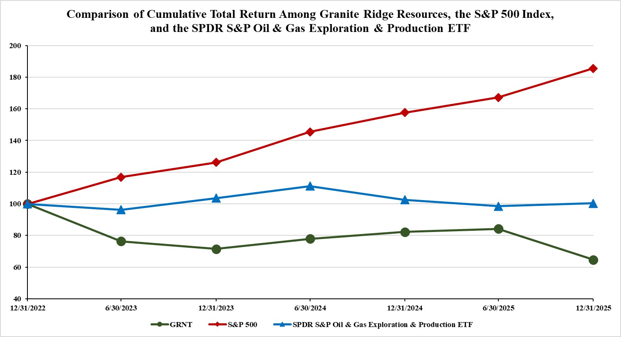
Repurchases of Equity Securities
During the quarter ended December 31, 2025, the Company did not repurchase any shares of common stock.

Item 6. [RESERVED]

Item 7. Management’s Discussion and Analysis of Financial Conditions and Results of Operations
The following discussion and analysis of our financial condition and results of operations should be read in conjunction with our financial statements and related notes included elsewhere in this Annual Report on Form 10-K.
The following discussion contains “forward-looking statements” reflecting our current expectations, estimates and assumptions concerning events and financial trends that may affect our future operating results or financial position. Actual results and the timing of events may differ materially from those contained in these forward-looking statements due to a number of factors. Factors that could cause or contribute to such differences include, but are not limited to, market prices for oil and natural gas, capital expenditures, economic and competitive conditions, regulatory changes and other uncertainties, as well as those factors discussed below and elsewhere in this report. Please read “Cautionary Note Regarding Forward-Looking Statements.” Also, please read the risk factors and other cautionary statements described under “Part I, Item 1A. Risk Factors.” We assume no obligation to update any of these forward-looking statements, except as required by applicable law.

Overview
Granite Ridge is a scaled energy company which aims to provide shareholders with exposure similar to energy private equity through operated partnerships and traditional non-operated assets. We own assets in six prolific unconventional basins across the United States. We aim to deliver a diversified portfolio with best-in-class full cycle returns by investing in a large number of high-graded opportunities developed by proven public and private operators. We focus on success as measured by total shareholder returns, which we seek to balance with a low leverage profile.
As of December 31, 2025, we owned an interest in 3,602 gross (245 net) producing wells, 355,252 gross (47,534 net) developed acres, and 33,399 gross (12,504 net) undeveloped acres, all located in the United States.
Our average daily production for the year ended December 31, 2025 was 31,984 Boe per day.

53
Table of Contents
Business Combination
On October 24, 2022 (the “Closing Date”), Granite Ridge and Executive Network Partnering Corporation ("ENPC") consummated the business combination pursuant to the terms of the Business Combination Agreement, dated as of May 16, 2022 (the “Business Combination Agreement”), by and among ENPC, Granite Ridge, ENPC Merger Sub, Inc., a Delaware corporation and a wholly-owned subsidiary of Granite Ridge (“ENPC Merger Sub”), GREP Merger Sub, LLC, a Delaware limited liability company and a wholly-owned subsidiary of Granite Ridge (“GREP Merger Sub”), and Granite Ridge Holdings, LLC, a Delaware limited liability company formerly known as GREP Holdings, LLC (“GREP”).
Pursuant to the Business Combination Agreement, on the Closing Date, (i) ENPC Merger Sub merged with and into ENPC (the “ENPC Merger”), with ENPC surviving the ENPC Merger as a wholly-owned subsidiary of Granite Ridge and (ii) GREP Merger Sub merged with and into GREP (the “GREP Merger,” and together with the ENPC Merger, the “Mergers”), with GREP surviving the GREP Merger as a wholly-owned subsidiary of Granite Ridge (the transactions contemplated by the foregoing clauses (i) and (ii) the “Business Combination,” and together with the other transactions contemplated by the Business Combination Agreement, the “Transactions”).
For additional information on the Business Combination See Note 1 in the Notes to the Consolidated Financial Statements.

Source of Our Revenues
We derive our revenues from our interests in the sale of oil and natural gas production. Revenues are a function of production, the prevailing market price at the time of sale, oil quality, and transportation costs to market. We use derivative instruments to hedge future sales prices on a portion of our oil and natural gas production. We expect our derivative activities will help us achieve more predictable cash flows and reduce our exposure to downward price fluctuations. The use of derivative instruments has in the past, and may in the future, prevent us from realizing the full benefit of upward price movements but also mitigates the effects of declining price movements.

Principal Components of Our Cost Structure
Lease operating expenses
Lease operating expenses are the costs incurred in the operation of producing properties, including workover costs. Expenses for field employees’ salaries, saltwater disposal, repairs and maintenance comprise the most significant portion of our lease operating expenses. Certain items, such as direct labor and materials and supplies, generally remain relatively fixed across broad production volume ranges, but can fluctuate depending on activities performed during a specific period. A portion of our operating cost components are variable and change in correlation to production levels.
Production and ad valorem taxes
Production taxes are paid on produced oil and natural gas. Ad valorem taxes are paid on the value of our properties in certain states. We seek to take full advantage of all credits and exemptions in our various taxing jurisdictions. In general, the production taxes we pay correlate to the changes in oil and natural gas revenues.
Depletion and accretion expense
Depletion and accretion include the systematic expensing of the capitalized costs incurred to acquire, explore and develop oil and natural gas. As a “successful efforts” company, we capitalize all costs associated with our acquisition and successful development efforts and allocate these costs to each unit of production using the units of production method. Accretion expense relates to the passage of time of our asset retirement obligations.
Impairment expense
We evaluate capitalized costs related to proved and unproved oil and natural gas properties, including wells and related oil sales support equipment and facilities, for recoverability when indicators of impairment exist. If undiscounted cash flows are insufficient to recover the net capitalized costs of proved properties, we recognize an impairment charge for the difference between the net capitalized cost of proved properties and their estimated fair values. Unproved oil and natural
54
Table of Contents
gas properties are periodically assessed for impairment by considering future drilling and exploration plans, results of exploration activities, commodity price outlooks, planned future sales and expiration of all or a portion of the projects.
General and administrative expenses
General and administrative expenses include overhead, including payroll and benefits for our corporate staff, management and annual service fees under the MSA, audit and other professional fees and legal compliance.
Interest expense
We finance a portion of our working capital requirements, capital expenditures and acquisitions with borrowings. As a result, we incur interest expense that is affected by both fluctuations in interest rates and our financing decisions.
Gain (loss) on derivative contracts
We utilize commodity derivative financial instruments to reduce our exposure to fluctuations in the prices of oil and natural gas. Gain (loss) on derivative contracts is comprised of (i) cash gains and losses we recognize on settled commodity derivatives during the period, and (ii) non-cash mark-to-market gains and losses we incur on commodity derivative instruments outstanding at period-end.

Selected Factors That Affect Our Operating Results
Our revenues, cash flows from operations and future growth depend substantially upon:
•the timing and success of drilling and production activities by our operating partners;
•the prices and the supply and demand for oil and natural gas;
•the quantity of oil and natural gas production from the wells in which we participate;
•changes in the fair value of the derivative instruments we use to reduce our exposure to fluctuations in the price of oil and natural gas;
•our ability to continue to identify and acquire high-quality acreage and drilling opportunities; and
•the level of our operating expenses.
In addition to the factors that affect companies in our industry generally, the location of substantially all of our acreage in the Eagle Ford, Permian, Bakken, Haynesville, Denver-Julesburg and Appalachian Basins subjects our operating results to factors specific to these regions. These factors include the potential adverse impact of weather on drilling, production and transportation activities, particularly during the winter and spring months, as well as infrastructure limitations, transportation capacity, regulatory matters and other factors that may specifically affect one or more of these regions.
The price of oil and natural gas can vary depending on the market in which it is sold and the means of transportation used to transport the oil and natural gas to market.
The price at which our oil and natural gas production is sold typically reflects either a premium or discount to the NYMEX benchmark price. Thus, our operating results are also affected by changes in the oil and natural gas price differentials between the applicable benchmark and the sales prices we receive for our oil and natural gas production.
Our oil price differential to the NYMEX benchmark price during 2025, 2024 and 2023 was $(3.76) per barrel, $(3.57) per barrel and $(1.40) per barrel, respectively. Our natural gas price differential during 2025, 2024 and 2023 was $(0.96) per Mcf, $(0.31) per Mcf and $0.19 per Mcf, respectively.

Market Conditions
The price that we receive for the oil and natural gas our operators produce is largely a function of market supply and demand. Because our oil and natural gas revenues are heavily weighted toward oil, we are more significantly impacted by
55
Table of Contents
changes in oil prices than by changes in the price of natural gas. Worldwide supply in terms of output, especially production from properties within the United States, the production quota set by OPEC, and the strength of the U.S. dollar can adversely impact oil prices.
Historically, commodity prices have been volatile, and we expect the volatility to continue in the future.
Although we cannot predict the occurrence of events that may affect future commodity prices, or the degree to which these prices will be affected, the prices for any commodity that we produce will generally approximate current market prices in the geographic region of the production. From time to time, we expect that we may hedge a portion of our commodity price risk to mitigate the impact of price volatility on our business.
Prices for various quantities of natural gas and oil that we produce significantly impact our revenues and cash flows. The following table lists average NYMEX prices for oil and natural gas for the years ended December 31, 2025, 2024 and 2023.
 |  |  | December 31,
 |  |  | 2025 |  |  |  |  |  | 2024 |  |  |  |  |  | 2023
Average NYMEX Prices(1)
Oil (per Bbl) |  |  | $ | 65.39 |  |  |  |  | $ | 76.63 |  |  |  |  | $ | 77.58
Natural gas (per Mcf) |  |  | $ | 3.52 |  |  |  |  | $ | 2.19 |  |  |  |  | $ | 2.53
__________________________________________
(1)Based on average NYMEX closing prices.

Results of Operations
The following tables and related discussion set forth key operating and financial data as of and for the years ended December 31, 2025 and 2024. For similar operating and financial data and discussion of our 2024 results compared to our 2023 results, refer to “Item 7. Management’s Discussion and Analysis of Financial Condition and Results of Operations” under Part II of our annual report on Form 10-K for the year ended December 31, 2024, which was filed with the SEC on March 6, 2025. Because of normal production declines, increased or decreased drilling activities, fluctuations in
56
Table of Contents
commodity prices and the effects of acquisitions and divestitures, the historical information presented below should not be interpreted as being indicative of future results.
 |  |  | Year Ended December 31,
 |  |  | 2025 |  |  |  |  |  | 2024
Net Sales (in thousands):
Oil sales |  |  | $ | 360,832 |  |  |  |  | $ | 327,491
Natural gas and related product sales |  |  | 89,474 |  |  |  |  |  | 52,539
Revenues |  |  | 450,306 |  |  |  |  |  | 380,030
Net Production:
Oil (MBbl) |  |  | 5,855 |  |  |  |  |  | 4,483
Natural gas (MMcf) |  |  | 34,912 |  |  |  |  |  | 27,944
Total (MBoe)(1) |  |  | 11,674 |  |  |  |  |  | 9,140
Average Daily Production:
Oil (Bbl) |  |  | 16,041 |  |  |  |  |  | 12,248
Natural gas (Mcf) |  |  | 95,649 |  |  |  |  |  | 76,350
Total (Boe)(1) |  |  | 31,984 |  |  |  |  |  | 24,973
Average Sales Prices:
Oil (per Bbl) |  |  | $ | 61.63 |  |  |  |  | $ | 73.06
Effect of gain on settled oil derivatives on average price (per Bbl) |  |  | 0.28 |  |  |  |  |  | 0.34
Oil net of settled oil derivatives (per Bbl)(2) |  |  | $ | 61.91 |  |  |  |  | $ | 73.40
Natural gas and related product sales (per Mcf) |  |  | $ | 2.56 |  |  |  |  | $ | 1.88
Effect of gain on settled natural gas derivatives on average price (per Mcf) |  |  | 0.08 |  |  |  |  |  | 0.53
Natural gas and related product sales net of settled natural gas derivatives (per Mcf)(2) |  |  | $ | 2.64 |  |  |  |  | $ | 2.41
Realized price on a Boe basis excluding settled commodity derivatives |  |  | $ | 38.57 |  |  |  |  | $ | 41.58
Effect of gain on settled commodity derivatives on average price (per Boe) |  |  | 0.38 |  |  |  |  |  | 1.79
Realized price on a Boe basis including settled commodity derivatives(2) |  |  | $ | 38.95 |  |  |  |  | $ | 43.37
Operating Expenses (in thousands):
Lease operating expenses |  |  | $ | 84,903 |  |  |  |  | $ | 57,461
Production and ad valorem taxes |  |  | 27,554 |  |  |  |  |  | 26,007
Depletion and accretion expense |  |  | 215,701 |  |  |  |  |  | 176,529
Impairments of long-lived assets |  |  | 44,654 |  |  |  |  |  | 36,369
General and administrative |  |  | 31,009 |  |  |  |  |  | 24,649
Costs and Expenses (per Boe):
Lease operating expenses |  |  | $ | 7.27 |  |  |  |  | $ | 6.29
Production and ad valorem taxes |  |  | 2.36 |  |  |  |  |  | 2.85
Depletion and accretion |  |  | 18.48 |  |  |  |  |  | 19.31
Impairments of long-lived assets |  |  | 3.83 |  |  |  |  |  | 3.98
General and administrative |  |  | 2.66 |  |  |  |  |  | 2.70
Net Producing Wells at Period-End: |  |  | 244.74 |  |  |  |  |  | 202.40
__________________________________________
(1)Natural gas is converted to Boe using the ratio of one barrel of oil to six Mcf of natural gas.
(2)The presentation of realized prices including settled commodity derivatives is a result of including the net cash receipts from (payments on) commodity derivatives that are presented in our consolidated statements of cash flows. This presentation of average prices with derivatives is a means by which to reflect the actual cash performance of our commodity derivatives for the respective periods and presents oil and natural gas prices with derivatives in a manner consistent with the presentation generally used by the investment community.
57
Table of Contents
Oil, Natural Gas and Related Product Sales
Our revenues vary from year to year primarily due to changes in realized commodity prices and production volumes. Our oil and natural gas sales for the year ended December 31, 2025 increased 18% from the year ended December 31, 2024. Oil revenues for the year ended December 31, 2025 increased by 10% compared to the same period in 2024, driven by an 31% increase in production, partially offset by a 16% decrease in realized prices, excluding the effect of settled derivatives. Natural gas revenues increased by 70% for the year ended December 31, 2025 compared to 2024, driven by a 36% increase in realized natural gas prices, excluding the effect of settled commodity derivatives, and a 25% increase in production.
Production from oil and gas properties increased because of drilling success and the acquisition of additional net revenue interests. This increase in total production is offset by the natural decline of the production rate of existing oil and natural gas wells. The number of wells we participated in increased from 202.40 net wells in 2024 to 244.74 net wells in 2025.
The following table sets forth information regarding our oil and natural gas production by basin.
 |  |  | Year Ended December 31,
 |  |  | 2025 |  |  |  |  |  | 2024
Net Production:
Oil (MBbl)
Permian |  |  | 4,288 |  |  |  |  |  | 2,956
Eagle Ford |  |  | 387 |  |  |  |  |  | 638
Bakken |  |  | 465 |  |  |  |  |  | 561
Haynesville |  |  | — |  |  |  |  |  | —
DJ |  |  | 373 |  |  |  |  |  | 322
Appalachian |  |  | 342 |  |  |  |  |  | 6
Total |  |  | 5,855 |  |  |  |  |  | 4,483
Natural Gas (MMcf)
Permian |  |  | 18,744 |  |  |  |  |  | 11,229
Eagle Ford |  |  | 3,224 |  |  |  |  |  | 3,847
Bakken |  |  | 1,150 |  |  |  |  |  | 1,235
Haynesville |  |  | 8,212 |  |  |  |  |  | 9,264
DJ |  |  | 2,240 |  |  |  |  |  | 2,345
Appalachian |  |  | 1,342 |  |  |  |  |  | 24
Total |  |  | 34,912 |  |  |  |  |  | 27,944
Total (MBoe)
Permian |  |  | 7,412 |  |  |  |  |  | 4,828
Eagle Ford |  |  | 924 |  |  |  |  |  | 1,279
Bakken |  |  | 657 |  |  |  |  |  | 767
Haynesville |  |  | 1,369 |  |  |  |  |  | 1,544
DJ |  |  | 746 |  |  |  |  |  | 712
Appalachian |  |  | 566 |  |  |  |  |  | 10
Total |  |  | 11,674 |  |  |  |  |  | 9,140
Lease Operating Expenses
Lease operating expenses were $84.9 million ($7.27 per Boe) for the year ended December 31, 2025, a increase of 48% from $57.5 million ($6.29 per Boe) for 2024. The increase was primarily due to a $6.2 million increase in saltwater disposal costs, as well as a $4.0 million increase in contract labor. Additionally, there has been an increase in certain other lease operating expenses as a result of an increase in well count due to acquisitions and additional wells successfully drilled and completed.
58
Table of Contents
Production and Ad Valorem Taxes
We generally pay production taxes based on realized oil and natural gas sales. Production taxes were $22.4 million ($1.92 per Boe) for the year ended December 31, 2025 compared to $21.0 million ($2.30 per Boe) for 2024. As a percentage of oil and natural gas sales, our production taxes were 5% and 6% for the years ended December 31, 2025 and 2024, respectively.
Production taxes generally fluctuate with the market value of our production sold, while ad valorem taxes are generally based on the valuation of our oil and natural gas properties at the beginning of the year, which vary across the different areas in which we operate.
Ad valorem taxes increased during the year ended December 31, 2025 as compared to 2024, primarily due to additional wells drilled and completed and new wells acquired.
Depletion and Accretion
Depletion and accretion was $215.7 million ($18.48 per Boe) for the year ended December 31, 2025, an increase of 22% from $176.5 million ($19.31 per Boe) in 2024. The increase in depletion and accretion expense was primarily due to the increase in depletion expense resulting from the increase in production during the year ended December 31, 2025.
Impairment of Long-Lived Assets
During the years ended December 31, 2025 and 2024, we recognized impairment expense of $44.7 million and $36.4 million, respectively. As of December 31, 2025, as a result of the decline in oil prices in the Eagle Ford Basin, we compared the sum of the expected undiscounted future net cash flows to the carrying amount of the assets. As the carrying amount of the assets was higher than the expected undiscounted future net cash flows, an impairment loss of $44.7 million was recorded as the difference between the carrying value and the estimated fair value.
During the year ended December 31, 2024, as a result of widening differentials and higher production cost assumptions, it was determined that the carrying amount of proved oil and gas properties in the Bakken exceeded undiscounted future net cash flows. As a result, an impairment of $35.6 million was recorded to write-down the carrying value to the estimated fair value of the proved oil and gas properties. Additionally, for the year ended December 31, 2024, an impairment of 0.7 million to the Company's unproved properties in the Permian Basin as the operator of those properties no longer intends to drill certain locations.
General and Administrative
The following table provides components of our general and administrative expenses for the years ended December 31, 2025 and 2024:
 |  |  | Year Ended December 31,
(in thousands) |  |  | 2025 |  |  |  |  |  | 2024
General and administrative expenses |  |  | $ | 27,253 |  |  |  |  | $ | 22,351
Non-cash stock-based compensation |  |  | 3,756 |  |  |  |  |  | 2,298
Total general and administrative expenses |  |  | $ | 31,009 |  |  |  |  | $ | 24,649
Total general and administrative expenses were $31.0 million ($2.66 per Boe) for the year ended December 31, 2025, a increase of 26% from $24.6 million ($2.70 per Boe) in 2024. The increase was primarily due to severance expense incurred during the period as a result of a management transition as well as expenses related to capital market activities.
59
Table of Contents
Gain/(Loss) on Derivatives – Commodity Derivatives
The following table summarizes the amounts reported as gain (loss) on derivatives - commodity derivatives in the condensed consolidated statements of operations for the years ended December 31, 2025, and 2024:
 |  |  | Year Ended December 31,
(in thousands) |  |  | 2025 |  |  |  |  |  | 2024
Net cash receipts from commodity derivatives
Oil derivatives |  |  | $ | 1,624 |  |  |  |  | $ | 1,503
Natural gas derivatives |  |  | 2,835 |  |  |  |  |  | 14,860
Total net cash receipts from commodity derivatives |  |  | $ | 4,459 |  |  |  |  | $ | 16,363
Unrealized gain (loss) on commodity derivatives
Oil derivatives |  |  | $ | 15,084 |  |  |  |  | $ | (5,508)
Natural gas derivatives |  |  | 6,726 |  |  |  |  |  | (11,763)
Power capacity contract |  |  | 852 |  |  |  |  |  | —
Total unrealized gain (loss) on commodity derivatives |  |  | $ | 22,662 |  |  |  |  | $ | (17,271)
Total gain (loss) on derivatives - commodity derivatives |  |  | $ | 27,121 |  |  |  |  | $ | (908)
Our earnings are affected by the changes in the value of our derivatives portfolio between periods and the related cash settlements of those derivatives, which could be significant. To the extent the future commodity price outlook declines between measurement periods, we will have mark-to-market gains; while to the extent future commodity price outlook increases between measurement periods, we will have mark-to-market losses.
Interest Expense
Interest expense was $25.5 million for the year ended December 31, 2025 compared to $18.5 million for 2024. The increase in interest expense was primarily due to a higher average outstanding balance on the revolving credit facility, as well as the issuance of $350.0 million aggregate principal amount of 8.875% senior unsecured notes in November 2025. See the section entitled “Management’s Discussion and Analysis of Results of Operations and Financial Condition — Liquidity and Capital Resources" for more information.
Income Tax Expense (Benefit)
For the year ended December 31, 2025, we recorded income tax expense of $7.8 million, which included current income tax expense of $0.4 million and deferred income tax expense of $7.4 million. Our effective income tax rate of 24.2% for the year ended December 31, 2025 differs from the federal statutory rate of 21% due primarily to the impact of certain discrete items, state income taxes, and certain nontaxable or nondeductible items. For the year ended December 31, 2024, we recorded income tax expense of $6.2 million, which included current income tax expense of $0.2 million and deferred income tax expense of $6.0 million. Our effective income tax rate of 24.9% for the year ended December 31, 2024 differed from the federal statutory rate of 21% primarily due to the impact of certain discrete items and state income taxes.

Liquidity and Capital Resources
Our main sources of liquidity and capital resources as of the periods covered by this report have been internally generated cash flow from operations, credit facility borrowings, and the issuance of senior notes. Our primary use of capital has been for the development and acquisition of oil and natural gas properties. We continually monitor potential capital sources for opportunities to enhance liquidity or otherwise improve our financial position.
As of December 31, 2025, the Company had $350.0 million of principal debt outstanding on 8.875% senior unsecured notes (the “2029 Senior Notes”) and $50.0 million of debt outstanding under our senior secured revolving credit agreement (as amended, the “Credit Agreement”). We had $339.5 million of liquidity as of December 31, 2025, consisting of $324.7 million of committed borrowing availability under the Credit Agreement and $14.8 million of cash on hand.
With our cash on hand, cash flow from operations, and borrowing capacity under the Credit Agreement, we believe that we will have sufficient cash flow and liquidity to fund our budgeted capital expenditures and operating expenses for at
60
Table of Contents
least the next twelve months. However, we may seek additional access to capital and liquidity. We cannot assure you that any additional capital will be available to us on favorable terms or at all.
Capital commitments
Our recent capital commitments have been to fund the development and acquisition of oil and natural gas properties. We expect to fund our near-term capital requirements and working capital needs with cash on hand, cash flows from operations and available borrowing capacity under our Credit Agreement. Our capital expenditures could be curtailed if our cash flows decline from expected levels.
Common stock dividends
We paid dividends of $57.7 million, or $0.44 per share, and $57.5 million, or $0.44 per share, during the years ended December 31, 2025 and 2024, respectively. On February 13, 2026, our Board of Directors declared a cash dividend of $0.11 per share for the first quarter of 2026 that will be paid on March 13, 2026 to stockholders of record as of February 27, 2026. Any payment of future dividends will be at the discretion of the Company’s Board of Directors.
Stock repurchase program
In December 2022, we announced that our Board of Directors approved a stock repurchase program for up to $50.0 million of our common stock through December 31, 2023. The stock repurchase program terminated on December 31, 2023. During the year ended December 31, 2023, the Company repurchased 5,651,707 shares under the program at an aggregate cost of $36.1 million. As of December 31, 2023, the Company had repurchased a total of 5,677,627 shares since the inception of the program at an aggregate cost of $36.3 million.
Cash Flows
Our cash flows for the years ended December 31, 2025, 2024 and 2023 are presented below:
 |  |  | Year Ended December 31,
(in thousands) |  |  | 2025 |  |  |  |  |  | 2024 |  |  |  |  |  | 2023
Net cash provided by operating activities |  |  | $ | 296,414 |  |  |  |  | $ | 275,733 |  |  |  |  | $ | 302,867
Net cash used in investing activities |  |  | (409,808) |  |  |  |  |  | (310,768) |  |  |  |  |  | (356,676)
Net cash provided by financing activities |  |  | 118,821 |  |  |  |  |  | 33,724 |  |  |  |  |  | 13,406
Net change in cash |  |  | $ | 5,427 |  |  |  |  | $ | (1,311) |  |  |  |  | $ | (40,403)
Cash Flows Provided by Operating Activities
The primary factors impacting our cash flows from operating activities generally include: (i) levels of production from our oil and natural gas properties, (ii) prices we receive from sales of oil and natural gas production, including settlement proceeds or payments related to our commodity derivatives, (iii) operating costs of our oil and natural gas properties, (iv) costs of our general and administrative activities and (v) interest expense. Our cash flows from operating activities have historically been impacted by fluctuations in oil and natural gas prices and our production volumes.
The $20.7 million increase in operating cash flows during the year ended December 31, 2025 as compared to 2024 was primarily due to the increase in oil and natural gas sales during 2025 as compared to 2024. Our net cash provided by operating activities included a benefit of $5.5 million and $0.9 million for the years ended December 31, 2025 and 2024, respectively, associated with changes in working capital items. Changes in working capital items adjust for the timing of receipts and payments of actual cash.
Cash Flows Used in Investing Activities
For the year ended December 31, 2025, our net cash used in investing activities was $409.8 million, which consisted primarily of $300.8 million of capital expenditures for oil and natural gas properties and $118.5 million of acquisitions of oil and natural gas properties. These cash flows used in investing activities are partially offset by cash proceeds from refund of advances from operators of $4.3 million, and proceeds from the sale of equity investments of $5.0 million during 2025.
61
Table of Contents
For the year ended December 31, 2024, our net cash used in investing activities was $310.8 million, which consisted primarily of $285.8 million of capital expenditures for oil and natural gas properties and $61.2 million of acquisitions of oil and natural gas properties. These cash flows used in investing activities are partially offset by proceeds from the disposal of oil and natural gas properties of 14.0 million and proceeds from refund of advances from operators of $19.7 million .
Cash Flows Provided by (Used in) Financing Activities
For the year ended December 31, 2025, our net cash provided by financing activities was $118.8 million primarily due to proceeds from senior notes, net of discount, of $336.0 million, partially offset by $155.0 million of net repayments under our Credit Agreement and $57.7 million of dividends paid on our common stock.
For the year ended December 31, 2024, our net cash provided by financing activities was $33.7 million primarily due to $95.0 million of net borrowings under our Credit Agreement, partially offset by $57.5 million of dividends paid on our common stock.
Granite Ridge Credit Agreement
At December 31, 2025, the Company had outstanding borrowings of $50.0 million and $0.3 million of letters of credit issued and outstanding under the Credit Agreement, resulting in availability of $324.7 million. The Credit Agreement is guaranteed by the restricted subsidiaries of Granite Ridge and is secured by a first priority mortgage and security interest in substantially all of the Company's and its restricted subsidiaries' assets.
On April 29, 2025, the Company and its lenders entered into the Fifth Amendment to Credit Agreement, which amended the Credit Agreement to, among other things, (i) increase the borrowing base from $325.0 million to $375.0 million, and (ii) increase the aggregate elected commitments from $325.0 million to $375.0 million.
On November 5, 2025, the Company and its lenders entered into the Sixth Amendment to Credit Agreement, which amended the Credit Agreement to, among other things, (i) reaffirm the borrowing base and aggregate elected commitment amounts at $375.0 million, (ii) permit the issuance of the 2029 Senior Notes (as defined below), (iii) extend the maturity date to the earliest to occur of (A) November 5, 2029 or (B) the date that is ninety-one days prior to the stated maturity date of the 2029 Senior Notes if any 2029 Senior Notes remain outstanding on such date, and (iv) adjust the interest payable on (A) SOFR loans to interest at a rate per annum equal to SOFR plus an applicable margin ranging from 275 to 375 basis points, depending on the percentage of the borrowing base utilized and (B) base rate loans to interest at a rate per annum equal to the greatest of: (a) the U.S. prime rate as publicly announced from time to time by Bank of America, N.A.; (b) the federal funds effective rate plus 50 basis points; (c) the adjusted SOFR rate for a one-month interest period plus 100 basis points; and (d) 100 basis points, plus, in the case of any base rate loan, an applicable margin ranging from 175 to 275 basis points, depending on the percentage of the borrowing base utilized.
2029 Senior Notes
On November 5, 2025, the Company, as issuer, completed an issuance of $350.0 million aggregate principal amount of 8.875% senior unsecured notes at 96.0% of par with stated maturity on November 5, 2029 (the “2029 Senior Notes”) pursuant to a note purchase agreement (the “Note Purchase Agreement”). The Company used the net proceeds from issuance of the 2029 Senior Notes to repay certain amounts under the Credit Agreement and to pay related fees and expenses. The Note Purchase Agreement allows the ability for the Company to incur up to $100.0 million of incremental notes for purposes of acquisition financing, subject to, among other things, the willingness of holders to provide such incremental notes and a pro forma net leverage ratio not greater than 2.00 to 1.00.
Interest is due to be paid at the end of each quarter, commencing December 31, 2025. In addition, the Company will repay quarterly 2.5% of the original principal amount of the notes issued on the closing date beginning on September 30, 2026. If quarterly scheduled repayments are missed, the coupon increases to 11.875% and the Company is restricted from making any dividend payments until all delinquent scheduled repayments have been fulfilled. The Company has $17.5 million included in current liabilities in our consolidated balance sheets related to quarterly principal repayments due within the next 12 months. On or after May 5, 2027 and on or prior to May 5, 2028, the Company may, at its option, redeem, at any time some or all of the 2029 Senior Notes at 103.0% of par, as set forth in the Note Purchase Agreement, plus accrued and unpaid interest, if any. Any redemption of the 2029 Senior Notes prior to May 5, 2027 is subject to payment of a make-whole amount. After May 5, 2028, the Company may redeem some or all of the Senior Notes at
62
Table of Contents
100.0% of the principal amount thereof plus accrued and unpaid interest, if any. The principal remaining outstanding at the time of maturity is required to be paid in full by the Issuer.
Known Contractual and Other Obligations; Planned Capital Expenditures
Contractual and Other Obligations
•As of December 31, 2025, we had $50.0 million of debt outstanding under our Credit Agreement. See Note 8 of the Notes to the Consolidated Financial Statements for information regarding future interest payment obligations on our Credit Agreement.
•As of December 31, 2025, we had $350.0 million of principal debt outstanding on our 2029 Senior Notes with quarterly repayments of $8.75 million beginning September 30, 2026.
•We entered into the MSA with the Manager in which we pay the Manager an annual services fee for certain Granite Ridge group costs related to the operation of our oil and gas assets and other properties of $11.75 million, subject to annual CPI-based adjustments beginning January 1, 2027. The authority to increase the Services Fee up to a maximum total of $12.5 million annually has been delegated to management. See Note 10 of the Notes to the Consolidated Financial Statements.
•We have contractual commitments that may require us to make payments upon future settlement of our commodity derivative contracts. See Note 3 of the Notes to the Consolidated Financial Statements.
•We have future obligations related to the abandonment of our oil and natural gas properties. See Note 6 of the Notes to the Consolidated Financial Statements.
•With respect to all of these items, except for our commitments under our debt agreements, we cannot determine with accuracy the amount and/or timing of such payments.
Planned Capital Expenditures
For 2026, we are budgeting approximately $320 million to $360 million in total planned capital expenditures, including approximately $20 million to $30 million of acquisitions of oil and natural gas properties. We expect to fund planned capital expenditures with cash generated from operations and, if required, borrowings under our Credit Agreement.
The amount, timing and allocation of capital expenditures are largely discretionary and subject to change based on a variety of factors. If oil and natural gas prices decline below our acceptable levels, or costs increase above our acceptable levels, we may choose to defer a portion of our budgeted capital expenditures until later periods to achieve the desired balance between sources and uses of liquidity and prioritize capital projects that we believe have the highest expected returns and potential to generate near-term cash flow. We may also increase our capital expenditures significantly to take advantage of opportunities we consider to be attractive. We will carefully monitor and may adjust our projected capital expenditures in response to changes in prices, availability of financing, drilling and acquisition costs, industry conditions, the timing of regulatory approvals, contractual obligations, internally generated cash flow, and other factors both within and outside our control.
Satisfaction of Our Cash Obligations for the Next Twelve Months
With our Credit Agreement and our positive cash flows from operations, we believe we will have sufficient capital to meet our drilling commitments, expected general and administrative expenses and other cash needs for the next twelve months. Nonetheless, any strategic acquisition of assets or increase in drilling activity may lead us to seek additional capital. We may also choose to seek additional capital rather than utilize our credit to fund accelerated or continued drilling at the discretion of management and depending on prevailing market conditions. We will evaluate any potential opportunities for acquisitions as they arise. However, there can be no assurance that any additional capital will be available to us on favorable terms or at all.
63
Table of Contents
Effects of Inflation and Pricing
The oil and natural gas industry is typically very cyclical and the demand for goods and services of oil field companies, suppliers and others associated with the industry put extreme pressure on the economic stability and pricing structure within the industry. Typically, as prices for oil and natural gas increase, so do all associated costs. Conversely, in a period of declining prices, associated cost declines are likely to lag and may not adjust downward in proportion.
Material changes in prices also impact our current revenue stream, estimates of future reserves, borrowing base calculations of bank loans, impairment assessments of oil and natural gas properties, and values of properties in purchase and sale transactions. Material changes in prices can impact the value of oil and natural gas companies and their ability to raise capital, borrow money and retain personnel. Higher prices for oil and natural gas could result in increases in the costs of materials, services and personnel.

Critical Accounting Estimates
The establishment and consistent application of accounting policies is a vital component of accurately and fairly presenting our financial statements in accordance with generally accepted accounting principles in the United States (“U.S. GAAP”), as well as ensuring compliance with applicable laws and regulations governing financial reporting. While there are rarely alternative methods or rules from which to select in establishing accounting and financial reporting policies, proper application often involves significant judgment regarding a given set of facts and circumstances and a complex series of decisions. Further, these estimates and other factors, including those outside of management’s control could have significant adverse impact to the financial condition, results of operations and cash flows of the Company.
Use of Estimates
The preparation of financial statements under U.S. GAAP requires management to make estimates and assumptions that affect our reported amounts of assets and liabilities and the reported amounts of revenues and expenses during the reporting period.
Oil and Natural Gas Reserves
The determination of depletion and amortization expense as well as impairments that are recognized on our oil and natural gas properties are highly dependent on the estimates of the proved oil and natural gas reserves attributable to our properties. Our estimate of proved reserves is based on the quantities of oil and natural gas which geological and engineering data demonstrate, with reasonable certainty, to be recoverable in the future years from known reservoirs under existing economic and operating conditions. The accuracy of any reserve estimate is a function of the quality of available data, engineering and geological interpretation, and judgment. For example, we must estimate the amount and timing of future operating costs, production taxes and development costs, all of which may in fact vary considerably from actual results. In addition, as the prices of oil and natural gas and cost levels change from year to year, the economics of producing our reserves may change and therefore the estimate of proved reserves may also change. As of December 31, 2025, approximately 24% of our total proved reserves were categorized as proved undeveloped reserves. Any significant variance in these assumptions could materially affect the estimated quantity and value of our reserves, future cash flows from our reserves, and future development of our proved undeveloped reserves.
The information regarding present value of the future net cash flows attributable to our proved oil and natural gas reserves are estimates only and should not be construed as the current market value of the estimated oil and natural gas reserves attributable to our properties. Such information includes revisions of certain reserve estimates attributable to the properties included in the prior year’s estimates. These revisions reflect additional information from subsequent activities, production history of the properties involved and any adjustments in the projected economic life of such properties resulting from changes in oil and natural gas prices.
External petroleum engineers independently estimated all of the proved reserve quantities included in our Annual Report, which were prepared in accordance with the rules promulgated by the SEC. In connection with our external petroleum engineers performing their independent reserve estimations, we provided them our historical information, such as oil and natural gas production, realized commodity prices, and operating and development costs. We also provided ownership interest information with respect to our properties. The third-party independent reserve engineers, NSAI, evaluated 100% of our estimated proved reserve quantities and their related pre-tax future net cash flows as of December 31, 2025.
64
Table of Contents
Oil and Natural Gas Properties
Oil and natural gas producing activities are accounted for under the successful efforts method of accounting.
The successful efforts method inherently relies on the estimation of proved oil and natural gas reserves. The amount of estimated proved reserve volumes affect, among other things, whether certain costs are capitalized or expensed, the amount and timing of costs depleted into net income and the presentation of supplemental information on oil and gas producing activities. In addition, the expected future cash flows to be generated by producing properties used for testing impairment, also in part, rely on estimates of quantities of net reserves.
Depletion of oil and natural gas producing properties is determined using the units-of-production method. During the years ended December 31, 2025, 2024, and 2023, we recognized depletion expense of $214.8 million, $175.7 million and $160.2 million, respectively.
Any reduction in proved reserves could result in an acceleration of future depletion expense. Such a decline may result from lower commodity prices which may make it uneconomical to drill certain proved undeveloped locations. In addition, a decline in proved reserve estimates may impact the outcome of our assessment of proved properties for impairment.
Holding all other factors constant, if proved reserves are revised downward, the rate at which we record depletion and accretion expense would increase, reducing net income. Conversely, if proved reserves are revised upward, the rate at which we record depletion and accretion expense would decrease. However, a sensitivity analysis is not practicable, given the numerous assumptions required to calculate proved reserves. In addition, any unfavorable adjustments to some of the above listed assumptions (e.g. commodity prices) would likely be offset by favorable adjustments in other assumptions (e.g. lower costs) as we have historically seen in our industry.
Impairment of Oil and Natural Gas Properties
All of our long-lived assets are monitored for potential impairment annually, or when circumstances indicate that the carrying value of an asset may be greater than management’s estimates of its future net cash flows, including cash flows from proved reserves and risk-adjusted probable and possible reserves. If the carrying value of the long-lived assets exceeds the sum of estimated undiscounted future net cash flows, an impairment loss is recognized for the difference between the estimated fair value, using the income or market approach, and the carrying value of the assets. The evaluations involve a significant amount of judgment since the results are based on estimated future events, such as future sales prices for oil and natural gas, future costs to develop and produce these products, estimates of future oil and natural gas reserves to be recovered and the timing thereof, the economic and regulatory climates, and other factors. The need to test an asset for impairment may result from significant declines in sales prices or downward revisions in estimated quantities of oil and natural gas reserves. Estimates of anticipated sales prices are highly judgmental and subject to material revision in future periods.
Unproved oil and natural gas properties are assessed for impairment by considering future drilling and exploration plans, results of exploration activities, commodity price outlooks, planned future sales and expiration of all or a portion of the projects.
Derivative Instruments – Commodity Derivatives
In order to reduce uncertainty around commodity prices received for our oil and natural gas operators’ production, we enter into commodity price derivative contracts from time to time. We exercise significant judgment in determining the types of instruments to be used, the level of production volumes to include in our commodity derivative contracts, the prices at which we enter into commodity derivative contracts and the counterparties’ creditworthiness.
We have not designated our derivative instruments as hedges for accounting purposes and, as a result, mark our derivative instruments to fair value and recognize the cash and non-cash change in fair value on derivative instruments for each period in the consolidated statements of operations. We are also required to recognize our derivative instruments on the consolidated balance sheets as assets or liabilities at fair value with such amounts classified as current or long-term based on their anticipated settlement dates. The accounting for the changes in fair value of a derivative depends on the intended use of the derivative and resulting designation, and fair value is generally determined using established index prices and other sources which are based upon, among other things, futures prices and time to maturity. These fair values are recorded by netting asset and liability positions, including any deferred premiums, that are with the same counterparty
65
Table of Contents
and are subject to contractual terms which provide for net settlement. Changes in the fair values of our commodity derivative instruments have a significant impact on our net income because we follow mark-to-market accounting and recognize all gains and losses on such instruments in earnings in the period in which they occur.
Revenue Recognition
The Company’s revenues are derived from its interests in the sale of oil and natural gas production. As we do not operate any of our wells, we have limited visibility into the timing of when new wells start producing and production statements may not be received for one to three months or more after the date production is delivered. As a result, we are required to estimate the amount of production delivered to the purchaser and the price that we will receive for the sale of the product. Engineering estimates are typically used to calculate expected volumes. Pricing estimates are based upon actual prices realized in an area by adjusting the market price for the basis differential from market on a basin-by-basin basis. The expected sales volumes and prices for these properties are estimated and recorded within the revenue receivable line item in the accompanying consolidated balance sheets. Differences between our estimates and the actual amounts received for oil and natural gas sales are recorded in the month that payment is received from the third party.

Recently Issued or Adopted Accounting Pronouncements
For discussion of recently issued or adopted accounting pronouncements, see Note 2 of the Notes to the Consolidated Financial Statements.

Off-Balance Sheet Arrangements
We do not have any off-balance sheet arrangements that have or are reasonably likely to have a current or future effect on our financial condition, changes in financial condition, revenues or expenses, results of operations, liquidity, capital expenditures or capital resources that is material to investors.

Item 7A. Quantitative and Qualitative Disclosure about Market Risk
Commodity Price Risk
We are exposed to market risk as the prices of our commodities are subject to fluctuations resulting from changes in supply and demand. To reduce our exposure to changes in the prices of our commodities, we have entered into, and may in the future enter into, additional commodity price risk management arrangements for a portion of our oil and natural gas production. The agreements that we have entered into generally have the effect of providing us with a fixed price for a portion of our expected future oil and natural gas production over a fixed period of time. Our commodity price risk management arrangements are recorded at fair value and thus changes to the future commodity prices will have an impact on our earnings. For the year ended December 31, 2025, a 10% increase in average commodity prices would have decreased the fair value of our collar option and swap commodity derivatives by $23.4 million. We may incur significant unrealized losses in the future from our use of derivative financial instruments to the extent market prices increase and our derivatives contracts remain in place.
We generally use derivatives to economically hedge a portion of our anticipated future production. Any payments due to counterparties under our derivative contracts are funded by proceeds received from the sale of our production. Production receipts, however, lag payments to the counterparties. Any interim cash needs are funded by cash from operations or borrowings under our Credit Agreement.
Interest Rate Risk
At December 31, 2025, our exposure to interest rate changes related primarily to the borrowings under the Credit Agreement as the 2029 Senior Notes bear a fixed interest rate. The interest we pay on these borrowings is set periodically based upon market rates. We had total indebtedness of $50.0 million outstanding under our Credit Agreement at December 31, 2025. The impact of a 100 basis point increase in the interest rate on this amount of debt would result in increased annual interest expense of approximately $0.5 million.
We may utilize interest rate derivatives to alter interest rate exposure in an attempt to reduce interest rate expense related to existing debt issues. Interest rate derivatives are used solely to modify interest rate exposure and not to modify the overall leverage of the debt portfolio. We had no outstanding interest rate derivative contracts at December 31, 2025.

66
Table of Contents
Item 8. Financial Statements and Supplementary Data
The financial statements and supplementary financial information required by this item are included on the pages immediately following the Index to Financial Statements appearing on page F-1.

Item 9. Changes in and Disagreements With Accountants on Accounting and Financial Disclosure
None.

Item 9A. Controls and Procedures
Evaluation of Disclosure Controls and Procedures
Disclosure controls and procedures are controls and other procedures that are designed to ensure that information required to be disclosed in our reports filed or submitted under the Exchange Act is recorded, processed, summarized and reported within the time periods specified in the SEC’s rules and forms. Disclosure controls and procedures include, without limitation, controls and procedures designed to ensure that information required to be disclosed in company reports filed or submitted under the Exchange Act is accumulated and communicated to management, including our Chief Executive Officer and Chief Financial Officer, to allow timely decisions regarding required disclosure.
Under the direction of our Chief Executive Officer and Chief Financial Officer, we have established disclosure controls and procedures, as defined in Rule 13a-15(e) and 15d-15(e) under the Exchange Act that are designed to ensure that information required to be disclosed by us in the reports that we file or submit under the Exchange Act is recorded, processed, summarized and reported within the time periods specified in the SEC’s rules and forms. The disclosure controls and procedures are also intended to ensure that such information is accumulated and communicated to management, including our Chief Executive Officer and Chief Financial Officer, as appropriate, to allow timely decisions regarding required disclosures. In designing and evaluating the disclosure controls and procedures, management recognizes that any controls and procedures, no matter how well designed and operated, can provide only reasonable assurance of achieving the desired control objectives. In addition, the design of disclosure controls and procedures must reflect the fact that there are resource constraints and that management is required to apply judgment in evaluating the benefits of possible controls and procedures relative to their costs.
As of December 31, 2025, an evaluation was performed under the supervision and with the participation of management, including our Chief Executive Officer and Chief Financial Officer, of the effectiveness of the design and operation of our disclosure controls and procedures pursuant to Rule 13a-15(b) under the Exchange Act. Based upon our evaluation, our Chief Executive Officer and Chief Financial Officer have concluded that as of December 31, 2025, our disclosure controls and procedures were effective at a level of reasonable assurance.
Management’s Annual Report on Internal Control Over Financial Reporting
The management of our Company is responsible for establishing and maintaining adequate internal control over financial reporting. The Company’s internal control over financial reporting is a process designed under the supervision of the Company’s Chief Executive Officer and Chief Financial Officer to provide reasonable assurance regarding the reliability of financial reporting and the preparation of the Company’s financial statements for external purposes in accordance with generally accepted accounting principles.
Management conducted an evaluation of the effectiveness of the Company’s internal control over financial reporting based on the framework in the 2013 Internal Control-Integrated Framework issued by the Committee of Sponsoring Organizations of the Treadway Commission. Based on its evaluation under the framework in the 2013 Internal Control-Integrated Framework, management did not identify any material weaknesses in the Company’s internal control over financial reporting and determined that the Company maintained effective internal control over financial reporting as of December 31, 2025.
Because of its inherent limitations, internal control over financial reporting may not prevent or detect misstatements. Also, projections of any evaluation of effectiveness to future periods are subject to the risk that controls may become inadequate because of changes in conditions, or that the degree of compliance with the policies or procedures may deteriorate.
67
Table of Contents
The Company’s independent registered public accounting firm, Forvis Mazars, LLP, which audited the Company’s Consolidated Financial Statements included in this Annual Report on Form 10-K, has issued an attestation report on the Company’s internal control over financial reporting, which is included herein.
Forvis Mazars, LLP, the independent registered public accounting firm that audited our consolidated financial statements included in this Annual Report, has also audited the effectiveness of our internal control over financial reporting as of December 31, 2025 and has issued an attestation report on the effectiveness of our internal control over financial reporting as of December 31, 2025. Please see their "Report of Independent Registered Public Accounting Firm" included below.
Inherent Limitations of Controls
Management does not expect that our disclosure controls and procedures or our internal control over financial reporting will prevent or detect all errors and all fraud. Controls and procedures, no matter how well designed and operated, can provide only reasonable assurance of achieving their objectives and management necessarily applies its judgment in evaluating the cost-benefit relationship of possible controls and procedures. Because of the inherent limitations in all control systems, no evaluation of controls can provide absolute assurance that all control issues and instances of fraud, if any, within the Company have been detected. These inherent limitations include the realities that judgments in decision-making can be faulty, and that breakdowns can occur because of a simple error or mistake. Additionally, controls can be circumvented by the individual acts of some persons, by collusion of two or more people, or by management override of the controls. The design of any system of controls is also based in part upon certain assumptions about the likelihood of future events, and there can be no assurance that any design will succeed in achieving its stated goals under all potential future conditions. Over time, controls may become inadequate because of changes in conditions, or deterioration in the degree of compliance with the policies or procedures. Because of the inherent limitations in a cost-effective control system, misstatements due to error or fraud may occur and not be detected.
REPORT OF INDEPENDENT REGISTERED PUBLIC ACCOUNTING FIRM

To the Shareholders, Board of Directors, and Audit Committee
Granite Ridge Resources, Inc.
Opinion on the Internal Control Over Financial Reporting
We have audited Granite Ridge Resources Inc.’s (the “Company”) internal control over financial reporting as of December 31, 2025, based on criteria established in Internal Control – Integrated Framework: (2013) issued by the Committee of Sponsoring Organizations of the Treadway Commission (COSO). In our opinion, the Company maintained, in all material respects, effective internal control over financial reporting as of December 31, 2025, based on criteria established in Internal Control – Integrated Framework: (2013) issued by COSO.
We also have audited, in accordance with the standards of the Public Company Accounting Oversight Board (United States) (PCAOB), the consolidated financial statements of the Company as of December 31, 2025 and 2024, and for each of the three years in the period ended December 31, 2025, and our report dated March 5, 2026 expressed an unqualified opinion on those financial statements.
Basis for Opinion
The Company’s management is responsible for maintaining effective internal control over financial reporting and for its assessment of the effectiveness of internal control over financial reporting, included in the accompanying Management’s Annual Report on Internal Control Over Financial Reporting. Our responsibility is to express an opinion on the Company’s internal control over financial reporting based on our audit.
We are a public accounting firm registered with the PCAOB and are required to be independent with respect to the Company in accordance with the U.S. federal securities laws and the applicable rules and regulations of the Securities and Exchange Commission and the PCAOB.
We conducted our audit in accordance with the standards of the PCAOB. Those standards require that we plan and perform the audit to obtain reasonable assurance about whether effective internal control over financial reporting was maintained in all material respects. Our audit included obtaining an understanding of internal control over financial reporting, assessing
68
Table of Contents
the risk that a material weakness exists, testing and evaluating the design and operating effectiveness of internal control based on the assessed risk, and performing such other procedures as we considered necessary in the circumstances. We believe that our audit provides a reasonable basis for our opinion.
Definitions and Limitations of Internal Control Over Financial Reporting
A company’s internal control over financial reporting is a process designed to provide reasonable assurance regarding the reliability of financial reporting and the preparation of reliable financial statements for external purposes in accordance with generally accepted accounting principles. A company’s internal control over financial reporting includes those policies and procedures that (1) pertain to the maintenance of records that, in reasonable detail, accurately and fairly reflect the transactions and dispositions of the assets of the company; (2) provide reasonable assurance that transactions are recorded as necessary to permit preparation of financial statements in accordance with generally accepted accounting principles, and that receipts and expenditures of the company are being made only in accordance with authorizations of management and directors of the company; and (3) provide reasonable assurance regarding prevention or timely detection of unauthorized acquisition, use, or disposition of the company’s assets that could have a material effect on the financial statements.
Because of its inherent limitations, internal control over financial reporting may not prevent or detect misstatements. Also, projections of any evaluation of effectiveness to future periods are subject to the risk that controls may become inadequate
/s/ Forvis Mazars, LLP
Dallas, Texas
March 5, 2026

Item 9B. Other Information
Employment Agreement Amendments
Amendment No. 1 to Farquharson Employment Agreement
On March 4, 2026, the Company entered into Amendment No. 1 to the Employment Agreement, dated as of October 24, 2022, with Tyler S. Farquharson, the Company’s President and Chief Executive Officer (the “Farquharson Amendment”). The Farquharson Amendment modifies the separation benefits and change-in-control benefits provisions of Mr. Farquharson’s employment agreement as follows:
•Separation benefits. The Farquharson Amendment provides that, if Mr. Farquharson’s employment is terminated by the Company without Cause, by Mr. Farquharson for Good Reason, or due to non-renewal by the Company, Mr. Farquharson will be entitled to receive, in addition to any earned but unpaid salary or vacation time, approved but unreimbursed business expenses, and any benefits to which Mr. Farquharson has a vested entitlement, (i) an amount equal to two (2) times the sum of (a) his base salary in effect immediately before the termination date plus (b) his annual bonus received for the fiscal year preceding the termination date, payable in lump sum within sixty days of his termination date, and (ii) during the 18-month period following the termination date, monthly reimbursements for COBRA continuation coverage. In addition, in the event of termination due to death or disability, Mr. Farquharson will be entitled to a prorated annual bonus for the year in which termination occurs. All separation payments, with the exception of any COBRA reimbursements, are subject to Mr. Farquharson’s execution and delivery of a release of claims.
•Change-in-control benefits. The Farquharson Amendment extends the change-in-control protection period from six (6) months to twelve (12) months following a change-in-control effective date. If Mr. Farquharson is employed by the Company on the change-in-control effective date and his employment is terminated by the Company without Cause or by Mr. Farquharson for Good Reason within twelve (12) months following such date, he will be entitled to receive, in lieu of the separation benefits described above: (i) an amount equal to three (3) times the sum of (a) his base salary in effect immediately before the termination date plus (b) his annual bonus received for the fiscal year preceding the termination date, (ii) accelerated vesting of all outstanding awards issued under the LTIP, and (iii) monthly reimbursement for COBRA continuation coverage for 18 months following the
69
Table of Contents
termination date. All change-in-control payments, with the exception of any COBRA reimbursements, are subject to Mr. Farquharson’s execution and delivery of a release of claims.
All other material terms of Mr. Farquharson’s employment agreement remain unchanged.
The foregoing description of the Farquharson Amendment does not purport to be complete and is qualified in its entirety by the full text of the Farquharson Amendment, a copy of which will be filed as an exhibit to the Company’s Quarterly Report on Form 10-Q for the quarter ending March 31, 2026.
Amendment No. 1 to Weimer Change of Control Termination Agreement
On March 4, 2026, the Company entered into Amendment No. 1 to the Change of Control Termination Agreement, dated as of March 6, 2024, with Kimberly A. Weimer, the Company’s Chief Accounting Officer (the “Weimer Amendment”). The Weimer Amendment modifies the change-in-control benefits provisions as follows:
•Change-in-control benefits. The Weimer Amendment extends the change-in-control protection period from six (6) months to twelve (12) months following a change-in-control effective date. Under the amended agreement, if Ms. Weimer is employed by the Company on the change-in-control effective date and her employment is terminated by the Company without Cause or by Ms. Weimer for Good Reason within twelve (12) months following such date, she will be entitled to receive the change-in-control benefits provided under the agreement.
All other material terms of Ms. Weimer’s Change of Control Termination Agreement remain unchanged.
The foregoing description of the Weimer Amendment does not purport to be complete and is qualified in its entirety by the full text of the Weimer Amendment, a copy of which will be filed as an exhibit to the Company’s Quarterly Report on Form 10-Q for the quarter ending March 31, 2026.
Trading Plans
None of our directors or "officers," as defined in Rule 16a-1(f) under the Exchange Act, adopted or terminated a Rule 10b5-1 trading plan or arrangement or a non-Rule 10b5-1 trading plan or arrangement, as defined in Item 408(c) of Regulation S-K, during the fourth fiscal quarter covered by this Annual Report.

Item 9C. Disclosure Regarding Foreign Jurisdictions that Prevent Inspections
Not applicable.

PART III

Item 10. Directors, Executive Officers and Corporate Governance
Item 10 will be incorporated by reference pursuant to Regulation 14A under the Exchange Act. We expect to file a definitive proxy statement with the SEC within 120 days after the close of the year ended December 31, 2025.
Granite Ridge has adopted a written code of business conduct and ethics that applies to its directors, officers, employees and individuals providing services to Granite Ridge pursuant to the MSA, in accordance with applicable federal securities laws, a copy of which is available on Granite Ridge’s website at www.graniteridge.com. Granite Ridge intends to disclose on its website any future amendments of the code of ethics or waivers that exempt any principal executive officer, principal financial officer, principal accounting officer or controller, persons performing similar functions or Granite Ridge’s directors from provisions in the code of business conduct and ethics.

Item 11. Executive Compensation
Item 11 will be incorporated by reference pursuant to Regulation 14A under the Exchange Act. We expect to file a definitive proxy statement with the SEC within 120 days after the close of the year ended December 31, 2025.

70
Table of Contents
Item 12. Security Ownership of Certain Beneficial Owners and Management and Related Stockholder Matters
Item 12 will be incorporated by reference pursuant to Regulation 14A under the Exchange Act. We expect to file a definitive proxy statement with the SEC within 120 days after the close of the year ended December 31, 2025.

Item 13. Certain Relationships and Related Transactions, and Director Independence
Item 13 will be incorporated by reference pursuant to Regulation 14A under the Exchange Act. We expect to file a definitive proxy statement with the SEC within 120 days after the close of the year ended December 31, 2025.

Item 14. Principal Accountant Fees and Services
Item 14 will be incorporated by reference pursuant to Regulation 14A under the Exchange Act. We expect to file a definitive proxy statement with the SEC within 120 days after the close of the year ended December 31, 2025.

Part IV

Item 15. Exhibits and Financial Statement Schedules
(a)The following consolidated financial statements are included in “Index to Financial Statements”:
Report of Independent Registered Public Accounting Firm
Consolidated Balance Sheets at December 31, 2025 and 2024
Consolidated Statements of Operations for the Years Ended December 31, 2025, 2024 and 2023
Consolidated Statements of Cash Flows for the Years Ended December 31, 2025, 2024 and 2023
Consolidated Statements of Stockholders Equity for the Years Ended December 31, 2025, 2024 and 2023
Notes to the Consolidated Financial Statements
(b)Financial Statement Schedules
All schedules have been omitted because they are either not applicable, not required or the information called for therein appears in the consolidated financial statements or notes thereto.
(c)Exhibits
Exhibit No. |  |  |  |  |  | Description
2.1 |  |  |  |  |  | Business Combination Agreement, dated May 16, 2022, by and among Executive Network Partnering Corporation, Granite Ridge Resources, Inc., ENPC Merger Sub, Inc., GREP Merger Sub, LLC, and GREP (incorporated by reference to Annex A of Granite Ridge Resources, Inc.’s Registration Statement on Form S-4, filed with the SEC on May 16, 2022).
3.1 |  |  |  |  |  | Amended and Restated Certificate of Incorporation of Granite Ridge Resources, Inc. (incorporated by reference to Exhibit 3.1 to the Company’s Current Report on Form 8-K filed with the SEC on October 28, 2022).
3.2 |  |  |  |  |  | Amended and Restated Bylaws of Granite Ridge Resources, Inc. (incorporated by reference to Exhibit 3.2 to the Company’s Current Report on Form 8-K filed with the SEC on October 28, 2022).
4.1 |  |  |  |  |  | Description of Securities (incorporated by reference to Exhibit 4.1 to the Company's Annual Report on Form 10-K filed with the SEC on March 27, 2023).
4.2 |  |  |  |  |  | Specimen Common Stock Certificate (incorporated by reference to Exhibit 4.1 to Granite Ridge Resources, Inc.’s Registration Statement on Form S-4/A, filed with the SEC on September 12, 2022).
71
Table of Contents
Exhibit No. |  |  |  |  |  | Description
4.3 |  |  |  |  |  | Assignment, Assumption and Amendment Agreement, dated October 24, 2022 by and among Executive Network Partnering Corporation, Granite Ridge Resources, Inc. and Continental Stock Transfer & Trust Company and Granite Ridge Resources, Inc. (incorporated by reference to Exhibit 4.5 to the Company’s Current Report on Form 8-K filed with the SEC on October 28, 2022).
4.4 |  |  |  |  |  | Note Purchase Agreement, dated as of November 5, 2025, by and among Granite Ridge Resources, Inc., as issuer, the guarantors party thereto, the purchasers party thereto, and U.S. Bank Trust Company, National Association, as agent for the holders and as dissemination agent (incorporated by reference to Exhibit 4.1 to the Company's Quarterly Report on Form 10-Q filed November 7, 2025).
10.1 |  |  |  |  |  | Registration Rights Agreement and Lock-Up Agreement, dated October 24, 2022 by and among Granite Ridge Resources, Inc., ENPC Holdings II, LLC and the other Holders (as defined therein) listed thereto (incorporated by reference to Exhibit 10.1 to the Company’s Current Report on Form 8-K filed with the SEC on October 28, 2022).
10.2 |  |  |  |  |  | Management Services Agreement, dated October 24, 2022 by and between Granite Ridge Resources, Inc. and Grey Rock Administration, LLC (incorporated by reference to Exhibit 10.2 to the Company’s Current Report on Form 8-K filed with the SEC on October 28, 2022).
10.3 |  |  |  |  |  | Amendment No. 1 to Management Services Agreement, dated as of December 10, 2025, by and between Granite Ridge Resources, Inc. and Grey Rock Administration, LLC (incorporated by reference to Exhibit 10.1 to the Company's Current Report on Form 8-K filed December 16, 2025).
10.4# |  |  |  |  |  | Granite Ridge Resources, Inc. 2022 Omnibus Incentive Plan (incorporated by reference to Exhibit 10.3 to the Company’s Current Report on Form 8-K filed with the SEC on October 28, 2022).
10.5# |  |  |  |  |  | Form of Restricted Stock Award Agreement under the Granite Ridge Resources, Inc. 2022 Omnibus Incentive Plan for grants made prior to March 5, 2025 (incorporated by reference to Exhibit 10.1 to the Company's Quarterly Report on Form 10-Q filed with the SEC on May 11, 2023).
10.6# |  |  |  |  |  | Form of Restricted Stock Award Agreement under the Granite Ridge Resources, Inc. 2022 Omnibus Incentive Plan for grants made on and after March 5, 2025 (incorporated by reference to Exhibit 10.5 to the Company's Annual Report on Form 10-K filed with the SEC on March 6, 2025).
10.7# |  |  |  |  |  | Form of Restricted Stock Award Agreement under the Granite Ridge Resources, Inc. 2022 Omnibus Incentive Plan for grants made on June 12, 2025 and February 9, 2026 (incorporated by reference to Exhibit 10.2 to the Company's Form 8-K filing filed with the SEC on June 12, 2025).
10.8# |  |  |  |  |  | Form of Performance Stock Unit Award Agreement under the Granite Ridge Resources, Inc. 2022 Omnibus Incentive Plan for grants made containing certain Company performance metrics (incorporated by reference to Exhibit 10.2 to the Company's Quarterly Report on Form 10-Q filed with the SEC on May 11, 2023).
10.9# |  |  |  |  |  | Form of Performance Stock Unit Award Agreement under the Granite Ridge Resources, Inc. 2022 Omnibus Incentive Plan for grants made containing certain Company stock price metrics (incorporated by reference to Exhibit 10.1 to the Company's Form 8-K filing filed with the SEC on June 12, 2025).
10.10# |  |  |  |  |  | Form of Nonqualified Stock Option Award Agreement under the Granite Ridge Resources, Inc. 2022 Omnibus Incentive Plan (incorporated by reference to Exhibit 10.3 to the Company's Quarterly Report on Form 10-Q filed with the SEC on May 11, 2023).
10.11 |  |  |  |  |  | Credit Agreement, dated October 24, 2022 by and among Granite Ridge Resources, Inc., as borrower, Texas Capital Bank, as administrative agent and the lenders party thereto (incorporated by reference to Exhibit 10.4 to the Company’s Current Report on Form 8-K filed with the SEC on October 28, 2022).
10.11.1 |  |  |  |  |  | First Amendment to Credit Agreement, dated as of November 7, 2023, by and among Granite Ridge Resources, Inc., as borrower, Texas Capital Bank, as administrative agent, and the lenders party thereto (incorporated by reference to Exhibit 10.1 to the Company's Current Report on Form 8-K filed with the SEC on November 9, 2023).
10.11.2 |  |  |  |  |  | Second Amendment to Credit Agreement, dated as of December 21, 2023, by and among Granite Ridge Resources, Inc., as borrower, Texas Capital Bank, as administrative agent, and the lenders party thereto (incorporated by reference to Exhibit 10.7.2 to the Company's Annual Report on Form 10-K filed with the SEC on March 8, 2024).
10.11.3 |  |  |  |  |  | Resignation, Appointment, Assignment and Third Amendment to Credit Agreement, dated as of April 1, 2024, by and among Granite Ridge Resources, Inc., as borrower, Texas Capital Bank, as resigning administrative agent, Bank of America, N.A., as successor administrative agent, and the lenders party thereto (incorporated by reference to Exhibit 10.1 to the Company’s Current Report on Form 8-K filed with the SEC on April 4, 2024).
72
Table of Contents
Exhibit No. |  |  |  |  |  | Description
10.11.4 |  |  |  |  |  | Fourth Amendment to Credit Agreement, dated as of November 1, 2024, by and among Granite Ridge Resources, Inc., as borrower, the guarantors party thereto, Bank of America, N.A., as administrative agent, and the lenders party thereto (incorporated by reference to Exhibit 10.1 to the Company’s Current Report on Form 8-K filed with the SEC on November 4, 2024).
10.11.5 |  |  |  |  |  | Fifth Amendment to Credit Agreement, dated as of April 29, 2025, by and among Granite Ridge Resources, Inc., as borrower, the guarantors party thereto, Bank of America, N.A., as administrative agent, and the lenders party thereto (incorporated by reference to Exhibit 10.1 to the Company's Quarterly Report on Form 10-Q filed August 7, 2025).
10.11.6 |  |  |  |  |  | Sixth Amendment to Credit Agreement, dated as of November 5, 2025, by and among Granite Ridge Resources, Inc., as borrower, the guarantors party thereto, Bank of America, N.A., as administrative agent, and the lenders party thereto (incorporated by reference to Exhibit 10.1 to the Company's Quarterly Report on Form 10-Q filed November 7, 2025).
10.12 |  |  |  |  |  | Form of Indemnity Agreement for Directors Affiliated with the Grey Rock funds (incorporated by reference to Exhibit 10.6 to the Company’s Current Report on Form 8-K filed with the SEC on October 28, 2022).
10.13 |  |  |  |  |  | Form of Indemnity Agreement for Officers and Outside Directors (incorporated by reference to Exhibit 10.7 to the Company’s Current Report on Form 8-K filed with the SEC on October 28, 2022).
10.14# |  |  |  |  |  | Executive Employment Agreement between Tyler S. Farquharson and Granite Ridge Resources, Inc., dated October 24, 2022 (incorporated by reference to Exhibit 10.9 to the Company’s Current Report on Form 8-K filed with the SEC on October 28, 2022).
10.15# |  |  |  |  |  | Executive Employment Agreement between Ronald Kyle Kettler and Granite Ridge Resources, Inc., dated February 9, 2026 (incorporated by reference to Exhibit 10.1 to the Company’s Current Report on Form 8-K filed with the SEC on February 5, 2026).
10.16# |  |  |  |  |  | Executive Change in Control Termination Agreement between Kimberly Weimer and Granite Ridge Resources, Inc. (incorporated by reference to Exhibit 10.1 to the Company's Quarterly Report on Form 10-Q filed with the SEC on May 9, 2024).
10.17*† |  |  |  |  |  | Schedule to the ISDA 2002 Master Agreement, dated as of December 12, 2025, by and between Conduit Bravo LLC and Granite Ridge Ventures, LLC.
10.18*† |  |  |  |  |  | Transaction Confirmation, dated as of December 12, 2025, by and between Conduit Bravo LLC and Granite Ridge Ventures, LLC.
10.19*† |  |  |  |  |  | Omnibus Agreement, dated as of December 12, 2025, by and between Conduit Bravo LLC and Granite Ridge Ventures, LLC.
19.1 |  |  |  |  |  | Granite Ridge Resources, Inc. Insider Trading Policy (incorporated by reference to Exhibit 19.1 to the Company's Annual Report on Form 10-K filed with the SEC on March 6, 2025.
21.1* |  |  |  |  |  | Subsidiaries of the Registrant.
23.1* |  |  |  |  |  | Consent of Forvis Mazars, LLP, independent registered accounting firm of Granite Ridge Resources, Inc.
23.2* |  |  |  |  |  | Consent of Netherland, Sewell & Associates, Inc.
31.1* |  |  |  |  |  | Certification of the Company’s Chief Executive Officer Pursuant to Section 302 of the Sarbanes Oxley Act of 2002 (18 U.S.C. Section 7241).
31.2* |  |  |  |  |  | Certification of the Company’s Chief Financial Officer Pursuant to Section 302 of the Sarbanes Oxley Act of 2002 (18 U.S.C. Section 7241).
32.1* |  |  |  |  |  | Certification of the Company’s Chief Executive Officer and Chief Financial Officer Pursuant to Section 906 of the Sarbanes Oxley Act of 2002 (18 U.S.C. Section 1350).
97.1 |  |  |  |  |  | Granite Ridge Resources, Inc. Clawback Policy (incorporated by reference to Exhibit 97.1 to the Company's Annual Report on Form 10-K filed with the SEC on March 8, 2024).
99.1* |  |  |  |  |  | Reserve Report of Granite Ridge Resources as of December 31, 2025.
101.INS* |  |  |  |  |  | Inline XBRL Instance Document
101.SCH* |  |  |  |  |  | Inline XBRL Taxonomy Extension Schema Document
101.CAL* |  |  |  |  |  | Inline XBRL Taxonomy Extension Calculation Linkbase Document
101.DEF* |  |  |  |  |  | Inline XBRL Taxonomy Extension Definition Document
101.LAB* |  |  |  |  |  | Inline XBRL Taxonomy Extension Label Linkbase Document
73
Table of Contents
Exhibit No. |  |  |  |  |  | Description
101.PRE* |  |  |  |  |  | Inline XBRL Taxonomy Extension Presentation Linkbase Document
104 |  |  |  |  |  | Cover Page Interactive Data File (embedded within the Inline XBRL document)
__________________________________________
*Filed herewith
#Indicates management plan or compensatory arrangement.
† Certain portions of this exhibit were redacted pursuant to Item 601(b)(10)(iv) of Regulation S-K.

Item 16. Form 10-K Summary
None.

74
Table of Contents
SIGNATURES
Pursuant to the requirements of the Securities Exchange Act of 1934, the registrant has duly caused this report to be signed on its behalf by the undersigned thereunto duly authorized.
 |  |  | GRANITE RIDGE RESOURCES, INC.
March 5, 2026 |  |  | By: |  |  | /s/ TYLER S. FARQUHARSON
 |  |  |  |  |  | Name: |  |  | Tyler S. Farquharson
 |  |  |  |  |  | Title: |  |  | President and Chief Executive Officer
March 5, 2026 |  |  | By: |  |  | /s/ R. KYLE KETTLER
 |  |  |  |  |  | Name: |  |  | R. Kyle Kettler
 |  |  |  |  |  | Title: |  |  | Chief Financial Officer
Pursuant to the requirements of the Securities Exchange Act of 1934, this report has been signed below by the following persons on behalf of the registrant and in the capacity and on the dates indicated:
75
Table of Contents
Signature |  |  |  |  |  | Title |  |  |  |  |  | Date
/s/ Tyler S. Farquharson |  |  |  |  |  | President and Chief Executive Officer |  |  |  |  |  | March 5, 2026
Tyler S. Farquharson |  |  |  |  |  | (Principal Executive Officer)
/s/ R. Kyle Kettler |  |  |  |  |  | Chief Financial Officer |  |  |  |  |  | March 5, 2026
R. Kyle Kettler |  |  |  |  |  | (Principal Financial Officer)
/s/ Kimberly A. Weimer |  |  |  |  |  | Chief Accounting Officer |  |  |  |  |  | March 5, 2026
Kimberly A. Weimer |  |  |  |  |  | (Principal Accounting Officer)
/s/ Matt Miller |  |  |  |  |  | Director and Co-Chairman of the Board |  |  |  |  |  | March 5, 2026
Matt Miller
/s/ Griffin Perry |  |  |  |  |  | Director and Co-Chairman of the Board |  |  |  |  |  | March 5, 2026
Griffin Perry
/s/ Amanda N. Coussens |  |  |  |  |  | Director |  |  |  |  |  | March 5, 2026
Amanda N. Coussens
/s/ Thaddeus Darden |  |  |  |  |  | Director |  |  |  |  |  | March 5, 2026
Thaddeus Darden
/s/ Michele J. Everard |  |  |  |  |  | Director |  |  |  |  |  | March 5, 2026
Michele J. Everard
/s/ Kirk Lazarine |  |  |  |  |  | Director |  |  |  |  |  | March 5, 2026
Kirk Lazarine
/s/ John McCartney |  |  |  |  |  | Director |  |  |  |  |  | March 5, 2026
John McCartney

76
Table of Contents

Audited Consolidated Financial Statements |  |  | Page
Report of Independent Registered Public Accounting Firm (PCAOB ID 686) |  |  | F-2
Consolidated Balance Sheets |  |  | F-5
Consolidated Statements of Operations |  |  | F-6
Consolidated Statements of Changes in Equity |  |  | F-7
Consolidated Statements of Cash Flows |  |  | F-8
Notes to the Consolidated Financial Statements |  |  | F-9

F-1
Table of Contents
Report of Independent Registered Public Accounting Firm
To the Shareholders, Board of Directors, and Audit Committee
Granite Ridge Resources, Inc.
Opinion on the Consolidated Financial Statements
We have audited the accompanying consolidated balance sheets of Granite Ridge Resources, Inc. (“Company”) as of December 31, 2025 and 2024, the related consolidated statements of operations, changes in equity, and cash flows for each of the years in the three-year period ended December 31, 2025, and the related notes (collectively referred to as the “financial statements”). In our opinion, the financial statements referred to above present fairly, in all material respects, the financial position of the Company as of December 31, 2025 and 2024, and the results of its operations and its cash flows for each of the years in the three-year period ended December 31, 2025, in conformity with accounting principles generally accepted in the United States of America
We also have audited, in accordance with the standards of the Public Company Accounting Oversight Board (United States) (PCAOB), the Company’s internal control over financial reporting as of December 31, 2025, based on criteria established in Internal Control – Integrated Framework: (2013) issued by the Committee of Sponsoring Organizations of the Treadway Commission and our report dated March 5, 2026, expressed an unqualified opinion.
Basis for Opinion
These financial statements are the responsibility of the Company’s management. Our responsibility is to express an opinion on the Company’s financial statements based on our audits.
We are a public accounting firm registered with the PCAOB and are required to be independent with respect to the Company in accordance with the U.S. federal securities laws and the applicable rules and regulations of the Securities and Exchange Commission and the PCAOB.
We conducted our audits in accordance with the standards of the PCAOB. Those standards require that we plan and perform the audits to obtain reasonable assurance about whether the financial statements are free of material misstatement, whether due to error or fraud.
Our audits included performing procedures to assess the risks of material misstatement of the financial statements, whether due to error or fraud, and performing procedures that respond to those risks. Such procedures include examining, on a test basis, evidence regarding the amounts and disclosures in the financial statements. Our audits also included evaluating the accounting principles used and significant estimates made by management, as well as evaluating the overall presentation of the financial statements. We believe that our audits provides a reasonable basis for our opinion.
Critical Audit Matters
The critical audit matters communicated below are matters arising from the current-period audit of the financial statements that were communicated or required to be communicated to the audit committee and that: (1) relate to accounts or disclosures that are material to the financial statements and (2) involved our especially challenging, subjective, or complex judgments. The communication of critical audit matters does not alter in any way our opinion on the financial statements, taken as a whole, and we are not, by communicating the critical audit matters below, providing separate opinions on the critical audit matters or on the accounts or disclosures to which they relate.
Proved Oil and Gas Properties – Oil and Gas Reserves and the Impact to Depletion of Proved Properties – Refer to Note 2 to the financial statements
The Company follows the successful efforts method of accounting for oil and natural gas producing activities. As such, oil and gas properties are depleted using the unit-of-production method based on estimated proved reserves. The net book value of oil and gas properties was $1.04 billion as of December 31, 2025, and depletion expense was $214.8 million for the year then ended.
Proved oil and gas reserve estimates are based on geological and engineering interpretation and judgment. Significant judgment is required in evaluating geological and engineering data when estimating proved oil and gas reserves. Estimating
F-2
Table of Contents
reserves also requires the selection of inputs, including production volumes, oil and gas price assumptions, future operating and capital cost assumptions and production tax rates by jurisdiction, among others. Changes in these estimates, assumptions, or engineering data involve judgments which could have a significant impact on the depletion calculation.
Because of the complexity involved in estimating oil and gas reserves, the Company in addition to having in-house reserve engineers, used an independent third-party petroleum engineering firm to prepare the proved reserve estimates as of December 31, 2025.
Given the significant judgments made relating to the estimates and assumptions required to evaluate the Company’s oil and gas reserve quantities used in the depletion calculation, a high degree of auditor judgment and an increased extent of effort is required.
How the Critical Audit Matter Was Addressed in the Audit
•We obtained an understanding, evaluated the design, and tested the operating effectiveness of controls related to the Company’s estimation of oil and gas reserves and the related future net cash flows.
•We evaluated the qualifications, experience, and objectivity of the Company’s specialist responsible for preparing the estimate.
•We evaluated the methods and the assumptions used by the Company’s specialist in the determination of the estimated total proved oil and gas reserves including production volumes, oil and gas price assumptions, future operating and capital cost assumptions, and production tax rates applied by basin.
•We tested the completeness and accuracy of the financial data used by the specialist in the determination of the estimated total proved oil and gas reserves.
•Additionally, related to proved undeveloped reserves, we evaluated the following:
•Historical conversions of proved undeveloped oil and gas reserves into proved developed oil and gas reserves;
•The Company’s intent and ability to develop; and
•The Company’s development plan for compliance with SEC requirements.
Estimate of Future Cash Flows of Proved Oil and Gas Reserves Used to Assess the Recoverability of the Carrying Value and Estimate the Fair Value of Oil and Gas Properties – Refer to Note 2 to the financial statements
The Company’s proved oil and gas properties are assessed for impairment when events or circumstances indicate the carrying value of those assets may not be recoverable. An impairment loss is indicated if the sum of the undiscounted cash flows is less than the carrying amount of the assets. For each property determined to be impaired, an impairment loss equal to the difference between the carrying value of the properties and the estimated fair value is recognized. Fair value of proved oil and gas properties is estimated by using the market or income approach, which includes discounting the estimated future cash flows of proved reserves. During the year ended December 31, 2025, the Company recorded an impairment of approximately $44.7 million related to its oil and gas properties.
The estimate of future cash flows of proved oil and gas reserves used to assess the recoverability of the carrying value and the discount rate applied to these cash flows used to estimate the fair value of oil and gas properties requires judgment. Significant judgment is required in the pricing and discount rate assumption required to determine the Company’s estimated fair value of oil and gas reserves. As such, there is a high degree of auditor judgment, and an increased extent of effort is required to audit these assumptions.
How the Critical Audit Matter Was Addressed in the Audit
•We obtained an understanding, evaluated the design and tested the operating effectiveness of controls relating to the Company’s impairment evaluation and fair value measurements.
F-3
Table of Contents
•We evaluated the Company’s significant judgments and assumptions regarding the impairment case oil and gas reserve report used to determine impairment of proved oil and gas properties by performing the following:
◦We evaluated the reasonableness of the expected future commodity prices used in the impairment case reserve report by comparing to external sources.
◦We evaluated the reasonableness of the Company’s inputs and assumptions into the impairment case reserve report by analytically comparing the individual inputs and assumptions to the reserve report.
◦We engaged a valuation specialist to assess the reasonableness of the future net cash flows associated with the impairment case reserve report, including assessing the discount rate for reasonableness.
/s/ Forvis Mazars, LLP
We have served as the Company’s auditor since 2015.
Dallas, Texas
March 5, 2026

F-4
Table of Contents
GRANITE RIDGE RESOURCES, INC.
CONSOLIDATED BALANCE SHEETS
 |  |  | December 31,
(in thousands, except par value and share data) |  |  | 2025 |  |  |  |  |  | 2024
ASSETS
Current assets:
Cash |  |  | $ | 14,846 |  |  |  |  | $ | 9,419
Revenue receivable |  |  | 74,166 |  |  |  |  |  | 69,692
Advances to operators |  |  | 2,682 |  |  |  |  |  | 19,959
Prepaid and other current assets |  |  | 2,251 |  |  |  |  |  | 3,831
Derivative assets - commodity derivatives |  |  | 13,978 |  |  |  |  |  | 537
Equity investments |  |  | 10,960 |  |  |  |  |  | 31,783
Total current assets |  |  | 118,883 |  |  |  |  |  | 135,221
Property and equipment:
Oil and gas properties, successful efforts method |  |  | 1,897,388 |  |  |  |  |  | 1,540,021
Accumulated depletion |  |  | (857,832) |  |  |  |  |  | (643,051)
Total property and equipment, net |  |  | 1,039,556 |  |  |  |  |  | 896,970
Long-term assets:
Derivative assets - commodity derivatives |  |  | 3,743 |  |  |  |  |  | —
Other long-term assets |  |  | 5,889 |  |  |  |  |  | 4,288
Total long-term assets |  |  | 9,632 |  |  |  |  |  | 4,288
Total assets |  |  | $ | 1,168,071 |  |  |  |  | $ | 1,036,479
LIABILITIES AND STOCKHOLDERS' EQUITY
Current liabilities:
Accounts payable and accrued liabilities |  |  | $ | 76,847 |  |  |  |  | $ | 99,440
Current portion of long-term debt |  |  | 17,500 |  |  |  |  |  | —
Other liabilities |  |  | 810 |  |  |  |  |  | 546
Derivative liabilities - commodity derivatives |  |  | 24 |  |  |  |  |  | 1,822
Total current liabilities |  |  | 95,181 |  |  |  |  |  | 101,808
Long-term liabilities:
Long-term debt, net |  |  | 367,832 |  |  |  |  |  | 205,000
Derivative liabilities - commodity derivatives |  |  | — |  |  |  |  |  | 3,679
Asset retirement obligations |  |  | 11,968 |  |  |  |  |  | 10,693
Deferred tax liability |  |  | 87,330 |  |  |  |  |  | 79,946
Total long-term liabilities |  |  | 467,130 |  |  |  |  |  | 299,318
Total liabilities |  |  | 562,311 |  |  |  |  |  | 401,126
Commitments and contingencies (Note 11)
Stockholders' Equity:
Common stock, $0.0001 par value, 431,000,000 shares authorized, 136,941,978 and 136,417,677 issued at December 31, 2025 and 2024, respectively |  |  | 14 |  |  |  |  |  | 14
Additional paid-in capital |  |  | 659,228 |  |  |  |  |  | 655,472
Retained earnings |  |  | (17,286) |  |  |  |  |  | 16,047
Treasury stock, at cost, 5,686,711 and 5,683,921 shares at December 31, 2025 and 2024, respectively |  |  | (36,196) |  |  |  |  |  | (36,180)
Total stockholders' equity |  |  | 605,760 |  |  |  |  |  | 635,353
Total liabilities and stockholders' equity |  |  | $ | 1,168,071 |  |  |  |  | $ | 1,036,479
The accompanying notes are an integral part of these consolidated financial statements.

F-5
Table of Contents
GRANITE RIDGE RESOURCES, INC.
CONSOLIDATED STATEMENTS OF OPERATIONS

 |  |  | Year Ended December 31,
(in thousands, except per share data) |  |  | 2025 |  |  |  |  |  | 2024 |  |  |  |  |  | 2023
Revenues:
Oil and natural gas sales |  |  | $ | 450,306 |  |  |  |  | $ | 380,030 |  |  |  |  | $ | 394,069
Operating costs and expenses:
Lease operating expenses |  |  | 84,903 |  |  |  |  |  | 57,461 |  |  |  |  |  | 60,521
Production and ad valorem taxes |  |  | 27,554 |  |  |  |  |  | 26,007 |  |  |  |  |  | 27,707
Depletion and accretion expense |  |  | 215,701 |  |  |  |  |  | 176,529 |  |  |  |  |  | 160,662
Impairments of long-lived assets |  |  | 44,654 |  |  |  |  |  | 36,369 |  |  |  |  |  | 26,496
General and administrative |  |  | 31,009 |  |  |  |  |  | 24,649 |  |  |  |  |  | 27,920
Other, net |  |  | 65 |  |  |  |  |  | (241) |  |  |  |  |  | 176
Total operating costs and expenses |  |  | 403,886 |  |  |  |  |  | 320,774 |  |  |  |  |  | 303,482
Net operating income |  |  | 46,420 |  |  |  |  |  | 59,256 |  |  |  |  |  | 90,587
Other income (expense):
Gain (loss) on derivatives - commodity derivatives |  |  | 27,121 |  |  |  |  |  | (908) |  |  |  |  |  | 25,544
Interest expense, net |  |  | (25,500) |  |  |  |  |  | (18,470) |  |  |  |  |  | (5,315)
Loss on derivatives - common stock warrants |  |  | — |  |  |  |  |  | — |  |  |  |  |  | (5,742)
Gain (loss) on equity investments |  |  | (15,833) |  |  |  |  |  | (15,183) |  |  |  |  |  | 508
Other income (expense) |  |  | (94) |  |  |  |  |  | 271 |  |  |  |  |  | —
Total other income (expense) |  |  | (14,306) |  |  |  |  |  | (34,290) |  |  |  |  |  | 14,995
Income before income taxes |  |  | 32,114 |  |  |  |  |  | 24,966 |  |  |  |  |  | 105,582
Income tax expense |  |  | 7,761 |  |  |  |  |  | 6,207 |  |  |  |  |  | 24,483
Net income |  |  | $ | 24,353 |  |  |  |  | $ | 18,759 |  |  |  |  | $ | 81,099
Net income per share:
Basic |  |  | $ | 0.18 |  |  |  |  | $ | 0.14 |  |  |  |  | $ | 0.61
Diluted |  |  | $ | 0.18 |  |  |  |  | $ | 0.14 |  |  |  |  | $ | 0.61
Weighted-average number of shares outstanding:
Basic |  |  | 130,439 |  |  |  |  |  | 130,189 |  |  |  |  |  | $ | 133,093
Diluted |  |  | 130,501 |  |  |  |  |  | 130,227 |  |  |  |  |  | 133,109
The accompanying notes are an integral part of these consolidated financial statements.

F-6
Table of Contents
GRANITE RIDGE RESOURCES, INC.
CONSOLIDATED STATEMENTS OF CHANGES IN EQUITY
 |  |  | Common Stock Issued |  |  |  |  |  |  |  |  |  |  |  | Additional  Paid-in  Capital |  |  |  |  |  | Retained  Earnings |  |  |  |  |  | Treasury Stock |  |  |  |  |  |  |  |  |  |  |  | Total  Equity
(in thousands) |  |  | Shares |  |  |  |  |  | Amount |  |  |  |  |  |  |  |  |  |  |  |  |  |  |  |  |  | Shares |  |  |  |  |  | Amount
As of December 31, 2022 |  |  | 133,295 |  |  |  |  |  | $ | 13 |  |  |  |  | $ | 632,075 |  |  |  |  | $ | 32,388 |  |  |  |  | (26) |  |  |  |  |  | $ | (229) |  |  |  |  | $ | 664,247
Adoption of ASU No. 2016-13 (Note 2) |  |  | — |  |  |  |  |  | — |  |  |  |  |  | — |  |  |  |  |  | (118) |  |  |  |  |  | — |  |  |  |  |  | — |  |  |  |  |  | (118)
As of January 1, 2023 |  |  | 133,295 |  |  |  |  |  | $ | 13 |  |  |  |  | $ | 632,075 |  |  |  |  | $ | 32,270 |  |  |  |  | (26) |  |  |  |  |  | $ | (229) |  |  |  |  | $ | 664,129
Grants of restricted stock |  |  | 403 |  |  |  |  |  | — |  |  |  |  |  | — |  |  |  |  |  | — |  |  |  |  |  | — |  |  |  |  |  | — |  |  |  |  |  | —
Forfeitures of restricted stock |  |  | (13) |  |  |  |  |  | — |  |  |  |  |  | — |  |  |  |  |  | — |  |  |  |  |  | — |  |  |  |  |  | — |  |  |  |  |  | —
Cancellation of vesting shares |  |  | (221) |  |  |  |  |  | — |  |  |  |  |  | — |  |  |  |  |  | — |  |  |  |  |  | — |  |  |  |  |  | — |  |  |  |  |  | —
Vesting shares |  |  | — |  |  |  |  |  | — |  |  |  |  |  | 1,287 |  |  |  |  |  | — |  |  |  |  |  | — |  |  |  |  |  | — |  |  |  |  |  | 1,287
Stock-based compensation |  |  | — |  |  |  |  |  | — |  |  |  |  |  | 2,162 |  |  |  |  |  | — |  |  |  |  |  | — |  |  |  |  |  | — |  |  |  |  |  | 2,162
Purchase of treasury stock |  |  | — |  |  |  |  |  | — |  |  |  |  |  | — |  |  |  |  |  | — |  |  |  |  |  | (5,652) |  |  |  |  |  | (36,096) |  |  |  |  |  | (36,096)
Common stock dividend declared ($0.44 per share) |  |  | — |  |  |  |  |  | — |  |  |  |  |  | — |  |  |  |  |  | (58,587) |  |  |  |  |  | — |  |  |  |  |  | — |  |  |  |  |  | (58,587)
Common stock issued in warrant exchange |  |  | 2,576 |  |  |  |  |  | 1 |  |  |  |  |  | 17,645 |  |  |  |  |  | — |  |  |  |  |  | — |  |  |  |  |  | — |  |  |  |  |  | 17,646
Common stock issued for exercise of warrants |  |  | 1 |  |  |  |  |  | — |  |  |  |  |  | 5 |  |  |  |  |  | — |  |  |  |  |  | — |  |  |  |  |  | — |  |  |  |  |  | 5
Net income |  |  | — |  |  |  |  |  | — |  |  |  |  |  | — |  |  |  |  |  | 81,099 |  |  |  |  |  | — |  |  |  |  |  | — |  |  |  |  |  | 81,099
As of December 31, 2023 |  |  | 136,041 |  |  |  |  |  | $ | 14 |  |  |  |  | $ | 653,174 |  |  |  |  | $ | 54,782 |  |  |  |  | (5,678) |  |  |  |  |  | $ | (36,325) |  |  |  |  | $ | 671,645
Grants of restricted stock |  |  | 383 |  |  |  |  |  | — |  |  |  |  |  | — |  |  |  |  |  | — |  |  |  |  |  | — |  |  |  |  |  | — |  |  |  |  |  | —
Forfeitures of restricted stock |  |  | (6) |  |  |  |  |  | — |  |  |  |  |  | — |  |  |  |  |  | — |  |  |  |  |  | — |  |  |  |  |  | — |  |  |  |  |  | —
Stock-based compensation |  |  | — |  |  |  |  |  | — |  |  |  |  |  | 2,298 |  |  |  |  |  | — |  |  |  |  |  | — |  |  |  |  |  | — |  |  |  |  |  | 2,298
Purchase of treasury stock |  |  | — |  |  |  |  |  | — |  |  |  |  |  | — |  |  |  |  |  | — |  |  |  |  |  | (6) |  |  |  |  |  | (40) |  |  |  |  |  | (40)
Excise tax adjustments on treasury stock |  |  | — |  |  |  |  |  | — |  |  |  |  |  | — |  |  |  |  |  | — |  |  |  |  |  | — |  |  |  |  |  | 185 |  |  |  |  |  | 185
Common stock dividend declared ($0.44 per share) |  |  | — |  |  |  |  |  | — |  |  |  |  |  | — |  |  |  |  |  | (57,494) |  |  |  |  |  | — |  |  |  |  |  | — |  |  |  |  |  | (57,494)
Net income |  |  | — |  |  |  |  |  | — |  |  |  |  |  | — |  |  |  |  |  | 18,759 |  |  |  |  |  | — |  |  |  |  |  | — |  |  |  |  |  | 18,759
As of December 31, 2024 |  |  | 136,418 |  |  |  |  |  | $ | 14 |  |  |  |  | $ | 655,472 |  |  |  |  | $ | 16,047 |  |  |  |  | (5,684) |  |  |  |  |  | $ | (36,180) |  |  |  |  | $ | 635,353
Grants of restricted stock |  |  | 626 |  |  |  |  |  | — |  |  |  |  |  | — |  |  |  |  |  | — |  |  |  |  |  | — |  |  |  |  |  | — |  |  |  |  |  | —
Forfeitures of restricted stock |  |  | (115) |  |  |  |  |  | — |  |  |  |  |  | — |  |  |  |  |  | — |  |  |  |  |  | — |  |  |  |  |  | — |  |  |  |  |  | —
Stock-based compensation |  |  | 13 |  |  |  |  |  | — |  |  |  |  |  | 3,756 |  |  |  |  |  | — |  |  |  |  |  | — |  |  |  |  |  | — |  |  |  |  |  | 3,756
Purchase of treasury stock |  |  | — |  |  |  |  |  | — |  |  |  |  |  | — |  |  |  |  |  | — |  |  |  |  |  | (3) |  |  |  |  |  | (16) |  |  |  |  |  | (16)
Common stock dividend declared ($0.44 per share) |  |  | — |  |  |  |  |  | — |  |  |  |  |  | — |  |  |  |  |  | (57,686) |  |  |  |  |  | — |  |  |  |  |  | — |  |  |  |  |  | (57,686)
Net income |  |  | — |  |  |  |  |  | — |  |  |  |  |  | — |  |  |  |  |  | 24,353 |  |  |  |  |  | — |  |  |  |  |  | — |  |  |  |  |  | 24,353
As of December 31, 2025 |  |  | 136,942 |  |  |  |  |  | $ | 14 |  |  |  |  | $ | 659,228 |  |  |  |  | $ | (17,286) |  |  |  |  | (5,687) |  |  |  |  |  | $ | (36,196) |  |  |  |  | $ | 605,760
The accompanying notes are an integral part of these consolidated financial statements.

F-7
Table of Contents
GRANITE RIDGE RESOURCES, INC.
CONSOLIDATED STATEMENTS OF CASH FLOWS
 |  |  | Year Ended December 31,
(in thousands) |  |  | 2025 |  |  |  |  |  | 2024 |  |  |  |  |  | 2023
Operating activities:
Net income |  |  | $ | 24,353 |  |  |  |  | $ | 18,759 |  |  |  |  | $ | 81,099
Adjustments to reconcile net income to net cash provided by operating activities:
Depletion and accretion expense |  |  | 215,701 |  |  |  |  |  | 176,529 |  |  |  |  |  | 160,662
Impairments of long-lived assets |  |  | 44,654 |  |  |  |  |  | 36,369 |  |  |  |  |  | 26,496
Unrealized (gain) loss on derivatives - commodity derivatives |  |  | (22,662) |  |  |  |  |  | 17,271 |  |  |  |  |  | (2,649)
Stock-based compensation |  |  | 3,756 |  |  |  |  |  | 2,298 |  |  |  |  |  | 2,162
Amortization of deferred financing costs and original issue discount |  |  | 2,208 |  |  |  |  |  | 3,540 |  |  |  |  |  | 1,260
Loss on derivatives - common stock warrants |  |  | — |  |  |  |  |  | — |  |  |  |  |  | 5,742
(Gain) loss on equity investments |  |  | 15,833 |  |  |  |  |  | 15,183 |  |  |  |  |  | (508)
Deferred income taxes |  |  | 7,383 |  |  |  |  |  | 5,958 |  |  |  |  |  | 24,274
Other |  |  | (359) |  |  |  |  |  | (1,034) |  |  |  |  |  | (313)
Increase (decrease) in cash attributable to changes in operating assets and liabilities:
Revenue receivable |  |  | (4,449) |  |  |  |  |  | 3,288 |  |  |  |  |  | (846)
Accounts payable and accrued liabilities |  |  | 9,561 |  |  |  |  |  | (1,153) |  |  |  |  |  | 4,550
Prepaid and other current assets |  |  | 693 |  |  |  |  |  | (1,228) |  |  |  |  |  | 588
Other liabilities |  |  | (258) |  |  |  |  |  | (47) |  |  |  |  |  | 350
Net cash provided by operating activities |  |  | 296,414 |  |  |  |  |  | 275,733 |  |  |  |  |  | 302,867
Investing activities:
Capital expenditures for oil and natural gas properties |  |  | (300,768) |  |  |  |  |  | (285,796) |  |  |  |  |  | (282,390)
Acquisition of oil and natural gas properties |  |  | (118,491) |  |  |  |  |  | (61,197) |  |  |  |  |  | (76,810)
Deposit on acquisition |  |  | — |  |  |  |  |  | (887) |  |  |  |  |  | —
Refund of advances to operators |  |  | 4,285 |  |  |  |  |  | 19,655 |  |  |  |  |  | 2,464
Proceeds from the disposal of oil and natural gas properties |  |  | 175 |  |  |  |  |  | 13,995 |  |  |  |  |  | 60
Proceeds from the sale of equity investments |  |  | 4,991 |  |  |  |  |  | 3,462 |  |  |  |  |  | —
Net cash used in investing activities |  |  | (409,808) |  |  |  |  |  | (310,768) |  |  |  |  |  | (356,676)
Financing activities:
Proceeds from borrowing on credit facilities |  |  | 190,000 |  |  |  |  |  | 110,000 |  |  |  |  |  | 162,500
Repayments of borrowing on credit facilities |  |  | (345,000) |  |  |  |  |  | (15,000) |  |  |  |  |  | (52,500)
Proceeds from senior notes, net of discount |  |  | 336,000 |  |  |  |  |  | — |  |  |  |  |  | —
Deferred financing costs |  |  | (4,477) |  |  |  |  |  | (3,340) |  |  |  |  |  | (2,616)
Payment of expenses related to formation of Granite Ridge Resources, Inc. |  |  | — |  |  |  |  |  | — |  |  |  |  |  | (43)
Purchase of treasury shares |  |  | (16) |  |  |  |  |  | (442) |  |  |  |  |  | (35,353)
Payment of dividends |  |  | (57,686) |  |  |  |  |  | (57,494) |  |  |  |  |  | (58,587)
Proceeds from issuance of common stock |  |  | — |  |  |  |  |  | — |  |  |  |  |  | 5
Net cash provided by financing activities |  |  | 118,821 |  |  |  |  |  | 33,724 |  |  |  |  |  | 13,406
Net change in cash and restricted cash |  |  | 5,427 |  |  |  |  |  | (1,311) |  |  |  |  |  | (40,403)
Cash and restricted cash at beginning of year |  |  | 9,419 |  |  |  |  |  | 10,730 |  |  |  |  |  | 51,133
Cash and restricted cash at end of year |  |  | $ | 14,846 |  |  |  |  | $ | 9,419 |  |  |  |  | $ | 10,730
Supplemental disclosure of cash flow information:
Cash paid during the year for interest, net of capitalized interest |  |  | $ | (24,748) |  |  |  |  | $ | (14,472) |  |  |  |  | $ | (4,825)
Cash paid during the year for income taxes, net of refunds |  |  | $ | (549) |  |  |  |  | $ | (197) |  |  |  |  | $ | (742)
Supplemental disclosure of non-cash investing activities:
Oil and natural gas properties divested in exchange for equity securities |  |  | $ | — |  |  |  |  | $ | — |  |  |  |  | $ | 49,920
Change in accrued capital expenditures included in accounts payable and accrued liabilities |  |  | $ | (10,900) |  |  |  |  | $ | 36,736 |  |  |  |  | $ | (12,325)
Advances to operators applied to development of oil and natural gas properties |  |  | $ | 150,692 |  |  |  |  | $ | 121,922 |  |  |  |  | $ | 98,224
Cash and restricted cash:
Cash |  |  | $ | 14,846 |  |  |  |  | $ | 9,419 |  |  |  |  | $ | 10,430
Restricted cash included in other long-term assets |  |  | — |  |  |  |  |  | — |  |  |  |  |  | 300
Cash and restricted cash |  |  | $ | 14,846 |  |  |  |  | $ | 9,419 |  |  |  |  | $ | 10,730
The accompanying notes are an integral part of these consolidated financial statements.

F-8
Table of Contents
GRANITE RIDGE RESOURCES, INC.
Notes to the Consolidated Financial Statements

1. Organization and Nature of Operations
Granite Ridge Resources, Inc. (together with its consolidated subsidiaries, “Granite Ridge” or the “Company”), a Delaware corporation, is a scaled energy company which aims to provide shareholders with exposure similar to energy private equity through operated partnerships and traditional non-operated assets in multiple basins throughout North America. The Company was initially formed in May 2022 for the purpose of the Business Combination (as defined below), and following the Business Combination, for the purpose of purchasing oil and natural gas assets in multiple basins in North America and realizing profits through participation in oil and natural gas wells.
On October 24, 2022, the Business Combination closed and was accounted for as a reverse recapitalization and Grey Rock Energy Fund III (as defined below) was determined to be the accounting acquirer and Predecessor (as defined below).
Business Combination
On October 24, 2022 (the “Closing Date”), Granite Ridge and Executive Network Partnering Corporation, a Delaware corporation (“ENPC”), consummated the Business Combination pursuant to the terms of the Business Combination Agreement, dated as of May 16, 2022 (the “Business Combination Agreement”), by and among ENPC, Granite Ridge, ENPC Merger Sub, Inc., a Delaware corporation and a wholly-owned subsidiary of Granite Ridge (“ENPC Merger Sub”), GREP Merger Sub, LLC, a Delaware limited liability company and a wholly-owned subsidiary of Granite Ridge (“GREP Merger Sub”), and Granite Ridge Holdings, LLC, a Delaware limited liability company formerly known as GREP Holdings, LLC (“GREP”).
Pursuant to the Business Combination Agreement, on the Closing Date, (i) ENPC Merger Sub merged with and into ENPC (the “ENPC Merger”), with ENPC surviving the ENPC Merger as a wholly-owned subsidiary of Granite Ridge and (ii) GREP Merger Sub merged with and into GREP (the “GREP Merger,” and together with the ENPC Merger, the “Mergers”), with GREP surviving the GREP Merger as a wholly-owned subsidiary of Granite Ridge (the transactions contemplated by the foregoing clauses (i) and (ii) the “Business Combination,” and together with the other transactions contemplated by the Business Combination Agreement, the “Transactions”).
Immediately prior to the closing of the Transactions, the net assets of Grey Rock Energy Fund, L.P., a Delaware limited partnership (“Fund I”), Grey Rock Energy Fund II, L.P., a Delaware limited partnership (“Fund II-A”), Grey Rock Energy Fund II-B, L.P., a Delaware limited partnership (“Fund II-B”) and Grey Rock Energy Fund II-B Holdings, L.P., a Delaware limited partnership (“Fund II-B Holdings”, and together with Fund II-A and Fund II-B, collectively, “Fund II”), and Grey Rock Energy Fund III-A, L.P., a Delaware limited partnership (“Fund III-A”), Grey Rock Energy Partners Fund III-B, L.P., a Delaware limited partnership (“Fund III-B”), and Grey Rock Energy Fund III-B Holdings, L.P., a Delaware limited partnership (“Fund III-B Holdings” and together with Fund III-A and Fund III-B, collectively, “Fund III” or “Predecessor”) were transferred (through various intermediary entities) to GREP (the “GREP Formation Transaction”). Fund I, Fund II and Fund III are collectively referred to herein as the “Funds”.
At the special meeting of ENPC stockholders held in connection with the Business Combination, of the 41,400,000 shares of ENPC Class A common stock, public stockholders of 39,343,496 shares of ENPC Class A common stock exercised their rights to have those shares redeemed for cash at a redemption price of approximately $10.07 per share, or an aggregate of approximately $396.1 million. The holders of membership interests in GREP (the “Existing GREP Members”) and their direct and indirect members were issued 130.0 million shares of Granite Ridge common stock at the closing. Upon consummation of the Business Combination, each public stockholder’s ENPC common stock and ENPC warrants were automatically converted into an equivalent number of shares of Granite Ridge common stock and Granite Ridge warrants as a result of the Transactions. At the effective time of the Mergers, (i) 495,357 shares of ENPC Class F common stock were converted to 1,238,393 shares of ENPC Class A common stock (of which an aggregate of 220,348 shares were subsequently forfeited pursuant to the terms of the Sponsor Agreement, dated as of May 16, 2022, by and among ENPC, Granite Ridge, and certain other parties thereto (the "Sponsor Agreement")) and the remaining shares of ENPC Class F common stock outstanding were automatically cancelled for no consideration (the “ENPC Class F Conversion”) (ii) all other remaining shares of ENPC Class A common stock automatically cancelled without any conversion, payment or distribution (the “Sponsor Share Cancellation”) and (iii) all shares of ENPC Class B common stock outstanding were deemed transferred to ENPC and surrendered and forfeited for no consideration (the “ENPC Class B Contribution”). In
F-9
Table of Contents
GRANITE RIDGE RESOURCES, INC.
Notes to the Consolidated Financial Statements
January 2023, 220,348 of the 371,518 shares subject to vesting and forfeiture provisions under the terms of the Sponsor Agreement were forfeited.
Following the ENPC Class F Conversion, the Sponsor Share Cancellation, the ENPC Class B Contribution and the separation of the securities offered in ENPC’s initial public offering, which consisted of one share of Class A common stock and one-quarter of one ENPC warrant (“CAPSTM Separation”), each share of ENPC Class A common stock outstanding was automatically converted into one share of Granite Ridge common stock. Total aggregate investment by ENPC was $6.8 million, which amount represents total risk capital contributed by ENPC, including working capital loans that were forgiven.
Fund III, Fund I and Fund II were identified as entities under common control, in which all entities are ultimately controlled by the same party before and after the GREP Formation Transaction and therefore resulted in a change in reporting entity. In accordance with Financial Accounting Standards Board (“FASB”) Accounting Standards Codification (“ASC”) 805-50-45-5, for transactions between entities under common control, the consolidated financial statements for periods prior to the GREP Formation Transaction were adjusted to retrospectively combine the previously separate entities for presentation purposes.
Warrant Exchange
On October 24, 2022, in connection with the Business Combination, the Company issued 10,349,975 common stock warrants. On June 22, 2023, the Company completed an offer to holders of its outstanding warrants which provided such holders the opportunity to receive 0.25 shares of the Company’s common stock in exchange for each warrant tendered by such holders (the “Offer”). This Offer coincided with a solicitation of consents from holders of the warrants to amend the warrant agreement governing such warrants to permit the Company to require that each warrant that remained outstanding upon the closing of the Offer be exchanged for 0.225 shares of the Company’s common stock (together with the Offer, the “Warrant Exchange”). On June 22, 2023, the Company issued 2,471,738 shares of common stock in exchange for 9,887,035 warrants tendered in the Offer, with a minimal cash settlement in lieu of partial shares. In July 2023, each remaining outstanding warrant was converted into 0.225 shares of the Company’s common stock, and subsequently, no warrants remained outstanding. See Note 9 for further discussion of the Warrant Exchange.

2. Summary of Significant Accounting Policies
Basis of Presentation, Principles of Consolidation and Reclassifications
The consolidated financial statements have been prepared in conformity with accounting principles generally accepted in the United States of America (“U.S. GAAP”). The accompanying consolidated financial statements include the accounts of the Company and all of its wholly owned subsidiaries. All intercompany balances and transactions have been eliminated in consolidation. Certain reclassifications have been made to prior years' reported amounts to conform to the current year presentation.
Segment Reporting
The Company operates in one reporting segment, which is oil and natural gas development, exploration and production. All of the Company's operations are conducted in the geographic area of the United States. The reporting segment generates revenue through the sale of oil and natural gas. The Company’s chief operating decision maker (“CODM”), who is the Company’s Chief Executive Officer, manages operations on a consolidated basis for purposes of evaluating operational performance and allocating resources. Net income, as reported within the Company’s consolidated statements of operations, is used by the CODM to assess performance for the oil and natural gas development, exploration and production segment. Significant segment expenses are the same as those reported in the consolidated statements of operations. Total assets, as reported within the Company’s consolidated balance sheets, is the measure of segment assets.
Use of Estimates
The preparation of the consolidated financial statements in conformity with U.S. GAAP requires management to make estimates and assumptions that affect the reported amounts of assets and liabilities at the date of the consolidated financial statements and the reported amounts of revenues and expenses during the reporting period. Significant estimates of
F-10
Table of Contents
GRANITE RIDGE RESOURCES, INC.
Notes to the Consolidated Financial Statements
reserves are used to determine depletion and to conduct impairment analysis. Estimating reserves is inherently uncertain, including the projection of future rates of production and the timing of development expenditures.
The Company’s estimates of oil and natural gas reserves are, by necessity, projections based on geologic and engineering data, and there are uncertainties inherent in the interpretation of such data as well as the projection of future rates of production and the timing of development expenditures. Reserve engineering is a subjective process of estimating underground accumulations of oil and natural gas that are difficult to measure. The accuracy of any reserve estimate is a function of the quality of available data, engineering and geological interpretation and judgment. Estimates of economically recoverable oil and natural gas reserves and future net cash flows necessarily depend upon a number of variable factors and assumptions, such as historical production from the area compared with production from other producing areas, the assumed effect of regulations by governmental agencies, and assumptions governing future oil and natural gas prices, future operating costs, severance taxes, development costs and workover costs, all of which may in fact vary considerably from actual results. The future drilling costs associated with reserves assigned to proved undeveloped locations may ultimately increase to the extent that these reserves are later determined to be uneconomic. For these reasons, estimates of the economically recoverable quantities of expected oil and natural gas attributable to any particular group of properties, classifications of such reserves based on risk of recovery, and estimates of the future net cash flows may vary substantially. Any significant variance in the assumptions could materially affect the estimated quantity of the reserves, which could affect the carrying value of the Company’s oil and natural gas properties and/or the rate of depletion related to the oil and natural gas properties.
Additional significant estimates include, but are not limited to, fair value of derivative financial instruments, fair value of assets acquired and liabilities assumed for business combinations, fair value of oil and natural gas properties for impairment, asset retirement obligations, revenue receivable and income taxes. Actual results could differ from those estimates.
Cash and Restricted Cash
Cash represents liquid cash and investments with an original maturity of 90 days or less. The Company places its cash with reputable financial institutions. At times, the balances deposited may exceed amounts covered by insurance provided by the U.S. Federal Deposit Insurance Corporation (“FDIC”). However, management believes that the Company’s counterparty risks are minimal based on the reputation and history of the institutions selected. The Company has not incurred any losses related to amounts in excess of FDIC limits.
Restricted cash consists of cash that is stated at cost, which approximates fair market value. Classification of restricted cash is based on the nature of the restrictions associated with the underlying assets. During 2024, the standby letters of credit associated with oil and natural gas lease agreements were terminated and, as a result, the Company had no restricted cash at December 31, 2025 or 2024.
Revenue Receivable
Revenue receivable is comprised of accrued oil and natural gas sales. The operators remit payment for production directly to the Company. In the event of complete non-performance by the Company’s customers, the maximum exposure to the Company is the outstanding revenue receivable balance at the date of non-performance. The Company monitors this exposure primarily by reviewing credit ratings, financial statements and payment history. Revenue receivables are generally unsecured and are typically received from the operator one to three months after production. As of December 31, 2025 and 2024, the Company had an allowance for expected credit losses of $0.1 million and $0.2 million, which was based on a historical loss rate.
The Company considers forecasts of future economic conditions in the estimate of its expected credit losses, in particular whether there is an increase in the probability that the Company’s counterparties are unable to pay their obligations when due, and adjusts its allowance for expected credit losses when necessary.
Advances to Operators
The Company participates in the drilling of oil and natural gas wells with other working interest partners. Due to the capital-intensive nature of oil and natural gas drilling activities, our partner operators may request advance payments from
F-11
Table of Contents
GRANITE RIDGE RESOURCES, INC.
Notes to the Consolidated Financial Statements
working interest partners for their share of the costs. The Company expects such advances to be applied by these operators against joint interest billings for its share of drilling operations within 90 days from when the advance is paid. Changes in advances to operators are presented as an investing outflow within capital expenditures for oil and natural gas properties on the consolidated statements of cash flows.
Oil and Natural Gas Properties
The Company uses the successful efforts method of accounting for oil and natural gas producing activities, as further defined under ASC 932, "Extractive Activities - Oil and Gas" (“ASC 932”). Costs to acquire mineral interests in oil and gas properties, to drill and equip exploratory leases that find proved reserves, and to drill and equip development leases and related asset retirement costs are capitalized. Costs to drill exploratory wells are capitalized pending determinations of whether the wells have proved reserves. If the Company determines that the wells do not have proved reserves, the costs are charged to expense. There were no exploratory wells capitalized pending determinations of whether the wells have proved reserves as of December 31, 2025 or 2024.
Capitalized leasehold costs relating to proved properties are depleted using the unit-of-production method based on proved reserves. The depletion of capitalized drilling and development costs and integrated assets is based on the unit-of-production method using proved developed reserves. The Company recognized depletion expense of $214.8 million, $175.7 million and $160.2 million for the years ended December 31, 2025, 2024, and 2023, respectively.
Costs of significant nonproducing properties, wells in the process of being drilled and completed and development projects are excluded from depletion until the related project is completed. Costs incurred to maintain wells and related equipment are charged to expense as incurred. The Company capitalizes interest on expenditures for significant exploration and development projects that last more than six months while activities are in progress to bring the assets to their intended use. The Company capitalized $1.3 million and $1.0 million of interest costs for the years ended December 31, 2025 and 2023, respectively. No interest costs were capitalized for the year ended December 31, 2024.
Gains or losses are recorded for sales or dispositions of proved oil and gas properties which constitute an entire depletion base or from the sale of less than an entire depletion base if the disposition is significant enough to materially impact the depletion rate of the remaining properties in the depletion base. Dispositions of individual properties that do not significantly alter the depletion rates are generally accounted for as adjustments to capitalized costs with no gain or loss recorded.
The Company reviews its long-lived assets to be held and used, including proved oil and natural gas properties, whenever events or circumstances indicate that the carrying value of those assets may not be recoverable; for instance, when there are declines in commodity prices or well performance. An impairment loss is indicated if the sum of the expected undiscounted future net cash flows is less than the carrying amount of the assets. For each property determined to be impaired, an impairment loss equal to the difference between the carrying value of the properties and the estimated fair market value is recognized at that time. The fair value of impaired assets is determined using the market or income valuation approach. The income approach is calculated using a discounted cash flow model. Discounted future cash flows use a discount rate similar to that used by market participants, or comparable market value if available. Estimating future cash flows involves the use of judgments, including estimation of the proved and risk-adjusted unproved oil and natural gas reserve quantities, timing of development and production, expected future commodity prices, capital expenditures and production costs. The Company recorded proved property impairment of $44.7 million, $35.6 million, and $26.5 million for the years ended December 31, 2025, 2024, and 2023, respectively.
Unproved oil and natural gas properties are periodically assessed for impairment by considering future drilling and exploration plans, results of exploration activities, commodity price outlooks, planned future sales and expiration of all or a portion of the projects. There were no impairments to unproved oil and gas properties for the years ended December 31, 2025 and 2023. The Company recorded unproved oil and gas properties impairment of $0.7 million for the year ended December 31, 2024.
F-12
Table of Contents
GRANITE RIDGE RESOURCES, INC.
Notes to the Consolidated Financial Statements
Derivative Instruments- Commodity Derivatives
The Company recognizes its derivative instruments as either assets or liabilities measured at fair value. The Company nets the fair value of the derivative instruments by counterparty in the accompanying consolidated balance sheets when the right of offset exists. The Company does not have any derivatives designated as fair value or cash flow hedges.
Derivative Instruments- Common Stock Warrants
Prior to the Warrant Exchange, the Company accounted for warrants as liability-classified instruments based on an assessment of the warrant’s specific terms and applicable authoritative guidance in ASC Topic 480, “Distinguishing Liabilities from Equity” (“ASC 480”) and ASC Topic 815, "Derivatives and Hedging" (“ASC 815”). The warrants were required to be recorded at their initial fair value on the date of issuance and each balance sheet date thereafter. Changes in the estimated fair value of the warrants were recognized as a non-operating gain or loss in the consolidated statements of operations. For the period during which the Company’s common stock was publicly traded, the fair value of the warrants was based on quoted prices in an active market.
On June 22, 2023, the Company issued 2,471,738 shares of common stock in exchange for 9,887,035 warrants tendered in the Offer. In July 2023, each remaining outstanding warrant was converted into 0.225 shares of the Company’s common stock, and subsequently, no warrants remained outstanding.
Equity Investments
In December 2023, the Company completed the sale of certain of its Permian Basin assets to Vital Energy, Inc. ("Vital Energy") for consideration of 561,752 shares of Vital Energy's common stock and 541,155 shares of Vital Energy's 2.0% cumulative mandatorily convertible preferred securities. On June 4, 2024, the 2.0% cumulative mandatorily convertible preferred securities were converted into the equivalent number of shares of Vital Energy’s common stock.
On December 15, 2025, Crescent Energy Company (“Crescent Energy”) completed its previously announced merger with Vital Energy. Under the merger agreement, each issued and outstanding share of Vital Energy common stock was converted into 1.9062 shares of Crescent Energy Class A common stock. As a result of the transaction, the Company’s 685,271 shares of Vital Energy common stock at the time of the merger were converted into 1,306,263 shares of Crescent Energy Class A common stock.
The Company follows the guidance in ASC 321, "Investments - Equity Securities" (“ASC 321”) for its investment in the common and preferred stock. ASC 321 requires equity investments with readily determinable fair values to be measured at fair value, with unrealized holding gains and losses recorded as a gain or loss in the consolidated statements of operations. Unrealized gain (loss) resulting from the changes in fair value of equity investments is included in gain (loss) on equity investments within the Company’s consolidated statements of operations. For the preferred stock that did not have a readily determinable fair value, the Company did not elect the measurement alternative in ASC 321 and instead accounted for the preferred stock at fair value with unrealized gains and losses recorded through net income for the periods until the preferred stock was converted into common stock. The Company divested of certain shares of common stock and recognized a realized gain (loss) included in gain (loss) on equity investments within the Company’s consolidated statements of operations.
The following table summarizes the amounts reported as gain (loss) on equity investments in the consolidated statements of operations for the years ended December 31, 2025, 2024 and 2023:
 |  |  | Year Ended December 31,
(in thousands) |  |  | 2025 |  |  |  |  |  | 2024 |  |  |  |  |  | 2023
Unrealized gain (loss) on equity investments |  |  | $ | (5,315) |  |  |  |  | $ | (15,283) |  |  |  |  | $ | 508
Realized gain (loss) on equity investment |  |  | (10,518) |  |  |  |  |  | 100 |  |  |  |  |  | —
Total gain (loss) on equity investments |  |  | $ | (15,833) |  |  |  |  | $ | (15,183) |  |  |  |  | $ | 508
F-13
Table of Contents
GRANITE RIDGE RESOURCES, INC.
Notes to the Consolidated Financial Statements
Asset Retirement Obligations
The Company follows the provisions of ASC 410-20, "Asset Retirement Obligations" ("ASC 410-20"). ASC 410-20 requires entities to record the fair value of obligations associated with the retirement of tangible long-lived assets in the period in which it is incurred. The Company’s asset retirement obligations relate to the plugging, dismantlement, removal, site reclamation and similar activities of its oil and natural gas properties. When the liability is initially recorded, the entity capitalizes a cost by increasing the carrying amount of the related oil and natural gas property asset. Over time, the liability is accreted to its present value each period, and the capitalized cost is depleted over the useful life of the related asset. Based on certain factors, including commodity prices and costs, the Company may revise its previous estimates of the liability, which would also increase or decrease the related oil and natural gas property asset. Upon settlement of the liability, an entity either settles the obligation for its recorded amount or incurs a gain or loss for the difference of the settled amount and recorded liability.
Asset retirement obligations are estimated at the present value of expected future net cash flows and are discounted using the Company’s credit adjusted risk free rate. The Company uses unobservable inputs in the estimation of asset retirement obligations that include, but are not limited to, costs of labor, costs of materials, profits on costs of labor and materials, the effect of inflation on estimated costs, and the discount rate. Due to the subjectivity of assumptions and the relatively long lives of the Company’s leases, the costs to ultimately retire the Company’s leases may vary significantly from prior estimates.
Revenue Recognition
The Company’s revenues are primarily derived from its interests in the sale of oil and natural gas production. The Company recognizes revenue from its interests in the sales of oil and natural gas in the period that its performance obligations are satisfied.
Performance obligations are satisfied when the customer obtains control of the product, when the Company has no further obligations to perform related to the sale, when the transaction price has been determined, and when collectability is probable.
The Company receives payment from the sale of oil and natural gas production from one to three months after delivery. The transaction price is variable as it is based on market prices for oil and natural gas, less revenue deductions such as gathering, transportation and compression costs. Management has determined that the variable revenue constraint is overcome at the date control passes to the customer since the variable consideration to be received can be reasonably estimated based on daily market prices and historical transportation charges. Revenue is presented net of these costs within the consolidated statements of operations. At the end of each month when the performance obligation is satisfied, the variable consideration can be reasonably estimated and amounts due from customers are accrued in revenue receivable in the consolidated balance sheets. Variances between the Company’s estimated revenue and actual payments are recorded in the month the payment is received; however, differences have been and are insignificant.
The Company does not disclose the value of unsatisfied performance obligations under its contracts with customers as it applies the practical expedient in accordance with ASC 606. The expedient, as described in ASC 606-10-50-14(a), applies to variable consideration that is recognized as control of the product is transferred to the customer. Since each unit of product represents a separate performance obligation, future volumes are wholly unsatisfied, and disclosure of the transaction price allocated to remaining performance obligations is not required.
Non-operated Crude Oil and Natural Gas Revenues
The Company’s proportionate share of production from non-operated properties is generally marketed at the discretion of the operators. For non-operated properties, the Company receives a net payment from the operator representing its proportionate share of sales proceeds, which is net of revenue deductions such as gathering, transportation and compression costs incurred by the operator. Such non-operated revenues are recognized at the net amount of proceeds to be received by the Company during the month in which production occurs and it is probable the Company will collect the consideration it is entitled to receive. Proceeds are generally received by the Company within one to three months after the month in which production occurs.
F-14
Table of Contents
GRANITE RIDGE RESOURCES, INC.
Notes to the Consolidated Financial Statements
Take in Kind Oil and Natural Gas Revenues
Under certain arrangements, the Company has the right to take a volume of unprocessed gas in kind at the operator's wellhead, representing its proportionate share of its natural gas production, in lieu of receiving a net payment from the operator. The Company currently takes certain natural gas volumes in kind in lieu of monetary settlement. When the Company elects to take volumes in kind, it pays third parties to transport the natural gas it took in kind to downstream delivery points, where it then sells to customers at prices applicable to those downstream markets. In such situations, revenues are recognized during the month in which control transfers to the customer at the delivery point and it is probable the Company will collect the consideration it is entitled to receive. Sales proceeds are generally received by the Company within one month after the month in which a sale has occurred. In these scenarios, gathering and processing costs and transportation expenses the Company incurs to transport the volumes to downstream customers are recorded in lease operating expenses in the consolidated statements of operations.
Disaggregated Oil and Natural Gas Revenues
The Company’s disaggregated revenue has two primary sources: oil sales and natural gas sales. Substantially all of the Company’s oil and natural gas sales come from six geographic areas in the United States: the Eagle Ford Basin (Texas), the Permian Basin (Texas/New Mexico), the Haynesville Basin (Texas/Louisiana), the Denver-Julesburg “DJ” Basin (Colorado), the Bakken Basin (Montana/North Dakota), and the Appalachian Basin (Ohio). The following tables present the disaggregation of the Company’s oil and natural gas revenues by basin for the years ended December 31, 2025, 2024 and 2023.
 |  |  | Year Ended December 31,
(in thousands) |  |  | 2025 |  |  |  |  |  | 2024 |  |  |  |  |  | 2023
Oil |  |  | $ | 360,832 |  |  |  |  | $ | 327,491 |  |  |  |  | $ | 317,099
Natural gas |  |  | 89,474 |  |  |  |  |  | 52,539 |  |  |  |  |  | 76,970
Total |  |  | $ | 450,306 |  |  |  |  | $ | 380,030 |  |  |  |  | $ | 394,069
Permian |  |  | $ | 308,877 |  |  |  |  | $ | 238,052 |  |  |  |  | $ | 237,730
Eagle Ford |  |  | 33,793 |  |  |  |  |  | 54,399 |  |  |  |  |  | 46,410
Bakken |  |  | 28,724 |  |  |  |  |  | 40,358 |  |  |  |  |  | 51,128
Haynesville |  |  | 25,899 |  |  |  |  |  | 16,776 |  |  |  |  |  | 24,833
DJ |  |  | 32,035 |  |  |  |  |  | 29,980 |  |  |  |  |  | 33,968
Appalachian |  |  | 20,978 |  |  |  |  |  | 465 |  |  |  |  |  | —
Total |  |  | $ | 450,306 |  |  |  |  | $ | 380,030 |  |  |  |  | $ | 394,069
Lease Operating Expenses
Lease operating expenses represents field employees’ salaries, saltwater disposal, repairs and maintenance, expensed workovers and other operating expenses. Lease operating expenses are expensed as incurred.
Production and Ad Valorem Taxes
The Company incurs production taxes on the sale of its production. These taxes are reported on a gross basis. Production taxes for the years ended December 31, 2025, 2024 and 2023 were approximately $22.4 million, $21.0 million and $24.9 million, respectively.
The Company incurs ad valorem tax on the value of its properties in certain states. Ad valorem taxes for the years ended December 31, 2025, 2024 and 2023 were approximately $5.2 million, $5.0 million and $2.8 million, respectively.
F-15
Table of Contents
GRANITE RIDGE RESOURCES, INC.
Notes to the Consolidated Financial Statements
Income Taxes
The Company is a C corporation and subject to U.S. federal, state, and local income taxes, and accounts for income taxes under the asset and liability method. Under this method, deferred tax assets and liabilities are recognized for the estimated future tax consequences attributable to differences between the financial statement carrying amounts of existing assets and liabilities and their respective tax bases. Deferred tax assets and liabilities are calculated by applying existing tax laws and the enacted rates expected to apply to taxable income in the years in which those temporary differences are expected to be recovered or settled. The effect of a change in tax rate on deferred income tax assets and liabilities is recognized in income in the period that includes the enactment date.
A valuation allowance is recorded against deferred tax assets when, based on the weight of available evidence, it is more likely than not that some or all of the deferred tax assets will not be realized. Additionally, the Company evaluates tax positions under a more likely than not recognition threshold and measurement analysis before the positions are recognized for financial statement reporting.
Stock-Based Compensation
The Company grants various types of stock-based awards, including restricted stock awards, performance stock units ("PSUs"), and stock options. Stock-based compensation awards are measured at fair value on the date of grant and are expensed over the requisite service period. The Company records expense associated with the fair value of stock-based compensation under the fair value recognition provisions of ASC Topic 718, "Compensation-Stock Compensation" and that expense is included within "General and administrative" expense in the accompanying consolidated statements of operations. The Company recognizes forfeitures of stock-based compensation awards as they occur. The Company's stock incentive plan and related accounting policies are defined and described more fully in Note 13.
Debt Issuance Costs and Discounts
Debt issuance costs related to the Company’s revolving credit facility are recorded as deferred financing costs within "Other long-term assets" in the consolidated balance sheets and are amortized to interest expense on a straight-line basis over the term of the facility. Debt issuance costs and original issuance discount associated with the Company’s senior unsecured notes are deferred and amortized to interest expense over the contractual term of the notes. Such amounts are presented as a reduction of the carrying amount of the related debt within long-term debt, net, in the consolidated balance sheets.
Recently Issued and Applicable Accounting Pronouncements (Issued and Not Yet Adopted)
In November 2024, the FASB issued ASU 2024-03, "Income Statement - Reporting Comprehensive Income - Expense Disaggregation Disclosures (Subtopic 220-40): Disaggregation of Income Statement Expenses" ("ASU 2024-03"), which requires enhanced disclosure about specific types of expenses included in the expense captions presented on the face of the consolidated statement of operations as well as disclosures about selling expenses. ASU 2024-03 is effective for annual periods beginning after December 15, 2026 and interim periods beginning after December 15, 2027, with early adoption permitted. The Company is currently assessing the effect that ASU 2024-03 will have on its disclosures.
Recently Issued and Applicable Accounting Pronouncements (Issued and Adopted)
The FASB issued ASU 2016-13, “Financial Instruments — Credit Losses (Topic 326): Measurement of Credit Losses on Financial Instruments” which replaced the “incurred loss” methodology for recognizing credit losses with an “expected loss” methodology. This new methodology requires that a financial asset measured at amortized cost be presented at the net amount expected to be collected. This standard is intended to provide more timely decision-useful information about the expected credit losses on financial instruments. The adoption of this guidance on January 1, 2023 did not have a material impact on the Company’s consolidated financial statements or related disclosures. Revenue receivable is the primary financial asset that is within the scope of the new guidance. A loss-rate method is applied to the receivables to estimate credit losses. The Company recognized a tax effected $0.1 million non-cash cumulative effect adjustment to retained earnings on its opening consolidated balance sheet at January 1, 2023 to record an allowance for expected credit losses associated with the Company’s revenue receivable.
F-16
Table of Contents
GRANITE RIDGE RESOURCES, INC.
Notes to the Consolidated Financial Statements
In December 2023, the FASB issued ASU 2023-09, "Improvements to Income Tax Disclosures" ("ASU 2023-09") which requires disaggregated information about a reporting entity’s effective tax rate reconciliation as well as information on income taxes paid. The standard is intended to benefit investors by providing more detailed income tax disclosures that would be useful in making capital allocation decisions. ASU 2023-09 was effective for annual periods beginning after December 15, 2024, with early adoption permitted. The Company adopted this accounting standard beginning in this Annual Report on Form 10-K. See Note 7 for enhanced income tax disclosures resulting from the adoption of ASU 2023-09.

3. Derivative Financial Instruments
The Company uses derivative financial instruments in connection with its oil and natural gas operations to provide an economic hedge of the Company’s exposure to commodity price risk associated with anticipated future oil and natural gas production. The Company does not hold or issue derivative financial instruments for speculative trading purposes.
The Company does not designate its derivative instruments to qualify for hedge accounting. Accordingly, the Company reflects changes in the fair value of its derivative instruments in its consolidated statements of operations as they occur.
Commodity Derivatives Collar Option Contracts and Swaps
The Company’s commodity derivative financial instruments consist of collar option contracts and swaps. A collar option is established with the sale of a short call option (ceiling price) and the purchase of a long put option (floor price) set to expire at a predetermined date in the future. The options give the owner the right but not the obligation to exercise the option at the expiration date.
When the settlement price is below the established floor price, the Company receives an amount from its counterparty equal to the difference between the settlement price and the floor price multiplied by the hedged contract volume. When the settlement price is above the established ceiling price, the Company pays its counterparty an amount equal to the difference between the settlement price and the ceiling price multiplied by the hedged contract volume. When the settlement price is between the established floor and the ceiling, no amounts are due to or from the counterparty.
A swap contract allows the Company to receive a fixed price and pay a floating market price to the counterparty for the hedged commodity.
The Company has master netting agreements on individual derivative instruments with its counterparties and therefore certain amounts may be presented on a net basis in the consolidated balance sheets.
F-17
Table of Contents
GRANITE RIDGE RESOURCES, INC.
Notes to the Consolidated Financial Statements
Volume of Commodity Derivative Collar Option Contracts and Swap Activities
The following table sets forth the Company’s outstanding commodity derivative contracts as of December 31, 2025.
 |  |  | 2026 |  |  |  |  |  |  |  |  |  |  |  |  |  |  |  |  |  |  |  |  |  |  |  |  |  |  |  |  |  | 2027
 |  |  | First Quarter |  |  |  |  |  | Second Quarter |  |  |  |  |  | Third Quarter |  |  |  |  |  | Fourth Quarter |  |  |  |  |  | Total |  |  |  |  |  | Total
Collars (oil)
Volume (Bbl) |  |  | 733,085 |  |  |  |  |  | 635,310 |  |  |  |  |  | 569,332 |  |  |  |  |  | 499,485 |  |  |  |  |  | 2,437,212 |  |  |  |  |  | 961,153
Weighted-average floor price ($/Bbl) |  |  | $ | 58.73 |  |  |  |  | $ | 58.93 |  |  |  |  | $ | 59.05 |  |  |  |  | $ | 59.36 |  |  |  |  | $ | 58.99 |  |  |  |  | $ | 52.50
Weighted-average ceiling price ($/Bbl) |  |  | $ | 70.11 |  |  |  |  | $ | 69.51 |  |  |  |  | $ | 70.06 |  |  |  |  | $ | 69.32 |  |  |  |  | $ | 69.78 |  |  |  |  | $ | 74.24
Swaps (oil)
Volume (Bbl) |  |  | 134,684 |  |  |  |  |  | 95,082 |  |  |  |  |  | 73,484 |  |  |  |  |  | 53,974 |  |  |  |  |  | 357,224 |  |  |  |  |  | 452,936
Weighted-average price ($/Bbl) |  |  | $ | 60.41 |  |  |  |  | $ | 60.33 |  |  |  |  | $ | 60.27 |  |  |  |  | $ | 60.24 |  |  |  |  | $ | 60.33 |  |  |  |  | $ | 60.21
Collars (natural gas)
Volume (Mcf) |  |  | 5,975,838 |  |  |  |  |  | 1,851,019 |  |  |  |  |  | 1,727,756 |  |  |  |  |  | 3,230,997 |  |  |  |  |  | 12,785,610 |  |  |  |  |  | 3,641,341
Weighted-average floor price ($/Mcf) |  |  | $ | 3.60 |  |  |  |  | $ | 3.25 |  |  |  |  | $ | 3.25 |  |  |  |  | $ | 3.59 |  |  |  |  | $ | 3.50 |  |  |  |  | $ | 3.99
Weighted-average ceiling price ($/Mcf) |  |  | $ | 4.52 |  |  |  |  | $ | 4.00 |  |  |  |  | $ | 4.00 |  |  |  |  | $ | 4.38 |  |  |  |  | $ | 4.34 |  |  |  |  | $ | 5.13
Swaps (natural gas)
Volume (Mcf) |  |  | — |  |  |  |  |  | 3,371,156 |  |  |  |  |  | 2,962,512 |  |  |  |  |  | 918,480 |  |  |  |  |  | 7,252,148 |  |  |  |  |  | 7,093,928
Weighted-average price ($/Mcf) |  |  | $ | — |  |  |  |  | $ | 3.73 |  |  |  |  | $ | 3.73 |  |  |  |  | $ | 3.73 |  |  |  |  | $ | 3.73 |  |  |  |  | $ | 3.64

Power Capacity Contract

On December 12, 2025, the Company entered into a power capacity contract ("Power Capacity Contract") as part of its strategy to enhance the value of its natural gas production. The arrangement is intended to economically hedge exposure to weak regional gas pricing and negative basis differentials by providing participation in power market revenues derived from converting natural gas into electricity.

The counterparty is constructing a fleet of distributed power generation facilities with an aggregate capacity of 200 megawatts, which are expected to begin commercial operations in late 2026. The Company’s agreement covers a portion of the total expected capacity and has a seven-year settlement term commencing upon the first facility achieving commercial operations.

Under the arrangement, the Company is obligated to make fixed monthly payments based on operating generation capacity multiplied by its participation interest. In return, the Company receives variable payments representing its share of the facilities’ operating profit. Operating profit is generally defined as revenue from the sale of power, less gas feedstock costs and a fixed operating and maintenance charge.

The structure allows the Company to benefit when power prices are favorable relative to gas prices, helping offset periods of depressed gas realizations. Conversely, when gas prices are strong and power generation is less economical, the Company may make net payments under the arrangement but benefits from improved cash flows on its physical gas sales. Overall, the arrangement is intended to stabilize and potentially enhance cash flows by diversifying the Company’s overall commodity price exposure.
F-18
Table of Contents
GRANITE RIDGE RESOURCES, INC.
Notes to the Consolidated Financial Statements
The following table summarizes the amounts reported as gain (loss) on derivatives - commodity derivatives in the consolidated statements of operations for the years ended December 31, 2025, 2024 and 2023:
 |  |  | Year Ended December 31,
(in thousands) |  |  | 2025 |  |  |  |  |  | 2024 |  |  |  |  |  | 2023
Net cash receipts from commodity derivatives
Oil derivatives |  |  | $ | 1,624 |  |  |  |  | $ | 1,503 |  |  |  |  | $ | 4,576
Natural gas derivatives |  |  | 2,835 |  |  |  |  |  | 14,860 |  |  |  |  |  | 18,319
Total net cash receipts from commodity derivatives |  |  | $ | 4,459 |  |  |  |  | $ | 16,363 |  |  |  |  | $ | 22,895
Unrealized gain (loss) on commodity derivatives
Oil derivatives |  |  | $ | 15,084 |  |  |  |  | $ | (5,508) |  |  |  |  | $ | 1,883
Natural gas derivatives |  |  | 6,726 |  |  |  |  |  | (11,763) |  |  |  |  |  | 766
Power capacity contract |  |  | 852 |  |  |  |  |  | — |  |  |  |  |  | —
Total unrealized gain (loss) on commodity derivatives |  |  | $ | 22,662 |  |  |  |  | $ | (17,271) |  |  |  |  | $ | 2,649
Total gain (loss) on derivatives - commodity derivatives |  |  | $ | 27,121 |  |  |  |  | $ | (908) |  |  |  |  | $ | 25,544
Common Stock Warrants
On October 24, 2022, in connection with the Business Combination, the Company issued 10,349,975 common stock warrants. Each warrant entitled the holder to purchase one share of Granite Ridge’s common stock at an exercise price of $11.50 per share. The common stock warrants became exercisable 30 days after the completion of the Business Combination and 461 common stock warrants were exercised during the period they were outstanding.
On June 22, 2023, the Company issued 2,471,738 shares of common stock in exchange for 9,887,035 warrants tendered in the Offer, with a minimal cash settlement in lieu of partial shares. In July 2023, each remaining outstanding warrant was converted into 0.225 shares of the Company’s common stock, and subsequently, no warrants remained outstanding.
The Company recognized a loss of $5.7 million during 2023 from the change in fair value of the warrant liability in the consolidated statements of operations. The warrants exchanged in the Offer were marked to fair value on the date of settlement, and the liability of $17.0 million and $0.7 million related to the exchanged common stock warrants was removed from the consolidated balance sheet in June 2023 and July 2023, respectively, and the issuance of shares of the Company’s common stock was reflected in stockholders’ equity. See Note 9 for further discussion of the Warrant Exchange.

4. Fair Value Measurements
The Company has adopted and follows ASC 820, Fair Value Measurements and Disclosures, for measurement and disclosures about fair value of its financial instruments. ASC 820 establishes a framework for measuring fair value in U.S. GAAP, and expands disclosures about fair value measurements. To increase consistency and comparability in fair value measurements and related disclosures, ASC 820 establishes a fair value hierarchy which prioritizes the inputs to valuation techniques used to measure fair value into three (3) broad levels. The fair value hierarchy gives the highest priority to quoted prices (unadjusted) in active markets for identical assets or liabilities and the lowest priority to unobservable inputs. The three (3) levels of fair value hierarchy defined by ASC 820 are:
Level 1 — Inputs are unadjusted, quoted prices in active markets for identical assets or liabilities at the measurement date.
Level 2 — Inputs (other than quoted market prices included in Level 1) are either directly or indirectly observable for the asset or liability through correlation with market data at the measurement date and for the duration of the instrument’s anticipated life.
Level 3 — Inputs reflect management’s best estimate of what market participants would use in pricing the asset or liability at the measurement date. Consideration is given to the risk inherent in the valuation technique and the risk inherent in the
F-19
Table of Contents
GRANITE RIDGE RESOURCES, INC.
Notes to the Consolidated Financial Statements
inputs to the model. Valuation of instruments includes unobservable inputs to the valuation methodology that are significant to the measurement of fair value of assets or liabilities.
As defined by ASC 820, the fair value of a financial instrument is the amount at which the instrument could be exchanged in a current transaction between willing parties, other than in a forced or liquidation sale, which was further clarified as the price that would be received to sell an asset or paid to transfer a liability (“an exit price”) in an orderly transaction between market participants at the measurement date.
As required, financial assets and liabilities are classified in their entirety based on the lowest level of input that is significant to the fair value measurement. The Company’s assessment of the significance of a particular input requires judgment and may affect the valuation of fair value assets and liabilities and their placement within the fair value hierarchy levels.
The following table presents the carrying amounts and fair values of the Company’s financial instruments as of December 31, 2025 and 2024:
 |  |  | December 31, 2025 |  |  |  |  |  |  |  |  |  |  |  | December 31, 2024
(in thousands) |  |  | Carrying Value |  |  |  |  |  | Fair Value |  |  |  |  |  | Carrying Value |  |  |  |  |  | Fair Value
Assets:
Derivative instruments - commodity derivatives |  |  | $ | 17,721 |  |  |  |  | $ | 17,721 |  |  |  |  | $ | 537 |  |  |  |  | $ | 537
Equity investments |  |  | $ | 10,960 |  |  |  |  | $ | 10,960 |  |  |  |  | $ | 31,783 |  |  |  |  | $ | 31,783
Liabilities:
Revolving credit facilities |  |  | $ | 50,000 |  |  |  |  | $ | 50,000 |  |  |  |  | $ | 205,000 |  |  |  |  | $ | 205,000
2029 Senior Notes |  |  | $ | 335,332 |  |  |  |  | $ | 348,373 |  |  |  |  | $ | — |  |  |  |  | $ | —
Derivative instruments - commodity derivatives |  |  | $ | 24 |  |  |  |  | $ | 24 |  |  |  |  | $ | 5,501 |  |  |  |  | $ | 5,501
Revolving credit facilities — The carrying amounts of the revolving credit facilities approximate their fair values, as the applicable interest rates are variable and reflective of market rates and are classified as Level 2 in the fair value hierarchy.
2029 Senior Notes - The carrying value reported for the Senior Notes is shown net of unamortized discount and unamortized deferred financing costs. The fair value of the Senior Notes was determined utilizing a discounted cash flow approach, discounted using market rates, and is classified as Level 3 in the fair value hierarchy.
Other financial assets and liabilities — The carrying amounts of the Company’s other financial assets and liabilities, such as revenue receivable and accrued expenses due to sellers, approximate their fair values because of the short maturity of these instruments.
Derivative instruments - commodity derivatives - collar option contracts and swaps — The fair value of the Company’s collar option contracts and swap commodity derivative instruments are estimated by management considering various factors, including closing exchange and over-the-counter quotations and the time value of the underlying commitments. The fair value of the Company’s commodity derivative instruments is considered to be a Level 2 measurement. Substantially all of these inputs are observable in the marketplace throughout the full term of the derivative instrument, can be derived from observable data, or supported by observable levels at which transactions are executed in the marketplace. The Company’s valuation models are primarily industry-standard models that consider various inputs including: (i) quoted forward prices for commodities, (ii) current market and contractual prices for the underlying instruments, (iii) applicable credit-adjusted risk-free rate curves, as well as other relevant economic measures.

Derivative instruments - commodity derivatives - power capacity contract — The fair value of the Company’s power capacity contract is estimated by management using a valuation model that incorporates both observable and unobservable inputs, as well as the time value of the underlying contractual cash flows. The fair value measurement is classified within Level 3 of the fair value hierarchy because significant inputs, including hourly forward power prices over the term of the agreement, are not observable for the term of the arrangement.
F-20
Table of Contents
GRANITE RIDGE RESOURCES, INC.
Notes to the Consolidated Financial Statements

The Company utilizes a Monte Carlo simulation model to estimate fair value. Key inputs include: (i) forecasted hourly forward power prices at the applicable delivery nodes of the generation facilities, (ii) forward natural gas prices, (iii) long-term power and natural gas price volatilities and correlations, (iv) expected commercial operation dates of the facilities, (v) assumed operating efficiencies of the facilities, (vi) credit-adjusted discount rates, (vii) risk-free interest rate curves, and (viii) other relevant economic assumptions.

Because the valuation incorporates significant unobservable inputs, changes in these assumptions could materially impact the estimated fair value of the arrangement.
Equity investments — The fair value of the Company’s equity investment in common stock was valued using the instrument's publicly listed trading price, which is considered to be a Level 1 measurement due to the use of an observable market quote in an active market.
As of December 31, 2024, the Company held 1,027,907 shares of Vital Energy’s common stock, for which the fair value is a Level 1 measurement. On December 15, 2025, Crescent Energy completed its previously announced merger with Vital Energy. Under the merger agreement, each issued and outstanding share of Vital Energy common stock was converted into 1.9062 shares of Crescent Energy Class A common stock. As a result of the transaction, the Company’s 685,271 outstanding shares at the time of the merger closing in Vital Energy common stock were converted into 1,306,263 shares of Crescent Class A common stock, which remained held by the Company as of December 31, 2025, for which the fair value is a Level 1 measurement.
Financial assets and liabilities are classified based on the lowest level of input that is significant to the fair value measurement. The Company’s assessment of the significance of a particular input to the fair value measurement requires judgment and may affect the valuation of the fair value of assets and liabilities and their placement within the fair value hierarchy levels. The following tables summarize (i) the valuation of each of the Company’s financial instruments by required fair value hierarchy levels and (ii) the gross fair value by the appropriate balance sheet classification, even when the derivative instruments are subject to netting arrangements and qualify for net presentation in the Company’s consolidated balance sheets as of December 31, 2025 and 2024. The Company nets the fair value of commodity derivative instruments by counterparty in the Company’s consolidated balance sheets.
 |  |  | December 31, 2025
 |  |  | Fair Value Measurement Using
(in thousands) |  |  | Level 1 |  |  |  |  |  | Level 2 |  |  |  |  |  | Level 3 |  |  |  |  |  | Total Fair  Value |  |  |  |  |  | Gross Amounts  Offset in the  Consolidated  Balance Sheet |  |  |  |  |  | Net Fair Value  Presented in the  Consolidated  Balance Sheet
Equity investments - common stock |  |  | $ | 10,960 |  |  |  |  | $ | — |  |  |  |  | $ | — |  |  |  |  | $ | 10,960 |  |  |  |  | $ | — |  |  |  |  | $ | 10,960
Assets (at fair value):
Commodity derivatives – current portion |  |  | $ | — |  |  |  |  | $ | 14,988 |  |  |  |  | $ | — |  |  |  |  | $ | 14,988 |  |  |  |  | $ | (1,010) |  |  |  |  | $ | 13,978
Commodity derivatives – noncurrent portion |  |  | — |  |  |  |  |  | 4,118 |  |  |  |  |  | 852 |  |  |  |  |  | 4,970 |  |  |  |  |  | (1,227) |  |  |  |  |  | 3,743
Liabilities (at fair value):
Commodity derivatives – current portion |  |  | — |  |  |  |  |  | (1,034) |  |  |  |  |  | — |  |  |  |  |  | (1,034) |  |  |  |  |  | 1,010 |  |  |  |  |  | (24)
Commodity derivatives – noncurrent portion |  |  | — |  |  |  |  |  | (1,227) |  |  |  |  |  | — |  |  |  |  |  | (1,227) |  |  |  |  |  | 1,227 |  |  |  |  |  | —
Net derivative instruments |  |  | $ | — |  |  |  |  | $ | 16,845 |  |  |  |  | $ | 852 |  |  |  |  | $ | 17,697 |  |  |  |  | $ | — |  |  |  |  | $ | 17,697
F-21
Table of Contents
GRANITE RIDGE RESOURCES, INC.
Notes to the Consolidated Financial Statements
 |  |  | December 31, 2024
 |  |  | Fair Value Measurement Using
(in thousands) |  |  | Level 1 |  |  |  |  |  | Level 2 |  |  |  |  |  | Level 3 |  |  |  |  |  | Total Fair  Value |  |  |  |  |  | Gross Amounts  Offset in the  Consolidated  Balance Sheet |  |  |  |  |  | Net Fair Value  Presented in the  Consolidated  Balance Sheet
Equity investments - common stock |  |  | $ | 31,783 |  |  |  |  | $ | — |  |  |  |  | $ | — |  |  |  |  | $ | 31,783 |  |  |  |  | $ | — |  |  |  |  | $ | 31,783
Assets (at fair value):
Commodity derivatives – current portion |  |  | $ | — |  |  |  |  | $ | 2,053 |  |  |  |  | $ | — |  |  |  |  | $ | 2,053 |  |  |  |  | $ | (1,516) |  |  |  |  | $ | 537
Liabilities (at fair value):
Commodity derivatives – current portion |  |  | — |  |  |  |  |  | (3,338) |  |  |  |  |  | — |  |  |  |  |  | (3,338) |  |  |  |  |  | 1,516 |  |  |  |  |  | (1,822)
Commodity derivatives – noncurrent portion |  |  | — |  |  |  |  |  | (3,679) |  |  |  |  |  | — |  |  |  |  |  | (3,679) |  |  |  |  |  | — |  |  |  |  |  | (3,679)
Net derivative instruments |  |  | $ | — |  |  |  |  | $ | (4,964) |  |  |  |  | $ | — |  |  |  |  | $ | (4,964) |  |  |  |  | $ | — |  |  |  |  | $ | (4,964)
The following table presents the significant unobservable inputs used in the valuation of the Level 3 Power Capacity Contract as of December 31, 2025. There were no Level 3 assets or liabilities as of December 31, 2024.
Significant Unobservable Inputs(1) |  |  | Range
 |  |  | Low |  |  |  |  |  | High |  |  |  |  |  | Average
Hourly forward power prices per MWh(2) |  |  | $ | (10.41) |  |  |  |  | $ | 551.31 |  |  |  |  | $ | 69.02
Forward gas prices per mmbtu(3) |  |  | $ | 1.99 |  |  |  |  | $ | 4.18 |  |  |  |  | $ | 2.86
Forward power volatility |  |  | 30 |  | % |  |  |  | 30 |  | % |  |  |  | 30 |  | %
Forward gas volatility |  |  | 50 |  | % |  |  |  | 50 |  | % |  |  |  | 50 |  | %
__________________________________________
(1)The range of the inputs may be influenced by factors such as time of day, delivery period, season and location. The average represents the arithmetic average of the underlying inputs and is not weighted by the related fair value or notional amount.
(2)Based on the Electric Reliability Council of Texas ("ERCOT") West Load Zone monthly forward around the clock swap prices shaped by historical hourly nodal prices in relation to ERCOT West Load Zone.
(3)Based on the Waha forward monthly gas prices.
Fair Values – Nonrecurring
Impairments of long-lived assets — The Company periodically reviews its long-lived assets to be held and used, including proved oil and natural gas properties, whenever events or circumstances indicate that the carrying value of those assets may not be recoverable; for instance, when there are declines in commodity prices or well performance. The Company reviews its oil and natural gas properties by depletion base. An impairment loss is indicated if the sum of the expected undiscounted future net cash flows is less than the carrying amount of the assets. If the estimated undiscounted future net cash flows are less than the carrying amount of the Company’s assets, it recognizes an impairment loss for the amount by which the carrying amount of the asset exceeds the estimated fair value of the asset.
The Company calculates the estimated fair values of its long-lived assets using the market and income valuation approaches. The income approach is calculated using a discounted future cash flow model. Fair value assumptions associated with the calculation of discounted future net cash flows include (i) market estimates of commodity prices, which are based on the NYMEX strip, (ii) pricing adjustments for differentials, (iii) production costs, (iv) capital expenditures, (v) production volumes, (vi) estimated proved and unproved reserves and (vii) discount rate. The expected future net cash flows are generally discounted using a market-based rate for proved developed producing reserves and an appropriate market discount rate based on risk for other reserve categories. The Company has historically also used the market approach by identifying market comparisons of recent transactions of oil and gas properties that share geographical and
F-22
Table of Contents
GRANITE RIDGE RESOURCES, INC.
Notes to the Consolidated Financial Statements
reserve characteristics to assess the fair value of the Company's assets. These are classified as Level 3 fair value assumptions.
As of December 31, 2025, the Company’s estimates of commodity prices for purposes of determining discounted future cash flows, which are based on the NYMEX strip, ranged from a 2026 price of $57.13 per barrel of oil increasing to a 2030 price of $60.77 per barrel of oil. Natural gas prices ranged from a 2026 price of $3.72 per Mcf of natural gas decreasing to a 2030 price of $3.61 per Mcf. Both oil and natural gas commodity prices for this purpose were held flat after 2030. The resulting cash flows were discounted using a market-based discount rate of 9% then further risked based on the reserve category.
As of December 31, 2024, the Company’s estimates of commodity prices for purposes of determining discounted future cash flows, which are based on the NYMEX strip, ranged from a 2025 price of $69.87 per barrel of oil decreasing to a 2029 price of $63.07 per barrel of oil. Natural gas prices ranged from a 2025 price of $3.53 per Mcf of natural gas increasing to a 2029 price of $3.58 per Mcf. Both oil and natural gas commodity prices for this purpose were held flat after 2029. The resulting cash flows were discounted using a market-based discount rate of 10% then further risked based on the reserve category.
As of December 31, 2023, the Company’s estimates of commodity prices for purposes of determining discounted future cash flows, which are based on the NYMEX strip, ranged from a 2024 price of $71.68 per barrel of oil decreasing to a 2028 price of $62.02 per barrel of oil. Natural gas prices ranged from a 2025 price of $2.67 per Mcf of natural gas increasing to a 2028 price of $3.80 per Mcf. Both oil and natural gas commodity prices for this purpose were held flat after 2028. The resulting cash flows were discounted using a market-based discount rate of 10% then further risked based on the reserve category.
Eagle Ford Impairment
In the fourth quarter of 2025, there were indicators that the carrying value of the Company's Eagle Ford proved oil and gas properties may be impaired due to a decline in oil prices. As a result of the impairment evaluation, where the income approach was utilized to assess fair value, the Company recorded impairment of $44.7 million, which is included in impairment of long-lived assets within the consolidated statements of operations.
Bakken Impairment
During 2024, there were indicators that the carrying value of the Company's Bakken proved oil and gas properties may be impaired due to widening differentials and higher production cost assumptions. As a result of the impairment evaluation, where the market and income approach were utilized to assess fair value, the Company recorded impairment of $35.6 million, which is included in impairment of long-lived assets within the consolidated statements of operations.
Haynesville Impairment
During 2023, there were indicators that the carrying value of the Company's Haynesville proved oil and gas properties may be impaired due to a decline in natural gas prices and negative reserve revisions for certain wells that had recently begun production as well as certain proved undeveloped wells. As a result of the impairment evaluation, where the income approach was utilized to assess fair value, the Company recorded impairment of $26.5 million, which is included in impairment of long-lived assets within the consolidated statements of operations.
Asset retirement obligations — The fair value measurements of asset retirement obligations are measured on a nonrecurring basis when a well is drilled or acquired or when production equipment and facilities are installed or acquired using a discounted cash flow model based on inputs that are not observable in the market and therefore represent Level 3 inputs. Significant inputs to the fair value measurement of asset retirement obligations include estimates of the costs of plugging and abandoning oil and natural gas wells, removing production equipment and facilities and restoring the surface of the land as well as estimates of the economic lives of the oil and natural gas wells and future inflation rates.

F-23
Table of Contents
GRANITE RIDGE RESOURCES, INC.
Notes to the Consolidated Financial Statements
5. Acquisitions and Divestitures
Asset Acquisitions
During the years ended December 31, 2025 and 2024, the Company acquired various oil and natural gas properties. The following table presents the cumulative adjusted purchase price of transactions accounted for as asset acquisitions in accordance with ASC Topic 805, Business Combinations (“ASC 805”) by basin included in oil and gas properties on the Company’s consolidated balance sheets:
 |  |  |  |  |  | Year Ended December 31,
(in thousands) |  |  |  |  |  | 2025 |  |  |  |  |  | 2024
Permian |  |  |  |  |  | $ | 87,178 |  |  |  |  | $ | 46,494
Bakken |  |  |  |  |  | — |  |  |  |  |  | 1,981
DJ |  |  |  |  |  | — |  |  |  |  |  | 5,325
Appalachian |  |  |  |  |  | 34,815 |  |  |  |  |  | 10,357
Total |  |  |  |  |  | $ | 121,993 |  |  |  |  | $ | 64,157
Divestitures
During the years ended December 31, 2025 and 2024, the Company divested certain proved and unproved properties for total proceeds of $0.2 million and $14.9 million, respectively. The Company recorded a gain on sale from the divested unproved properties of $0.1 million and $0.5 million for the years ended December 31, 2025 and 2024, respectively, which is included in other, net in the consolidated statements of operations.
In December 2023, the Company completed the sale of certain of its Permian Basin assets to Vital Energy in exchange for consideration of 561,752 shares of Vital Energy's common stock and 541,155 shares of Vital Energy's 2.0% cumulative mandatorily convertible preferred securities (the "Preferred Stock"). As the sale of oil and natural gas properties did not significantly affect the unit-of-production amortization rate of the Permian Basin depletion aggregation, the Company accounted for the divestiture as a normal retirement with no gain or loss recorded on the sale.

6. Asset Retirement Obligations
The Company recognizes the fair value of its asset retirement obligations related to the future costs of plugging, abandonment, and remediation of oil and natural gas producing properties at the times the obligations are incurred. Upon initial recognition of a liability, that cost is capitalized as part of the related oil and natural gas properties and allocated to expense over the useful life of the asset. The Company's asset retirement obligations primarily represent the present value of the estimated amounts that will be incurred to plug, abandon and remediate proved producing properties at the end of their productive lives, in accordance with applicable state laws.
F-24
Table of Contents
GRANITE RIDGE RESOURCES, INC.
Notes to the Consolidated Financial Statements
The following table presents the changes in the asset retirement obligations during the years ended December 31, 2025, 2024 and 2023:
 |  |  | Year Ended December 31,
(in thousands) |  |  | 2025 |  |  |  |  |  | 2024 |  |  |  |  |  | 2023
Asset retirement obligations, beginning of year |  |  | $ | 10,921 |  |  |  |  | $ | 9,874 |  |  |  |  | $ | 4,963
Liabilities incurred during the period |  |  | 1,092 |  |  |  |  |  | 760 |  |  |  |  |  | 2,370
Revision of estimates(1) |  |  | — |  |  |  |  |  | — |  |  |  |  |  | 2,596
Accretion expense |  |  | 920 |  |  |  |  |  | 791 |  |  |  |  |  | 441
Disposals or settlements |  |  | (213) |  |  |  |  |  | (504) |  |  |  |  |  | (496)
Asset retirement obligations, end of year |  |  | $ | 12,720 |  |  |  |  | $ | 10,921 |  |  |  |  | $ | 9,874
Less current portion of asset retirement obligations |  |  | 752 |  |  |  |  |  | 228 |  |  |  |  |  | 483
Asset retirement obligations, long-term |  |  | $ | 11,968 |  |  |  |  | $ | 10,693 |  |  |  |  | $ | 9,391
__________________________________________
(1)Revisions in estimated liabilities during 2023 relate primarily to changes in estimated well lives

7. Income Taxes
The Company is a C corporation and subject to U.S. federal income tax and state and local income taxes. In 2025, the Company adopted ASU 2023-09, Improvements to Income Tax Disclosures, on a retrospective basis.
The Components of income tax expense were as follows for the periods indicated:
 |  |  | Year Ended December 31,
(in thousands) |  |  | 2025 |  |  |  |  |  | 2024 |  |  |  |  |  | 2023
Current
Federal |  |  | $ | — |  |  |  |  | $ | — |  |  |  |  | $ | —
State |  |  | 378 |  |  |  |  |  | 249 |  |  |  |  |  | 209
 |  |  | 378 |  |  |  |  |  | 249 |  |  |  |  |  | 209
Deferred
Federal |  |  | $ | 6,902 |  |  |  |  | $ | 6,449 |  |  |  |  | $ | 22,314
State |  |  | 481 |  |  |  |  |  | (491) |  |  |  |  |  | 1,960
 |  |  | 7,383 |  |  |  |  |  | 5,958 |  |  |  |  |  | 24,274
Income tax expense |  |  | $ | 7,761 |  |  |  |  | $ | 6,207 |  |  |  |  | $ | 24,483
The Company's effective tax rate was 24.2%, 24.9% and 23.2% for the years ended December 31, 2025, 2024 and 2023, respectively. For 2025, the effective tax rate differs from the enacted statutory rate of 21% primarily due to the impact of state income taxes. For 2024, the effective tax rate differed from the enacted statutory rate of 21% primarily due to the impact of certain discrete items and state income taxes.
F-25
Table of Contents
GRANITE RIDGE RESOURCES, INC.
Notes to the Consolidated Financial Statements
The following reconciles the income tax expense included in the consolidated statements of operations with the income tax expense that would result from the application of the statutory federal tax rate:
 |  |  | Year Ended December 31,
 |  |  | 2025 |  |  |  |  |  |  |  |  |  |  |  | 2024 |  |  |  |  |  |  |  |  |  |  |  | 2023
 |  |  | Amount |  |  |  |  |  | Percent |  |  |  |  |  | Amount |  |  |  |  |  | Percent |  |  |  |  |  | Amount |  |  |  |  |  | Percent
Income before income taxes |  |  | $ | 32,114 |  |  |  |  |  |  |  |  |  |  | $ | 24,966 |  |  |  |  |  |  |  |  |  |  | $ | 105,582
Income tax expense (benefit) at federal statutory rate |  |  | 6,744 |  |  |  |  |  | 21.0 |  | % |  |  |  | 5,243 |  |  |  |  |  | 21.0 |  | % |  |  |  | 22,172 |  |  |  |  |  | 21.0 |  | %
State income taxes, net of federal benefit(1) |  |  | 846 |  |  |  |  |  | 2.7 |  | % |  |  |  | (242) |  |  |  |  |  | (1.0 |  | %) |  |  |  | 2,169 |  |  |  |  |  | 2.1 |  | %
Nontaxable or nondeductible items |  |  | 193 |  |  |  |  |  | 0.6 |  | % |  |  |  | — |  |  |  |  |  | — |  |  |  |  |  | — |  |  |  |  |  | —
Impact of prior tax returns |  |  | (22) |  |  |  |  |  | (0.1 |  | %) |  |  |  | 1,206 |  |  |  |  |  | 4.9 |  | % |  |  |  | 142 |  |  |  |  |  | 0.1 |  | %
Effective income tax rate |  |  | $ | 7,761 |  |  |  |  | 24.2 |  | % |  |  |  | $ | 6,207 |  |  |  |  | 24.9 |  | % |  |  |  | $ | 24,483 |  |  |  |  | 23.2 |  | %
__________________________________________
(1)The majority of the state income tax, net of federal benefit, is attributable to activities in Texas, Louisiana and North Dakota.
Significant components of deferred tax assets and liabilities are included in the table below:
 |  |  | Year Ended December 31,
(in thousands) |  |  | 2025 |  |  |  |  |  | 2024
Deferred tax assets
Net operating loss carryforwards |  |  | $ | 16,173 |  |  |  |  | $ | 14,152
Disallowed interest expense carryforward |  |  | — |  |  |  |  |  | 5,410
Asset retirement obligations |  |  | 2,854 |  |  |  |  |  | 2,459
Unrealized derivatives |  |  | — |  |  |  |  |  | 1,118
Unrealized loss on investment |  |  | 4,507 |  |  |  |  |  | 3,327
Other deductible temporary differences |  |  | 1,275 |  |  |  |  |  | 831
Total deferred tax assets |  |  | 24,809 |  |  |  |  |  | 27,297
Less: valuation allowance |  |  | — |  |  |  |  |  | —
Net deferred tax assets |  |  | $ | 24,809 |  |  |  |  | $ | 27,297
Deferred tax liabilities
Property, plant and equipment |  |  | $ | (108,166) |  |  |  |  | $ | (107,243)
Unrealized derivatives |  |  | (3,973) |  |  |  |  |  | —
Total deferred tax liabilities |  |  | (112,139) |  |  |  |  |  | (107,243)
Net deferred tax liability |  |  | $ | (87,330) |  |  |  |  | $ | (79,946)
As of December 31, 2025, the Company had accumulated federal net operating loss carryforwards of $73.4 million, none of which are expected to expire, and state net operating loss carryforwards of approximately $73.4 million in states that allow net operating loss carryforward, some of which begin to expire in 2042. Utilization of these net operating losses may be limited if there were to be an ownership change as defined by Section 382 of the U.S. Internal Revenue Code. As of December 31, 2025, the Company does not believe any of its net operating losses were limited under these rules.
F-26
Table of Contents
GRANITE RIDGE RESOURCES, INC.
Notes to the Consolidated Financial Statements
Income taxes paid, net of refunds, are listed below by the jurisdiction in which the taxes relate:
 |  |  | Year Ended December 31,
(in thousands) |  |  | 2025 |  |  |  |  |  | 2024 |  |  |  |  |  | 2023
Texas |  |  | $ | 445 |  |  |  |  | $ | 59 |  |  |  |  | $ | 33
North Dakota |  |  | — |  |  |  |  |  | — |  |  |  |  |  | 457
Louisiana |  |  | 104 |  |  |  |  |  | 138 |  |  |  |  |  | 192
Other |  |  | — |  |  |  |  |  | — |  |  |  |  |  | 60
Total income taxes paid, net of refunds |  |  | $ | 549 |  |  |  |  | $ | 197 |  |  |  |  | $ | 742
The Company is subject to the various taxing jurisdictions in the United States, including federal and certain state jurisdictions. As of December 31, 2025, the Company has no current tax years under audit. The Company remains subject to examination for federal income taxes for tax years 2022 through 2025 and state income taxes for tax years 2020 through 2025.
The Company has evaluated all tax positions for which the statute of limitations remains open and believes that the material positions taken would more likely than not be sustained upon examination. Therefore, as of December 31, 2025 and 2024, the Company had no unrecognized tax benefits and did not recognize any interest or penalties during those respective periods related to unrecognized tax benefits.
On July 4, 2025, President Trump signed the One Big Beautiful Bill Act ("OBBBA") into law. The OBBBA includes, among other things, a permanent extension of 100% bonus depreciation for certain capital expenditures and modifications to the interest expense limitation under Section 163(j). In accordance with ASC Topic 740, Income Taxes, the effects of the law are recognized in the period of enactment and, as a result, the Company recognized the impacts of the OBBBA legislation in 2025. The effective income tax rates and total income tax provision were not materially impacted by the enactment of OBBBA.

8. Debt
The Company’s long-term debt is comprised of the following:
 |  |  |  |  |  | Year Ended December 31,
(in thousands) |  |  |  |  |  | 2025 |  |  |  |  |  | 2024
Credit Facility |  |  |  |  |  | $ | 50,000 |  |  |  |  | $ | 205,000
Senior Notes due 2029 |  |  |  |  |  | 350,000 |  |  |  |  |  | —
Total debt |  |  |  |  |  | 400,000 |  |  |  |  |  | 205,000
Less: Current portion of outstanding long-term debt(1) |  |  |  |  |  | 17,500 |  |  |  |  |  | —
Total long-term debt |  |  |  |  |  | $ | 382,500 |  |  |  |  | $ | 205,000
Less: Unamortized debt issuance costs on Senior Notes |  |  |  |  |  | $ | (1,214) |  |  |  |  | $ | —
Less: Unamortized debt discount |  |  |  |  |  | (13,454) |  |  |  |  |  | —
Total long-term debt, net |  |  |  |  |  | $ | 367,832 |  |  |  |  | $ | 205,000
_______________________________________
(1)As of December 31, 2025, the current portion of long-term debt reflects $17.5 million due on the Senior Notes over the next twelve months.
Granite Ridge Credit Agreement
On October 24, 2022, Granite Ridge entered into a senior secured revolving credit agreement (as amended, the "Credit Agreement") with a syndicate of banks, currently led by Bank of America, N.A., as administrative agent.
F-27
Table of Contents
GRANITE RIDGE RESOURCES, INC.
Notes to the Consolidated Financial Statements
The borrowing base is redetermined semiannually on or about April 1 and October 1 of each calendar year, and is subject to additional adjustments from time to time, including for asset sales, elimination or reduction of hedge positions and incurrence of other debt.
On April 29, 2025, the Company and its lenders entered into the Fifth Amendment to Credit Agreement, which amended the Credit Agreement to, among other things, (i) increase the borrowing base from $325.0 million to $375.0 million, and (ii) increase the aggregate elected commitments from $325.0 million to $375.0 million.
On November 5, 2025, the Company and its lenders entered into the Sixth Amendment to Credit Agreement, which amended the Credit Agreement to, among other things, (i) reaffirm the borrowing base and aggregate elected commitment amounts at $375.0 million, (ii) permit the issuance of the 2029 Senior Notes (as defined below), (iii) extend the maturity date to the earliest to occur of (A) November 5, 2029 or (B) the date that is ninety-one days prior to the stated maturity date of the 2029 Senior Notes if any 2029 Senior Notes remain outstanding on such date, and (iv) adjust the interest payable on (A) SOFR loans to interest at a rate per annum equal to SOFR plus an applicable margin ranging from 275 to 375 basis points, depending on the percentage of the borrowing base utilized and (B) base rate loans to interest at a rate per annum equal to the greatest of: (a) the U.S. prime rate as publicly announced from time to time by Bank of America, N.A.; (b) the federal funds effective rate plus 50 basis points; (c) the adjusted SOFR rate for a one-month interest period plus 100 basis points; and (d) 100 basis points, plus, in the case of any base rate loan, an applicable margin ranging from 175 to 275 basis points, depending on the percentage of the borrowing base utilized.
The Company and the Required Lenders (as defined in the Credit Agreement) may request one unscheduled redetermination of the borrowing base between each scheduled redetermination. The amount of the borrowing base is determined by the lenders in their sole discretion and consistent with the oil and gas lending criteria of the lenders at the time of the relevant redetermination. The amount the Company is able to borrow under the Credit Agreement is subject to compliance with the financial covenants, satisfaction of various conditions precedent to borrowing and other provisions of the Credit Agreement.
Deferred financing costs were $5.9 million at December 31, 2025, and these costs are being amortized over the term of the Credit Agreement. At December 31, 2025, the Company had outstanding borrowings of $50.0 million and $0.3 million of letters of credit issued and outstanding under the Credit Agreement, resulting in availability of $324.7 million. The Credit Agreement is guaranteed by the restricted subsidiaries of Granite Ridge and is secured by a first priority mortgage and security interest in substantially all of the Company's and its restricted subsidiaries' assets. The Company's weighted average effective interest rate under the Credit Agreement as of December 31, 2025 and 2024 was 7.86% and 8.12%, respectively.
The Company also pays a commitment fee on unused elected commitment amounts under its facility ranging from 37.5 to 50 basis points. The Company may repay any amounts borrowed under the Credit Agreement prior to the maturity date without any premium or penalty.
The Credit Agreement contains certain financial covenants, including the maintenance of the following financial ratios:
(i)a leverage ratio, which is the ratio of Consolidated Total Debt to EBITDAX (each as defined in the Credit Agreement), of not greater than 3.00 to 1.00 as of the last day of any fiscal quarter, and
(ii)a Current Ratio (as defined in the Credit Agreement), of not less than 1.00 to 1.00 as of the last day of each fiscal quarter, and
(iii)an Asset Coverage Ratio (as defined in the Credit Agreement), commencing with the fiscal quarter ending June 30, 2026, of not less than (a) for each such fiscal quarter ending prior to December 31, 2026, 1.25 to 1.00 and (b) for each such fiscal quarter ending on or after December 31, 2026, 1.50 to 1.00.
At December 31, 2025, the Company was in compliance with all financial covenants required by the Credit Agreement.
F-28
Table of Contents
GRANITE RIDGE RESOURCES, INC.
Notes to the Consolidated Financial Statements
2029 Senior Notes
On November 5, 2025, the Company, as issuer, completed an issuance of $350.0 million aggregate principal amount of 8.875% senior unsecured notes at 96.0% of par with stated maturity on November 5, 2029 (the "2029 Senior Notes") pursuant to the Note Purchase Agreement. The Company used the net proceeds from issuance of the 2029 Senior Notes to repay certain amounts under the Credit Agreement and to pay related fees and expenses. The Note Purchase Agreement allows the ability for the Company to incur up to $100.0 million of incremental notes for purposes of acquisition financing, subject to, among other things, the willingness of holders to provide such incremental notes and a pro forma net leverage ratio not greater than 2.00 to 1.00.
Interest is due to be paid at the end of each quarter, commencing December 31, 2025. In addition, the Company will repay quarterly 2.5% of the original principal amount of the notes issued on the closing date beginning on September 30, 2026. If quarterly scheduled repayments are missed, the coupon increases to 11.875% and the Company is restricted from making any dividend payments until all delinquent scheduled repayments have been fulfilled. The Company has $17.5 million included in current liabilities in the consolidated balance sheets related to quarterly principal repayments due within the next 12 months. On or after May 5, 2027 and on or prior to May 5, 2028, the Company may, at its option, redeem, at any time some or all of the 2029 Senior Notes at 103.0% of par, as set forth in the Note Purchase Agreement, plus accrued and unpaid interest, if any. Any redemption of the 2029 Senior Notes prior to May 5, 2027 is subject to payment of a make-whole amount. After May 5, 2028, the Company may redeem some or all of the Senior Notes at 100.0% of the principal amount thereof plus accrued and unpaid interest, if any. The principal remaining outstanding at the time of maturity is required to be paid in full by the Issuer.
The 2029 Senior Notes include certain covenants, which, among other things, requires the maintenance of (i) a net leverage ratio not greater than 3.25 to 1.00 and an (ii) asset coverage ratio greater than or equal to (A) for each Fiscal Quarter ending prior to December 31, 2026, 1.25 to 1.00 and (B) for each Fiscal Quarter ending on or after December 31, 2026, 1.50 to 1.00. The 2029 Senior Notes also contain a total leverage ratio and asset coverage ratio basket for Restricted Payments (as defined in the 2029 Senior Notes), which permits Restricted Payments in the form of cash distributions so long as, subject to certain other conditions, the leverage ratio, after giving pro forma effect to such Restricted Payments, cannot exceed 1.75 to 1.00, and the asset coverage ratio, after giving effect to such Restricted Payments, must be greater than or equal to 1.50 to 1.00. Upon issuance of the 2029 Senior Notes, the Company must maintain a minimum hedging requirement included within the Senior Notes for oil and natural gas based on our proved developed producing projected volumes for each commodity on a rolling 18-month basis.
The Senior Notes are general unsecured obligations ranking equally in right of payment with all other senior unsecured indebtedness of the Company and are senior in right of payment to all existing and future subordinated indebtedness of the Company. The Note Purchase Agreement contains customary terms and covenants and events of default, including limitations on the Company’s ability to incur additional secured and unsecured indebtedness.
At December 31, 2025, the Company was in compliance with all financial covenants required by the Note Purchase Agreement.

9. Equity
Warrant Exchange
On June 22, 2023, the Company completed an Offer to holders of its outstanding warrants which provided such holders the opportunity to receive 0.25 shares of the Company’s common stock in exchange for each warrant tendered by such holders. This Offer coincided with a solicitation of consents from holders of the warrants to amend the warrant agreement to permit the Company to require that each warrant that remained outstanding upon the closing of the Offer be exchanged for 0.225 shares of the Company’s common stock. On June 22, 2023, the Company issued 2,471,738 shares of common stock in exchange for 9,887,035 warrants tendered in the Offer, with a minimal cash settlement in lieu of partial shares. In July 2023, each remaining outstanding warrant was converted into 0.225 shares of the Company’s common stock, and subsequently, no warrants remained outstanding.
F-29
Table of Contents
GRANITE RIDGE RESOURCES, INC.
Notes to the Consolidated Financial Statements
The warrants exchanged in the Offer were marked to fair value on the date of settlement, which was recorded in "Gain (loss) on derivatives - common stock warrants" on the consolidated statements of operations. Upon exchange, the liability of $17.0 million and $0.7 million related to the exchanged common stock warrants in June 2023 and July 2023, respectively, was removed from the consolidated balance sheet and the issuance of shares of the Company’s common stock was reflected in stockholders’ equity.
The Company incurred $2.5 million of costs directly related to the Warrant Exchange, consisting primarily of professional, legal, printing, filing, regulatory, and other costs. The costs were recorded in general and administrative expenses on the consolidated statements of operations for the year ended December 31, 2023.
Common stock dividends
The Company paid dividends of $57.7 million, or $0.44 per share, $57.5 million, or $0.44 per share, and $58.6 million, or $0.44 per share during the years ended December 31, 2025, 2024 and 2023, respectively. Any payment of future dividends will be at the discretion of the Company’s Board of Directors.
Share repurchase program
In December 2022, the Company announced that its Board of Directors approved a share repurchase program for up to $50.0 million. The stock repurchase program terminated on December 31, 2023.
During the year ended December 31, 2023, the Company repurchased 5,651,707 shares under the program at an aggregate cost of $36.1 million. As of December 31, 2023, the Company had repurchased a total of 5,677,627 shares since the inception of the program at an aggregate cost of $36.3 million.

10. Related Party Transactions
On the Closing Date of the Business Combination, Grey Rock Administration, LLC (the “Manager”) entered into a Management Services Agreement with Granite Ridge (the “MSA”). Under the MSA, the Manager provides general management, administrative, and operating services covering the oil and gas assets and other properties of the Company and other day-to-day business and affairs of the Company. In accordance with the MSA, the Company pays the Manager an annual services fee of $10.0 million and reimburses the Manager for certain Granite Ridge group costs related to the operation of the Company’s assets (including for third party costs allocated or attributable to the assets of the Company). The initial term of the MSA expires on April 30, 2028; however, the MSA will automatically renew for additional consecutive one-year renewal terms until terminated in accordance with its terms. Upon any termination of the MSA, the Manager shall provide transition services for a period of up to 90 days. For each of the years ended December 31, 2025, 2024 and 2023, service fees for the Company under the MSA were approximately $10.0 million.
On December 10, 2025, the Company entered into Amendment No. 1 to the Management Services Agreement, which amended the Company’s existing MSA with the Manager ("Amendment No. 1"). Amendment No. 1, among other things, (a) extended the initial term from April 30, 2028 to April 30, 2031 and (b) increased the Services Fee (as defined in MSA) from $10.0 million to $11.75 million effective January 1, 2026, provided for annual CPI-based adjustments beginning January 1, 2027 and delegated to management the authority to increase the Services Fee up to a maximum total of $12.5 million. Other than the foregoing, the material terms of the existing MSA remain unchanged.
On December 12, 2025, Granite Ridge Ventures, LLC, a Delaware limited liability company and wholly owned subsidiary of the Company, entered into a power capacity contract with a portfolio company of funds managed by affiliates of Grey Rock Investment Partners ("Conduit Bravo"). A third party entered into a transaction with Conduit Bravo on substantially similar terms and at a substantially similar time to this transaction.
During the year ended December 31, 2024, the Company divested of partial interests in certain unproved oil and natural gas properties to an affiliate of the Manager for consideration of $7.5 million. No gain or loss was recognized on the sale.

F-30
Table of Contents
GRANITE RIDGE RESOURCES, INC.
Notes to the Consolidated Financial Statements
11. Commitments and Contingencies
The Company is subject to various possible contingencies that arise primarily from interpretation of federal and state laws and regulations affecting the oil and gas industry. Such contingencies include differing interpretations as to the prices at which oil and natural gas sales may be made, the prices at which royalty owners may be paid for production from their leases, environmental issues and other matters. Although management believes that it has complied with the various laws and regulations, administrative rulings and interpretations thereof, adjustments could be required as new interpretations and regulations are issued. In addition, environmental matters are subject to regulation by various federal and state agencies.
On the Closing Date of the Business Combination, the Company entered into the MSA agreement between Granite Ridge and the Manager whereby the Company pays the Manager an annual services fee of $10.0 million and reimburses the Manager for certain Granite Ridge group costs. The initial term of the MSA expires on April 30, 2028; however, the MSA automatically renews for additional consecutive one-year renewal terms until terminated in accordance with its terms. As described in Note 10, Amendment No. 1 to the MSA extended the initial term to April 30, 2031, increased the annual Services Fee to $11.75 million effective January 1, 2026, provided for annual CPI-based adjustments beginning January 1, 2027 and delegated to management the authority to increase the Services Fee up to a maximum total of $12.5 million annually.

12. Risk Concentrations
As a non-operator, 100% of the Company’s wells are operated by third-party operating partners. As a result, the Company is highly dependent on the success of these third-party operators. If they are not successful in the development, exploitation, production and exploration activities relating to the Company’s leasehold interests, or are unable or unwilling to perform, the Company’s financial condition and results of operations could be adversely affected. These risks are heightened in a low commodity price environment, which may present significant challenges to these third-party operators. The Company’s third-party operators will make decisions in connection with their operations that may not be in the Company’s best interests, and the Company may have little or no ability to exercise influence over the operational decisions of its third-party operators.
The following table sets forth the percentage of revenues attributable to third-party operating partners who have accounted for 10% or more of revenues attributable to the Company’s assets during the years ended December 31, 2025, 2024 and 2023.
Major Operators |  |  | 2025 |  |  |  |  |  | 2024 |  |  |  |  |  | 2023
Operator A |  |  | * |  |  |  |  |  | * |  |  |  |  |  | 11 |  | %
Operator B |  |  | * |  |  |  |  |  | * |  |  |  |  |  | 12 |  | %
Operator C |  |  | 11 |  | % |  |  |  | * |  |  |  |  |  | *
Operator D |  |  | 26 |  | % |  |  |  | 14 |  | % |  |  |  | *
__________________________________________
*Less than 10%
No other operator accounted for 10% or more of revenue attributable to the Company’s assets on a combined basis in the years ended December 31, 2025, 2024, or 2023. The loss of any such operator could adversely affect revenues attributable to the Company’s assets in the short term.
In the normal course of business, the Company maintains its cash balances in financial institutions, which at times may exceed federally insured limits. The Company is subject to credit risk to the extent any financial institution with which it conducts business is unable to fulfill contractual obligations on its behalf. Management monitors the financial condition of such financial institutions and does not anticipate any losses from these counterparties.
Derivative counterparties - The Company uses credit and other financial criteria to evaluate the creditworthiness of counterparties to its derivative instruments. The Company believes that all of its derivative counterparties are currently acceptable credit risks. All of the Company’s outstanding derivative instruments are covered by International Swap Dealers Association Master Agreements (“ISDAs”). All collar option contracts and swap derivatives entered into are with parties
F-31
Table of Contents
GRANITE RIDGE RESOURCES, INC.
Notes to the Consolidated Financial Statements
that are also lenders under the Company’s Credit Agreement. The Company’s obligations under the derivative instruments, with the exception of the Power Capacity Contract, are secured pursuant to the Credit Agreement, and no additional collateral has been posted by the Company.

13. Stock Incentive Plan
The Granite Ridge Resources, Inc. 2022 Omnibus Incentive Plan (the “Plan”) provides the Company the ability to grant, among other award types, stock options, restricted stock awards, and PSUs to directors, officers, employees and consultants or advisors employed by or providing service to the Company. The maximum number of shares of common stock that may be issued under the Plan is 6.5 million shares. As of December 31, 2025, the Company had 3.8 million shares of common stock remaining available for future awards under the Plan. Shares issued as a result of awards granted under the Plan are generally new common shares.
Stock-based compensation expense is recognized net of forfeitures within general and administrative expenses on the consolidated statements of operations. The Company has elected to account for forfeitures of stock-based compensation awards as they occur in determining compensation expense. The stock-based compensation expense is presented below for the indicated periods:
 |  |  | Year Ended December 31,
(in thousands) |  |  | 2025 |  |  |  |  |  | 2024 |  |  |  |  |  | 2023
Stock-based compensation expense
Restricted Stock Awards |  |  | $ | 1,928 |  |  |  |  | $ | 1,872 |  |  |  |  | $ | 1,081
Performance Stock Units |  |  | 1,664 |  |  |  |  |  | 210 |  |  |  |  |  | 47
Stock Options |  |  | 89 |  |  |  |  |  | 216 |  |  |  |  |  | 234
Other Awards |  |  | 75 |  |  |  |  |  | — |  |  |  |  |  | 800
Total stock-based compensation expense |  |  | $ | 3,756 |  |  |  |  | $ | 2,298 |  |  |  |  | $ | 2,162
Restricted Stock Awards - The Company grants service-based restricted stock awards to certain of its employees and consultants, which generally vest ratably over a period of three years or cliff vest at the end of five years, and to non-employee directors, which vest in full after one year. Restricted stock awards are valued at the closing price of the Company's common stock on the date of grant. All restricted shares are legally issued and outstanding. If an employee terminates employment prior to the restriction lapse date, the awarded shares are forfeited and canceled and are no longer considered issued and outstanding. For restricted stock awards granted prior to March 2025, the holders of such unvested restricted stock awards have voting rights and the right to receive dividends. For restricted stock awards granted in March 2025 and thereafter, the holders of such unvested restricted stock awards do not have voting rights but do have the right to receive dividends. The Company recognizes compensation expense utilizing graded vesting whereby compensation expense is recognized over the service period for each separately vesting tranche.
The following table presents the Company's restricted stock award activity during the year ended December 31, 2025.
 |  |  | Restricted Stock Awards |  |  |  |  |  | Weighted  Average  Grant Date  Fair Value  Per Share
Unvested at December 31, 2024 |  |  | 518,048 |  |  |  |  |  | $ | 5.77
Awards granted |  |  | 625,527 |  |  |  |  |  | $ | 5.86
Awards canceled/forfeited |  |  | (114,708) |  |  |  |  |  | $ | 5.71
Awards vested |  |  | (253,220) |  |  |  |  |  | $ | 5.78
Unvested at December 31, 2025 |  |  | 775,647 |  |  |  |  |  | $ | 5.85
The weighted average grant date fair values of the restricted stock awards granted during the years ended December 31, 2024 and 2023 were $6.07 and $5.72 per share, respectively. The aggregate fair value of restricted stock awards that vested
F-32
Table of Contents
GRANITE RIDGE RESOURCES, INC.
Notes to the Consolidated Financial Statements
was $1.5 million and $1.0 million during the years ended December 31, 2025 and 2024, respectively. There were no restricted stock awards that vested during the year ended December 31, 2023. As of December 31, 2025, the Company's unrecognized compensation cost related to unvested restricted stock was $2.1 million, which is expected to be recognized over a weighted average period of 1.6 years.
PSUs - The Company grants PSUs to certain of its officers under the Plan. PSUs represent the contingent right to receive shares of the Company's common stock once the PSU is vested and earned. PSUs, other than those granted during the three months ended June 30, 2025, cliff vest at the end of three years, generally subject to continued employment through the performance period. The total number of shares eligible to be earned may range from zero to 200% of the target number of PSUs granted, determined based upon achievement of certain “financial performance” and “market performance” criteria for the Company and individual performance criteria for the officers awarded PSUs. Financial performance is based on the Company’s financial performance at the end of the applicable performance period, while market performance is based on the relative standing of total shareholder return ("TSR") achieved by the Company compared to the TSR achieved by a predetermined group of peer companies at the end of the applicable performance period. Individual performance criteria is based on the officer's performance relative to individual performance goals at the end of the performance period. The Company utilizes the Monte Carlo simulation method to determine the fair value of the PSUs based on market performance, while PSUs based on financial performance are valued using the closing price of the Company's common stock on the date of grant.
During the second quarter of 2025, the Company granted 644,330 PSUs to certain of its officers under the Plan. These PSUs are eligible to vest, generally subject to continued employment, upon the satisfaction of certain stock price thresholds during the performance period, which ends on December 31, 2032. Each such PSU is earned based on whether the Company's stock price achieves a target average stock price for any 20 consecutive trading days during the performance period. If the stock price thresholds are not met by the end of the performance period, the PSUs will be forfeited and no shares of common stock will be issued. Compensation expense for these awards is based on the grant date fair market value of the award, calculated using a Monte Carlo simulation, and such costs are recorded on a straight-line basis over the derived requisite service period for each separately vesting portion of the award, as if the award was, in-substance, multiple awards, as applicable.
The following table presents the Company's PSU activity for the year ended December 31, 2025.
 |  |  | Performance Stock Units |  |  |  |  |  | Weighted  Average  Grant Date  Fair Value  Per Share
Outstanding at December 31, 2024 |  |  | 97,532 |  |  |  |  |  | $ | 7.10
Awards granted |  |  | 720,980 |  |  |  |  |  | $ | 5.38
Awards canceled/forfeited |  |  | (99,105) |  |  |  |  |  | $ | 6.98
Outstanding at December 31, 2025 |  |  | 719,407 |  |  |  |  |  | $ | 6.02
As of December 31, 2025, the Company's unrecognized compensation cost related to unvested performance stock units was $2.0 million, which is expected to be recognized over a weighted average period of 0.6 years.
The following table presents a summary of the assumptions utilized to estimate the fair value of the PSUs based on market performance granted during the periods presented.
 |  |  | Year Ended December 31,
 |  |  | 2025 |  |  |  |  |  | 2024 |  |  |  |  |  | 2023
Risk-free interest rate |  |  | 4% |  |  |  |  |  | 4% |  |  |  |  |  | 4%
Volatility |  |  | 48% |  |  |  |  |  | 40% |  |  |  |  |  | 59%
Expected term |  |  | 2.82 years |  |  |  |  |  | 2.82 years |  |  |  |  |  | 2.78 years
F-33
Table of Contents
GRANITE RIDGE RESOURCES, INC.
Notes to the Consolidated Financial Statements
Stock Options - The Company grants stock options to certain of its officers under the Plan. The Company’s outstanding stock options expire 10 years following the date of grant. Pursuant to the stock options granted under the Plan, 33% of the options vest immediately with an additional 33% to vest on each of the next two anniversaries of the date of the grant, generally subject to continued employment through each such vesting date.
The following table presents the Company's stock option activity for the year ended December 31, 2025.
 |  |  | Stock Options |  |  |  |  |  | Weighted  Average  Exercise Price  Per Share |  |  |  |  |  | Aggregate intrinsic value
 |  |  |  |  |  |  |  |  |  |  |  |  |  |  | (in thousands)
Outstanding at December 31, 2024 |  |  | 526,483 |  |  |  |  |  | $ | 7.84
Options granted |  |  | 110,257 |  |  |  |  |  | $ | 5.61
Options canceled/forfeited |  |  | (68,777) |  |  |  |  |  | $ | 5.78
Options exercised |  |  | — |  |  |  |  |  | $ | —
Options expired |  |  | (269,505) |  |  |  |  |  | $ | 7.76
Outstanding at December 31, 2025 |  |  | 298,458 |  |  |  |  |  | $ | 7.56 |  |  |  |  | $ | —
Options exercisable at December 31, 2025 |  |  | 248,939 |  |  |  |  |  | $ | 7.91 |  |  |  |  | $ | —
The fair value of each stock option award is estimated on the date of grant. For stock options granted at-the-money, grant date fair value is estimated using the Black-Scholes pricing model. As these options represent plain vanilla options and the Company did not have historical exercise detail, the expected term for these options was estimated using the simplified method allowed under Staff Accounting Bulletin Topic 14.D.2, which is the average of the weighted average vesting term and time to expiration as of the grant date. For stock options granted with an exercise price higher than the stock price at the date of grant, grant date fair value is estimated using a lattice-based option valuation model that incorporates a range of assumptions. Expected volatilities were based on historical volatilities of the Company's stock and other factors. The expected term was derived from the output of the option valuation model and represents the period of time that options granted are expected to be outstanding. The weighted average fair value of stock options on the date of the grant during the years ended December 31, 2025, 2024 and 2023 was $1.21, $1.38, and $0.82 per share, respectively. As of December 31, 2025, the weighted average remaining terms on the outstanding options and the exercisable options was 7.8 years and 7.5 years, respectively.
The following table presents a summary of the assumptions utilized to estimate the fair value of the stock option awards granted during the periods presented.
 |  |  | Year Ended December 31,
 |  |  | 2025 |  |  |  |  |  | 2024 |  |  |  |  |  | 2023
Risk-free interest rate |  |  | 4% |  |  |  |  |  | 4% |  |  |  |  |  | 3.5% - 3.7%
Volatility |  |  | 44% |  |  |  |  |  | 44% |  |  |  |  |  | 56% - 59%
Expected term |  |  | 5.53 years |  |  |  |  |  | 5.53 years |  |  |  |  |  | 5.5 - 7.8 years
Dividend yield |  |  | 7.8% |  |  |  |  |  | 7.3% |  |  |  |  |  | 8.8%
Other Awards - During the year ended December 31, 2025, the Company issued 13,482 common shares to a director in lieu of cash compensation. During 2023, the Company issued 94,007 fully vested stock awards to certain of its employees and consultants under the Plan. The weighted average grant date fair value of these awards in 2023 was $8.51.
F-34
Table of Contents
GRANITE RIDGE RESOURCES, INC.
Notes to the Consolidated Financial Statements
Future stock-based compensation expense - The following table reflects the future stock-based compensation expense to be recorded for all the stock-based compensation awards that were outstanding at December 31, 2025:
(in thousands) |  |  | Restricted Stock Awards |  |  |  |  |  | Performance Stock Units |  |  |  |  |  | Stock Options
2026 |  |  | $ | 982 |  |  |  |  | $ | 1,604 |  |  |  |  | $ | 15
2027 |  |  | 495 |  |  |  |  |  | 364 |  |  |  |  |  | 2
2028 |  |  | 286 |  |  |  |  |  | — |  |  |  |  |  | —
2029 |  |  | 256 |  |  |  |  |  | — |  |  |  |  |  | —
2030 |  |  | 114 |  |  |  |  |  | — |  |  |  |  |  | —
Total |  |  | $ | 2,133 |  |  |  |  | $ | 1,968 |  |  |  |  | $ | 17

14. Earnings Per Share
The Company uses the two-class method of calculating earnings per share because certain of the Company’s unvested stock-based awards qualify as participating securities.
The Company’s basic earnings per share attributable to common stockholders is computed as (i) net income as reported, (ii) less participating basic earnings, (iii) divided by weighted average basic common shares outstanding. The Company’s diluted earnings per share attributable to common stockholders is computed as (i) basic earnings attributable to common stockholders, (ii) plus reallocation of participating earnings, (iii) divided by weighted average diluted common shares outstanding.
The computation of diluted net income per share excludes contingently issuable shares related to certain market-based equity awards as the required market price conditions had not been satisfied as of the end of the reporting period. These awards represent 644,330 shares of common stock that may be issued if specified market price targets are achieved. Because the market conditions were not met as of December 31, 2025, the shares were not included in the diluted weighted average share count. If the market conditions are satisfied in future periods, these shares could have a dilutive effect on earnings per share.
F-35
Table of Contents
GRANITE RIDGE RESOURCES, INC.
Notes to the Consolidated Financial Statements
The following table presents the basic and diluted earnings per share computations for the years ended December 31, 2025, 2024 and 2023:
 |  |  | Year Ended December 31,
(in thousands) |  |  | 2025 |  |  |  |  |  | 2024 |  |  |  |  |  | 2023
Net income |  |  | $ | 24,353 |  |  |  |  | $ | 18,759 |  |  |  |  | $ | 81,099
Participating basic earnings (a) |  |  | (297) |  |  |  |  |  | (211) |  |  |  |  |  | (152)
Basic earnings attributable to common stockholders |  |  | 24,056 |  |  |  |  |  | 18,548 |  |  |  |  |  | 80,947
Reallocation of participating earnings |  |  | — |  |  |  |  |  | — |  |  |  |  |  | —
Diluted earnings attributable to common stockholders |  |  | $ | 24,056 |  |  |  |  | $ | 18,548 |  |  |  |  | $ | 80,947
Weighted average common shares outstanding:
Weighted average common shares outstanding – basic |  |  | 130,439 |  |  |  |  |  | 130,189 |  |  |  |  |  | 133,093
Dilutive performance stock units |  |  | 59 |  |  |  |  |  | 29 |  |  |  |  |  | 10
Dilutive stock options |  |  | 3 |  |  |  |  |  | 9 |  |  |  |  |  | 6
Weighted average common shares outstanding – diluted |  |  | 130,501 |  |  |  |  |  | 130,227 |  |  |  |  |  | 133,109
Net income per common share:
Basic |  |  | $ | 0.18 |  |  |  |  | $ | 0.14 |  |  |  |  | $ | 0.61
Diluted |  |  | $ | 0.18 |  |  |  |  | $ | 0.14 |  |  |  |  | $ | 0.61
(a) Unvested restricted stock awards represent participating securities because they participate in nonforfeitable dividends with the common stockholders of the Company. Participating earnings represent the distributed and undistributed earnings of the Company attributable to the participating securities. Unvested restricted stock awards do not participate in undistributed net losses as they are not contractually obligated to do so.
The following table is a summary of the PSUs and stock options, which were not included in the computation of diluted earnings per share, as inclusion of these items would be antidilutive.
 |  |  | Year Ended December 31,
 |  |  | 2025 |  |  |  |  |  | 2024 |  |  |  |  |  | 2023
Number of antidilutive common shares:
Antidilutive performance stock units |  |  | 71,832 |  |  |  |  |  | 44,649 |  |  |  |  |  | 23,428
Antidilutive stock options |  |  | 493,648 |  |  |  |  |  | 491,745 |  |  |  |  |  | 303,805
Total antidilutive common shares |  |  | 565,480 |  |  |  |  |  | 536,394 |  |  |  |  |  | 327,233

F-36
Table of Contents
GRANITE RIDGE RESOURCES, INC.
Notes to the Consolidated Financial Statements
15. Accounts Payable and Accrued Liabilities
The following table provides the components of the Company’s accounts payable and accrued liabilities at December 31, 2025 and December 31, 2024:
 |  |  | December 31,
(in thousands) |  |  | 2025 |  |  |  |  |  | 2024
Accounts payable and accrued liabilities:
Accrued capital expenditures |  |  | $ | 38,174 |  |  |  |  | $ | 62,346
Accounts and JIB payable |  |  | 21,331 |  |  |  |  |  | 26,438
Accrued production costs |  |  | 13,167 |  |  |  |  |  | 7,646
Other |  |  | 4,175 |  |  |  |  |  | 3,010
Total accounts payable and accrued liabilities |  |  | $ | 76,847 |  |  |  |  | $ | 99,440

16. Subsequent Events
Dividend
On February 13, 2026, the Company's Board of Directors declared a cash dividend of $0.11 per share for the first quarter of 2026. The dividend will be paid on March 13, 2026 to stockholders of record as of February 27, 2026.
New Commodity Derivative Contracts
Subsequent to December 31, 2025, the Company entered into the following oil and natural gas derivative contracts to hedge additional amounts of estimated future production.
 |  |  | 2026 |  |  |  |  |  |  |  |  |  |  |  |  |  |  |  |  |  |  |  |  |  |  |  |  |  |  |  |  |  | 2027 |  |  |  |  |  | 2028
 |  |  | First Quarter |  |  |  |  |  | Second Quarter |  |  |  |  |  | Third Quarter |  |  |  |  |  | Fourth Quarter |  |  |  |  |  | Total |  |  |  |  |  | Total |  |  |  |  |  | Total
Collars (oil)
Volume (Bbl) |  |  | — |  |  |  |  |  | 414,120 |  |  |  |  |  | 340,280 |  |  |  |  |  | 295,553 |  |  |  |  |  | 1,049,953 |  |  |  |  |  | — |  |  |  |  |  | —
Weighted-average floor price ($/Bbl) |  |  | $ | — |  |  |  |  | $ | 65.00 |  |  |  |  | $ | 63.00 |  |  |  |  | $ | 61.00 |  |  |  |  | $ | 63.23 |  |  |  |  | $ | — |  |  |  |  | $ | —
Weighted-average ceiling price ($/Bbl) |  |  | $ | — |  |  |  |  | $ | 72.40 |  |  |  |  | $ | 69.72 |  |  |  |  | $ | 67.20 |  |  |  |  | $ | 70.07 |  |  |  |  | $ | — |  |  |  |  | $ | —
Collars (natural gas)
Volume (Mcf) |  |  | 828,665 |  |  |  |  |  | — |  |  |  |  |  | — |  |  |  |  |  | 637,323 |  |  |  |  |  | 1,465,988 |  |  |  |  |  | 2,457,747 |  |  |  |  |  | 2,211,640
Weighted-average floor price ($/Mcf) |  |  | $ | 3.75 |  |  |  |  | $ | — |  |  |  |  | $ | — |  |  |  |  | $ | 4.00 |  |  |  |  | $ | 3.86 |  |  |  |  | $ | 3.74 |  |  |  |  | $ | 3.60
Weighted-average ceiling price ($/Mcf) |  |  | $ | 4.80 |  |  |  |  | $ | — |  |  |  |  | $ | — |  |  |  |  | $ | 4.75 |  |  |  |  | $ | 4.78 |  |  |  |  | $ | 4.74 |  |  |  |  | $ | 4.73
Swaps (natural gas)
Volume (Mcf) |  |  | — |  |  |  |  |  | 1,175,693 |  |  |  |  |  | 998,851 |  |  |  |  |  | 303,738 |  |  |  |  |  | 2,478,282 |  |  |  |  |  | 2,229,886 |  |  |  |  |  | —
Weighted-average price ($/Mcf) |  |  | $ | — |  |  |  |  | $ | 3.73 |  |  |  |  | $ | 3.73 |  |  |  |  | $ | 3.73 |  |  |  |  | $ | 3.73 |  |  |  |  | $ | 3.48 |  |  |  |  | $ | —
Swaps (Platts IFERC Waha)
Volume (Mcf) |  |  | — |  |  |  |  |  | — |  |  |  |  |  | — |  |  |  |  |  | — |  |  |  |  |  | — |  |  |  |  |  | 2,540,087 |  |  |  |  |  | —
Weighted-average price ($/Mcf) |  |  | $ | — |  |  |  |  | $ | — |  |  |  |  | $ | — |  |  |  |  | $ | — |  |  |  |  | $ | — |  |  |  |  | $ | (1.08) |  |  |  |  | $ | —
F-37
Table of Contents
GRANITE RIDGE RESOURCES, INC.
Notes to the Consolidated Financial Statements
Stock-Based Compensation
In January and February 2026, the Company granted a total of 209,648 restricted stock awards. In addition, in February 2026, the Company granted 292,398 PSUs to an officer, which will be eligible to vest upon the satisfaction of certain stock price thresholds during the performance period, which ends on December 31, 2032.

F-38

GRANITE RIDGE RESOURCES, INC.
Unaudited Supplementary Information
Capitalized Costs
 |  |  | December 31,
(in thousands) |  |  | 2025 |  |  |  |  |  | 2024
Oil and natural gas properties:
Proved |  |  | $ | 1,788,292 |  |  |  |  | $ | 1,484,968
Unproved |  |  | 109,096 |  |  |  |  |  | 55,053
Less: accumulated depletion |  |  | (857,832) |  |  |  |  |  | (643,051)
Net capitalized costs for oil and natural gas properties |  |  | $ | 1,039,556 |  |  |  |  | $ | 896,970
Costs Incurred for Oil and Natural Gas Producing Activities
 |  |  | December 31,
(in thousands) |  |  | 2025 |  |  |  |  |  | 2024 |  |  |  |  |  | 2023
Property acquisition costs:
Proved |  |  | $ | 14,754 |  |  |  |  | $ | 3,436 |  |  |  |  | $ | 36,824
Unproved |  |  | 107,239 |  |  |  |  |  | 60,721 |  |  |  |  |  | 42,225
Development costs |  |  | 278,993 |  |  |  |  |  | 290,283 |  |  |  |  |  | 283,915
Total costs incurred for oil and natural gas properties |  |  | $ | 400,986 |  |  |  |  | $ | 354,440 |  |  |  |  | $ | 362,964
Oil and Natural Gas Reserves and Related Financial Data
Information with respect to the Company’s oil and natural gas producing activities is presented in the following tables. Reserve quantities, as well as certain information regarding future production and discounted cash flows, were determined by independent third-party reserve engineers, based on information provided by the Company.
Prices presented in the table below are the trailing 12 month simple average spot price at the first of the month for natural gas at Henry Hub and West Texas Intermediate crude oil at Cushing, Oklahoma, prior to adjustments for location, grade and quality.
 |  |  | December 31,
 |  |  | 2025 |  |  |  |  |  | 2024 |  |  |  |  |  | 2023
Prices utilized in the reserve estimates before adjustments:
Oil per Bbl |  |  | $ | 66.01 |  |  |  |  | $ | 76.32 |  |  |  |  | $ | 78.21
Natural gas per Mcf |  |  | $ | 3.39 |  |  |  |  | $ | 2.13 |  |  |  |  | $ | 2.64
The following tables present the Company’s third-party independent reserve engineers' estimates of its proved developed and undeveloped oil and natural gas reserves. The Company emphasizes that reserves are approximations and are expected to change as additional information becomes available. Reservoir engineering is a subjective process of estimating underground accumulations of crude oil and natural gas that cannot be measured in an exact way, and the accuracy of any
F-39

GRANITE RIDGE RESOURCES, INC.
Unaudited Supplementary Information
reserve estimate is a function of the quality of the available data and of engineering and geological interpretation and judgment.
 |  |  | Oil  (MBbl) |  |  |  |  |  | Natural Gas  (MMcf) |  |  |  |  |  | MBoe
Proved developed and undeveloped reserves at December 31, 2022 |  |  | 25,494 |  |  |  |  |  | 150,239 |  |  |  |  |  | 50,534
Revisions of previous estimates |  |  | (3,928) |  |  |  |  |  | (16,401) |  |  |  |  |  | (6,662)
Extensions and discoveries |  |  | 7,150 |  |  |  |  |  | 35,798 |  |  |  |  |  | 13,116
Divestiture of reserves |  |  | (1,338) |  |  |  |  |  | (5,253) |  |  |  |  |  | (2,213)
Acquisition of reserves |  |  | 4,101 |  |  |  |  |  | 20,811 |  |  |  |  |  | 7,570
Production |  |  | (4,162) |  |  |  |  |  | (28,266) |  |  |  |  |  | (8,873)
Proved developed and undeveloped reserves at December 31, 2023 |  |  | 27,317 |  |  |  |  |  | 156,928 |  |  |  |  |  | 53,472
Revisions of previous estimates |  |  | (1,992) |  |  |  |  |  | (1,860) |  |  |  |  |  | (2,302)
Extensions and discoveries |  |  | 3,545 |  |  |  |  |  | 20,043 |  |  |  |  |  | 6,885
Divestiture of reserves |  |  | (1,718) |  |  |  |  |  | (10,840) |  |  |  |  |  | (3,525)
Acquisition of reserves |  |  | 5,518 |  |  |  |  |  | 20,442 |  |  |  |  |  | 8,925
Production |  |  | (4,483) |  |  |  |  |  | (27,944) |  |  |  |  |  | (9,140)
Proved developed and undeveloped reserves at December 31, 2024 |  |  | 28,187 |  |  |  |  |  | 156,769 |  |  |  |  |  | 54,315
Revisions of previous estimates |  |  | (3,089) |  |  |  |  |  | 13,494 |  |  |  |  |  | (840)
Extensions and discoveries |  |  | 5,727 |  |  |  |  |  | 37,612 |  |  |  |  |  | 11,996
Acquisition of reserves |  |  | 5,603 |  |  |  |  |  | 17,680 |  |  |  |  |  | 8,550
Production |  |  | (5,855) |  |  |  |  |  | (34,912) |  |  |  |  |  | (11,674)
Proved developed and undeveloped reserves at December 31, 2025 |  |  | 30,573 |  |  |  |  |  | 190,643 |  |  |  |  |  | 62,347
 |  |  | Oil  (MBbl) |  |  |  |  |  | Natural Gas  (MMcf) |  |  |  |  |  | MBoe
Proved developed reserves:
December 31, 2022 |  |  | 15,714 |  |  |  |  |  | 91,034 |  |  |  |  |  | 30,886
December 31, 2023 |  |  | 14,972 |  |  |  |  |  | 96,833 |  |  |  |  |  | 31,111
December 31, 2024 |  |  | 19,269 |  |  |  |  |  | 118,103 |  |  |  |  |  | 38,953
December 31, 2025 |  |  | 21,498 |  |  |  |  |  | 156,161 |  |  |  |  |  | 47,525
Proved undeveloped reserves:
December 31, 2022 |  |  | 9,780 |  |  |  |  |  | 59,205 |  |  |  |  |  | 19,648
December 31, 2023 |  |  | 12,345 |  |  |  |  |  | 60,095 |  |  |  |  |  | 22,361
December 31, 2024 |  |  | 8,918 |  |  |  |  |  | 38,666 |  |  |  |  |  | 15,362
December 31, 2025 |  |  | 9,075 |  |  |  |  |  | 34,482 |  |  |  |  |  | 14,822
Notable changes in proved reserves for the year ended December 31, 2025 included the following:
•Revisions of previous estimates. In 2025, revisions of previous estimates decreased proved developed and undeveloped reserves by approximately 840 MBoe. The decrease was driven in part by lower oil prices. The Company’s proved reserves at December 31, 2025 were determined using the SEC price of $66.01 per Bbl of oil as compared to corresponding price of $76.32 per Bbl of oil at December 31, 2024. This decrease was partially offset by higher natural gas pricing. Proved natural gas reserves at December 31, 2025 were determined using the
F-40

GRANITE RIDGE RESOURCES, INC.
Unaudited Supplementary Information
SEC price of $3.39 per Mcf of natural gas as compared to corresponding price of $2.13 per Mcf of natural gas at December 31, 2024.
•Extensions and discoveries. In 2025, total extensions and discoveries of 11,996 MBoe were primarily attributable to successful drilling in the Permian Basin, which added 8,518 MBoe. Proved developed reserves increased approximately 8,746 MBoe due to the Company’s drilling activity in 2025, and 3,250 MBoe as a result of new proved undeveloped locations added.
•Acquisitions of reserves. In 2025, total acquisitions of reserves of 8,550 MBoe were attributable to the acquisitions of oil and natural gas properties primarily in the Permian Basin. The Permian Basin accounted for 6,739 MBoe of acquisitions during 2025. See Note 5 for additional discussion regarding acquisitions.
Notable changes in proved reserves for the year ended December 31, 2024 included the following:
•Revisions of previous estimates. In 2024, revisions of previous estimates decreased proved developed and undeveloped reserves by approximately 2,302 MBoe. The decrease was driven in part by lower oil and natural gas prices. The Company’s proved reserves at December 31, 2024 were determined using the SEC prices of $76.32 per Bbl of oil and $2.13 per MMBtu of natural gas, as compared to corresponding prices of $78.21 per Bbl of oil and $2.64 per MMBtu of natural gas at December 31, 2023. In addition to price revisions, there were negative revisions of 2,013 MBoe related to the removal of undeveloped drilling locations as they were no longer expected to be developed within five years of their initial recognition.
•Extensions and discoveries. In 2024, total extensions and discoveries of 6,885 MBoe were primarily attributable to successful drilling in the Permian Basin, which added 5,760 MBoe. Proved developed reserves increased approximately 2,120 MBoe due to the Company’s drilling activity in 2024, and 4,765 MBoe as a result of new proved undeveloped locations added.
•Divestiture of reserves. In 2024, the Company divested 3,525 MBoe of proved reserves primarily in the Permian Basin (see Note 5).
•Acquisitions of reserves. In 2024, total acquisitions of reserves of 8,925 MBoe were attributable to the acquisitions of oil and natural gas properties primarily in the Permian Basin. The Permian Basin accounted for 7,233 MBoe of acquisitions during 2024. See Note 5 for additional discussion regarding acquisitions.
Notable changes in proved reserves for the year ended December 31, 2023, included the following:
•Revisions of previous estimates. In 2023, revisions of previous estimates decreased proved developed and undeveloped reserves by approximately 6,662 MBoe. The decrease was primarily driven by lower oil and natural gas prices. The Company’s proved reserves at December 31, 2023 were determined using the SEC prices of $78.21 per Bbl of oil and $2.64 per MMBtu of natural gas, as compared to corresponding prices of $94.14 per Bbl of oil and $6.36 per MMBtu of natural gas at December 31, 2022. In addition to price revisions, there were negative revisions of 1,477 MBoe related to the removal of undeveloped drilling locations as they were no longer expected to be developed within five years of their initial recognition.
•Extensions and discoveries. In 2023, total extensions and discoveries of 13,116 MBoe were primarily attributable to successful drilling in the Permian Basin, which added 10,643 MBoe, and the Eagle Ford Basin, which added 1,835 MBoe. Proved developed reserves increased approximately 1,972 MBoe due to the Company’s drilling activity in 2023, and 11,144 MBoe as a result of new proved undeveloped locations added.
•Divestiture of reserves. In 2023, the Company divested 2,213 MBoe of proved reserves in the Permian Basin.
•Acquisitions of reserves. In 2023, total acquisitions of reserves of 7,570 MBoe were primarily attributable to the acquisitions of oil and natural gas properties in the Permian Basin and DJ Basin. The Permian Basin accounted for 5,342 MBoe of acquisitions and the DJ Basin accounted for 1,197 MBoe.
F-41

GRANITE RIDGE RESOURCES, INC.
Unaudited Supplementary Information
Proved reserves are estimated quantities of crude oil and natural gas, which geological and engineering data indicates with reasonable certainty to be recoverable in future years from known reservoirs under existing economic and operating conditions. Proved developed reserves are proved reserves that can be expected to be recovered through existing wells with existing equipment and operating methods. Proved undeveloped reserves are included for reserves for which there is a high degree of confidence in their recoverability and they are scheduled to be drilled within the next five years.
Standardized Measure of Discounted Future Net Cash Inflows and Changes Therein
Future oil and natural gas sales, production and development costs have been estimated using prices and costs in effect at the end of the years included, as required by ASC 932. ASC 932 requires that net cash flow amounts be discounted at 10%. Future production and development costs are computed by estimating the expenditures to be incurred in developing and producing our oil and natural gas reserves and for asset retirement obligations, assuming continuation of existing economic conditions. Future income tax expenses are computed by applying the appropriate period-end statutory tax rates to the future pretax net cash flow relating to our proved oil and natural gas reserves, less the tax basis of the related properties and tax credits and loss carry forwards relating to crude oil and natural gas producing activities. The future income tax expenses do not give effect to tax credits, allowances, or the impact of general and administrative costs of ongoing operations relating to the Company’s proved oil and natural gas reserves.
The projections should not be viewed as realistic estimates of future cash flows, nor should the “standardized measure” be interpreted as representing current value to the Company. Material revisions to estimates of proved reserves may occur in the future; development and production of reserves may not occur in the period assumed; actual prices realized are expected to vary significantly from those used and actual costs may vary.
The following table sets forth the standardized measure of discounted future net cash flows attributable to the Company’s proved oil and natural gas reserves at the periods indicated:
 |  |  | December 31,
(in thousands) |  |  | 2025 |  |  |  |  |  | 2024 |  |  |  |  |  | 2023
Future cash inflows |  |  | $ | 2,524,552 |  |  |  |  | $ | 2,425,248 |  |  |  |  | $ | 2,589,302
Future production costs |  |  | (919,379) |  |  |  |  |  | (809,466) |  |  |  |  |  | (791,705)
Future development costs |  |  | (251,811) |  |  |  |  |  | (277,341) |  |  |  |  |  | (366,751)
Future income tax expense |  |  | (158,985) |  |  |  |  |  | (192,593) |  |  |  |  |  | (226,732)
Future net cash flows |  |  | 1,194,377 |  |  |  |  |  | 1,145,848 |  |  |  |  |  | 1,204,114
10% discount for estimated timing of cash flows |  |  | (404,496) |  |  |  |  |  | (424,880) |  |  |  |  |  | (482,206)
Standardized measure of discounted future net cash flows |  |  | $ | 789,881 |  |  |  |  | $ | 720,968 |  |  |  |  | $ | 721,908
F-42

GRANITE RIDGE RESOURCES, INC.
Unaudited Supplementary Information
A summary of the changes in the standardized measure of discounted future net cash flows attributable to the Company’s proved reserves are as follows:
 |  |  | December 31,
(in thousands) |  |  | 2025 |  |  |  |  |  | 2024 |  |  |  |  |  | 2023
Balance, beginning of period |  |  | $ | 720,968 |  |  |  |  | $ | 721,908 |  |  |  |  | $ | 1,265,927
Sales of oil and natural gas produced, net of production costs |  |  | (337,849) |  |  |  |  |  | (296,562) |  |  |  |  |  | (305,843)
Extensions and discoveries |  |  | 222,407 |  |  |  |  |  | 96,196 |  |  |  |  |  | 157,605
Previously estimated development cost incurred during the period |  |  | 93,552 |  |  |  |  |  | 106,117 |  |  |  |  |  | 98,461
Net change of prices and production costs |  |  | (161,376) |  |  |  |  |  | (131,694) |  |  |  |  |  | (691,751)
Change in future development costs |  |  | 74,843 |  |  |  |  |  | 16,705 |  |  |  |  |  | 6,284
Revisions of quantity and timing estimates |  |  | (16,612) |  |  |  |  |  | (7,561) |  |  |  |  |  | (204,963)
Accretion of discount |  |  | 84,193 |  |  |  |  |  | 85,643 |  |  |  |  |  | 155,912
Change in income taxes |  |  | 13,957 |  |  |  |  |  | 13,559 |  |  |  |  |  | 158,677
Acquisition of reserves |  |  | 99,471 |  |  |  |  |  | 157,044 |  |  |  |  |  | 135,526
Divestiture of reserves |  |  | — |  |  |  |  |  | (36,769) |  |  |  |  |  | (77,402)
Other |  |  | (3,673) |  |  |  |  |  | (3,618) |  |  |  |  |  | 23,475
Balance, end of period |  |  | $ | 789,881 |  |  |  |  | $ | 720,968 |  |  |  |  | $ | 721,908
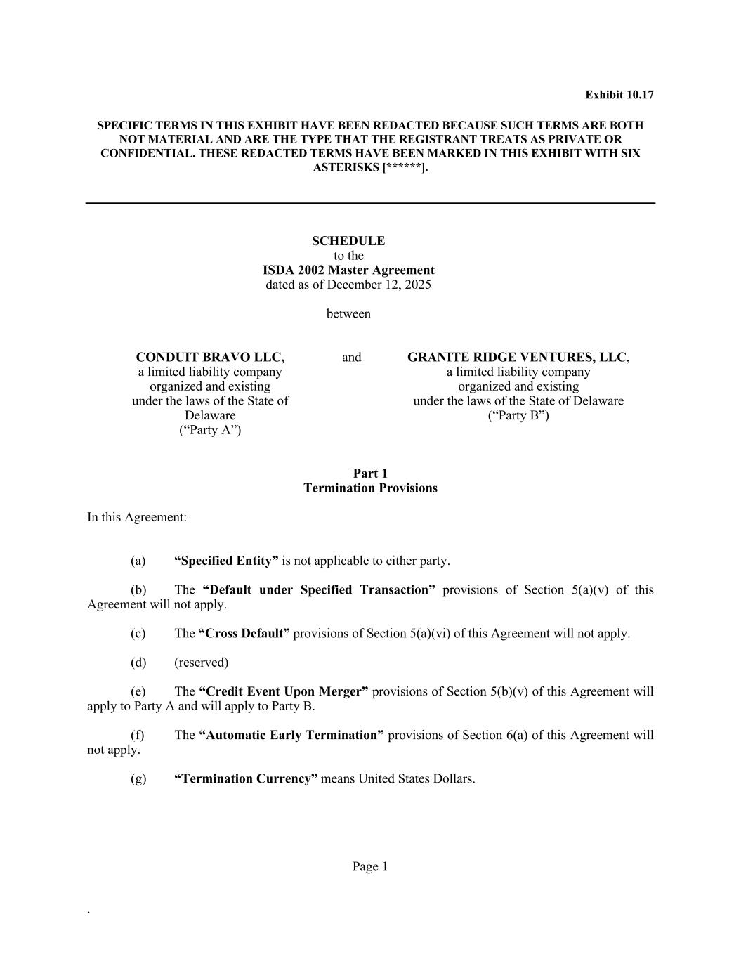
F-43
Page 1 . Exhibit 10.17 SPECIFIC TERMS IN THIS EXHIBIT HAVE BEEN REDACTED BECAUSE SUCH TERMS ARE BOTH NOT MATERIAL AND ARE THE TYPE THAT THE REGISTRANT TREATS AS PRIVATE OR CONFIDENTIAL. THESE REDACTED TERMS HAVE BEEN MARKED IN THIS EXHIBIT WITH SIX ASTERISKS [******]. SCHEDULE to the ISDA 2002 Master Agreement dated as of December 12, 2025 between CONDUIT BRAVO LLC, a limited liability company organized and existing under the laws of the State of Delaware (“Party A”) and GRANITE RIDGE VENTURES, LLC, a limited liability company organized and existing under the laws of the State of Delaware (“Party B”) Part 1 Termination Provisions In this Agreement: (a) “Specified Entity” is not applicable to either party. (b) The “Default under Specified Transaction” provisions of Section 5(a)(v) of this Agreement will not apply. (c) The “Cross Default” provisions of Section 5(a)(vi) of this Agreement will not apply. (d) (reserved) (e) The “Credit Event Upon Merger” provisions of Section 5(b)(v) of this Agreement will apply to Party A and will apply to Party B. (f) The “Automatic Early Termination” provisions of Section 6(a) of this Agreement will not apply. (g) “Termination Currency” means United States Dollars.

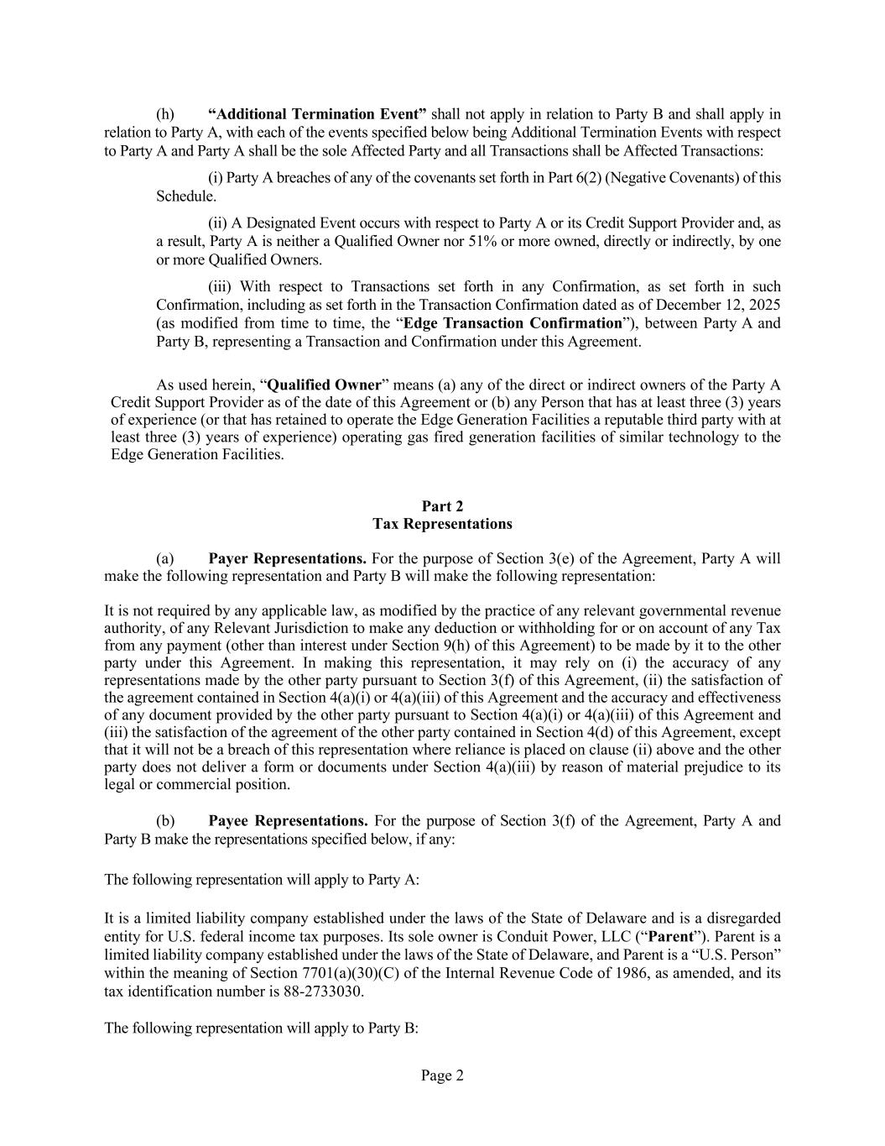
Page 2 (h) “Additional Termination Event” shall not apply in relation to Party B and shall apply in relation to Party A, with each of the events specified below being Additional Termination Events with respect to Party A and Party A shall be the sole Affected Party and all Transactions shall be Affected Transactions: (i) Party A breaches of any of the covenants set forth in Part 6(2) (Negative Covenants) of this Schedule. (ii) A Designated Event occurs with respect to Party A or its Credit Support Provider and, as a result, Party A is neither a Qualified Owner nor 51% or more owned, directly or indirectly, by one or more Qualified Owners. (iii) With respect to Transactions set forth in any Confirmation, as set forth in such Confirmation, including as set forth in the Transaction Confirmation dated as of December 12, 2025 (as modified from time to time, the “Edge Transaction Confirmation”), between Party A and Party B, representing a Transaction and Confirmation under this Agreement. As used herein, “Qualified Owner” means (a) any of the direct or indirect owners of the Party A Credit Support Provider as of the date of this Agreement or (b) any Person that has at least three (3) years of experience (or that has retained to operate the Edge Generation Facilities a reputable third party with at least three (3) years of experience) operating gas fired generation facilities of similar technology to the Edge Generation Facilities. Part 2 Tax Representations (a) Payer Representations. For the purpose of Section 3(e) of the Agreement, Party A will make the following representation and Party B will make the following representation: It is not required by any applicable law, as modified by the practice of any relevant governmental revenue authority, of any Relevant Jurisdiction to make any deduction or withholding for or on account of any Tax from any payment (other than interest under Section 9(h) of this Agreement) to be made by it to the other party under this Agreement. In making this representation, it may rely on (i) the accuracy of any representations made by the other party pursuant to Section 3(f) of this Agreement, (ii) the satisfaction of the agreement contained in Section 4(a)(i) or 4(a)(iii) of this Agreement and the accuracy and effectiveness of any document provided by the other party pursuant to Section 4(a)(i) or 4(a)(iii) of this Agreement and (iii) the satisfaction of the agreement of the other party contained in Section 4(d) of this Agreement, except that it will not be a breach of this representation where reliance is placed on clause (ii) above and the other party does not deliver a form or documents under Section 4(a)(iii) by reason of material prejudice to its legal or commercial position. (b) Payee Representations. For the purpose of Section 3(f) of the Agreement, Party A and Party B make the representations specified below, if any: The following representation will apply to Party A: It is a limited liability company established under the laws of the State of Delaware and is a disregarded entity for U.S. federal income tax purposes. Its sole owner is Conduit Power, LLC (“Parent”). Parent is a limited liability company established under the laws of the State of Delaware, and Parent is a “U.S. Person” within the meaning of Section 7701(a)(30)(C) of the Internal Revenue Code of 1986, as amended, and its tax identification number is 88-2733030. The following representation will apply to Party B:

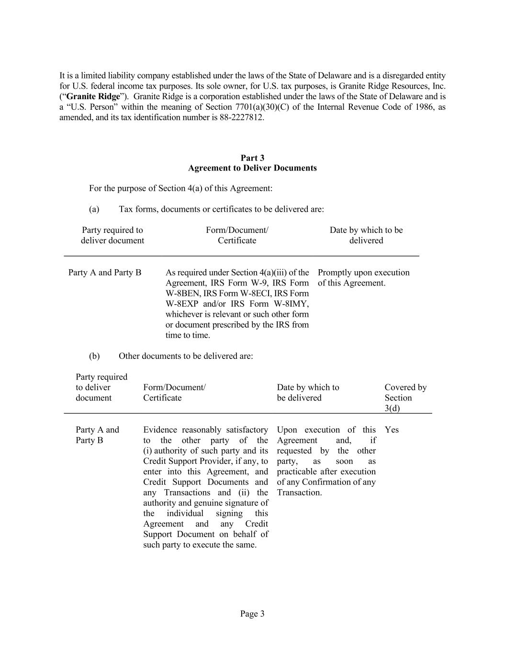
Page 3 It is a limited liability company established under the laws of the State of Delaware and is a disregarded entity for U.S. federal income tax purposes. Its sole owner, for U.S. tax purposes, is Granite Ridge Resources, Inc. (“Granite Ridge”). Granite Ridge is a corporation established under the laws of the State of Delaware and is a “U.S. Person” within the meaning of Section 7701(a)(30)(C) of the Internal Revenue Code of 1986, as amended, and its tax identification number is 88-2227812. Part 3 Agreement to Deliver Documents For the purpose of Section 4(a) of this Agreement: (a) Tax forms, documents or certificates to be delivered are: Party required to deliver document Form/Document/ Certificate Date by which to be delivered Party A and Party B As required under Section 4(a)(iii) of the Agreement, IRS Form W-9, IRS Form W-8BEN, IRS Form W-8ECI, IRS Form W-8EXP and/or IRS Form W-8IMY, whichever is relevant or such other form or document prescribed by the IRS from time to time. Promptly upon execution of this Agreement. (b) Other documents to be delivered are: Party required to deliver document Form/Document/ Certificate Date by which to be delivered Covered by Section 3(d) Party A and Party B Evidence reasonably satisfactory to the other party of the (i) authority of such party and its Credit Support Provider, if any, to enter into this Agreement, and Credit Support Documents and any Transactions and (ii) the authority and genuine signature of the individual signing this Agreement and any Credit Support Document on behalf of such party to execute the same. Upon execution of this Agreement and, if requested by the other party, as soon as practicable after execution of any Confirmation of any Transaction. Yes

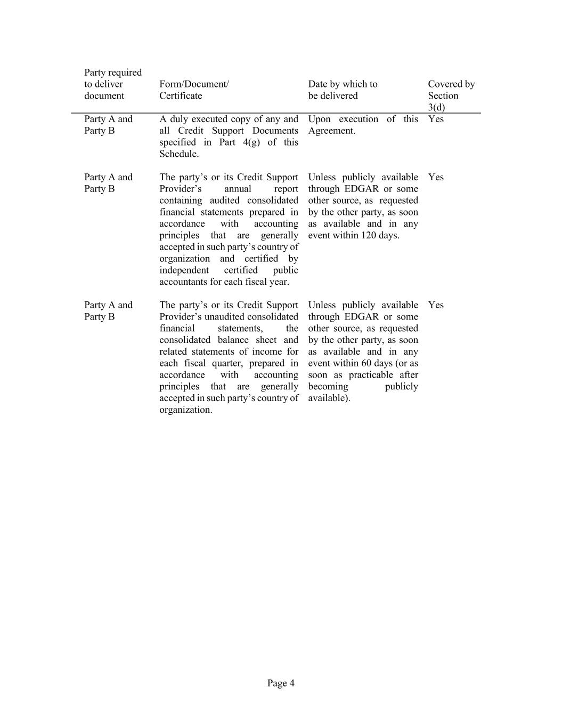
Page 4 Party required to deliver document Form/Document/ Certificate Date by which to be delivered Covered by Section 3(d) Party A and Party B A duly executed copy of any and all Credit Support Documents specified in Part 4(g) of this Schedule. Upon execution of this Agreement. Yes Party A and Party B The party’s or its Credit Support Provider’s annual report containing audited consolidated financial statements prepared in accordance with accounting principles that are generally accepted in such party’s country of organization and certified by independent certified public accountants for each fiscal year. Unless publicly available through EDGAR or some other source, as requested by the other party, as soon as available and in any event within 120 days. Yes Party A and Party B The party’s or its Credit Support Provider’s unaudited consolidated financial statements, the consolidated balance sheet and related statements of income for each fiscal quarter, prepared in accordance with accounting principles that are generally accepted in such party’s country of organization. Unless publicly available through EDGAR or some other source, as requested by the other party, as soon as available and in any event within 60 days (or as soon as practicable after becoming publicly available). Yes

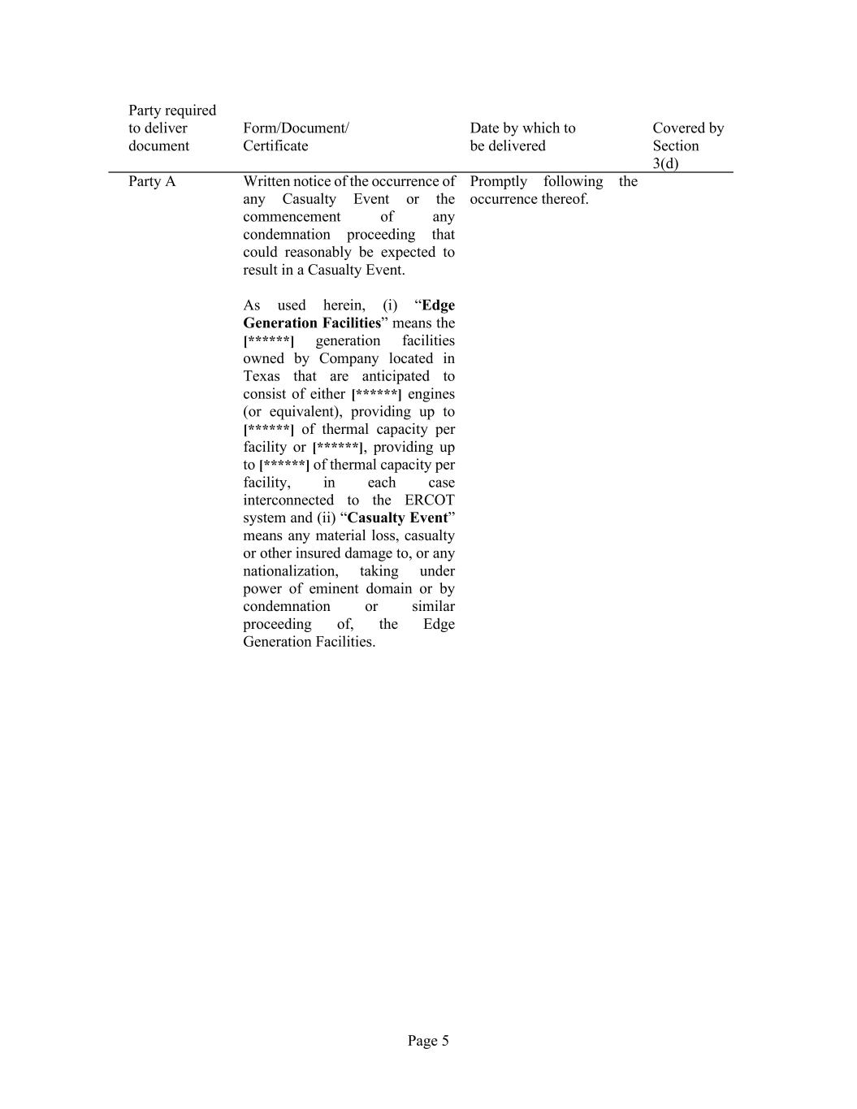
Page 5 Party required to deliver document Form/Document/ Certificate Date by which to be delivered Covered by Section 3(d) Party A Written notice of the occurrence of any Casualty Event or the commencement of any condemnation proceeding that could reasonably be expected to result in a Casualty Event. As used herein, (i) “Edge Generation Facilities” means the [******] generation facilities owned by Company located in Texas that are anticipated to consist of either [******] engines (or equivalent), providing up to [******] of thermal capacity per facility or [******], providing up to [******] of thermal capacity per facility, in each case interconnected to the ERCOT system and (ii) “Casualty Event” means any material loss, casualty or other insured damage to, or any nationalization, taking under power of eminent domain or by condemnation or similar proceeding of, the Edge Generation Facilities. Promptly following the occurrence thereof.

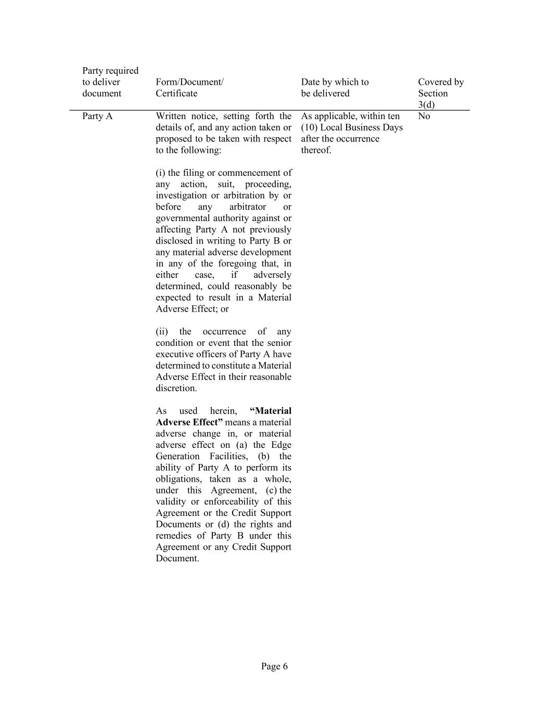
Page 6 Party required to deliver document Form/Document/ Certificate Date by which to be delivered Covered by Section 3(d) Party A Written notice, setting forth the details of, and any action taken or proposed to be taken with respect to the following: (i) the filing or commencement of any action, suit, proceeding, investigation or arbitration by or before any arbitrator or governmental authority against or affecting Party A not previously disclosed in writing to Party B or any material adverse development in any of the foregoing that, in either case, if adversely determined, could reasonably be expected to result in a Material Adverse Effect; or (ii) the occurrence of any condition or event that the senior executive officers of Party A have determined to constitute a Material Adverse Effect in their reasonable discretion. As used herein, “Material Adverse Effect” means a material adverse change in, or material adverse effect on (a) the Edge Generation Facilities, (b) the ability of Party A to perform its obligations, taken as a whole, under this Agreement, (c) the validity or enforceability of this Agreement or the Credit Support Documents or (d) the rights and remedies of Party B under this Agreement or any Credit Support Document. As applicable, within ten (10) Local Business Days after the occurrence thereof. No

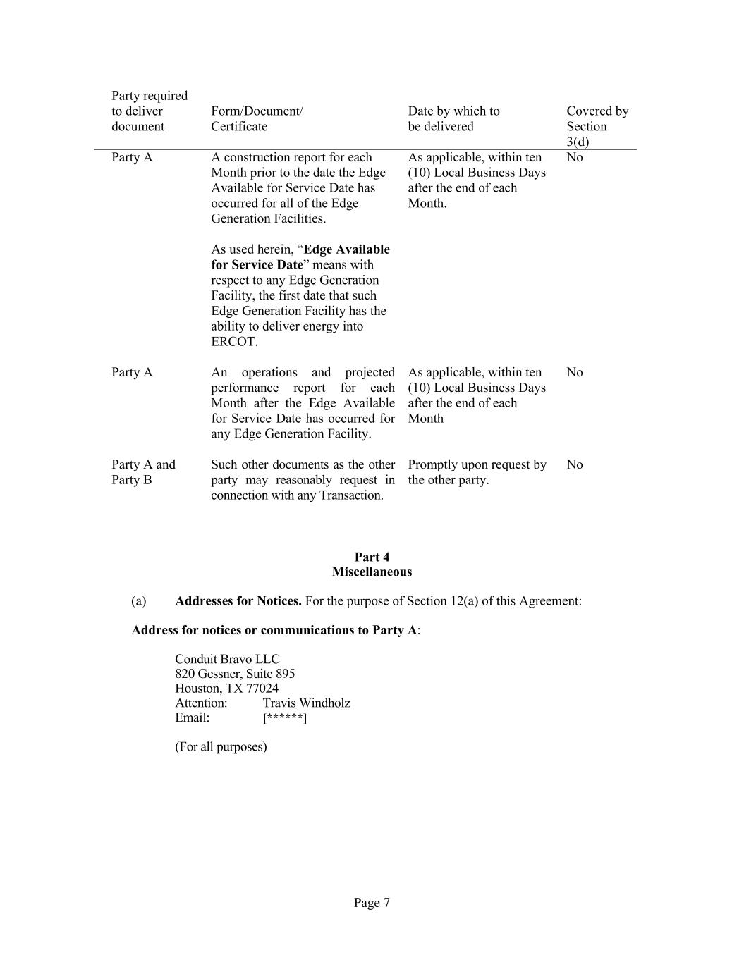
Page 7 Party required to deliver document Form/Document/ Certificate Date by which to be delivered Covered by Section 3(d) Party A A construction report for each Month prior to the date the Edge Available for Service Date has occurred for all of the Edge Generation Facilities. As used herein, “Edge Available for Service Date” means with respect to any Edge Generation Facility, the first date that such Edge Generation Facility has the ability to deliver energy into ERCOT. As applicable, within ten (10) Local Business Days after the end of each Month. No Party A An operations and projected performance report for each Month after the Edge Available for Service Date has occurred for any Edge Generation Facility. As applicable, within ten (10) Local Business Days after the end of each Month No Party A and Party B Such other documents as the other party may reasonably request in connection with any Transaction. Promptly upon request by the other party. No Part 4 Miscellaneous (a) Addresses for Notices. For the purpose of Section 12(a) of this Agreement: Address for notices or communications to Party A: Conduit Bravo LLC 820 Gessner, Suite 895 Houston, TX 77024 Attention: Travis Windholz Email: [******] (For all purposes)

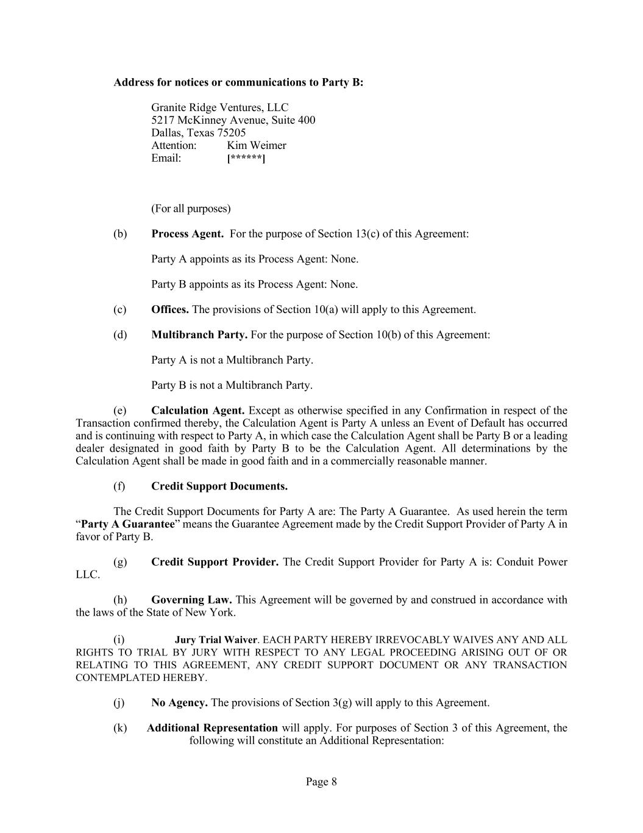
Page 8 Address for notices or communications to Party B: Granite Ridge Ventures, LLC 5217 McKinney Avenue, Suite 400 Dallas, Texas 75205 Attention: Kim Weimer Email: [******] (For all purposes) (b) Process Agent. For the purpose of Section 13(c) of this Agreement: Party A appoints as its Process Agent: None. Party B appoints as its Process Agent: None. (c) Offices. The provisions of Section 10(a) will apply to this Agreement. (d) Multibranch Party. For the purpose of Section 10(b) of this Agreement: Party A is not a Multibranch Party. Party B is not a Multibranch Party. (e) Calculation Agent. Except as otherwise specified in any Confirmation in respect of the Transaction confirmed thereby, the Calculation Agent is Party A unless an Event of Default has occurred and is continuing with respect to Party A, in which case the Calculation Agent shall be Party B or a leading dealer designated in good faith by Party B to be the Calculation Agent. All determinations by the Calculation Agent shall be made in good faith and in a commercially reasonable manner. (f) Credit Support Documents. The Credit Support Documents for Party A are: The Party A Guarantee. As used herein the term “Party A Guarantee” means the Guarantee Agreement made by the Credit Support Provider of Party A in favor of Party B. (g) Credit Support Provider. The Credit Support Provider for Party A is: Conduit Power LLC. (h) Governing Law. This Agreement will be governed by and construed in accordance with the laws of the State of New York. (i) Jury Trial Waiver. EACH PARTY HEREBY IRREVOCABLY WAIVES ANY AND ALL RIGHTS TO TRIAL BY JURY WITH RESPECT TO ANY LEGAL PROCEEDING ARISING OUT OF OR RELATING TO THIS AGREEMENT, ANY CREDIT SUPPORT DOCUMENT OR ANY TRANSACTION CONTEMPLATED HEREBY. (j) No Agency. The provisions of Section 3(g) will apply to this Agreement. (k) Additional Representation will apply. For purposes of Section 3 of this Agreement, the following will constitute an Additional Representation:

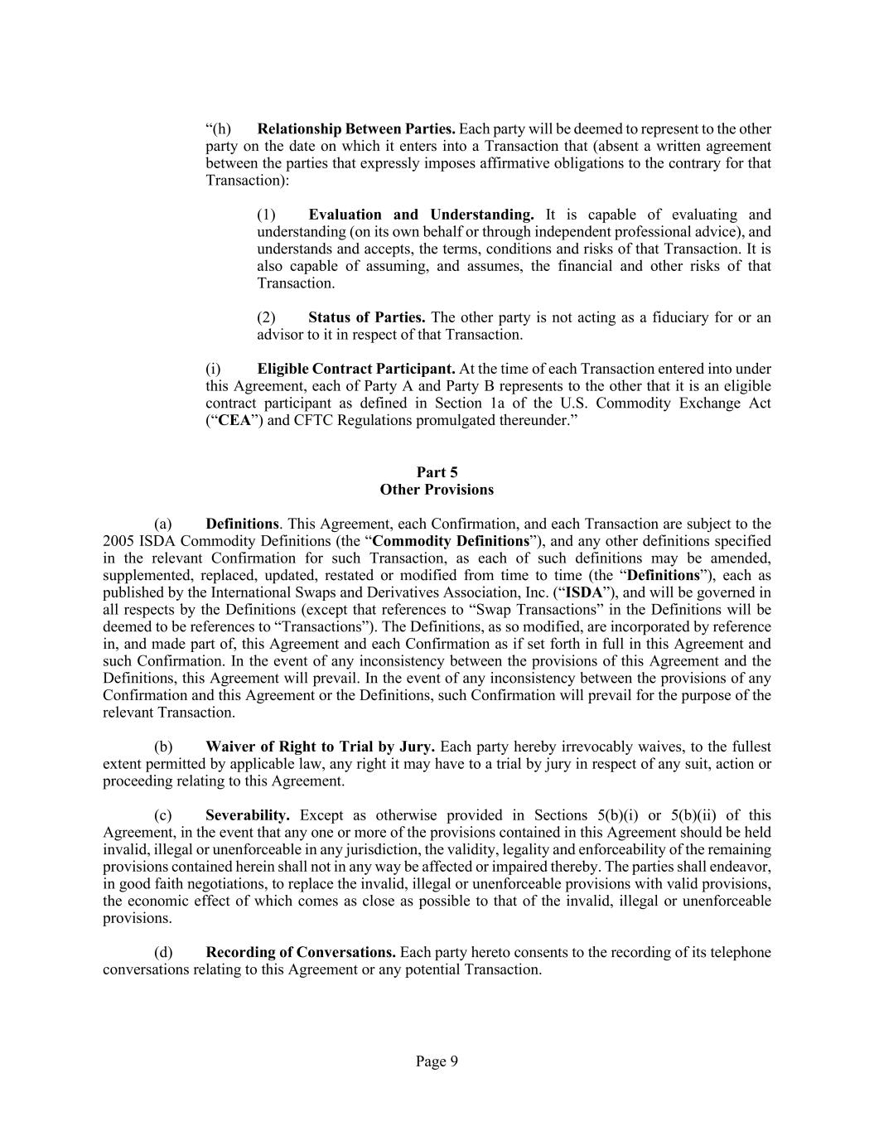
Page 9 “(h) Relationship Between Parties. Each party will be deemed to represent to the other party on the date on which it enters into a Transaction that (absent a written agreement between the parties that expressly imposes affirmative obligations to the contrary for that Transaction): (1) Evaluation and Understanding. It is capable of evaluating and understanding (on its own behalf or through independent professional advice), and understands and accepts, the terms, conditions and risks of that Transaction. It is also capable of assuming, and assumes, the financial and other risks of that Transaction. (2) Status of Parties. The other party is not acting as a fiduciary for or an advisor to it in respect of that Transaction. (i) Eligible Contract Participant. At the time of each Transaction entered into under this Agreement, each of Party A and Party B represents to the other that it is an eligible contract participant as defined in Section 1a of the U.S. Commodity Exchange Act (“CEA”) and CFTC Regulations promulgated thereunder.” Part 5 Other Provisions (a) Definitions. This Agreement, each Confirmation, and each Transaction are subject to the 2005 ISDA Commodity Definitions (the “Commodity Definitions”), and any other definitions specified in the relevant Confirmation for such Transaction, as each of such definitions may be amended, supplemented, replaced, updated, restated or modified from time to time (the “Definitions”), each as published by the International Swaps and Derivatives Association, Inc. (“ISDA”), and will be governed in all respects by the Definitions (except that references to “Swap Transactions” in the Definitions will be deemed to be references to “Transactions”). The Definitions, as so modified, are incorporated by reference in, and made part of, this Agreement and each Confirmation as if set forth in full in this Agreement and such Confirmation. In the event of any inconsistency between the provisions of this Agreement and the Definitions, this Agreement will prevail. In the event of any inconsistency between the provisions of any Confirmation and this Agreement or the Definitions, such Confirmation will prevail for the purpose of the relevant Transaction. (b) Waiver of Right to Trial by Jury. Each party hereby irrevocably waives, to the fullest extent permitted by applicable law, any right it may have to a trial by jury in respect of any suit, action or proceeding relating to this Agreement. (c) Severability. Except as otherwise provided in Sections 5(b)(i) or 5(b)(ii) of this Agreement, in the event that any one or more of the provisions contained in this Agreement should be held invalid, illegal or unenforceable in any jurisdiction, the validity, legality and enforceability of the remaining provisions contained herein shall not in any way be affected or impaired thereby. The parties shall endeavor, in good faith negotiations, to replace the invalid, illegal or unenforceable provisions with valid provisions, the economic effect of which comes as close as possible to that of the invalid, illegal or unenforceable provisions. (d) Recording of Conversations. Each party hereto consents to the recording of its telephone conversations relating to this Agreement or any potential Transaction.

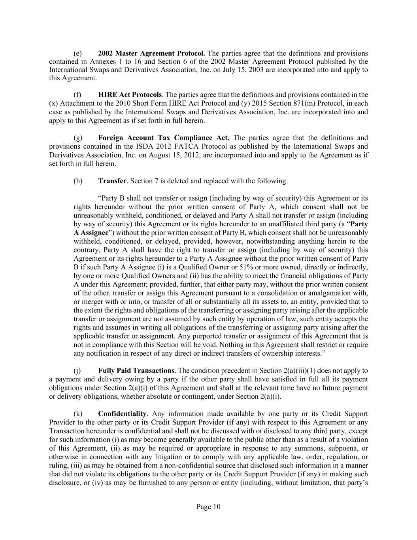
Page 10 (e) 2002 Master Agreement Protocol. The parties agree that the definitions and provisions contained in Annexes 1 to 16 and Section 6 of the 2002 Master Agreement Protocol published by the International Swaps and Derivatives Association, Inc. on July 15, 2003 are incorporated into and apply to this Agreement. (f) HIRE Act Protocols. The parties agree that the definitions and provisions contained in the (x) Attachment to the 2010 Short Form HIRE Act Protocol and (y) 2015 Section 871(m) Protocol, in each case as published by the International Swaps and Derivatives Association, Inc. are incorporated into and apply to this Agreement as if set forth in full herein. (g) Foreign Account Tax Compliance Act. The parties agree that the definitions and provisions contained in the ISDA 2012 FATCA Protocol as published by the International Swaps and Derivatives Association, Inc. on August 15, 2012, are incorporated into and apply to the Agreement as if set forth in full herein. (h) Transfer. Section 7 is deleted and replaced with the following: “Party B shall not transfer or assign (including by way of security) this Agreement or its rights hereunder without the prior written consent of Party A, which consent shall not be unreasonably withheld, conditioned, or delayed and Party A shall not transfer or assign (including by way of security) this Agreement or its rights hereunder to an unaffiliated third party (a “Party A Assignee”) without the prior written consent of Party B, which consent shall not be unreasonably withheld, conditioned, or delayed, provided, however, notwithstanding anything herein to the contrary, Party A shall have the right to transfer or assign (including by way of security) this Agreement or its rights hereunder to a Party A Assignee without the prior written consent of Party B if such Party A Assignee (i) is a Qualified Owner or 51% or more owned, directly or indirectly, by one or more Qualified Owners and (ii) has the ability to meet the financial obligations of Party A under this Agreement; provided, further, that either party may, without the prior written consent of the other, transfer or assign this Agreement pursuant to a consolidation or amalgamation with, or merger with or into, or transfer of all or substantially all its assets to, an entity, provided that to the extent the rights and obligations of the transferring or assigning party arising after the applicable transfer or assignment are not assumed by such entity by operation of law, such entity accepts the rights and assumes in writing all obligations of the transferring or assigning party arising after the applicable transfer or assignment. Any purported transfer or assignment of this Agreement that is not in compliance with this Section will be void. Nothing in this Agreement shall restrict or require any notification in respect of any direct or indirect transfers of ownership interests.” (j) Fully Paid Transactions. The condition precedent in Section 2(a)(iii)(1) does not apply to a payment and delivery owing by a party if the other party shall have satisfied in full all its payment obligations under Section 2(a)(i) of this Agreement and shall at the relevant time have no future payment or delivery obligations, whether absolute or contingent, under Section 2(a)(i). (k) Confidentiality. Any information made available by one party or its Credit Support Provider to the other party or its Credit Support Provider (if any) with respect to this Agreement or any Transaction hereunder is confidential and shall not be discussed with or disclosed to any third party, except for such information (i) as may become generally available to the public other than as a result of a violation of this Agreement, (ii) as may be required or appropriate in response to any summons, subpoena, or otherwise in connection with any litigation or to comply with any applicable law, order, regulation, or ruling, (iii) as may be obtained from a non-confidential source that disclosed such information in a manner that did not violate its obligations to the other party or its Credit Support Provider (if any) in making such disclosure, or (iv) as may be furnished to any person or entity (including, without limitation, that party’s

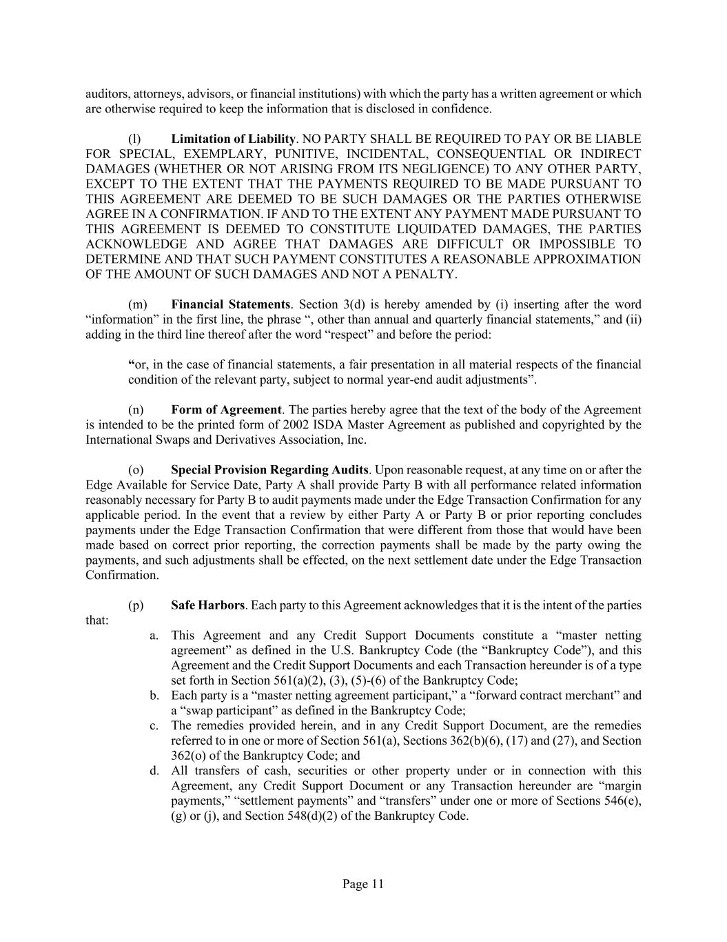
Page 11 auditors, attorneys, advisors, or financial institutions) with which the party has a written agreement or which are otherwise required to keep the information that is disclosed in confidence. (l) Limitation of Liability. NO PARTY SHALL BE REQUIRED TO PAY OR BE LIABLE FOR SPECIAL, EXEMPLARY, PUNITIVE, INCIDENTAL, CONSEQUENTIAL OR INDIRECT DAMAGES (WHETHER OR NOT ARISING FROM ITS NEGLIGENCE) TO ANY OTHER PARTY, EXCEPT TO THE EXTENT THAT THE PAYMENTS REQUIRED TO BE MADE PURSUANT TO THIS AGREEMENT ARE DEEMED TO BE SUCH DAMAGES OR THE PARTIES OTHERWISE AGREE IN A CONFIRMATION. IF AND TO THE EXTENT ANY PAYMENT MADE PURSUANT TO THIS AGREEMENT IS DEEMED TO CONSTITUTE LIQUIDATED DAMAGES, THE PARTIES ACKNOWLEDGE AND AGREE THAT DAMAGES ARE DIFFICULT OR IMPOSSIBLE TO DETERMINE AND THAT SUCH PAYMENT CONSTITUTES A REASONABLE APPROXIMATION OF THE AMOUNT OF SUCH DAMAGES AND NOT A PENALTY. (m) Financial Statements. Section 3(d) is hereby amended by (i) inserting after the word “information” in the first line, the phrase “, other than annual and quarterly financial statements,” and (ii) adding in the third line thereof after the word “respect” and before the period: “or, in the case of financial statements, a fair presentation in all material respects of the financial condition of the relevant party, subject to normal year-end audit adjustments”. (n) Form of Agreement. The parties hereby agree that the text of the body of the Agreement is intended to be the printed form of 2002 ISDA Master Agreement as published and copyrighted by the International Swaps and Derivatives Association, Inc. (o) Special Provision Regarding Audits. Upon reasonable request, at any time on or after the Edge Available for Service Date, Party A shall provide Party B with all performance related information reasonably necessary for Party B to audit payments made under the Edge Transaction Confirmation for any applicable period. In the event that a review by either Party A or Party B or prior reporting concludes payments under the Edge Transaction Confirmation that were different from those that would have been made based on correct prior reporting, the correction payments shall be made by the party owing the payments, and such adjustments shall be effected, on the next settlement date under the Edge Transaction Confirmation. (p) Safe Harbors. Each party to this Agreement acknowledges that it is the intent of the parties that: a. This Agreement and any Credit Support Documents constitute a “master netting agreement” as defined in the U.S. Bankruptcy Code (the “Bankruptcy Code”), and this Agreement and the Credit Support Documents and each Transaction hereunder is of a type set forth in Section 561(a)(2), (3), (5)-(6) of the Bankruptcy Code; b. Each party is a “master netting agreement participant,” a “forward contract merchant” and a “swap participant” as defined in the Bankruptcy Code; c. The remedies provided herein, and in any Credit Support Document, are the remedies referred to in one or more of Section 561(a), Sections 362(b)(6), (17) and (27), and Section 362(o) of the Bankruptcy Code; and d. All transfers of cash, securities or other property under or in connection with this Agreement, any Credit Support Document or any Transaction hereunder are “margin payments,” “settlement payments” and “transfers” under one or more of Sections 546(e), (g) or (j), and Section 548(d)(2) of the Bankruptcy Code.

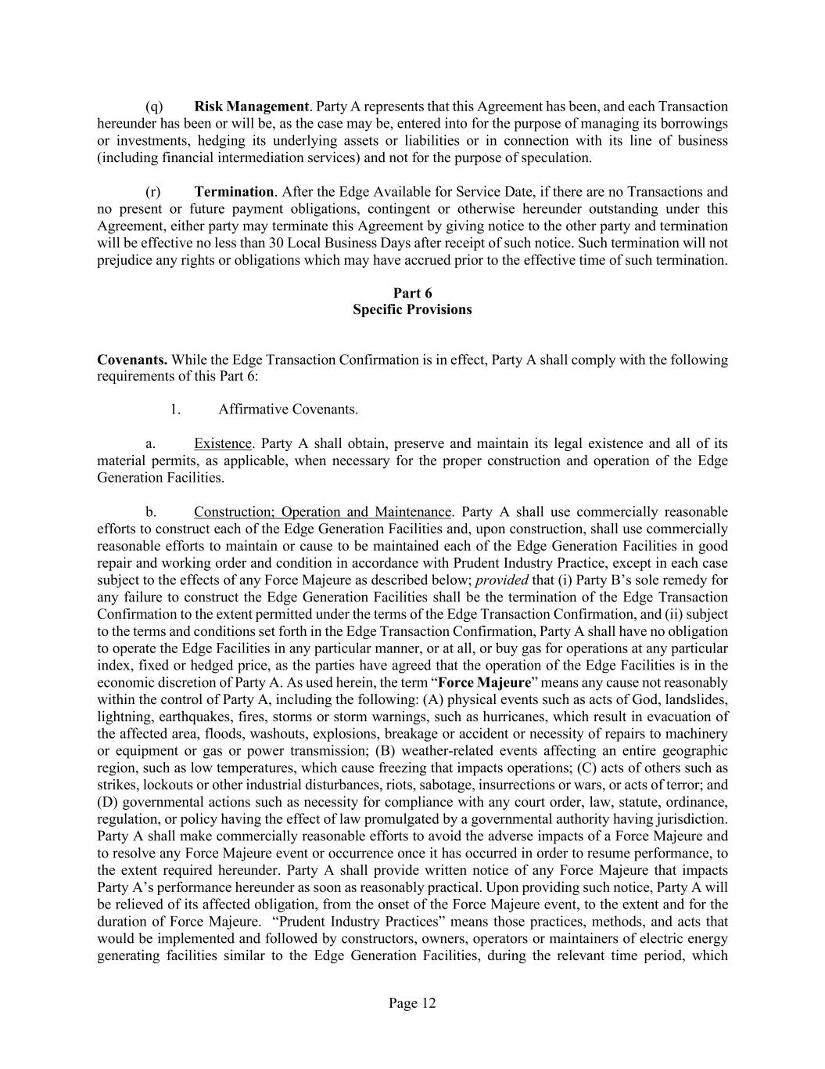
Page 12 (q) Risk Management. Party A represents that this Agreement has been, and each Transaction hereunder has been or will be, as the case may be, entered into for the purpose of managing its borrowings or investments, hedging its underlying assets or liabilities or in connection with its line of business (including financial intermediation services) and not for the purpose of speculation. (r) Termination. After the Edge Available for Service Date, if there are no Transactions and no present or future payment obligations, contingent or otherwise hereunder outstanding under this Agreement, either party may terminate this Agreement by giving notice to the other party and termination will be effective no less than 30 Local Business Days after receipt of such notice. Such termination will not prejudice any rights or obligations which may have accrued prior to the effective time of such termination. Part 6 Specific Provisions Covenants. While the Edge Transaction Confirmation is in effect, Party A shall comply with the following requirements of this Part 6: 1. Affirmative Covenants. a. Existence. Party A shall obtain, preserve and maintain its legal existence and all of its material permits, as applicable, when necessary for the proper construction and operation of the Edge Generation Facilities. b. Construction; Operation and Maintenance. Party A shall use commercially reasonable efforts to construct each of the Edge Generation Facilities and, upon construction, shall use commercially reasonable efforts to maintain or cause to be maintained each of the Edge Generation Facilities in good repair and working order and condition in accordance with Prudent Industry Practice, except in each case subject to the effects of any Force Majeure as described below; provided that (i) Party B’s sole remedy for any failure to construct the Edge Generation Facilities shall be the termination of the Edge Transaction Confirmation to the extent permitted under the terms of the Edge Transaction Confirmation, and (ii) subject to the terms and conditions set forth in the Edge Transaction Confirmation, Party A shall have no obligation to operate the Edge Facilities in any particular manner, or at all, or buy gas for operations at any particular index, fixed or hedged price, as the parties have agreed that the operation of the Edge Facilities is in the economic discretion of Party A. As used herein, the term “Force Majeure” means any cause not reasonably within the control of Party A, including the following: (A) physical events such as acts of God, landslides, lightning, earthquakes, fires, storms or storm warnings, such as hurricanes, which result in evacuation of the affected area, floods, washouts, explosions, breakage or accident or necessity of repairs to machinery or equipment or gas or power transmission; (B) weather-related events affecting an entire geographic region, such as low temperatures, which cause freezing that impacts operations; (C) acts of others such as strikes, lockouts or other industrial disturbances, riots, sabotage, insurrections or wars, or acts of terror; and (D) governmental actions such as necessity for compliance with any court order, law, statute, ordinance, regulation, or policy having the effect of law promulgated by a governmental authority having jurisdiction. Party A shall make commercially reasonable efforts to avoid the adverse impacts of a Force Majeure and to resolve any Force Majeure event or occurrence once it has occurred in order to resume performance, to the extent required hereunder. Party A shall provide written notice of any Force Majeure that impacts Party A’s performance hereunder as soon as reasonably practical. Upon providing such notice, Party A will be relieved of its affected obligation, from the onset of the Force Majeure event, to the extent and for the duration of Force Majeure. “Prudent Industry Practices” means those practices, methods, and acts that would be implemented and followed by constructors, owners, operators or maintainers of electric energy generating facilities similar to the Edge Generation Facilities, during the relevant time period, which

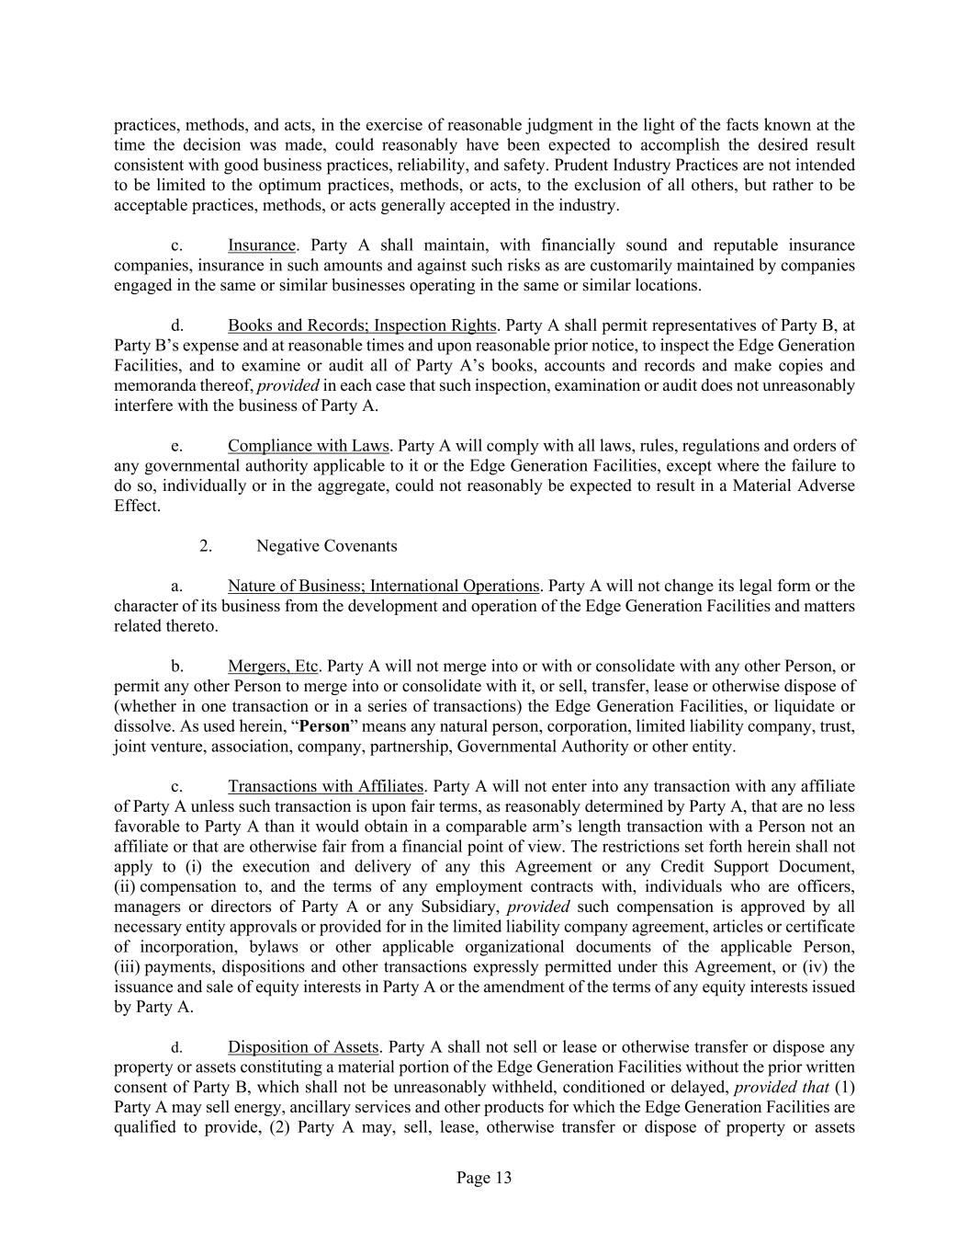
Page 13 practices, methods, and acts, in the exercise of reasonable judgment in the light of the facts known at the time the decision was made, could reasonably have been expected to accomplish the desired result consistent with good business practices, reliability, and safety. Prudent Industry Practices are not intended to be limited to the optimum practices, methods, or acts, to the exclusion of all others, but rather to be acceptable practices, methods, or acts generally accepted in the industry. c. Insurance. Party A shall maintain, with financially sound and reputable insurance companies, insurance in such amounts and against such risks as are customarily maintained by companies engaged in the same or similar businesses operating in the same or similar locations. d. Books and Records; Inspection Rights. Party A shall permit representatives of Party B, at Party B’s expense and at reasonable times and upon reasonable prior notice, to inspect the Edge Generation Facilities, and to examine or audit all of Party A’s books, accounts and records and make copies and memoranda thereof, provided in each case that such inspection, examination or audit does not unreasonably interfere with the business of Party A. e. Compliance with Laws. Party A will comply with all laws, rules, regulations and orders of any governmental authority applicable to it or the Edge Generation Facilities, except where the failure to do so, individually or in the aggregate, could not reasonably be expected to result in a Material Adverse Effect. 2. Negative Covenants a. Nature of Business; International Operations. Party A will not change its legal form or the character of its business from the development and operation of the Edge Generation Facilities and matters related thereto. b. Mergers, Etc. Party A will not merge into or with or consolidate with any other Person, or permit any other Person to merge into or consolidate with it, or sell, transfer, lease or otherwise dispose of (whether in one transaction or in a series of transactions) the Edge Generation Facilities, or liquidate or dissolve. As used herein, “Person” means any natural person, corporation, limited liability company, trust, joint venture, association, company, partnership, Governmental Authority or other entity. c. Transactions with Affiliates. Party A will not enter into any transaction with any affiliate of Party A unless such transaction is upon fair terms, as reasonably determined by Party A, that are no less favorable to Party A than it would obtain in a comparable arm’s length transaction with a Person not an affiliate or that are otherwise fair from a financial point of view. The restrictions set forth herein shall not apply to (i) the execution and delivery of any this Agreement or any Credit Support Document, (ii) compensation to, and the terms of any employment contracts with, individuals who are officers, managers or directors of Party A or any Subsidiary, provided such compensation is approved by all necessary entity approvals or provided for in the limited liability company agreement, articles or certificate of incorporation, bylaws or other applicable organizational documents of the applicable Person, (iii) payments, dispositions and other transactions expressly permitted under this Agreement, or (iv) the issuance and sale of equity interests in Party A or the amendment of the terms of any equity interests issued by Party A. d. Disposition of Assets. Party A shall not sell or lease or otherwise transfer or dispose any property or assets constituting a material portion of the Edge Generation Facilities without the prior written consent of Party B, which shall not be unreasonably withheld, conditioned or delayed, provided that (1) Party A may sell energy, ancillary services and other products for which the Edge Generation Facilities are qualified to provide, (2) Party A may, sell, lease, otherwise transfer or dispose of property or assets

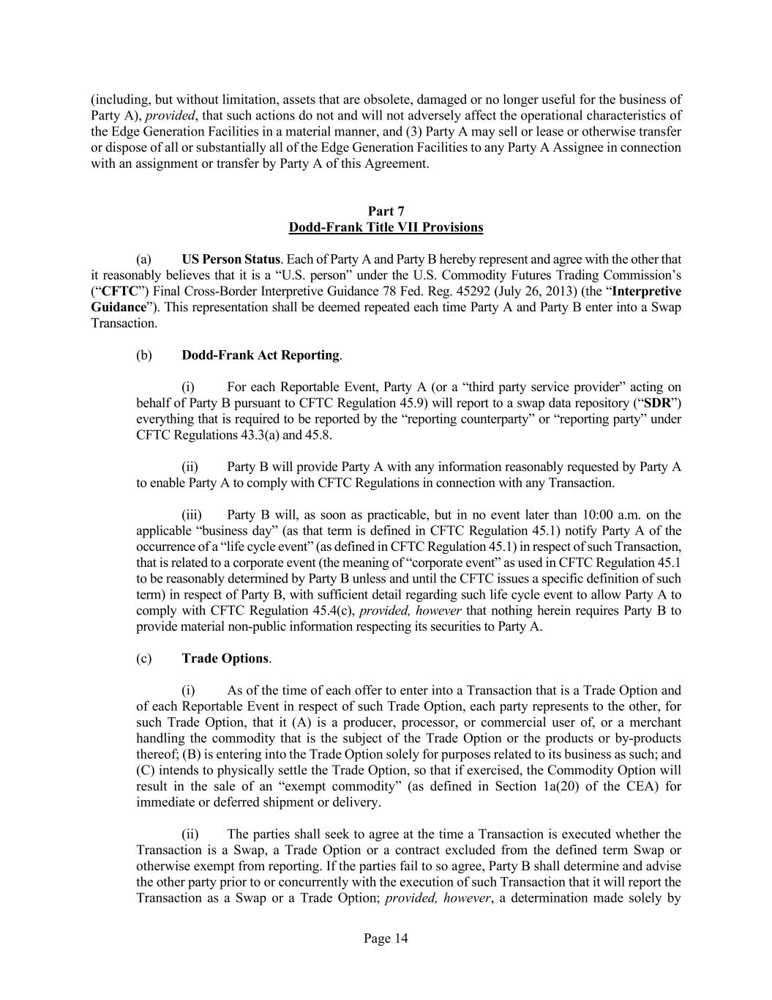
Page 14 (including, but without limitation, assets that are obsolete, damaged or no longer useful for the business of Party A), provided, that such actions do not and will not adversely affect the operational characteristics of the Edge Generation Facilities in a material manner, and (3) Party A may sell or lease or otherwise transfer or dispose of all or substantially all of the Edge Generation Facilities to any Party A Assignee in connection with an assignment or transfer by Party A of this Agreement. Part 7 Dodd-Frank Title VII Provisions (a) US Person Status. Each of Party A and Party B hereby represent and agree with the other that it reasonably believes that it is a “U.S. person” under the U.S. Commodity Futures Trading Commission’s (“CFTC”) Final Cross-Border Interpretive Guidance 78 Fed. Reg. 45292 (July 26, 2013) (the “Interpretive Guidance”). This representation shall be deemed repeated each time Party A and Party B enter into a Swap Transaction. (b) Dodd-Frank Act Reporting. (i) For each Reportable Event, Party A (or a “third party service provider” acting on behalf of Party B pursuant to CFTC Regulation 45.9) will report to a swap data repository (“SDR”) everything that is required to be reported by the “reporting counterparty” or “reporting party” under CFTC Regulations 43.3(a) and 45.8. (ii) Party B will provide Party A with any information reasonably requested by Party A to enable Party A to comply with CFTC Regulations in connection with any Transaction. (iii) Party B will, as soon as practicable, but in no event later than 10:00 a.m. on the applicable “business day” (as that term is defined in CFTC Regulation 45.1) notify Party A of the occurrence of a “life cycle event” (as defined in CFTC Regulation 45.1) in respect of such Transaction, that is related to a corporate event (the meaning of “corporate event” as used in CFTC Regulation 45.1 to be reasonably determined by Party B unless and until the CFTC issues a specific definition of such term) in respect of Party B, with sufficient detail regarding such life cycle event to allow Party A to comply with CFTC Regulation 45.4(c), provided, however that nothing herein requires Party B to provide material non-public information respecting its securities to Party A. (c) Trade Options. (i) As of the time of each offer to enter into a Transaction that is a Trade Option and of each Reportable Event in respect of such Trade Option, each party represents to the other, for such Trade Option, that it (A) is a producer, processor, or commercial user of, or a merchant handling the commodity that is the subject of the Trade Option or the products or by-products thereof; (B) is entering into the Trade Option solely for purposes related to its business as such; and (C) intends to physically settle the Trade Option, so that if exercised, the Commodity Option will result in the sale of an “exempt commodity” (as defined in Section 1a(20) of the CEA) for immediate or deferred shipment or delivery. (ii) The parties shall seek to agree at the time a Transaction is executed whether the Transaction is a Swap, a Trade Option or a contract excluded from the defined term Swap or otherwise exempt from reporting. If the parties fail to so agree, Party B shall determine and advise the other party prior to or concurrently with the execution of such Transaction that it will report the Transaction as a Swap or a Trade Option; provided, however, a determination made solely by

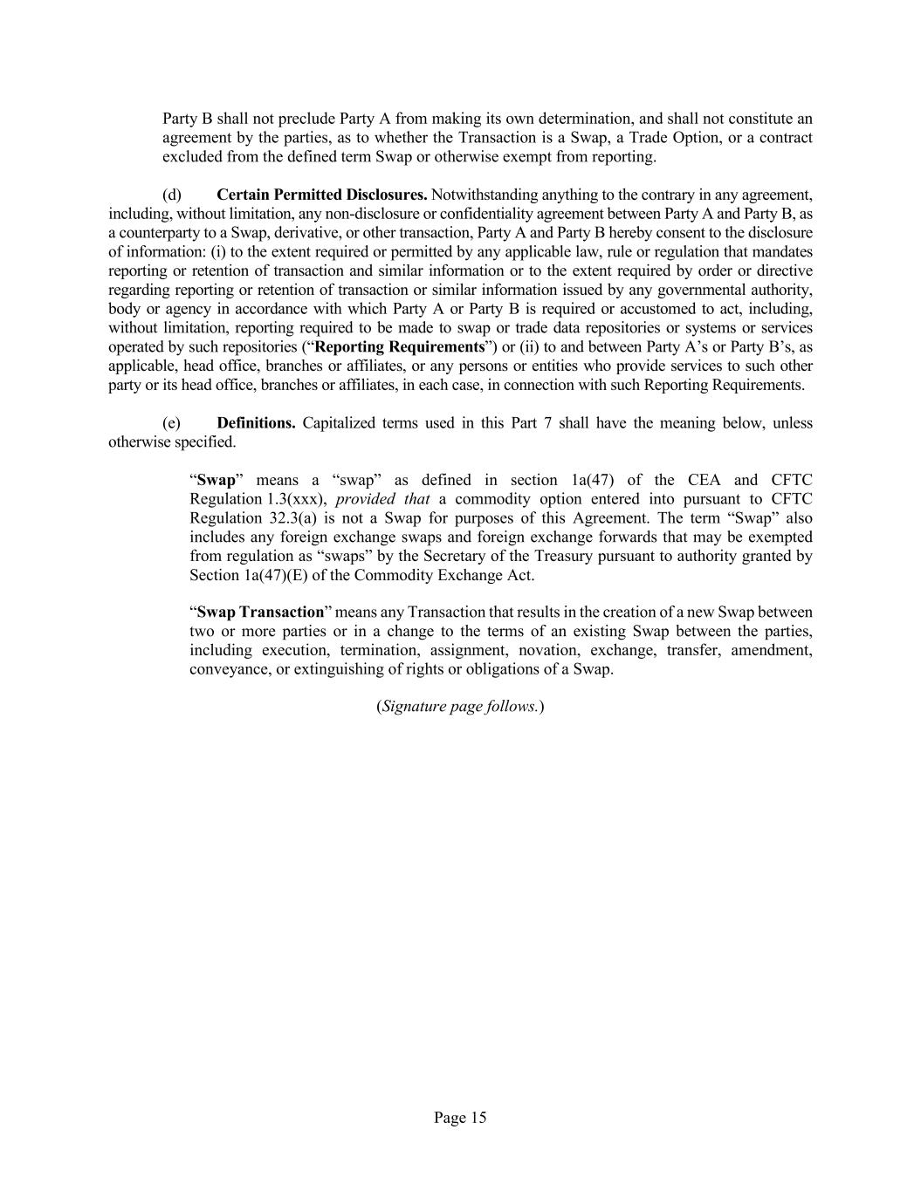
Page 15 Party B shall not preclude Party A from making its own determination, and shall not constitute an agreement by the parties, as to whether the Transaction is a Swap, a Trade Option, or a contract excluded from the defined term Swap or otherwise exempt from reporting. (d) Certain Permitted Disclosures. Notwithstanding anything to the contrary in any agreement, including, without limitation, any non-disclosure or confidentiality agreement between Party A and Party B, as a counterparty to a Swap, derivative, or other transaction, Party A and Party B hereby consent to the disclosure of information: (i) to the extent required or permitted by any applicable law, rule or regulation that mandates reporting or retention of transaction and similar information or to the extent required by order or directive regarding reporting or retention of transaction or similar information issued by any governmental authority, body or agency in accordance with which Party A or Party B is required or accustomed to act, including, without limitation, reporting required to be made to swap or trade data repositories or systems or services operated by such repositories (“Reporting Requirements”) or (ii) to and between Party A’s or Party B’s, as applicable, head office, branches or affiliates, or any persons or entities who provide services to such other party or its head office, branches or affiliates, in each case, in connection with such Reporting Requirements. (e) Definitions. Capitalized terms used in this Part 7 shall have the meaning below, unless otherwise specified. “Swap” means a “swap” as defined in section 1a(47) of the CEA and CFTC Regulation 1.3(xxx), provided that a commodity option entered into pursuant to CFTC Regulation 32.3(a) is not a Swap for purposes of this Agreement. The term “Swap” also includes any foreign exchange swaps and foreign exchange forwards that may be exempted from regulation as “swaps” by the Secretary of the Treasury pursuant to authority granted by Section 1a(47)(E) of the Commodity Exchange Act. “Swap Transaction” means any Transaction that results in the creation of a new Swap between two or more parties or in a change to the terms of an existing Swap between the parties, including execution, termination, assignment, novation, exchange, transfer, amendment, conveyance, or extinguishing of rights or obligations of a Swap. (Signature page follows.)

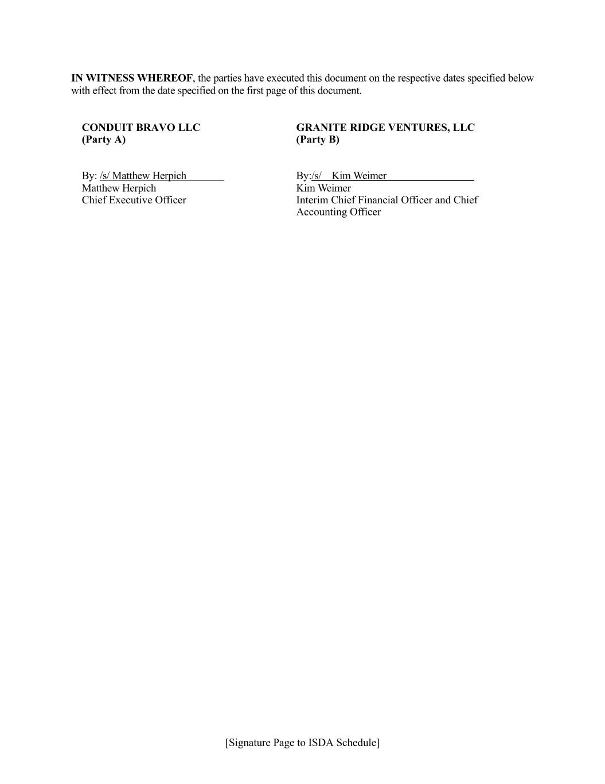
[Signature Page to ISDA Schedule] IN WITNESS WHEREOF, the parties have executed this document on the respective dates specified below with effect from the date specified on the first page of this document. CONDUIT BRAVO LLC (Party A) By: /s/ Matthew Herpich Matthew Herpich Chief Executive Officer GRANITE RIDGE VENTURES, LLC (Party B) By:/s/ Kim Weimer Kim Weimer Interim Chief Financial Officer and Chief Accounting Officer

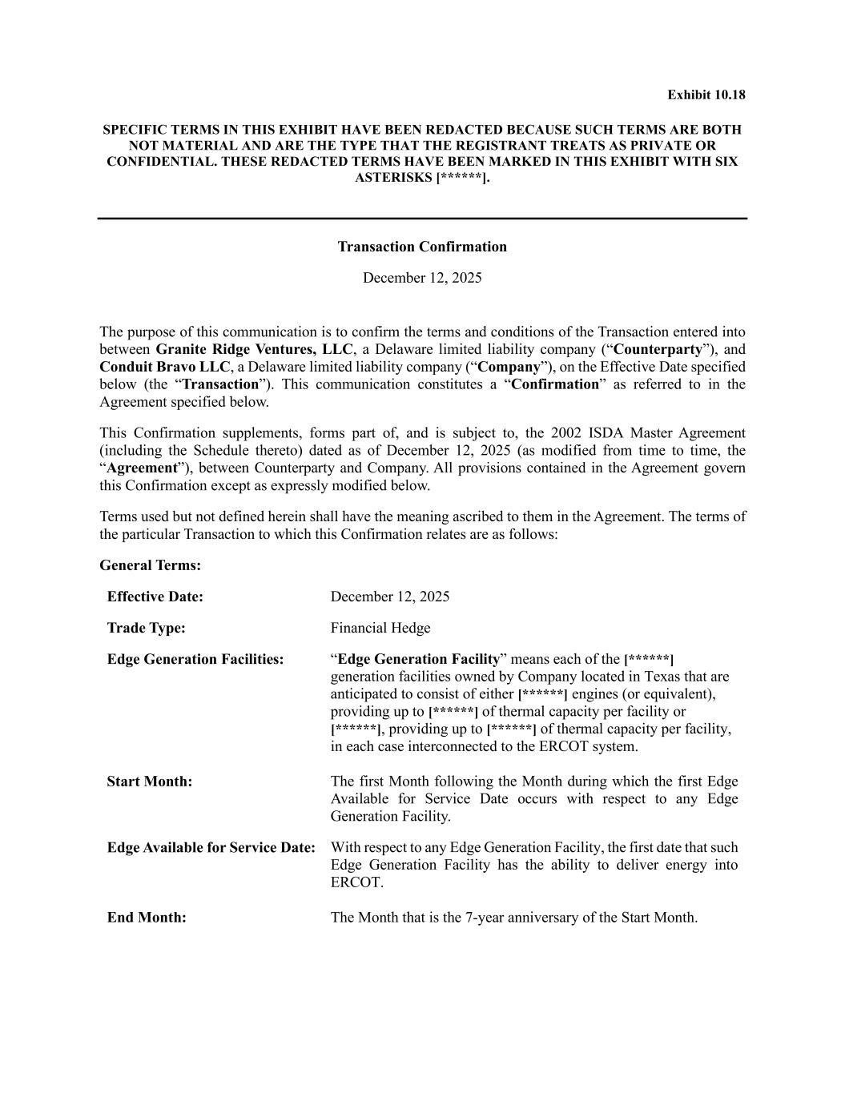
Exhibit 10.18 SPECIFIC TERMS IN THIS EXHIBIT HAVE BEEN REDACTED BECAUSE SUCH TERMS ARE BOTH NOT MATERIAL AND ARE THE TYPE THAT THE REGISTRANT TREATS AS PRIVATE OR CONFIDENTIAL. THESE REDACTED TERMS HAVE BEEN MARKED IN THIS EXHIBIT WITH SIX ASTERISKS [******]. Transaction Confirmation December 12, 2025 The purpose of this communication is to confirm the terms and conditions of the Transaction entered into between Granite Ridge Ventures, LLC, a Delaware limited liability company (“Counterparty”), and Conduit Bravo LLC, a Delaware limited liability company (“Company”), on the Effective Date specified below (the “Transaction”). This communication constitutes a “Confirmation” as referred to in the Agreement specified below. This Confirmation supplements, forms part of, and is subject to, the 2002 ISDA Master Agreement (including the Schedule thereto) dated as of December 12, 2025 (as modified from time to time, the “Agreement”), between Counterparty and Company. All provisions contained in the Agreement govern this Confirmation except as expressly modified below. Terms used but not defined herein shall have the meaning ascribed to them in the Agreement. The terms of the particular Transaction to which this Confirmation relates are as follows: General Terms: Effective Date: December 12, 2025 Trade Type: Financial Hedge Edge Generation Facilities: “Edge Generation Facility” means each of the [******] generation facilities owned by Company located in Texas that are anticipated to consist of either [******] engines (or equivalent), providing up to [******] of thermal capacity per facility or [******], providing up to [******] of thermal capacity per facility, in each case interconnected to the ERCOT system. Start Month: The first Month following the Month during which the first Edge Available for Service Date occurs with respect to any Edge Generation Facility. Edge Available for Service Date: With respect to any Edge Generation Facility, the first date that such Edge Generation Facility has the ability to deliver energy into ERCOT. End Month: The Month that is the 7-year anniversary of the Start Month.

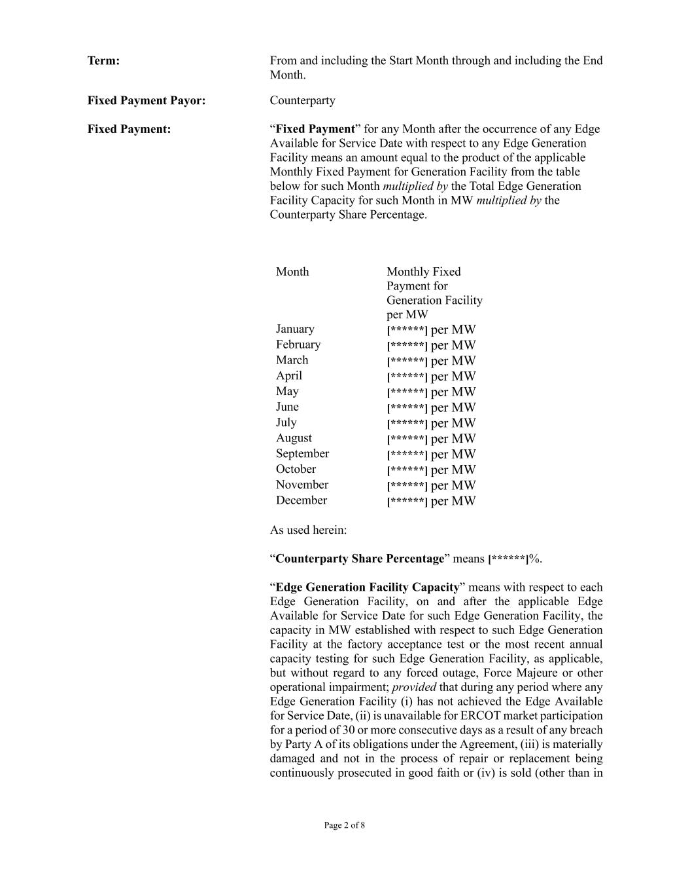
Page 2 of 8 Term: From and including the Start Month through and including the End Month. Fixed Payment Payor: Counterparty Fixed Payment: “Fixed Payment” for any Month after the occurrence of any Edge Available for Service Date with respect to any Edge Generation Facility means an amount equal to the product of the applicable Monthly Fixed Payment for Generation Facility from the table below for such Month multiplied by the Total Edge Generation Facility Capacity for such Month in MW multiplied by the Counterparty Share Percentage. Month Monthly Fixed Payment for Generation Facility per MW January [******] per MW February [******] per MW March [******] per MW April [******] per MW May [******] per MW June [******] per MW July [******] per MW August [******] per MW September [******] per MW October [******] per MW November [******] per MW December [******] per MW As used herein: “Counterparty Share Percentage” means [******]%. “Edge Generation Facility Capacity” means with respect to each Edge Generation Facility, on and after the applicable Edge Available for Service Date for such Edge Generation Facility, the capacity in MW established with respect to such Edge Generation Facility at the factory acceptance test or the most recent annual capacity testing for such Edge Generation Facility, as applicable, but without regard to any forced outage, Force Majeure or other operational impairment; provided that during any period where any Edge Generation Facility (i) has not achieved the Edge Available for Service Date, (ii) is unavailable for ERCOT market participation for a period of 30 or more consecutive days as a result of any breach by Party A of its obligations under the Agreement, (iii) is materially damaged and not in the process of repair or replacement being continuously prosecuted in good faith or (iv) is sold (other than in

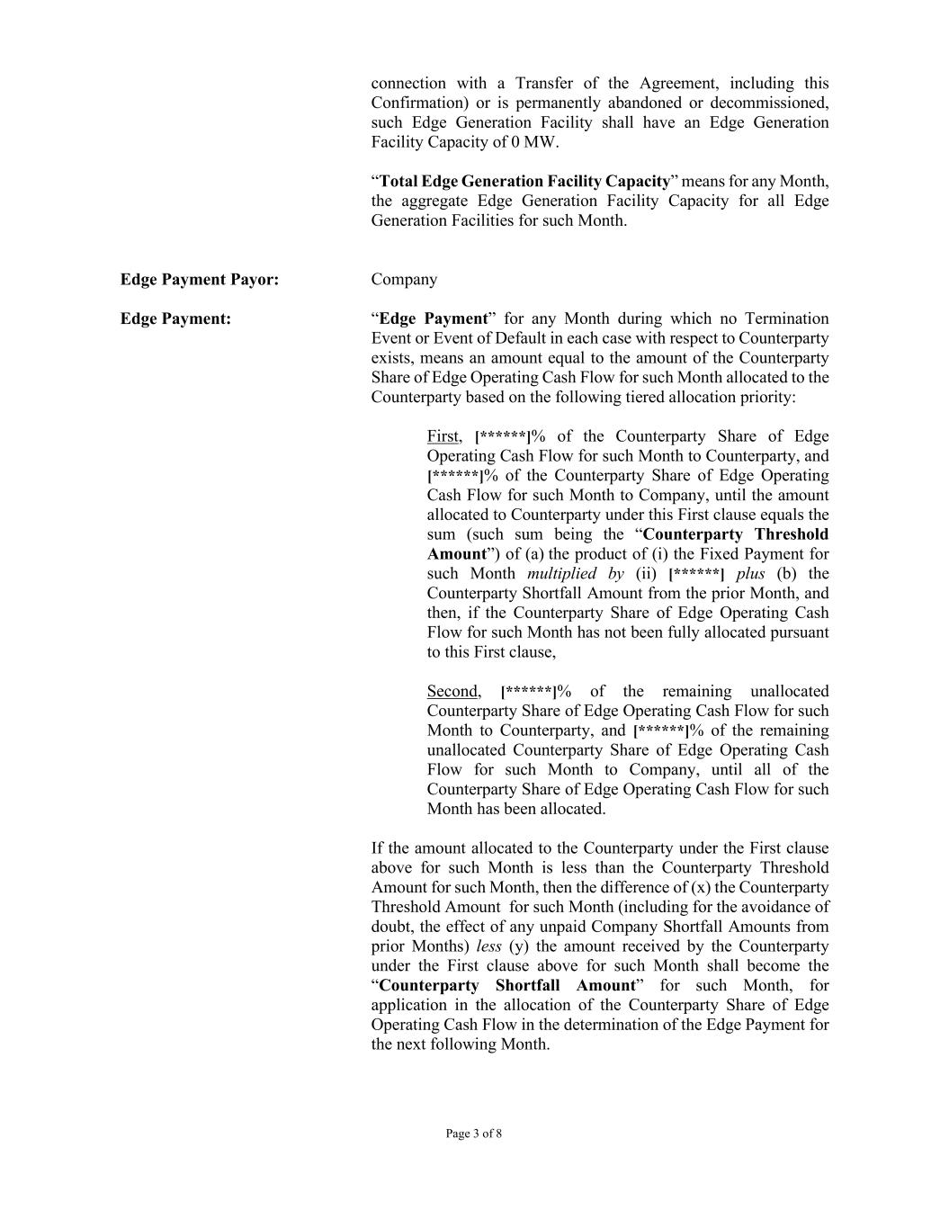
Page 3 of 8 connection with a Transfer of the Agreement, including this Confirmation) or is permanently abandoned or decommissioned, such Edge Generation Facility shall have an Edge Generation Facility Capacity of 0 MW. “Total Edge Generation Facility Capacity” means for any Month, the aggregate Edge Generation Facility Capacity for all Edge Generation Facilities for such Month. Edge Payment Payor: Company Edge Payment: “Edge Payment” for any Month during which no Termination Event or Event of Default in each case with respect to Counterparty exists, means an amount equal to the amount of the Counterparty Share of Edge Operating Cash Flow for such Month allocated to the Counterparty based on the following tiered allocation priority: First, [******]% of the Counterparty Share of Edge Operating Cash Flow for such Month to Counterparty, and [******]% of the Counterparty Share of Edge Operating Cash Flow for such Month to Company, until the amount allocated to Counterparty under this First clause equals the sum (such sum being the “Counterparty Threshold Amount”) of (a) the product of (i) the Fixed Payment for such Month multiplied by (ii) [******] plus (b) the Counterparty Shortfall Amount from the prior Month, and then, if the Counterparty Share of Edge Operating Cash Flow for such Month has not been fully allocated pursuant to this First clause, Second, [******]% of the remaining unallocated Counterparty Share of Edge Operating Cash Flow for such Month to Counterparty, and [******]% of the remaining unallocated Counterparty Share of Edge Operating Cash Flow for such Month to Company, until all of the Counterparty Share of Edge Operating Cash Flow for such Month has been allocated. If the amount allocated to the Counterparty under the First clause above for such Month is less than the Counterparty Threshold Amount for such Month, then the difference of (x) the Counterparty Threshold Amount for such Month (including for the avoidance of doubt, the effect of any unpaid Company Shortfall Amounts from prior Months) less (y) the amount received by the Counterparty under the First clause above for such Month shall become the “Counterparty Shortfall Amount” for such Month, for application in the allocation of the Counterparty Share of Edge Operating Cash Flow in the determination of the Edge Payment for the next following Month.

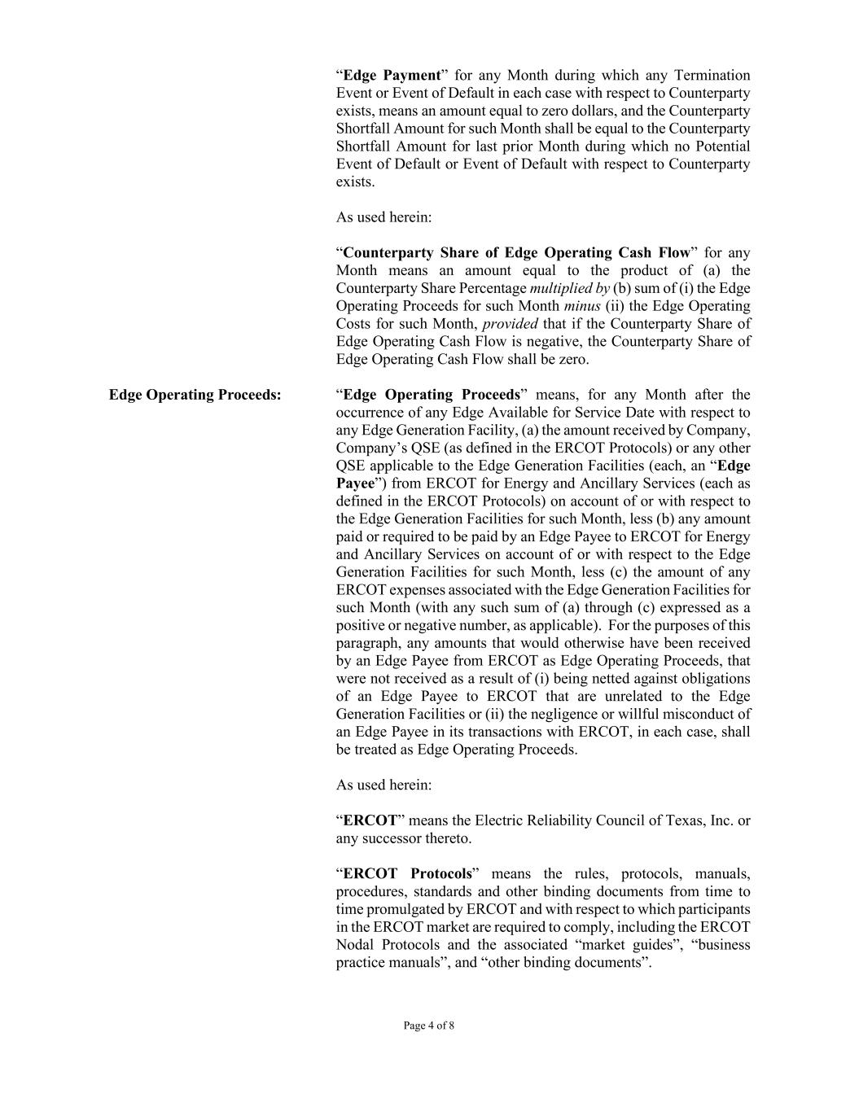
Page 4 of 8 “Edge Payment” for any Month during which any Termination Event or Event of Default in each case with respect to Counterparty exists, means an amount equal to zero dollars, and the Counterparty Shortfall Amount for such Month shall be equal to the Counterparty Shortfall Amount for last prior Month during which no Potential Event of Default or Event of Default with respect to Counterparty exists. As used herein: “Counterparty Share of Edge Operating Cash Flow” for any Month means an amount equal to the product of (a) the Counterparty Share Percentage multiplied by (b) sum of (i) the Edge Operating Proceeds for such Month minus (ii) the Edge Operating Costs for such Month, provided that if the Counterparty Share of Edge Operating Cash Flow is negative, the Counterparty Share of Edge Operating Cash Flow shall be zero. Edge Operating Proceeds: “Edge Operating Proceeds” means, for any Month after the occurrence of any Edge Available for Service Date with respect to any Edge Generation Facility, (a) the amount received by Company, Company’s QSE (as defined in the ERCOT Protocols) or any other QSE applicable to the Edge Generation Facilities (each, an “Edge Payee”) from ERCOT for Energy and Ancillary Services (each as defined in the ERCOT Protocols) on account of or with respect to the Edge Generation Facilities for such Month, less (b) any amount paid or required to be paid by an Edge Payee to ERCOT for Energy and Ancillary Services on account of or with respect to the Edge Generation Facilities for such Month, less (c) the amount of any ERCOT expenses associated with the Edge Generation Facilities for such Month (with any such sum of (a) through (c) expressed as a positive or negative number, as applicable). For the purposes of this paragraph, any amounts that would otherwise have been received by an Edge Payee from ERCOT as Edge Operating Proceeds, that were not received as a result of (i) being netted against obligations of an Edge Payee to ERCOT that are unrelated to the Edge Generation Facilities or (ii) the negligence or willful misconduct of an Edge Payee in its transactions with ERCOT, in each case, shall be treated as Edge Operating Proceeds. As used herein: “ERCOT” means the Electric Reliability Council of Texas, Inc. or any successor thereto. “ERCOT Protocols” means the rules, protocols, manuals, procedures, standards and other binding documents from time to time promulgated by ERCOT and with respect to which participants in the ERCOT market are required to comply, including the ERCOT Nodal Protocols and the associated “market guides”, “business practice manuals”, and “other binding documents”.

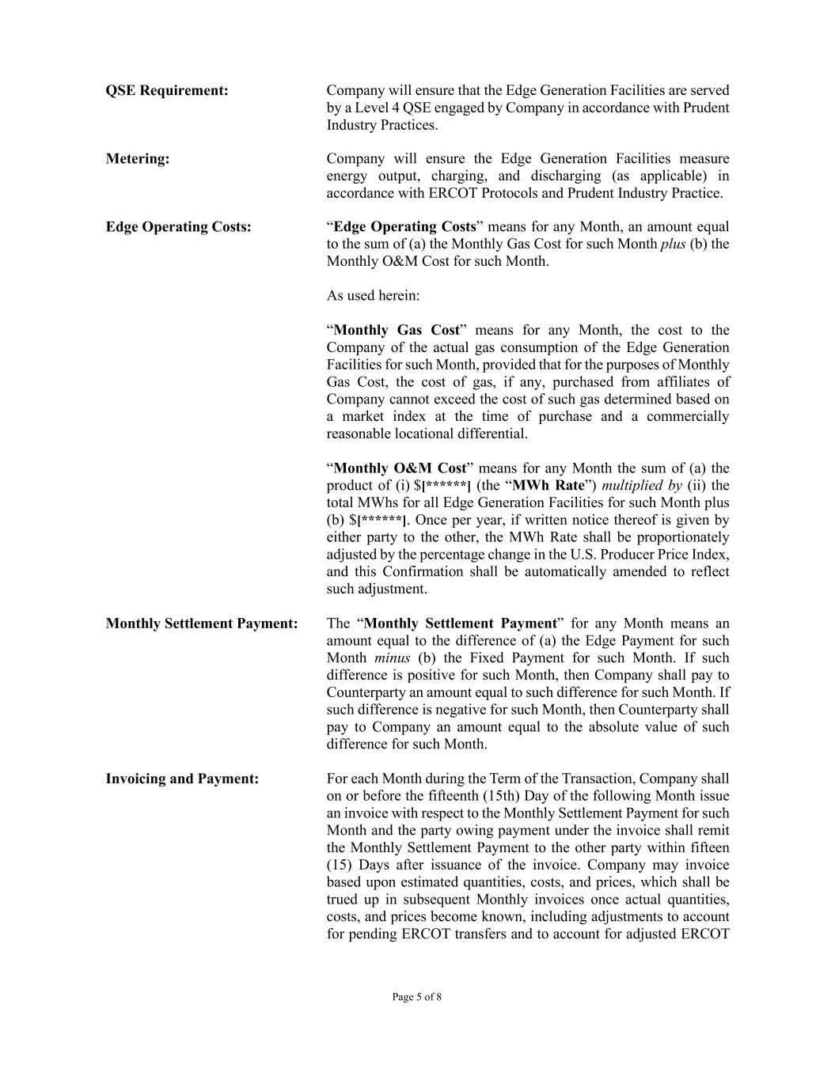
Page 5 of 8 QSE Requirement: Company will ensure that the Edge Generation Facilities are served by a Level 4 QSE engaged by Company in accordance with Prudent Industry Practices. Metering: Company will ensure the Edge Generation Facilities measure energy output, charging, and discharging (as applicable) in accordance with ERCOT Protocols and Prudent Industry Practice. Edge Operating Costs: “Edge Operating Costs” means for any Month, an amount equal to the sum of (a) the Monthly Gas Cost for such Month plus (b) the Monthly O&M Cost for such Month. As used herein: “Monthly Gas Cost” means for any Month, the cost to the Company of the actual gas consumption of the Edge Generation Facilities for such Month, provided that for the purposes of Monthly Gas Cost, the cost of gas, if any, purchased from affiliates of Company cannot exceed the cost of such gas determined based on a market index at the time of purchase and a commercially reasonable locational differential. “Monthly O&M Cost” means for any Month the sum of (a) the product of (i) $[******] (the “MWh Rate”) multiplied by (ii) the total MWhs for all Edge Generation Facilities for such Month plus (b) $[******]. Once per year, if written notice thereof is given by either party to the other, the MWh Rate shall be proportionately adjusted by the percentage change in the U.S. Producer Price Index, and this Confirmation shall be automatically amended to reflect such adjustment. Monthly Settlement Payment: The “Monthly Settlement Payment” for any Month means an amount equal to the difference of (a) the Edge Payment for such Month minus (b) the Fixed Payment for such Month. If such difference is positive for such Month, then Company shall pay to Counterparty an amount equal to such difference for such Month. If such difference is negative for such Month, then Counterparty shall pay to Company an amount equal to the absolute value of such difference for such Month. Invoicing and Payment: For each Month during the Term of the Transaction, Company shall on or before the fifteenth (15th) Day of the following Month issue an invoice with respect to the Monthly Settlement Payment for such Month and the party owing payment under the invoice shall remit the Monthly Settlement Payment to the other party within fifteen (15) Days after issuance of the invoice. Company may invoice based upon estimated quantities, costs, and prices, which shall be trued up in subsequent Monthly invoices once actual quantities, costs, and prices become known, including adjustments to account for pending ERCOT transfers and to account for adjusted ERCOT

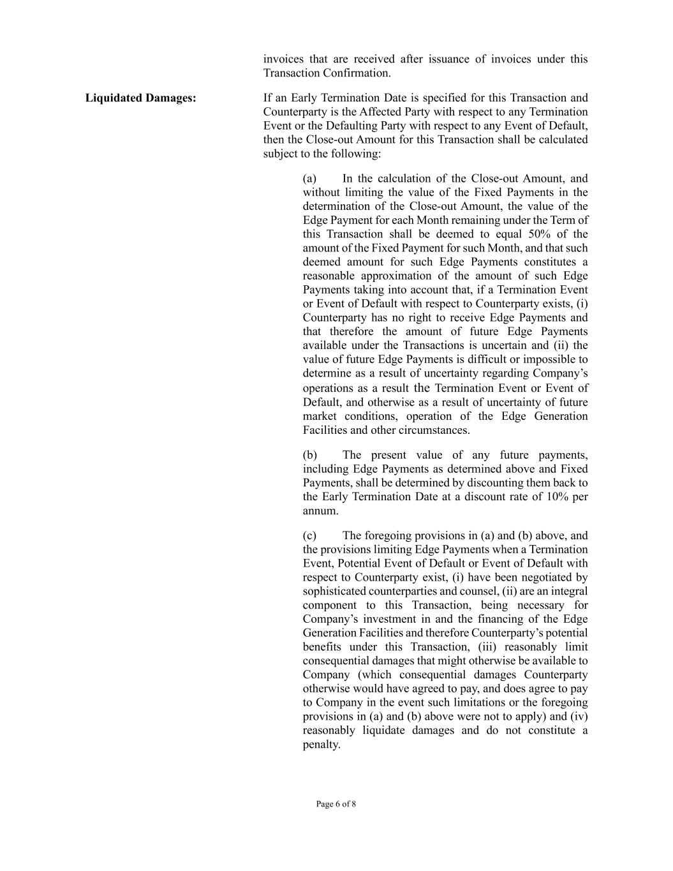
Page 6 of 8 invoices that are received after issuance of invoices under this Transaction Confirmation. Liquidated Damages: If an Early Termination Date is specified for this Transaction and Counterparty is the Affected Party with respect to any Termination Event or the Defaulting Party with respect to any Event of Default, then the Close-out Amount for this Transaction shall be calculated subject to the following: (a) In the calculation of the Close-out Amount, and without limiting the value of the Fixed Payments in the determination of the Close-out Amount, the value of the Edge Payment for each Month remaining under the Term of this Transaction shall be deemed to equal 50% of the amount of the Fixed Payment for such Month, and that such deemed amount for such Edge Payments constitutes a reasonable approximation of the amount of such Edge Payments taking into account that, if a Termination Event or Event of Default with respect to Counterparty exists, (i) Counterparty has no right to receive Edge Payments and that therefore the amount of future Edge Payments available under the Transactions is uncertain and (ii) the value of future Edge Payments is difficult or impossible to determine as a result of uncertainty regarding Company’s operations as a result the Termination Event or Event of Default, and otherwise as a result of uncertainty of future market conditions, operation of the Edge Generation Facilities and other circumstances. (b) The present value of any future payments, including Edge Payments as determined above and Fixed Payments, shall be determined by discounting them back to the Early Termination Date at a discount rate of 10% per annum. (c) The foregoing provisions in (a) and (b) above, and the provisions limiting Edge Payments when a Termination Event, Potential Event of Default or Event of Default with respect to Counterparty exist, (i) have been negotiated by sophisticated counterparties and counsel, (ii) are an integral component to this Transaction, being necessary for Company’s investment in and the financing of the Edge Generation Facilities and therefore Counterparty’s potential benefits under this Transaction, (iii) reasonably limit consequential damages that might otherwise be available to Company (which consequential damages Counterparty otherwise would have agreed to pay, and does agree to pay to Company in the event such limitations or the foregoing provisions in (a) and (b) above were not to apply) and (iv) reasonably liquidate damages and do not constitute a penalty.

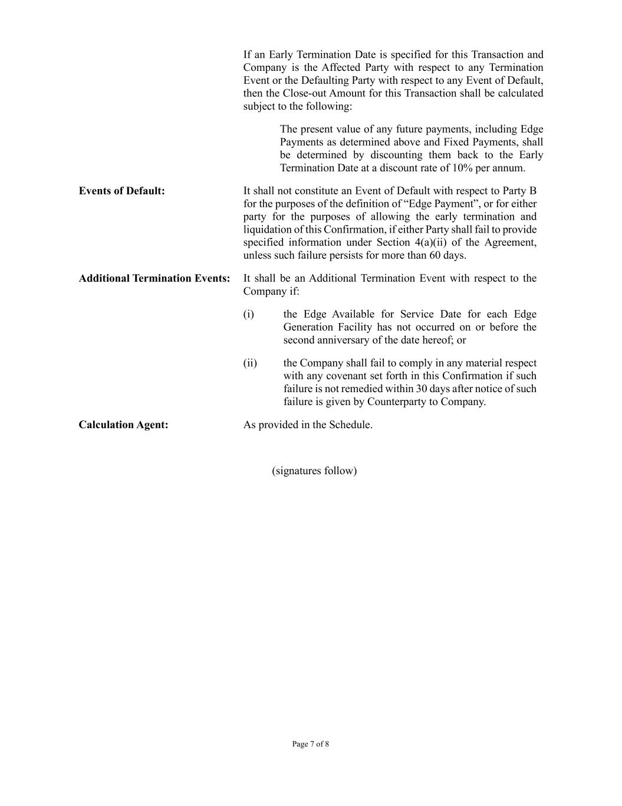
Page 7 of 8 If an Early Termination Date is specified for this Transaction and Company is the Affected Party with respect to any Termination Event or the Defaulting Party with respect to any Event of Default, then the Close-out Amount for this Transaction shall be calculated subject to the following: The present value of any future payments, including Edge Payments as determined above and Fixed Payments, shall be determined by discounting them back to the Early Termination Date at a discount rate of 10% per annum. Events of Default: It shall not constitute an Event of Default with respect to Party B for the purposes of the definition of “Edge Payment”, or for either party for the purposes of allowing the early termination and liquidation of this Confirmation, if either Party shall fail to provide specified information under Section 4(a)(ii) of the Agreement, unless such failure persists for more than 60 days. Additional Termination Events: It shall be an Additional Termination Event with respect to the Company if: (i) the Edge Available for Service Date for each Edge Generation Facility has not occurred on or before the second anniversary of the date hereof; or (ii) the Company shall fail to comply in any material respect with any covenant set forth in this Confirmation if such failure is not remedied within 30 days after notice of such failure is given by Counterparty to Company. Calculation Agent: As provided in the Schedule. (signatures follow)

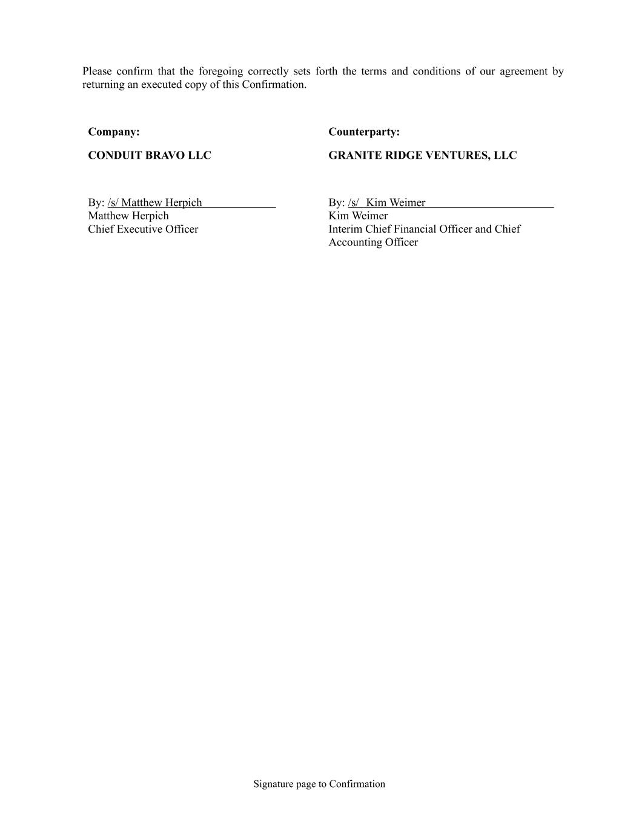
Signature page to Confirmation Please confirm that the foregoing correctly sets forth the terms and conditions of our agreement by returning an executed copy of this Confirmation. Company: Counterparty: CONDUIT BRAVO LLC By: /s/ Matthew Herpich Matthew Herpich Chief Executive Officer GRANITE RIDGE VENTURES, LLC By: /s/ Kim Weimer Kim Weimer Interim Chief Financial Officer and Chief Accounting Officer

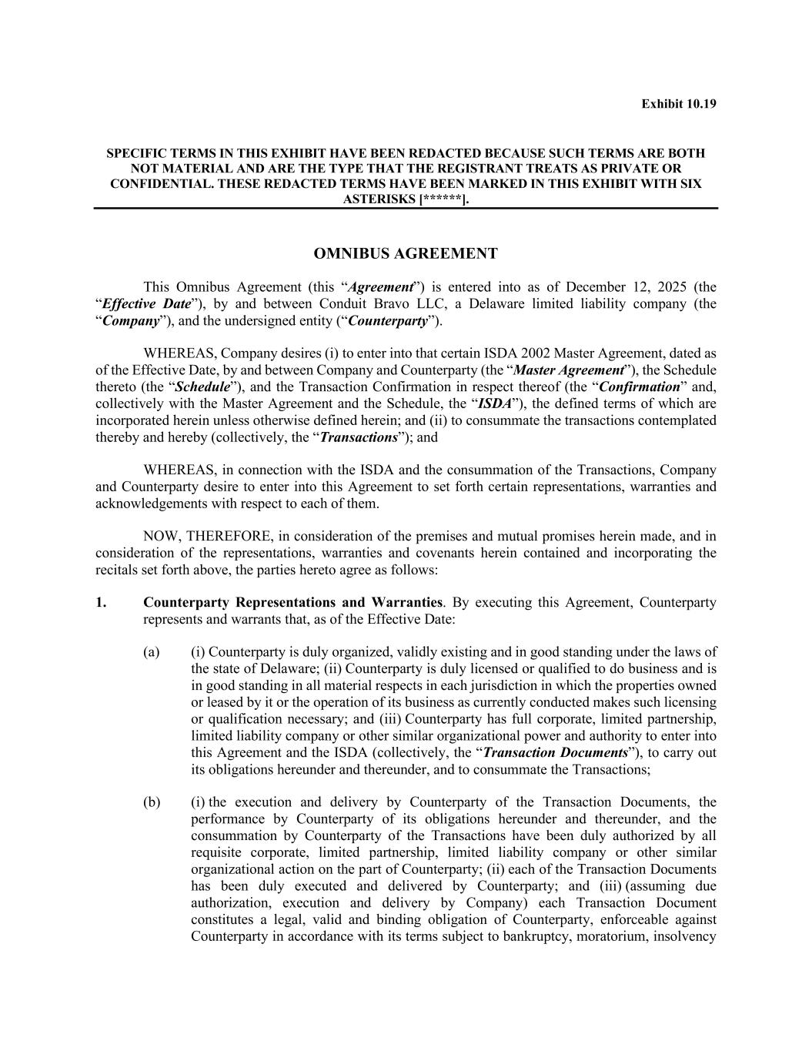
Exhibit 10.19 SPECIFIC TERMS IN THIS EXHIBIT HAVE BEEN REDACTED BECAUSE SUCH TERMS ARE BOTH NOT MATERIAL AND ARE THE TYPE THAT THE REGISTRANT TREATS AS PRIVATE OR CONFIDENTIAL. THESE REDACTED TERMS HAVE BEEN MARKED IN THIS EXHIBIT WITH SIX ASTERISKS [******]. OMNIBUS AGREEMENT This Omnibus Agreement (this “Agreement”) is entered into as of December 12, 2025 (the “Effective Date”), by and between Conduit Bravo LLC, a Delaware limited liability company (the “Company”), and the undersigned entity (“Counterparty”). WHEREAS, Company desires (i) to enter into that certain ISDA 2002 Master Agreement, dated as of the Effective Date, by and between Company and Counterparty (the “Master Agreement”), the Schedule thereto (the “Schedule”), and the Transaction Confirmation in respect thereof (the “Confirmation” and, collectively with the Master Agreement and the Schedule, the “ISDA”), the defined terms of which are incorporated herein unless otherwise defined herein; and (ii) to consummate the transactions contemplated thereby and hereby (collectively, the “Transactions”); and WHEREAS, in connection with the ISDA and the consummation of the Transactions, Company and Counterparty desire to enter into this Agreement to set forth certain representations, warranties and acknowledgements with respect to each of them. NOW, THEREFORE, in consideration of the premises and mutual promises herein made, and in consideration of the representations, warranties and covenants herein contained and incorporating the recitals set forth above, the parties hereto agree as follows: 1. Counterparty Representations and Warranties. By executing this Agreement, Counterparty represents and warrants that, as of the Effective Date: (a) (i) Counterparty is duly organized, validly existing and in good standing under the laws of the state of Delaware; (ii) Counterparty is duly licensed or qualified to do business and is in good standing in all material respects in each jurisdiction in which the properties owned or leased by it or the operation of its business as currently conducted makes such licensing or qualification necessary; and (iii) Counterparty has full corporate, limited partnership, limited liability company or other similar organizational power and authority to enter into this Agreement and the ISDA (collectively, the “Transaction Documents”), to carry out its obligations hereunder and thereunder, and to consummate the Transactions; (b) (i) the execution and delivery by Counterparty of the Transaction Documents, the performance by Counterparty of its obligations hereunder and thereunder, and the consummation by Counterparty of the Transactions have been duly authorized by all requisite corporate, limited partnership, limited liability company or other similar organizational action on the part of Counterparty; (ii) each of the Transaction Documents has been duly executed and delivered by Counterparty; and (iii) (assuming due authorization, execution and delivery by Company) each Transaction Document constitutes a legal, valid and binding obligation of Counterparty, enforceable against Counterparty in accordance with its terms subject to bankruptcy, moratorium, insolvency

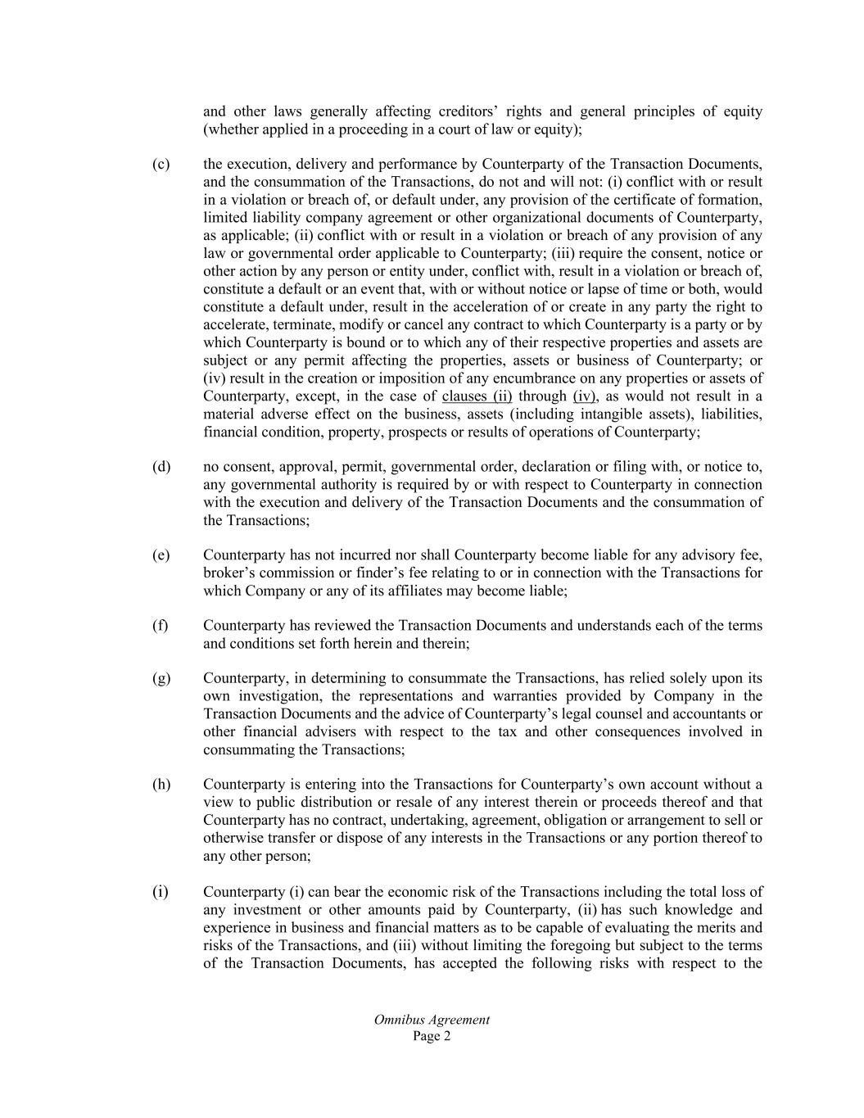
Omnibus Agreement Page 2 and other laws generally affecting creditors’ rights and general principles of equity (whether applied in a proceeding in a court of law or equity); (c) the execution, delivery and performance by Counterparty of the Transaction Documents, and the consummation of the Transactions, do not and will not: (i) conflict with or result in a violation or breach of, or default under, any provision of the certificate of formation, limited liability company agreement or other organizational documents of Counterparty, as applicable; (ii) conflict with or result in a violation or breach of any provision of any law or governmental order applicable to Counterparty; (iii) require the consent, notice or other action by any person or entity under, conflict with, result in a violation or breach of, constitute a default or an event that, with or without notice or lapse of time or both, would constitute a default under, result in the acceleration of or create in any party the right to accelerate, terminate, modify or cancel any contract to which Counterparty is a party or by which Counterparty is bound or to which any of their respective properties and assets are subject or any permit affecting the properties, assets or business of Counterparty; or (iv) result in the creation or imposition of any encumbrance on any properties or assets of Counterparty, except, in the case of clauses (ii) through (iv), as would not result in a material adverse effect on the business, assets (including intangible assets), liabilities, financial condition, property, prospects or results of operations of Counterparty; (d) no consent, approval, permit, governmental order, declaration or filing with, or notice to, any governmental authority is required by or with respect to Counterparty in connection with the execution and delivery of the Transaction Documents and the consummation of the Transactions; (e) Counterparty has not incurred nor shall Counterparty become liable for any advisory fee, broker’s commission or finder’s fee relating to or in connection with the Transactions for which Company or any of its affiliates may become liable; (f) Counterparty has reviewed the Transaction Documents and understands each of the terms and conditions set forth herein and therein; (g) Counterparty, in determining to consummate the Transactions, has relied solely upon its own investigation, the representations and warranties provided by Company in the Transaction Documents and the advice of Counterparty’s legal counsel and accountants or other financial advisers with respect to the tax and other consequences involved in consummating the Transactions; (h) Counterparty is entering into the Transactions for Counterparty’s own account without a view to public distribution or resale of any interest therein or proceeds thereof and that Counterparty has no contract, undertaking, agreement, obligation or arrangement to sell or otherwise transfer or dispose of any interests in the Transactions or any portion thereof to any other person; (i) Counterparty (i) can bear the economic risk of the Transactions including the total loss of any investment or other amounts paid by Counterparty, (ii) has such knowledge and experience in business and financial matters as to be capable of evaluating the merits and risks of the Transactions, and (iii) without limiting the foregoing but subject to the terms of the Transaction Documents, has accepted the following risks with respect to the

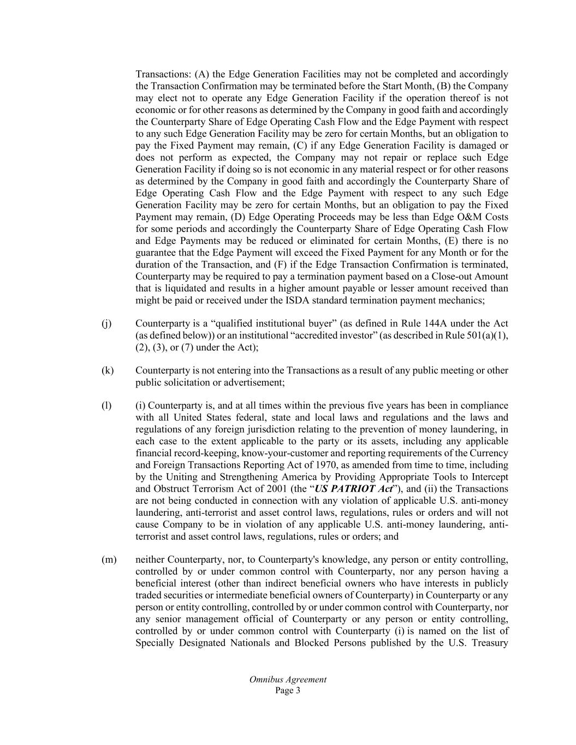
Omnibus Agreement Page 3 Transactions: (A) the Edge Generation Facilities may not be completed and accordingly the Transaction Confirmation may be terminated before the Start Month, (B) the Company may elect not to operate any Edge Generation Facility if the operation thereof is not economic or for other reasons as determined by the Company in good faith and accordingly the Counterparty Share of Edge Operating Cash Flow and the Edge Payment with respect to any such Edge Generation Facility may be zero for certain Months, but an obligation to pay the Fixed Payment may remain, (C) if any Edge Generation Facility is damaged or does not perform as expected, the Company may not repair or replace such Edge Generation Facility if doing so is not economic in any material respect or for other reasons as determined by the Company in good faith and accordingly the Counterparty Share of Edge Operating Cash Flow and the Edge Payment with respect to any such Edge Generation Facility may be zero for certain Months, but an obligation to pay the Fixed Payment may remain, (D) Edge Operating Proceeds may be less than Edge O&M Costs for some periods and accordingly the Counterparty Share of Edge Operating Cash Flow and Edge Payments may be reduced or eliminated for certain Months, (E) there is no guarantee that the Edge Payment will exceed the Fixed Payment for any Month or for the duration of the Transaction, and (F) if the Edge Transaction Confirmation is terminated, Counterparty may be required to pay a termination payment based on a Close-out Amount that is liquidated and results in a higher amount payable or lesser amount received than might be paid or received under the ISDA standard termination payment mechanics; (j) Counterparty is a “qualified institutional buyer” (as defined in Rule 144A under the Act (as defined below)) or an institutional “accredited investor” (as described in Rule 501(a)(1), (2), (3), or (7) under the Act); (k) Counterparty is not entering into the Transactions as a result of any public meeting or other public solicitation or advertisement; (l) (i) Counterparty is, and at all times within the previous five years has been in compliance with all United States federal, state and local laws and regulations and the laws and regulations of any foreign jurisdiction relating to the prevention of money laundering, in each case to the extent applicable to the party or its assets, including any applicable financial record-keeping, know-your-customer and reporting requirements of the Currency and Foreign Transactions Reporting Act of 1970, as amended from time to time, including by the Uniting and Strengthening America by Providing Appropriate Tools to Intercept and Obstruct Terrorism Act of 2001 (the “US PATRIOT Act”), and (ii) the Transactions are not being conducted in connection with any violation of applicable U.S. anti-money laundering, anti-terrorist and asset control laws, regulations, rules or orders and will not cause Company to be in violation of any applicable U.S. anti-money laundering, anti- terrorist and asset control laws, regulations, rules or orders; and (m) neither Counterparty, nor, to Counterparty's knowledge, any person or entity controlling, controlled by or under common control with Counterparty, nor any person having a beneficial interest (other than indirect beneficial owners who have interests in publicly traded securities or intermediate beneficial owners of Counterparty) in Counterparty or any person or entity controlling, controlled by or under common control with Counterparty, nor any senior management official of Counterparty or any person or entity controlling, controlled by or under common control with Counterparty (i) is named on the list of Specially Designated Nationals and Blocked Persons published by the U.S. Treasury

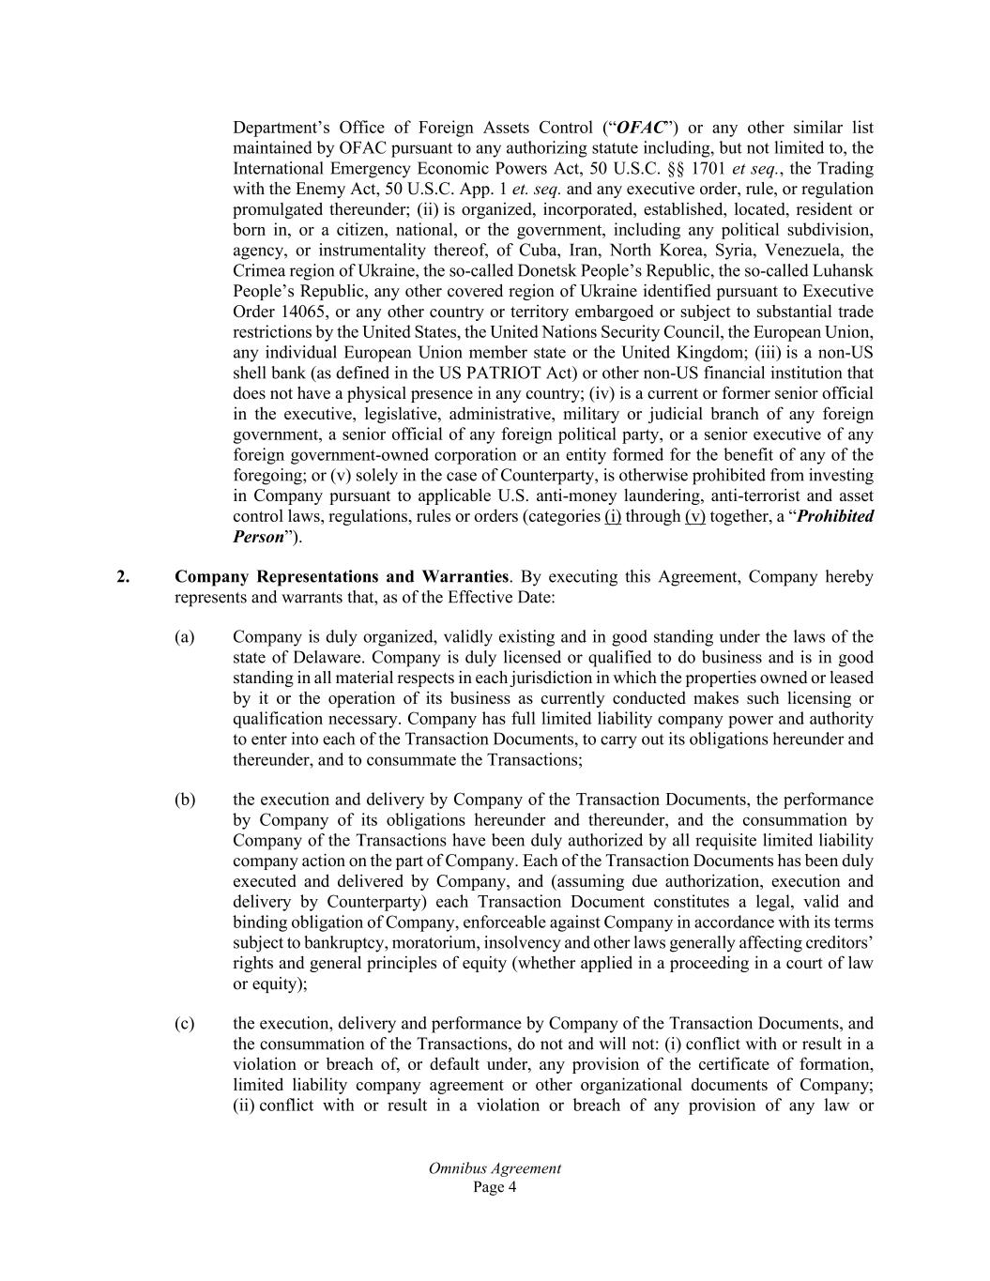
Omnibus Agreement Page 4 Department’s Office of Foreign Assets Control (“OFAC”) or any other similar list maintained by OFAC pursuant to any authorizing statute including, but not limited to, the International Emergency Economic Powers Act, 50 U.S.C. §§ 1701 et seq., the Trading with the Enemy Act, 50 U.S.C. App. 1 et. seq. and any executive order, rule, or regulation promulgated thereunder; (ii) is organized, incorporated, established, located, resident or born in, or a citizen, national, or the government, including any political subdivision, agency, or instrumentality thereof, of Cuba, Iran, North Korea, Syria, Venezuela, the Crimea region of Ukraine, the so-called Donetsk People’s Republic, the so-called Luhansk People’s Republic, any other covered region of Ukraine identified pursuant to Executive Order 14065, or any other country or territory embargoed or subject to substantial trade restrictions by the United States, the United Nations Security Council, the European Union, any individual European Union member state or the United Kingdom; (iii) is a non-US shell bank (as defined in the US PATRIOT Act) or other non-US financial institution that does not have a physical presence in any country; (iv) is a current or former senior official in the executive, legislative, administrative, military or judicial branch of any foreign government, a senior official of any foreign political party, or a senior executive of any foreign government-owned corporation or an entity formed for the benefit of any of the foregoing; or (v) solely in the case of Counterparty, is otherwise prohibited from investing in Company pursuant to applicable U.S. anti-money laundering, anti-terrorist and asset control laws, regulations, rules or orders (categories (i) through (v) together, a “Prohibited Person”). 2. Company Representations and Warranties. By executing this Agreement, Company hereby represents and warrants that, as of the Effective Date: (a) Company is duly organized, validly existing and in good standing under the laws of the state of Delaware. Company is duly licensed or qualified to do business and is in good standing in all material respects in each jurisdiction in which the properties owned or leased by it or the operation of its business as currently conducted makes such licensing or qualification necessary. Company has full limited liability company power and authority to enter into each of the Transaction Documents, to carry out its obligations hereunder and thereunder, and to consummate the Transactions; (b) the execution and delivery by Company of the Transaction Documents, the performance by Company of its obligations hereunder and thereunder, and the consummation by Company of the Transactions have been duly authorized by all requisite limited liability company action on the part of Company. Each of the Transaction Documents has been duly executed and delivered by Company, and (assuming due authorization, execution and delivery by Counterparty) each Transaction Document constitutes a legal, valid and binding obligation of Company, enforceable against Company in accordance with its terms subject to bankruptcy, moratorium, insolvency and other laws generally affecting creditors’ rights and general principles of equity (whether applied in a proceeding in a court of law or equity); (c) the execution, delivery and performance by Company of the Transaction Documents, and the consummation of the Transactions, do not and will not: (i) conflict with or result in a violation or breach of, or default under, any provision of the certificate of formation, limited liability company agreement or other organizational documents of Company; (ii) conflict with or result in a violation or breach of any provision of any law or

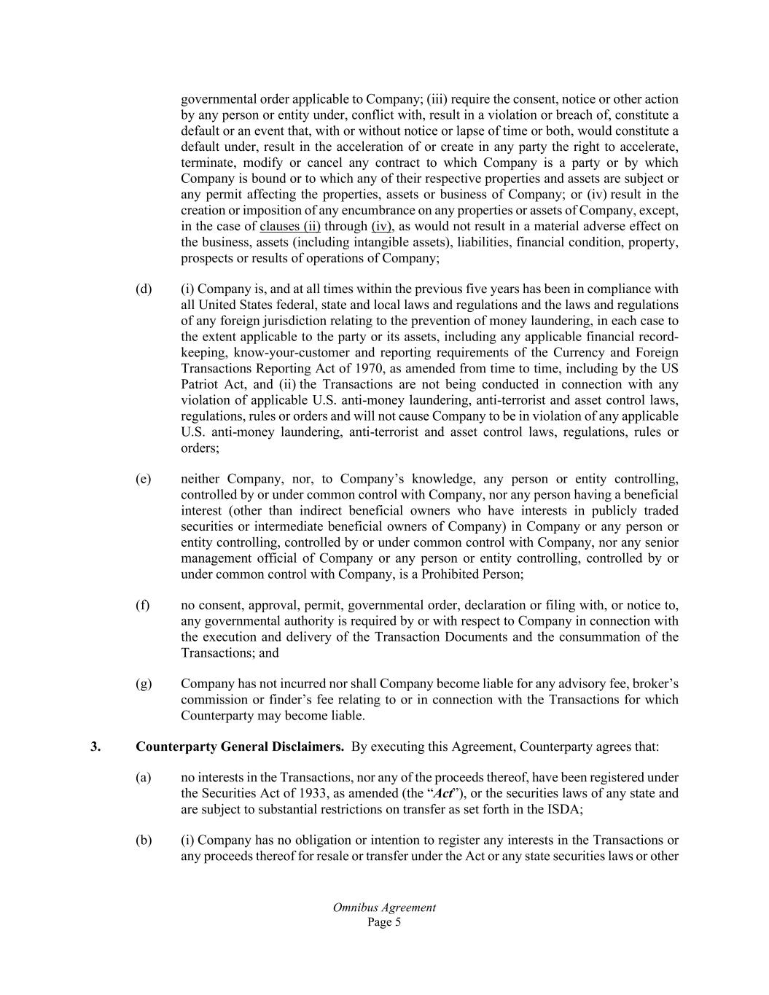
Omnibus Agreement Page 5 governmental order applicable to Company; (iii) require the consent, notice or other action by any person or entity under, conflict with, result in a violation or breach of, constitute a default or an event that, with or without notice or lapse of time or both, would constitute a default under, result in the acceleration of or create in any party the right to accelerate, terminate, modify or cancel any contract to which Company is a party or by which Company is bound or to which any of their respective properties and assets are subject or any permit affecting the properties, assets or business of Company; or (iv) result in the creation or imposition of any encumbrance on any properties or assets of Company, except, in the case of clauses (ii) through (iv), as would not result in a material adverse effect on the business, assets (including intangible assets), liabilities, financial condition, property, prospects or results of operations of Company; (d) (i) Company is, and at all times within the previous five years has been in compliance with all United States federal, state and local laws and regulations and the laws and regulations of any foreign jurisdiction relating to the prevention of money laundering, in each case to the extent applicable to the party or its assets, including any applicable financial record- keeping, know-your-customer and reporting requirements of the Currency and Foreign Transactions Reporting Act of 1970, as amended from time to time, including by the US Patriot Act, and (ii) the Transactions are not being conducted in connection with any violation of applicable U.S. anti-money laundering, anti-terrorist and asset control laws, regulations, rules or orders and will not cause Company to be in violation of any applicable U.S. anti-money laundering, anti-terrorist and asset control laws, regulations, rules or orders; (e) neither Company, nor, to Company’s knowledge, any person or entity controlling, controlled by or under common control with Company, nor any person having a beneficial interest (other than indirect beneficial owners who have interests in publicly traded securities or intermediate beneficial owners of Company) in Company or any person or entity controlling, controlled by or under common control with Company, nor any senior management official of Company or any person or entity controlling, controlled by or under common control with Company, is a Prohibited Person; (f) no consent, approval, permit, governmental order, declaration or filing with, or notice to, any governmental authority is required by or with respect to Company in connection with the execution and delivery of the Transaction Documents and the consummation of the Transactions; and (g) Company has not incurred nor shall Company become liable for any advisory fee, broker’s commission or finder’s fee relating to or in connection with the Transactions for which Counterparty may become liable. 3. Counterparty General Disclaimers. By executing this Agreement, Counterparty agrees that: (a) no interests in the Transactions, nor any of the proceeds thereof, have been registered under the Securities Act of 1933, as amended (the “Act”), or the securities laws of any state and are subject to substantial restrictions on transfer as set forth in the ISDA; (b) (i) Company has no obligation or intention to register any interests in the Transactions or any proceeds thereof for resale or transfer under the Act or any state securities laws or other

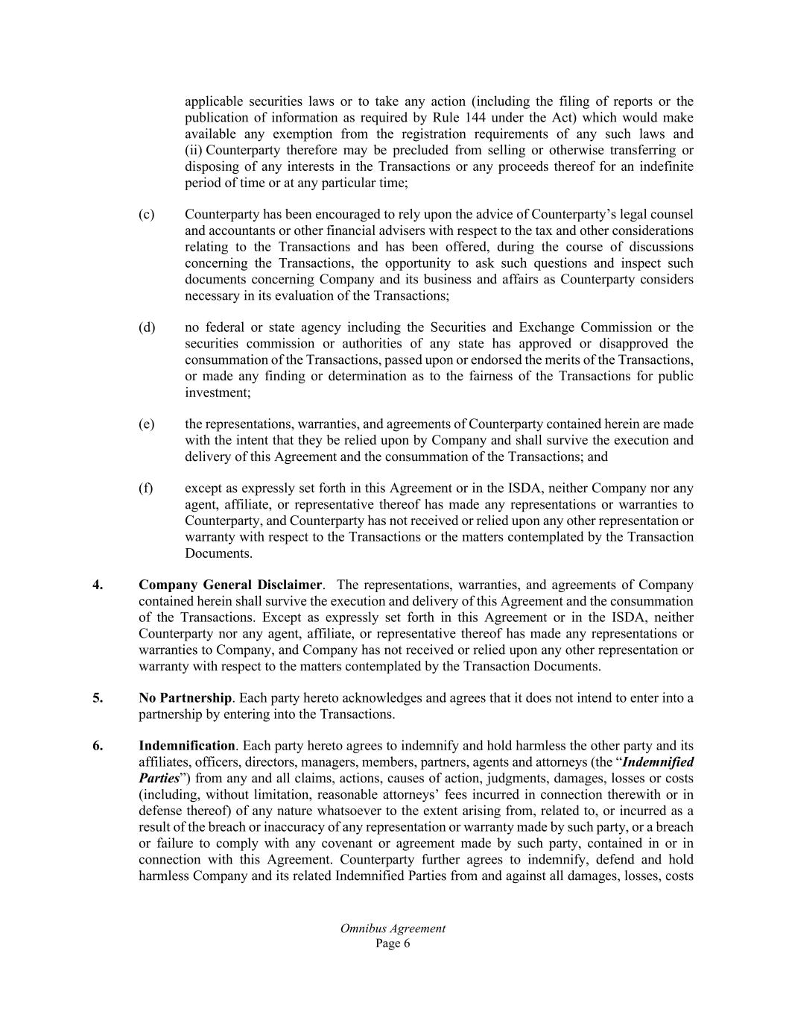
Omnibus Agreement Page 6 applicable securities laws or to take any action (including the filing of reports or the publication of information as required by Rule 144 under the Act) which would make available any exemption from the registration requirements of any such laws and (ii) Counterparty therefore may be precluded from selling or otherwise transferring or disposing of any interests in the Transactions or any proceeds thereof for an indefinite period of time or at any particular time; (c) Counterparty has been encouraged to rely upon the advice of Counterparty’s legal counsel and accountants or other financial advisers with respect to the tax and other considerations relating to the Transactions and has been offered, during the course of discussions concerning the Transactions, the opportunity to ask such questions and inspect such documents concerning Company and its business and affairs as Counterparty considers necessary in its evaluation of the Transactions; (d) no federal or state agency including the Securities and Exchange Commission or the securities commission or authorities of any state has approved or disapproved the consummation of the Transactions, passed upon or endorsed the merits of the Transactions, or made any finding or determination as to the fairness of the Transactions for public investment; (e) the representations, warranties, and agreements of Counterparty contained herein are made with the intent that they be relied upon by Company and shall survive the execution and delivery of this Agreement and the consummation of the Transactions; and (f) except as expressly set forth in this Agreement or in the ISDA, neither Company nor any agent, affiliate, or representative thereof has made any representations or warranties to Counterparty, and Counterparty has not received or relied upon any other representation or warranty with respect to the Transactions or the matters contemplated by the Transaction Documents. 4. Company General Disclaimer. The representations, warranties, and agreements of Company contained herein shall survive the execution and delivery of this Agreement and the consummation of the Transactions. Except as expressly set forth in this Agreement or in the ISDA, neither Counterparty nor any agent, affiliate, or representative thereof has made any representations or warranties to Company, and Company has not received or relied upon any other representation or warranty with respect to the matters contemplated by the Transaction Documents. 5. No Partnership. Each party hereto acknowledges and agrees that it does not intend to enter into a partnership by entering into the Transactions. 6. Indemnification. Each party hereto agrees to indemnify and hold harmless the other party and its affiliates, officers, directors, managers, members, partners, agents and attorneys (the “Indemnified Parties”) from any and all claims, actions, causes of action, judgments, damages, losses or costs (including, without limitation, reasonable attorneys’ fees incurred in connection therewith or in defense thereof) of any nature whatsoever to the extent arising from, related to, or incurred as a result of the breach or inaccuracy of any representation or warranty made by such party, or a breach or failure to comply with any covenant or agreement made by such party, contained in or in connection with this Agreement. Counterparty further agrees to indemnify, defend and hold harmless Company and its related Indemnified Parties from and against all damages, losses, costs

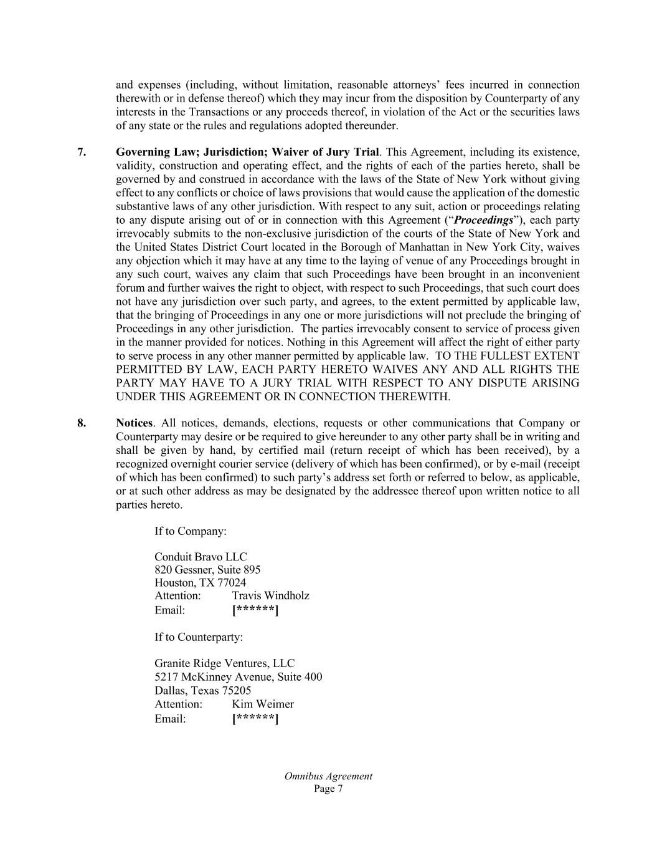
Omnibus Agreement Page 7 and expenses (including, without limitation, reasonable attorneys’ fees incurred in connection therewith or in defense thereof) which they may incur from the disposition by Counterparty of any interests in the Transactions or any proceeds thereof, in violation of the Act or the securities laws of any state or the rules and regulations adopted thereunder. 7. Governing Law; Jurisdiction; Waiver of Jury Trial. This Agreement, including its existence, validity, construction and operating effect, and the rights of each of the parties hereto, shall be governed by and construed in accordance with the laws of the State of New York without giving effect to any conflicts or choice of laws provisions that would cause the application of the domestic substantive laws of any other jurisdiction. With respect to any suit, action or proceedings relating to any dispute arising out of or in connection with this Agreement (“Proceedings”), each party irrevocably submits to the non-exclusive jurisdiction of the courts of the State of New York and the United States District Court located in the Borough of Manhattan in New York City, waives any objection which it may have at any time to the laying of venue of any Proceedings brought in any such court, waives any claim that such Proceedings have been brought in an inconvenient forum and further waives the right to object, with respect to such Proceedings, that such court does not have any jurisdiction over such party, and agrees, to the extent permitted by applicable law, that the bringing of Proceedings in any one or more jurisdictions will not preclude the bringing of Proceedings in any other jurisdiction. The parties irrevocably consent to service of process given in the manner provided for notices. Nothing in this Agreement will affect the right of either party to serve process in any other manner permitted by applicable law. TO THE FULLEST EXTENT PERMITTED BY LAW, EACH PARTY HERETO WAIVES ANY AND ALL RIGHTS THE PARTY MAY HAVE TO A JURY TRIAL WITH RESPECT TO ANY DISPUTE ARISING UNDER THIS AGREEMENT OR IN CONNECTION THEREWITH. 8. Notices. All notices, demands, elections, requests or other communications that Company or Counterparty may desire or be required to give hereunder to any other party shall be in writing and shall be given by hand, by certified mail (return receipt of which has been received), by a recognized overnight courier service (delivery of which has been confirmed), or by e-mail (receipt of which has been confirmed) to such party’s address set forth or referred to below, as applicable, or at such other address as may be designated by the addressee thereof upon written notice to all parties hereto. If to Company: Conduit Bravo LLC 820 Gessner, Suite 895 Houston, TX 77024 Attention: Travis Windholz Email: [******] If to Counterparty: Granite Ridge Ventures, LLC 5217 McKinney Avenue, Suite 400 Dallas, Texas 75205 Attention: Kim Weimer Email: [******]

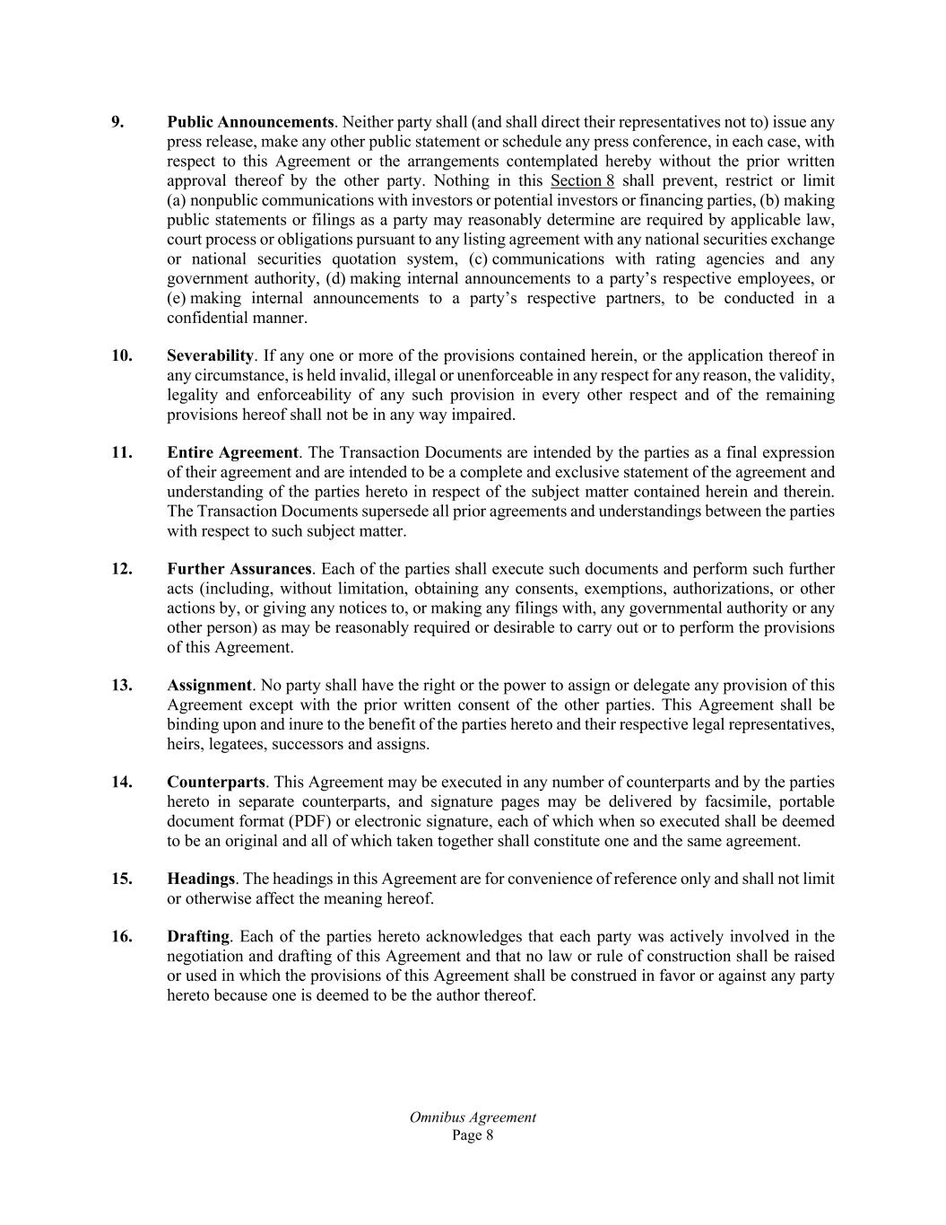
Omnibus Agreement Page 8 9. Public Announcements. Neither party shall (and shall direct their representatives not to) issue any press release, make any other public statement or schedule any press conference, in each case, with respect to this Agreement or the arrangements contemplated hereby without the prior written approval thereof by the other party. Nothing in this Section 8 shall prevent, restrict or limit (a) nonpublic communications with investors or potential investors or financing parties, (b) making public statements or filings as a party may reasonably determine are required by applicable law, court process or obligations pursuant to any listing agreement with any national securities exchange or national securities quotation system, (c) communications with rating agencies and any government authority, (d) making internal announcements to a party’s respective employees, or (e) making internal announcements to a party’s respective partners, to be conducted in a confidential manner. 10. Severability. If any one or more of the provisions contained herein, or the application thereof in any circumstance, is held invalid, illegal or unenforceable in any respect for any reason, the validity, legality and enforceability of any such provision in every other respect and of the remaining provisions hereof shall not be in any way impaired. 11. Entire Agreement. The Transaction Documents are intended by the parties as a final expression of their agreement and are intended to be a complete and exclusive statement of the agreement and understanding of the parties hereto in respect of the subject matter contained herein and therein. The Transaction Documents supersede all prior agreements and understandings between the parties with respect to such subject matter. 12. Further Assurances. Each of the parties shall execute such documents and perform such further acts (including, without limitation, obtaining any consents, exemptions, authorizations, or other actions by, or giving any notices to, or making any filings with, any governmental authority or any other person) as may be reasonably required or desirable to carry out or to perform the provisions of this Agreement. 13. Assignment. No party shall have the right or the power to assign or delegate any provision of this Agreement except with the prior written consent of the other parties. This Agreement shall be binding upon and inure to the benefit of the parties hereto and their respective legal representatives, heirs, legatees, successors and assigns. 14. Counterparts. This Agreement may be executed in any number of counterparts and by the parties hereto in separate counterparts, and signature pages may be delivered by facsimile, portable document format (PDF) or electronic signature, each of which when so executed shall be deemed to be an original and all of which taken together shall constitute one and the same agreement. 15. Headings. The headings in this Agreement are for convenience of reference only and shall not limit or otherwise affect the meaning hereof. 16. Drafting. Each of the parties hereto acknowledges that each party was actively involved in the negotiation and drafting of this Agreement and that no law or rule of construction shall be raised or used in which the provisions of this Agreement shall be construed in favor or against any party hereto because one is deemed to be the author thereof.


Omnibus Agreement Page 9 Balance of Page Intentionally Blank. Signature Pages Follow.

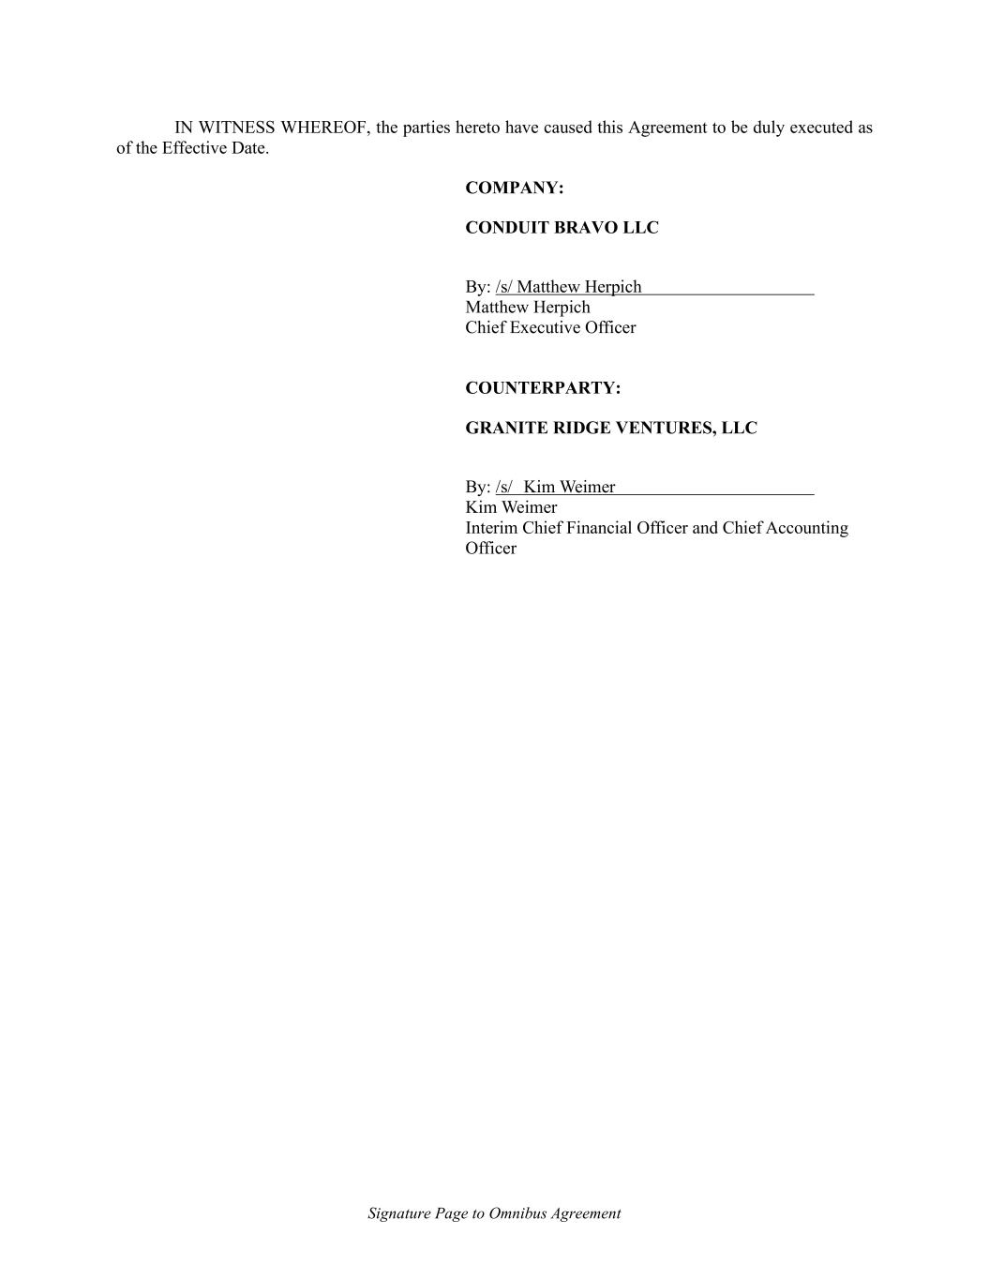
Signature Page to Omnibus Agreement IN WITNESS WHEREOF, the parties hereto have caused this Agreement to be duly executed as of the Effective Date. COMPANY: CONDUIT BRAVO LLC By: /s/ Matthew Herpich Matthew Herpich Chief Executive Officer COUNTERPARTY: GRANITE RIDGE VENTURES, LLC By: /s/ Kim Weimer Kim Weimer Interim Chief Financial Officer and Chief Accounting Officer

Exhibit 21.1

Subsidiaries of the Registrant

The following list includes subsidiaries of Granite Ridge Resources, Inc. All subsidiaries are wholly-owned unless otherwise indicated.

Granite Ridge Holdings, LLC, a Delaware limited liability company

Granite Ridge Reeves, LLC, a Delaware limited liability company

Granite Ridge Ventures, LLC, a Delaware limited liability company

Exhibit 23.1

Consent of Independent Registered Public Accounting Firm
We consent to the incorporation by reference in the Registration Statements on Form S-3 (Nos. 333-268478, etc.) and Form S-8 (No. 333-269036) of Granite Ridge Resources, Inc. of our reports dated March 5, 2026, with respect to the consolidated financial statements of Granite Ridge Resources, Inc. and the effectiveness of internal control over financial reporting, included in this Annual Report on Form 10-K for the year ended December 31, 2025 and 2024, and for each of the three years in the three-year period ended December 31, 2025.

/s/ Forvis Mazars, LLP

Dallas, Texas
March 5, 2026



Exhibit 23.2
CONSENT OF INDEPENDENT PETROLEUM ENGINEERS AND GEOLOGISTS

We hereby consent to the inclusion in the annual report on Form 10-K (the "Annual Report") of Granite Ridge Resources, Inc. (the "Company") of our report prepared for the Company dated January 5, 2026, with respect to estimates of reserves and future net revenue to the Company's interest, as of December 31, 2025, in certain oil and gas properties located in Colorado, Louisiana, Montana, New Mexico, North Dakota, Ohio, Texas, and Wyoming. We also hereby consent to all references to our firm or such report included in or incorporated by reference into such Annual Report, and thus incorporated by reference into the Registration Statement on Form S-3 (File No. 333-268478) (including any amendments or supplements thereto, related appendices, and financial statements) and the Registration Statement on Form S-8 (File No. 333-269036) of Granite Ridge Resources, Inc.

NETHERLAND, SEWELL & ASSOCIATES, INC.

/s/ Eric J. Stevens
By:
Eric J. Stevens, P.E.
President and Chief Operating Officer

Dallas, Texas
March 5, 2026

Exhibit 31.1
CERTIFICATION
I, Tyler S. Farquharson, certify that:
1.I have reviewed this Annual Report on Form 10-K of Granite Ridge Resources, Inc.;
2.Based on my knowledge, this report does not contain any untrue statement of a material fact or omit to state a material fact necessary to make the statements made, in light of the circumstances under which such statements were made, not misleading with respect to the period covered by this report;
3.Based on my knowledge, the financial statements, and other financial information included in this report, fairly present in all material respects the financial condition, results of operations and cash flows of the registrant as of, and for, the periods presented in this report;
4.The registrant’s other certifying officer(s) and I are responsible for establishing and maintaining disclosure controls and procedures (as defined in Exchange Act Rules 13a-15(e) and 15d-15(e)) and internal control over financial reporting (as defined in Exchange Act Rules 13a-15(f) and 15d-15(f)) for the registrant and have:
a)Designed such disclosure controls and procedures, or caused such disclosure controls and procedures to be designed under our supervision, to ensure that material information relating to the registrant, including its consolidated subsidiaries, is made known to us by others within those entities, particularly during the period in which this report is being prepared;
b)Designed such internal control over financial reporting, or caused such internal control over financial reporting to be designed under our supervision, to provide reasonable assurance regarding the reliability of financial reporting and the preparation of financial statements for external purposes in accordance with generally accepted accounting principles;
c)Evaluated the effectiveness of the registrant’s disclosure controls and procedures and presented in this report our conclusions about the effectiveness of the disclosure controls and procedures, as of the end of the period covered by this report based on such evaluation; and
d)Disclosed in this report any change in the registrant’s internal control over financial reporting that occurred during the registrant’s most recent fiscal quarter (the registrant’s fourth fiscal quarter in the case of an annual report) that has materially affected, or is reasonably likely to materially affect, the registrant’s internal control over financial reporting; and
5.The registrant’s other certifying officer(s) and I have disclosed, based on our most recent evaluation of internal control over financial reporting, to the registrant's auditors and the audit committee of registrant’s board of directors (or persons performing the equivalent functions):
a)All significant deficiencies and material weaknesses in the design or operation of internal control over financial reporting which are reasonably likely to adversely affect the registrant’s ability to record, process, summarize and report financial information; and
b)Any fraud, whether or not material, that involves management or other employees who have a significant role in the registrant’s internal control over financial reporting.
Dated: March 5, 2026 |  |  | By: /s/ |  |  | TYLER S. FARQUHARSON
 |  |  |  |  |  | Tyler S. Farquharson
 |  |  |  |  |  | President and Chief Executive Officer

Exhibit 31.2
CERTIFICATION
I, R. Kyle Kettler, certify that:
1.I have reviewed this Annual Report on Form 10-K of Granite Ridge Resources, Inc.;
2.Based on my knowledge, this report does not contain any untrue statement of a material fact or omit to state a material fact necessary to make the statements made, in light of the circumstances under which such statements were made, not misleading with respect to the period covered by this report;
3.Based on my knowledge, the financial statements, and other financial information included in this report, fairly present in all material respects the financial condition, results of operations and cash flows of the registrant as of, and for, the periods presented in this report;
4.The registrant’s other certifying officer(s) and I are responsible for establishing and maintaining disclosure controls and procedures (as defined in Exchange Act Rules 13a-15(e) and 15d-15(e)) and internal control over financial reporting (as defined in Exchange Act Rules 13a-15(f) and 15d-15(f)) for the registrant and have:
a)Designed such disclosure controls and procedures, or caused such disclosure controls and procedures to be designed under our supervision, to ensure that material information relating to the registrant, including its consolidated subsidiaries, is made known to us by others within those entities, particularly during the period in which this report is being prepared;
b)Designed such internal control over financial reporting, or caused such internal control over financial reporting to be designed under our supervision, to provide reasonable assurance regarding the reliability of financial reporting and the preparation of financial statements for external purposes in accordance with generally accepted accounting principles;
c)Evaluated the effectiveness of the registrant’s disclosure controls and procedures and presented in this report our conclusions about the effectiveness of the disclosure controls and procedures, as of the end of the period covered by this report based on such evaluation; and
d)Disclosed in this report any change in the registrant’s internal control over financial reporting that occurred during the registrant’s most recent fiscal quarter (the registrant’s fourth fiscal quarter in the case of an annual report) that has materially affected, or is reasonably likely to materially affect, the registrant’s internal control over financial reporting; and
5.The registrant’s other certifying officer(s) and I have disclosed, based on our most recent evaluation of internal control over financial reporting, to the registrant’s auditors and the audit committee of registrant's board of directors (or persons performing the equivalent functions):
a)All significant deficiencies and material weaknesses in the design or operation of internal control over financial reporting which are reasonably likely to adversely affect the registrant’s ability to record, process, summarize and report financial information; and
b)Any fraud, whether or not material, that involves management or other employees who have a significant role in the registrant’s internal control over financial reporting.
Dated: March 5, 2026 |  |  | By: /s/ |  |  | R. KYLE KETTLER
 |  |  |  |  |  | R. Kyle Kettler
 |  |  |  |  |  | Chief Financial Officer

Exhibit 32.1
CERTIFICATION PURSUANT TO
18 U.S.C. SECTION 1350
AS ADOPTED PURSUANT TO
SECTION 906 OF THE SARBANES-OXLEY ACT OF 2002
In connection with the Annual Report of Granite Ridge Resources, Inc. (the “Company”) on Form 10-K for the year ended December 31, 2025, as filed with the United States Securities and Exchange Commission on the date hereof (the “Report”), the undersigned officers of the Company hereby certify, pursuant to 18 U.S.C. Section 1350, as adopted pursuant to Section 906 of the Sarbanes-Oxley Act of 2002, that, to their knowledge:
1.The Report fully complies with the requirements of Section 13(a) or 15(d) of the Securities Exchange Act of 1934; and
2.The information contained in the Report fairly presents, in all material respects, the financial condition and results of operations of the Company.
Dated: March 5, 2026 |  |  | By: |  |  | /s/ TYLER S. FARQUHARSON
 |  |  |  |  |  | Name: |  |  | Tyler S. Farquharson
 |  |  |  |  |  | Title: |  |  | President and Chief Executive Officer
Dated: March 5, 2026 |  |  | By: |  |  | /s/ R. KYLE KETTLER
 |  |  |  |  |  | Name: |  |  | R. Kyle Kettler
 |  |  |  |  |  | Title: |  |  | Chief Financial Officer
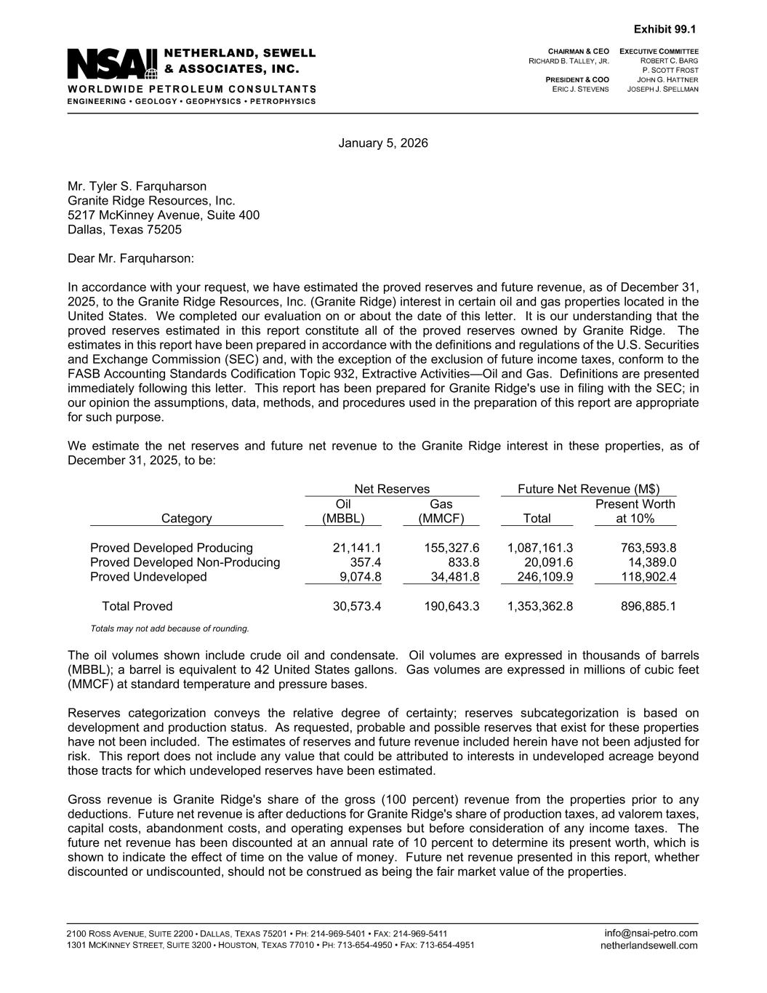

January 5, 2026 Mr. Tyler S. Farquharson Granite Ridge Resources, Inc. 5217 McKinney Avenue, Suite 400 Dallas, Texas 75205 Dear Mr. Farquharson: In accordance with your request, we have estimated the proved reserves and future revenue, as of December 31, 2025, to the Granite Ridge Resources, Inc. (Granite Ridge) interest in certain oil and gas properties located in the United States. We completed our evaluation on or about the date of this letter. It is our understanding that the proved reserves estimated in this report constitute all of the proved reserves owned by Granite Ridge. The estimates in this report have been prepared in accordance with the definitions and regulations of the U.S. Securities and Exchange Commission (SEC) and, with the exception of the exclusion of future income taxes, conform to the FASB Accounting Standards Codification Topic 932, Extractive Activities—Oil and Gas. Definitions are presented immediately following this letter. This report has been prepared for Granite Ridge's use in filing with the SEC; in our opinion the assumptions, data, methods, and procedures used in the preparation of this report are appropriate for such purpose. We estimate the net reserves and future net revenue to the Granite Ridge interest in these properties, as of December 31, 2025, to be: Net Reserves Future Net Revenue (M$) Oil Gas Present Worth Category (MBBL) (MMCF) Total at 10% Proved Developed Producing 21,141.1 155,327.6 1,087,161.3 763,593.8 Proved Developed Non-Producing 357.4 833.8 20,091.6 14,389.0 Proved Undeveloped 9,074.8 34,481.8 246,109.9 118,902.4 Total Proved 30,573.4 190,643.3 1,353,362.8 896,885.1 Totals may not add because of rounding. The oil volumes shown include crude oil and condensate. Oil volumes are expressed in thousands of barrels (MBBL); a barrel is equivalent to 42 United States gallons. Gas volumes are expressed in millions of cubic feet (MMCF) at standard temperature and pressure bases. Reserves categorization conveys the relative degree of certainty; reserves subcategorization is based on development and production status. As requested, probable and possible reserves that exist for these properties have not been included. The estimates of reserves and future revenue included herein have not been adjusted for risk. This report does not include any value that could be attributed to interests in undeveloped acreage beyond those tracts for which undeveloped reserves have been estimated. Gross revenue is Granite Ridge's share of the gross (100 percent) revenue from the properties prior to any deductions. Future net revenue is after deductions for Granite Ridge's share of production taxes, ad valorem taxes, capital costs, abandonment costs, and operating expenses but before consideration of any income taxes. The future net revenue has been discounted at an annual rate of 10 percent to determine its present worth, which is shown to indicate the effect of time on the value of money. Future net revenue presented in this report, whether discounted or undiscounted, should not be construed as being the fair market value of the properties. Exhibit 99.1

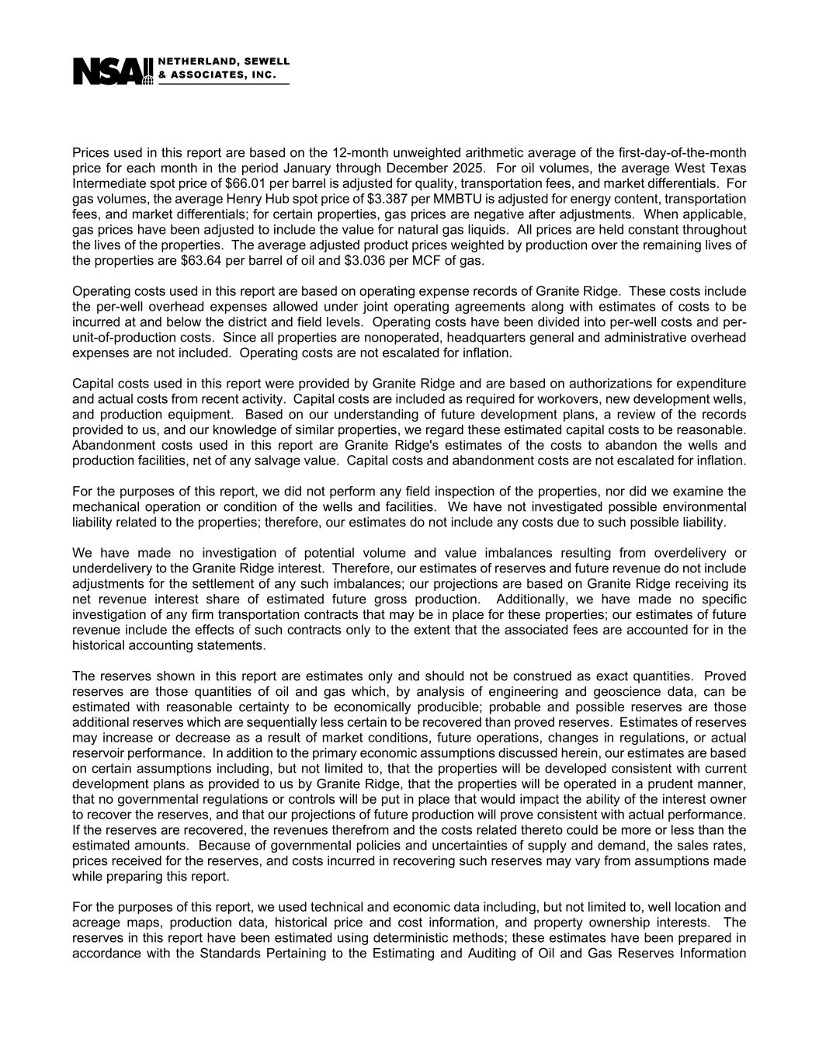
Prices used in this report are based on the 12-month unweighted arithmetic average of the first-day-of-the-month price for each month in the period January through December 2025. For oil volumes, the average West Texas Intermediate spot price of $66.01 per barrel is adjusted for quality, transportation fees, and market differentials. For gas volumes, the average Henry Hub spot price of $3.387 per MMBTU is adjusted for energy content, transportation fees, and market differentials; for certain properties, gas prices are negative after adjustments. When applicable, gas prices have been adjusted to include the value for natural gas liquids. All prices are held constant throughout the lives of the properties. The average adjusted product prices weighted by production over the remaining lives of the properties are $63.64 per barrel of oil and $3.036 per MCF of gas. Operating costs used in this report are based on operating expense records of Granite Ridge. These costs include the per-well overhead expenses allowed under joint operating agreements along with estimates of costs to be incurred at and below the district and field levels. Operating costs have been divided into per-well costs and per- unit-of-production costs. Since all properties are nonoperated, headquarters general and administrative overhead expenses are not included. Operating costs are not escalated for inflation. Capital costs used in this report were provided by Granite Ridge and are based on authorizations for expenditure and actual costs from recent activity. Capital costs are included as required for workovers, new development wells, and production equipment. Based on our understanding of future development plans, a review of the records provided to us, and our knowledge of similar properties, we regard these estimated capital costs to be reasonable. Abandonment costs used in this report are Granite Ridge's estimates of the costs to abandon the wells and production facilities, net of any salvage value. Capital costs and abandonment costs are not escalated for inflation. For the purposes of this report, we did not perform any field inspection of the properties, nor did we examine the mechanical operation or condition of the wells and facilities. We have not investigated possible environmental liability related to the properties; therefore, our estimates do not include any costs due to such possible liability. We have made no investigation of potential volume and value imbalances resulting from overdelivery or underdelivery to the Granite Ridge interest. Therefore, our estimates of reserves and future revenue do not include adjustments for the settlement of any such imbalances; our projections are based on Granite Ridge receiving its net revenue interest share of estimated future gross production. Additionally, we have made no specific investigation of any firm transportation contracts that may be in place for these properties; our estimates of future revenue include the effects of such contracts only to the extent that the associated fees are accounted for in the historical accounting statements. The reserves shown in this report are estimates only and should not be construed as exact quantities. Proved reserves are those quantities of oil and gas which, by analysis of engineering and geoscience data, can be estimated with reasonable certainty to be economically producible; probable and possible reserves are those additional reserves which are sequentially less certain to be recovered than proved reserves. Estimates of reserves may increase or decrease as a result of market conditions, future operations, changes in regulations, or actual reservoir performance. In addition to the primary economic assumptions discussed herein, our estimates are based on certain assumptions including, but not limited to, that the properties will be developed consistent with current development plans as provided to us by Granite Ridge, that the properties will be operated in a prudent manner, that no governmental regulations or controls will be put in place that would impact the ability of the interest owner to recover the reserves, and that our projections of future production will prove consistent with actual performance. If the reserves are recovered, the revenues therefrom and the costs related thereto could be more or less than the estimated amounts. Because of governmental policies and uncertainties of supply and demand, the sales rates, prices received for the reserves, and costs incurred in recovering such reserves may vary from assumptions made while preparing this report. For the purposes of this report, we used technical and economic data including, but not limited to, well location and acreage maps, production data, historical price and cost information, and property ownership interests. The reserves in this report have been estimated using deterministic methods; these estimates have been prepared in accordance with the Standards Pertaining to the Estimating and Auditing of Oil and Gas Reserves Information

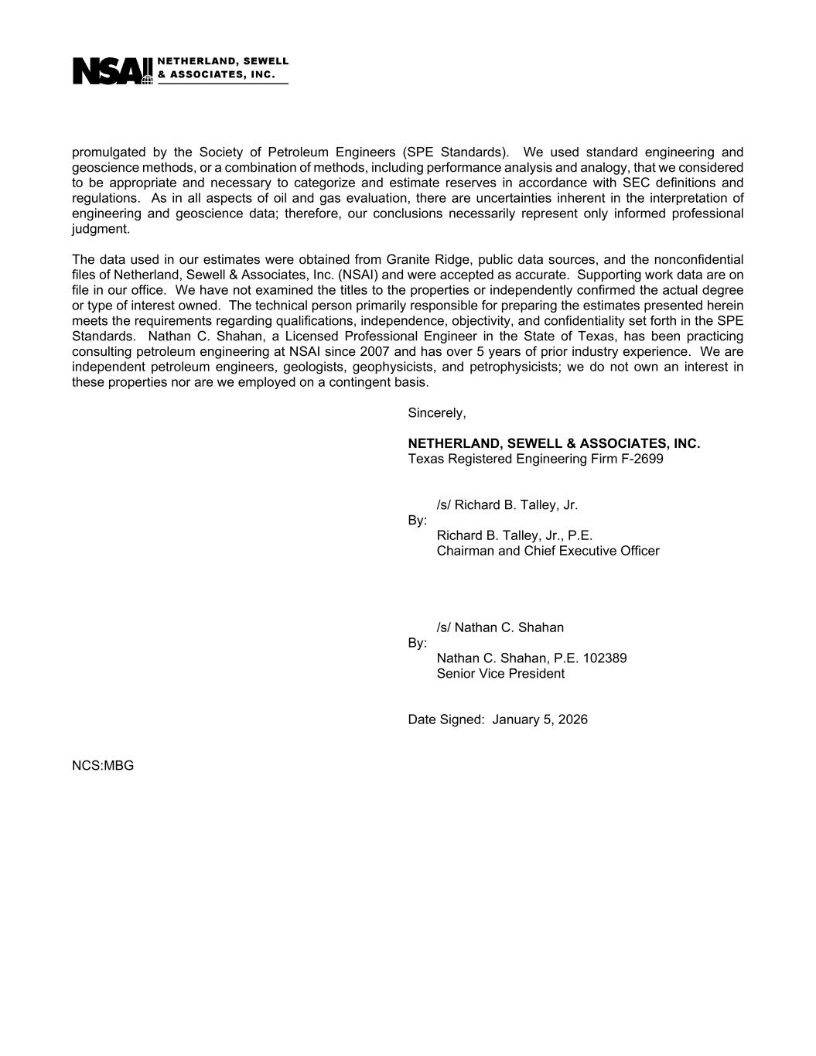
promulgated by the Society of Petroleum Engineers (SPE Standards). We used standard engineering and geoscience methods, or a combination of methods, including performance analysis and analogy, that we considered to be appropriate and necessary to categorize and estimate reserves in accordance with SEC definitions and regulations. As in all aspects of oil and gas evaluation, there are uncertainties inherent in the interpretation of engineering and geoscience data; therefore, our conclusions necessarily represent only informed professional judgment. The data used in our estimates were obtained from Granite Ridge, public data sources, and the nonconfidential files of Netherland, Sewell & Associates, Inc. (NSAI) and were accepted as accurate. Supporting work data are on file in our office. We have not examined the titles to the properties or independently confirmed the actual degree or type of interest owned. The technical person primarily responsible for preparing the estimates presented herein meets the requirements regarding qualifications, independence, objectivity, and confidentiality set forth in the SPE Standards. Nathan C. Shahan, a Licensed Professional Engineer in the State of Texas, has been practicing consulting petroleum engineering at NSAI since 2007 and has over 5 years of prior industry experience. We are independent petroleum engineers, geologists, geophysicists, and petrophysicists; we do not own an interest in these properties nor are we employed on a contingent basis. Sincerely, NETHERLAND, SEWELL & ASSOCIATES, INC. Texas Registered Engineering Firm F-2699 /s/ Richard B. Talley, Jr. By: Richard B. Talley, Jr., P.E. Chairman and Chief Executive Officer /s/ Nathan C. Shahan By: Nathan C. Shahan, P.E. 102389 Senior Vice President Date Signed: January 5, 2026 NCS:MBG

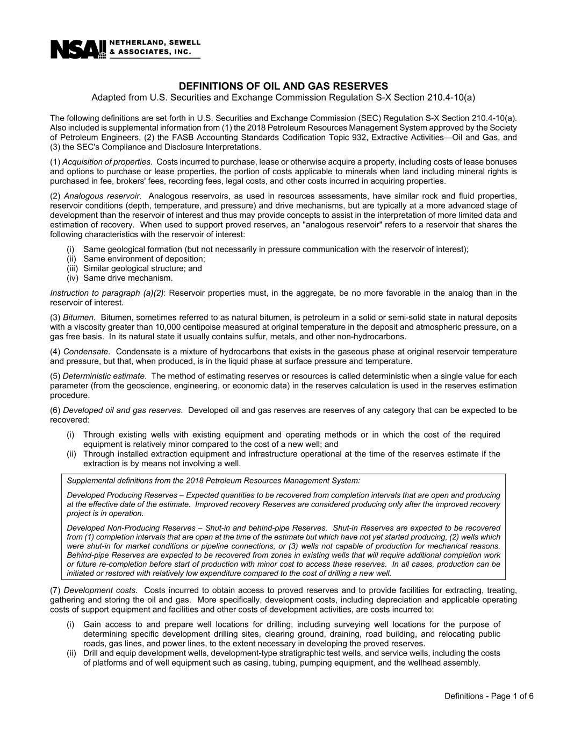
DEFINITIONS OF OIL AND GAS RESERVES Adapted from U.S. Securities and Exchange Commission Regulation S-X Section 210.4-10(a) Definitions - Page 1 of 6 The following definitions are set forth in U.S. Securities and Exchange Commission (SEC) Regulation S-X Section 210.4-10(a). Also included is supplemental information from (1) the 2018 Petroleum Resources Management System approved by the Society of Petroleum Engineers, (2) the FASB Accounting Standards Codification Topic 932, Extractive Activities—Oil and Gas, and (3) the SEC's Compliance and Disclosure Interpretations. (1) Acquisition of properties. Costs incurred to purchase, lease or otherwise acquire a property, including costs of lease bonuses and options to purchase or lease properties, the portion of costs applicable to minerals when land including mineral rights is purchased in fee, brokers' fees, recording fees, legal costs, and other costs incurred in acquiring properties. (2) Analogous reservoir. Analogous reservoirs, as used in resources assessments, have similar rock and fluid properties, reservoir conditions (depth, temperature, and pressure) and drive mechanisms, but are typically at a more advanced stage of development than the reservoir of interest and thus may provide concepts to assist in the interpretation of more limited data and estimation of recovery. When used to support proved reserves, an "analogous reservoir" refers to a reservoir that shares the following characteristics with the reservoir of interest: (i) Same geological formation (but not necessarily in pressure communication with the reservoir of interest); (ii) Same environment of deposition; (iii) Similar geological structure; and (iv) Same drive mechanism. Instruction to paragraph (a)(2): Reservoir properties must, in the aggregate, be no more favorable in the analog than in the reservoir of interest. (3) Bitumen. Bitumen, sometimes referred to as natural bitumen, is petroleum in a solid or semi-solid state in natural deposits with a viscosity greater than 10,000 centipoise measured at original temperature in the deposit and atmospheric pressure, on a gas free basis. In its natural state it usually contains sulfur, metals, and other non-hydrocarbons. (4) Condensate. Condensate is a mixture of hydrocarbons that exists in the gaseous phase at original reservoir temperature and pressure, but that, when produced, is in the liquid phase at surface pressure and temperature. (5) Deterministic estimate. The method of estimating reserves or resources is called deterministic when a single value for each parameter (from the geoscience, engineering, or economic data) in the reserves calculation is used in the reserves estimation procedure. (6) Developed oil and gas reserves. Developed oil and gas reserves are reserves of any category that can be expected to be recovered: (i) Through existing wells with existing equipment and operating methods or in which the cost of the required equipment is relatively minor compared to the cost of a new well; and (ii) Through installed extraction equipment and infrastructure operational at the time of the reserves estimate if the extraction is by means not involving a well. Supplemental definitions from the 2018 Petroleum Resources Management System: Developed Producing Reserves – Expected quantities to be recovered from completion intervals that are open and producing at the effective date of the estimate. Improved recovery Reserves are considered producing only after the improved recovery project is in operation. Developed Non-Producing Reserves – Shut-in and behind-pipe Reserves. Shut-in Reserves are expected to be recovered from (1) completion intervals that are open at the time of the estimate but which have not yet started producing, (2) wells which were shut-in for market conditions or pipeline connections, or (3) wells not capable of production for mechanical reasons. Behind-pipe Reserves are expected to be recovered from zones in existing wells that will require additional completion work or future re-completion before start of production with minor cost to access these reserves. In all cases, production can be initiated or restored with relatively low expenditure compared to the cost of drilling a new well. (7) Development costs. Costs incurred to obtain access to proved reserves and to provide facilities for extracting, treating, gathering and storing the oil and gas. More specifically, development costs, including depreciation and applicable operating costs of support equipment and facilities and other costs of development activities, are costs incurred to: (i) Gain access to and prepare well locations for drilling, including surveying well locations for the purpose of determining specific development drilling sites, clearing ground, draining, road building, and relocating public roads, gas lines, and power lines, to the extent necessary in developing the proved reserves. (ii) Drill and equip development wells, development-type stratigraphic test wells, and service wells, including the costs of platforms and of well equipment such as casing, tubing, pumping equipment, and the wellhead assembly.

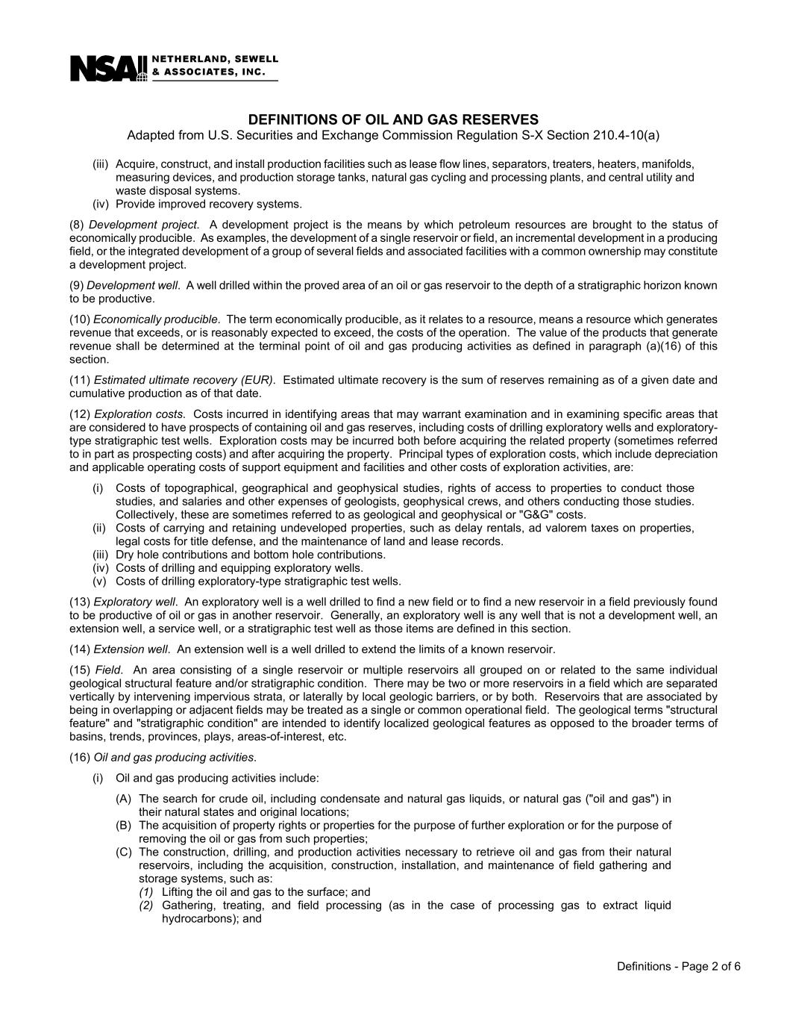
DEFINITIONS OF OIL AND GAS RESERVES Adapted from U.S. Securities and Exchange Commission Regulation S-X Section 210.4-10(a) Definitions - Page 2 of 6 (iii) Acquire, construct, and install production facilities such as lease flow lines, separators, treaters, heaters, manifolds, measuring devices, and production storage tanks, natural gas cycling and processing plants, and central utility and waste disposal systems. (iv) Provide improved recovery systems. (8) Development project. A development project is the means by which petroleum resources are brought to the status of economically producible. As examples, the development of a single reservoir or field, an incremental development in a producing field, or the integrated development of a group of several fields and associated facilities with a common ownership may constitute a development project. (9) Development well. A well drilled within the proved area of an oil or gas reservoir to the depth of a stratigraphic horizon known to be productive. (10) Economically producible. The term economically producible, as it relates to a resource, means a resource which generates revenue that exceeds, or is reasonably expected to exceed, the costs of the operation. The value of the products that generate revenue shall be determined at the terminal point of oil and gas producing activities as defined in paragraph (a)(16) of this section. (11) Estimated ultimate recovery (EUR). Estimated ultimate recovery is the sum of reserves remaining as of a given date and cumulative production as of that date. (12) Exploration costs. Costs incurred in identifying areas that may warrant examination and in examining specific areas that are considered to have prospects of containing oil and gas reserves, including costs of drilling exploratory wells and exploratory- type stratigraphic test wells. Exploration costs may be incurred both before acquiring the related property (sometimes referred to in part as prospecting costs) and after acquiring the property. Principal types of exploration costs, which include depreciation and applicable operating costs of support equipment and facilities and other costs of exploration activities, are: (i) Costs of topographical, geographical and geophysical studies, rights of access to properties to conduct those studies, and salaries and other expenses of geologists, geophysical crews, and others conducting those studies. Collectively, these are sometimes referred to as geological and geophysical or "G&G" costs. (ii) Costs of carrying and retaining undeveloped properties, such as delay rentals, ad valorem taxes on properties, legal costs for title defense, and the maintenance of land and lease records. (iii) Dry hole contributions and bottom hole contributions. (iv) Costs of drilling and equipping exploratory wells. (v) Costs of drilling exploratory-type stratigraphic test wells. (13) Exploratory well. An exploratory well is a well drilled to find a new field or to find a new reservoir in a field previously found to be productive of oil or gas in another reservoir. Generally, an exploratory well is any well that is not a development well, an extension well, a service well, or a stratigraphic test well as those items are defined in this section. (14) Extension well. An extension well is a well drilled to extend the limits of a known reservoir. (15) Field. An area consisting of a single reservoir or multiple reservoirs all grouped on or related to the same individual geological structural feature and/or stratigraphic condition. There may be two or more reservoirs in a field which are separated vertically by intervening impervious strata, or laterally by local geologic barriers, or by both. Reservoirs that are associated by being in overlapping or adjacent fields may be treated as a single or common operational field. The geological terms "structural feature" and "stratigraphic condition" are intended to identify localized geological features as opposed to the broader terms of basins, trends, provinces, plays, areas-of-interest, etc. (16) Oil and gas producing activities. (i) Oil and gas producing activities include: (A) The search for crude oil, including condensate and natural gas liquids, or natural gas ("oil and gas") in their natural states and original locations; (B) The acquisition of property rights or properties for the purpose of further exploration or for the purpose of removing the oil or gas from such properties; (C) The construction, drilling, and production activities necessary to retrieve oil and gas from their natural reservoirs, including the acquisition, construction, installation, and maintenance of field gathering and storage systems, such as: (1) Lifting the oil and gas to the surface; and (2) Gathering, treating, and field processing (as in the case of processing gas to extract liquid hydrocarbons); and

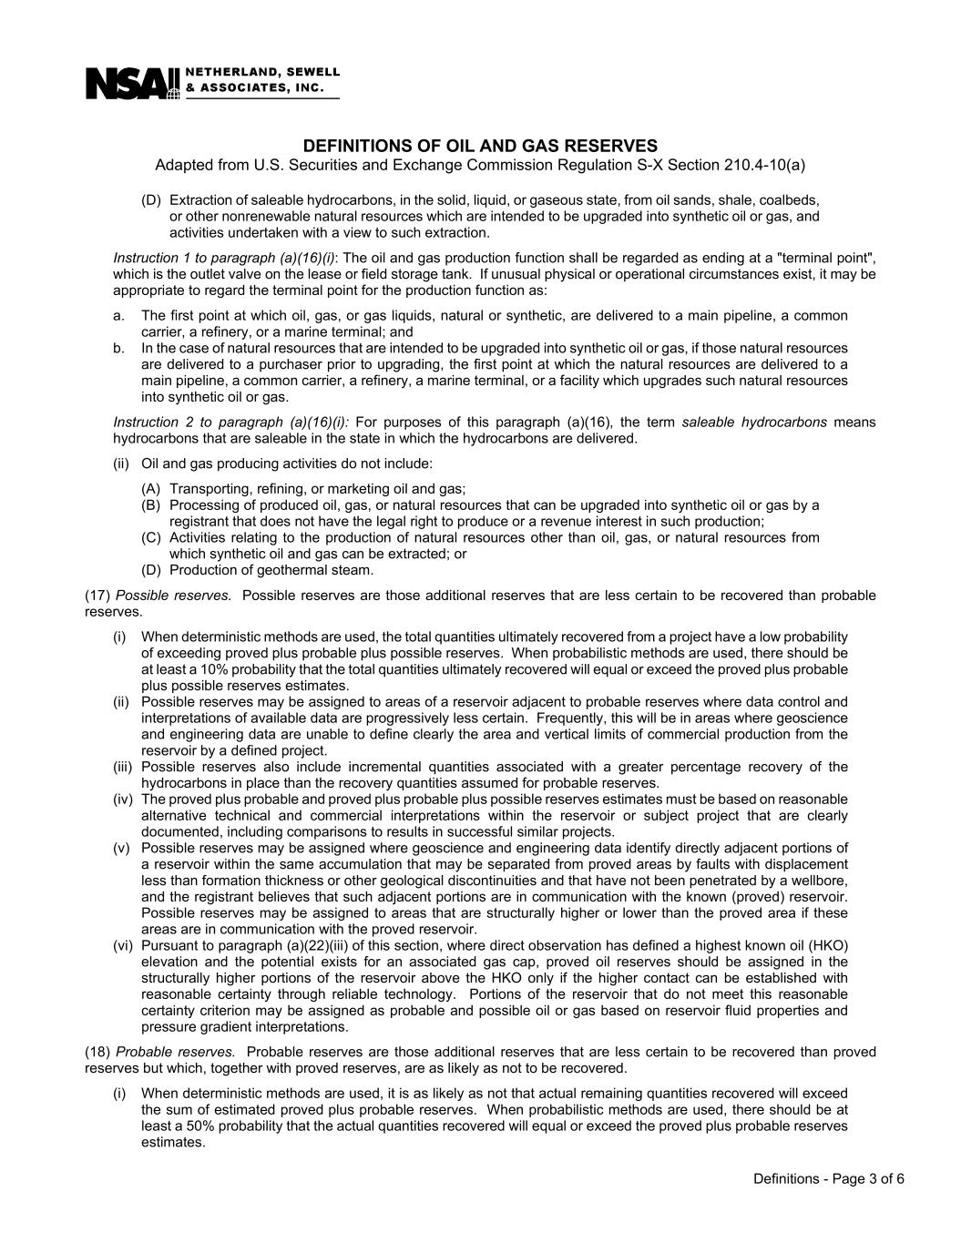
DEFINITIONS OF OIL AND GAS RESERVES Adapted from U.S. Securities and Exchange Commission Regulation S-X Section 210.4-10(a) Definitions - Page 3 of 6 (D) Extraction of saleable hydrocarbons, in the solid, liquid, or gaseous state, from oil sands, shale, coalbeds, or other nonrenewable natural resources which are intended to be upgraded into synthetic oil or gas, and activities undertaken with a view to such extraction. Instruction 1 to paragraph (a)(16)(i): The oil and gas production function shall be regarded as ending at a "terminal point", which is the outlet valve on the lease or field storage tank. If unusual physical or operational circumstances exist, it may be appropriate to regard the terminal point for the production function as: a. The first point at which oil, gas, or gas liquids, natural or synthetic, are delivered to a main pipeline, a common carrier, a refinery, or a marine terminal; and b. In the case of natural resources that are intended to be upgraded into synthetic oil or gas, if those natural resources are delivered to a purchaser prior to upgrading, the first point at which the natural resources are delivered to a main pipeline, a common carrier, a refinery, a marine terminal, or a facility which upgrades such natural resources into synthetic oil or gas. Instruction 2 to paragraph (a)(16)(i): For purposes of this paragraph (a)(16), the term saleable hydrocarbons means hydrocarbons that are saleable in the state in which the hydrocarbons are delivered. (ii) Oil and gas producing activities do not include: (A) Transporting, refining, or marketing oil and gas; (B) Processing of produced oil, gas, or natural resources that can be upgraded into synthetic oil or gas by a registrant that does not have the legal right to produce or a revenue interest in such production; (C) Activities relating to the production of natural resources other than oil, gas, or natural resources from which synthetic oil and gas can be extracted; or (D) Production of geothermal steam. (17) Possible reserves. Possible reserves are those additional reserves that are less certain to be recovered than probable reserves. (i) When deterministic methods are used, the total quantities ultimately recovered from a project have a low probability of exceeding proved plus probable plus possible reserves. When probabilistic methods are used, there should be at least a 10% probability that the total quantities ultimately recovered will equal or exceed the proved plus probable plus possible reserves estimates. (ii) Possible reserves may be assigned to areas of a reservoir adjacent to probable reserves where data control and interpretations of available data are progressively less certain. Frequently, this will be in areas where geoscience and engineering data are unable to define clearly the area and vertical limits of commercial production from the reservoir by a defined project. (iii) Possible reserves also include incremental quantities associated with a greater percentage recovery of the hydrocarbons in place than the recovery quantities assumed for probable reserves. (iv) The proved plus probable and proved plus probable plus possible reserves estimates must be based on reasonable alternative technical and commercial interpretations within the reservoir or subject project that are clearly documented, including comparisons to results in successful similar projects. (v) Possible reserves may be assigned where geoscience and engineering data identify directly adjacent portions of a reservoir within the same accumulation that may be separated from proved areas by faults with displacement less than formation thickness or other geological discontinuities and that have not been penetrated by a wellbore, and the registrant believes that such adjacent portions are in communication with the known (proved) reservoir. Possible reserves may be assigned to areas that are structurally higher or lower than the proved area if these areas are in communication with the proved reservoir. (vi) Pursuant to paragraph (a)(22)(iii) of this section, where direct observation has defined a highest known oil (HKO) elevation and the potential exists for an associated gas cap, proved oil reserves should be assigned in the structurally higher portions of the reservoir above the HKO only if the higher contact can be established with reasonable certainty through reliable technology. Portions of the reservoir that do not meet this reasonable certainty criterion may be assigned as probable and possible oil or gas based on reservoir fluid properties and pressure gradient interpretations. (18) Probable reserves. Probable reserves are those additional reserves that are less certain to be recovered than proved reserves but which, together with proved reserves, are as likely as not to be recovered. (i) When deterministic methods are used, it is as likely as not that actual remaining quantities recovered will exceed the sum of estimated proved plus probable reserves. When probabilistic methods are used, there should be at least a 50% probability that the actual quantities recovered will equal or exceed the proved plus probable reserves estimates.

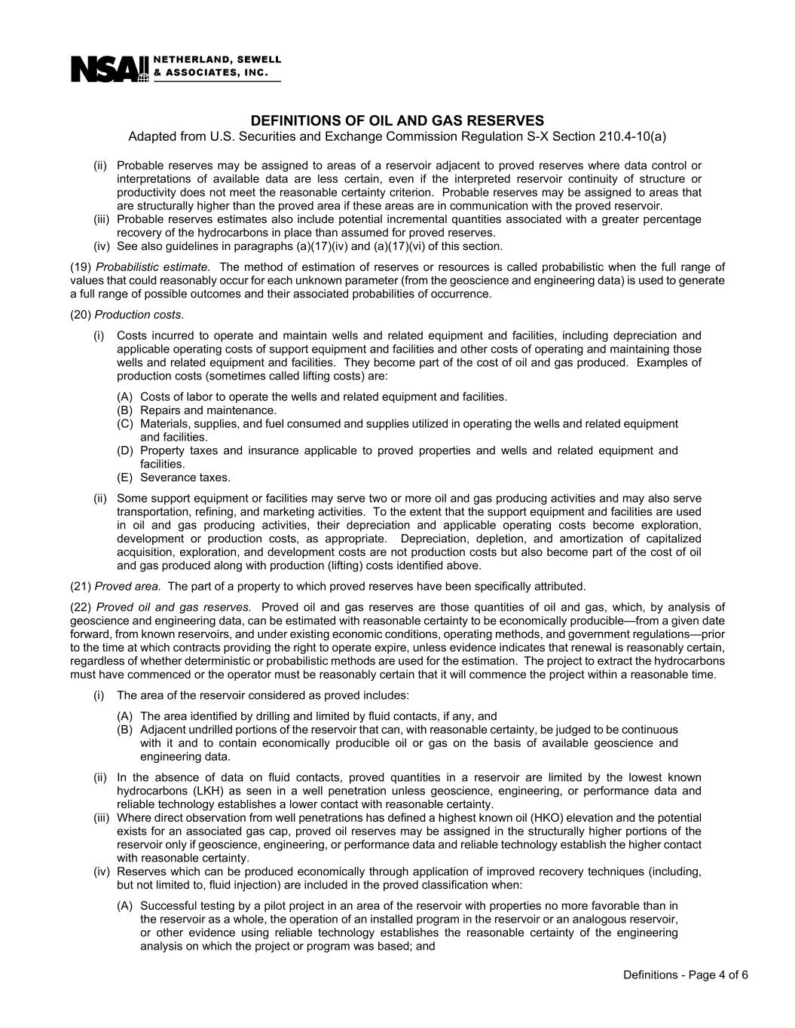
DEFINITIONS OF OIL AND GAS RESERVES Adapted from U.S. Securities and Exchange Commission Regulation S-X Section 210.4-10(a) Definitions - Page 4 of 6 (ii) Probable reserves may be assigned to areas of a reservoir adjacent to proved reserves where data control or interpretations of available data are less certain, even if the interpreted reservoir continuity of structure or productivity does not meet the reasonable certainty criterion. Probable reserves may be assigned to areas that are structurally higher than the proved area if these areas are in communication with the proved reservoir. (iii) Probable reserves estimates also include potential incremental quantities associated with a greater percentage recovery of the hydrocarbons in place than assumed for proved reserves. (iv) See also guidelines in paragraphs (a)(17)(iv) and (a)(17)(vi) of this section. (19) Probabilistic estimate. The method of estimation of reserves or resources is called probabilistic when the full range of values that could reasonably occur for each unknown parameter (from the geoscience and engineering data) is used to generate a full range of possible outcomes and their associated probabilities of occurrence. (20) Production costs. (i) Costs incurred to operate and maintain wells and related equipment and facilities, including depreciation and applicable operating costs of support equipment and facilities and other costs of operating and maintaining those wells and related equipment and facilities. They become part of the cost of oil and gas produced. Examples of production costs (sometimes called lifting costs) are: (A) Costs of labor to operate the wells and related equipment and facilities. (B) Repairs and maintenance. (C) Materials, supplies, and fuel consumed and supplies utilized in operating the wells and related equipment and facilities. (D) Property taxes and insurance applicable to proved properties and wells and related equipment and facilities. (E) Severance taxes. (ii) Some support equipment or facilities may serve two or more oil and gas producing activities and may also serve transportation, refining, and marketing activities. To the extent that the support equipment and facilities are used in oil and gas producing activities, their depreciation and applicable operating costs become exploration, development or production costs, as appropriate. Depreciation, depletion, and amortization of capitalized acquisition, exploration, and development costs are not production costs but also become part of the cost of oil and gas produced along with production (lifting) costs identified above. (21) Proved area. The part of a property to which proved reserves have been specifically attributed. (22) Proved oil and gas reserves. Proved oil and gas reserves are those quantities of oil and gas, which, by analysis of geoscience and engineering data, can be estimated with reasonable certainty to be economically producible—from a given date forward, from known reservoirs, and under existing economic conditions, operating methods, and government regulations—prior to the time at which contracts providing the right to operate expire, unless evidence indicates that renewal is reasonably certain, regardless of whether deterministic or probabilistic methods are used for the estimation. The project to extract the hydrocarbons must have commenced or the operator must be reasonably certain that it will commence the project within a reasonable time. (i) The area of the reservoir considered as proved includes: (A) The area identified by drilling and limited by fluid contacts, if any, and (B) Adjacent undrilled portions of the reservoir that can, with reasonable certainty, be judged to be continuous with it and to contain economically producible oil or gas on the basis of available geoscience and engineering data. (ii) In the absence of data on fluid contacts, proved quantities in a reservoir are limited by the lowest known hydrocarbons (LKH) as seen in a well penetration unless geoscience, engineering, or performance data and reliable technology establishes a lower contact with reasonable certainty. (iii) Where direct observation from well penetrations has defined a highest known oil (HKO) elevation and the potential exists for an associated gas cap, proved oil reserves may be assigned in the structurally higher portions of the reservoir only if geoscience, engineering, or performance data and reliable technology establish the higher contact with reasonable certainty. (iv) Reserves which can be produced economically through application of improved recovery techniques (including, but not limited to, fluid injection) are included in the proved classification when: (A) Successful testing by a pilot project in an area of the reservoir with properties no more favorable than in the reservoir as a whole, the operation of an installed program in the reservoir or an analogous reservoir, or other evidence using reliable technology establishes the reasonable certainty of the engineering analysis on which the project or program was based; and

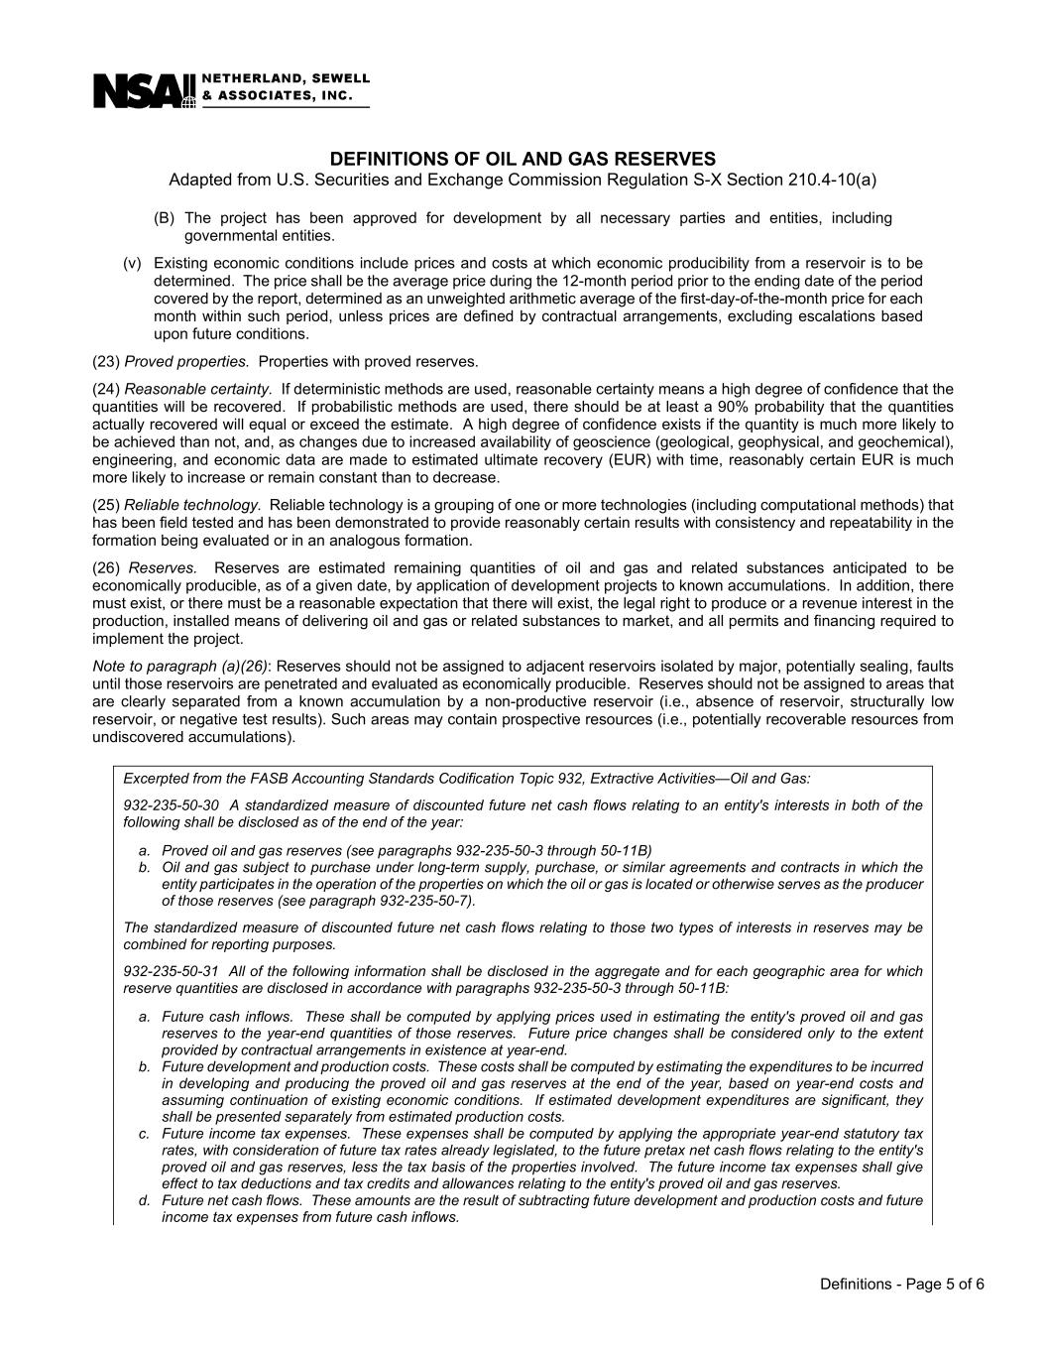
DEFINITIONS OF OIL AND GAS RESERVES Adapted from U.S. Securities and Exchange Commission Regulation S-X Section 210.4-10(a) Definitions - Page 5 of 6 (B) The project has been approved for development by all necessary parties and entities, including governmental entities. (v) Existing economic conditions include prices and costs at which economic producibility from a reservoir is to be determined. The price shall be the average price during the 12-month period prior to the ending date of the period covered by the report, determined as an unweighted arithmetic average of the first-day-of-the-month price for each month within such period, unless prices are defined by contractual arrangements, excluding escalations based upon future conditions. (23) Proved properties. Properties with proved reserves. (24) Reasonable certainty. If deterministic methods are used, reasonable certainty means a high degree of confidence that the quantities will be recovered. If probabilistic methods are used, there should be at least a 90% probability that the quantities actually recovered will equal or exceed the estimate. A high degree of confidence exists if the quantity is much more likely to be achieved than not, and, as changes due to increased availability of geoscience (geological, geophysical, and geochemical), engineering, and economic data are made to estimated ultimate recovery (EUR) with time, reasonably certain EUR is much more likely to increase or remain constant than to decrease. (25) Reliable technology. Reliable technology is a grouping of one or more technologies (including computational methods) that has been field tested and has been demonstrated to provide reasonably certain results with consistency and repeatability in the formation being evaluated or in an analogous formation. (26) Reserves. Reserves are estimated remaining quantities of oil and gas and related substances anticipated to be economically producible, as of a given date, by application of development projects to known accumulations. In addition, there must exist, or there must be a reasonable expectation that there will exist, the legal right to produce or a revenue interest in the production, installed means of delivering oil and gas or related substances to market, and all permits and financing required to implement the project. Note to paragraph (a)(26): Reserves should not be assigned to adjacent reservoirs isolated by major, potentially sealing, faults until those reservoirs are penetrated and evaluated as economically producible. Reserves should not be assigned to areas that are clearly separated from a known accumulation by a non-productive reservoir (i.e., absence of reservoir, structurally low reservoir, or negative test results). Such areas may contain prospective resources (i.e., potentially recoverable resources from undiscovered accumulations). Excerpted from the FASB Accounting Standards Codification Topic 932, Extractive Activities—Oil and Gas: 932-235-50-30 A standardized measure of discounted future net cash flows relating to an entity's interests in both of the following shall be disclosed as of the end of the year: a. Proved oil and gas reserves (see paragraphs 932-235-50-3 through 50-11B) b. Oil and gas subject to purchase under long-term supply, purchase, or similar agreements and contracts in which the entity participates in the operation of the properties on which the oil or gas is located or otherwise serves as the producer of those reserves (see paragraph 932-235-50-7). The standardized measure of discounted future net cash flows relating to those two types of interests in reserves may be combined for reporting purposes. 932-235-50-31 All of the following information shall be disclosed in the aggregate and for each geographic area for which reserve quantities are disclosed in accordance with paragraphs 932-235-50-3 through 50-11B: a. Future cash inflows. These shall be computed by applying prices used in estimating the entity's proved oil and gas reserves to the year-end quantities of those reserves. Future price changes shall be considered only to the extent provided by contractual arrangements in existence at year-end. b. Future development and production costs. These costs shall be computed by estimating the expenditures to be incurred in developing and producing the proved oil and gas reserves at the end of the year, based on year-end costs and assuming continuation of existing economic conditions. If estimated development expenditures are significant, they shall be presented separately from estimated production costs. c. Future income tax expenses. These expenses shall be computed by applying the appropriate year-end statutory tax rates, with consideration of future tax rates already legislated, to the future pretax net cash flows relating to the entity's proved oil and gas reserves, less the tax basis of the properties involved. The future income tax expenses shall give effect to tax deductions and tax credits and allowances relating to the entity's proved oil and gas reserves. d. Future net cash flows. These amounts are the result of subtracting future development and production costs and future income tax expenses from future cash inflows.

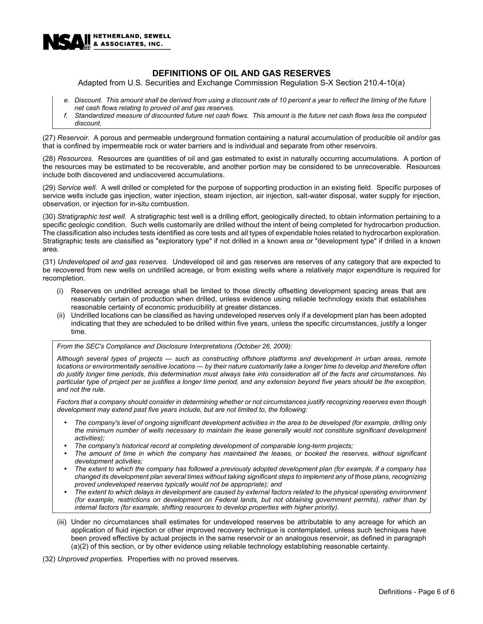
DEFINITIONS OF OIL AND GAS RESERVES Adapted from U.S. Securities and Exchange Commission Regulation S-X Section 210.4-10(a) Definitions - Page 6 of 6 e. Discount. This amount shall be derived from using a discount rate of 10 percent a year to reflect the timing of the future net cash flows relating to proved oil and gas reserves. f. Standardized measure of discounted future net cash flows. This amount is the future net cash flows less the computed discount. (27) Reservoir. A porous and permeable underground formation containing a natural accumulation of producible oil and/or gas that is confined by impermeable rock or water barriers and is individual and separate from other reservoirs. (28) Resources. Resources are quantities of oil and gas estimated to exist in naturally occurring accumulations. A portion of the resources may be estimated to be recoverable, and another portion may be considered to be unrecoverable. Resources include both discovered and undiscovered accumulations. (29) Service well. A well drilled or completed for the purpose of supporting production in an existing field. Specific purposes of service wells include gas injection, water injection, steam injection, air injection, salt-water disposal, water supply for injection, observation, or injection for in-situ combustion. (30) Stratigraphic test well. A stratigraphic test well is a drilling effort, geologically directed, to obtain information pertaining to a specific geologic condition. Such wells customarily are drilled without the intent of being completed for hydrocarbon production. The classification also includes tests identified as core tests and all types of expendable holes related to hydrocarbon exploration. Stratigraphic tests are classified as "exploratory type" if not drilled in a known area or "development type" if drilled in a known area. (31) Undeveloped oil and gas reserves. Undeveloped oil and gas reserves are reserves of any category that are expected to be recovered from new wells on undrilled acreage, or from existing wells where a relatively major expenditure is required for recompletion. (i) Reserves on undrilled acreage shall be limited to those directly offsetting development spacing areas that are reasonably certain of production when drilled, unless evidence using reliable technology exists that establishes reasonable certainty of economic producibility at greater distances. (ii) Undrilled locations can be classified as having undeveloped reserves only if a development plan has been adopted indicating that they are scheduled to be drilled within five years, unless the specific circumstances, justify a longer time. From the SEC's Compliance and Disclosure Interpretations (October 26, 2009): Although several types of projects — such as constructing offshore platforms and development in urban areas, remote locations or environmentally sensitive locations — by their nature customarily take a longer time to develop and therefore often do justify longer time periods, this determination must always take into consideration all of the facts and circumstances. No particular type of project per se justifies a longer time period, and any extension beyond five years should be the exception, and not the rule. Factors that a company should consider in determining whether or not circumstances justify recognizing reserves even though development may extend past five years include, but are not limited to, the following: • The company's level of ongoing significant development activities in the area to be developed (for example, drilling only the minimum number of wells necessary to maintain the lease generally would not constitute significant development activities); • The company's historical record at completing development of comparable long-term projects; • The amount of time in which the company has maintained the leases, or booked the reserves, without significant development activities; • The extent to which the company has followed a previously adopted development plan (for example, if a company has changed its development plan several times without taking significant steps to implement any of those plans, recognizing proved undeveloped reserves typically would not be appropriate); and • The extent to which delays in development are caused by external factors related to the physical operating environment (for example, restrictions on development on Federal lands, but not obtaining government permits), rather than by internal factors (for example, shifting resources to develop properties with higher priority). (iii) Under no circumstances shall estimates for undeveloped reserves be attributable to any acreage for which an application of fluid injection or other improved recovery technique is contemplated, unless such techniques have been proved effective by actual projects in the same reservoir or an analogous reservoir, as defined in paragraph (a)(2) of this section, or by other evidence using reliable technology establishing reasonable certainty. (32) Unproved properties. Properties with no proved reserves.

